DSWD DROMIC Preparedness for Response Report #2
on Tropical Depression “Ambo”
as of 12 May 2020, 6PM

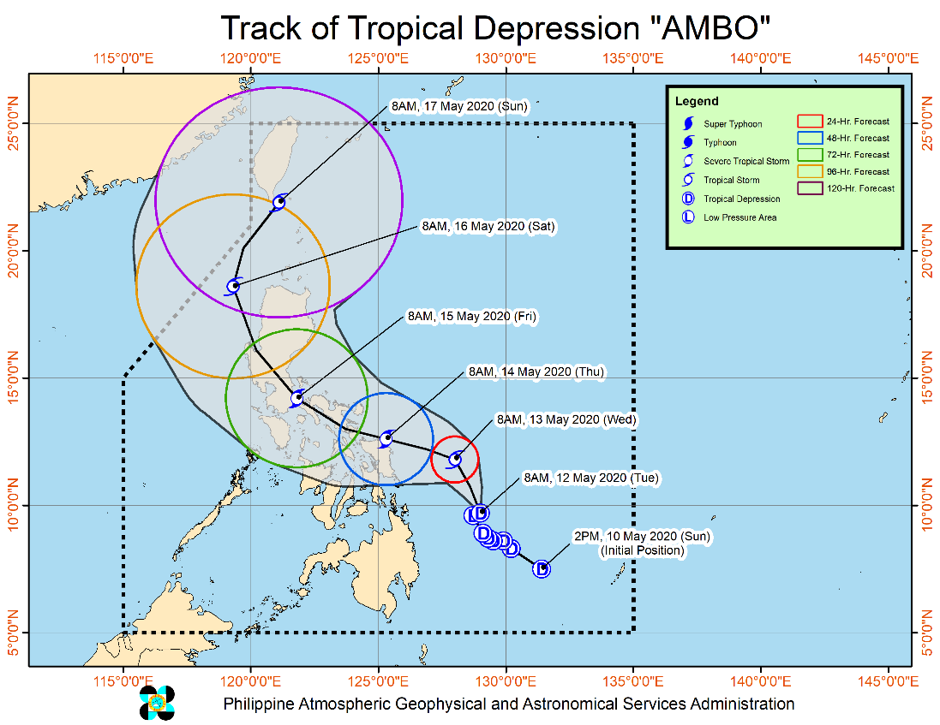
Situation Overview

At 11:00 AM, 12 May 2020, “AMBO” MAINTAINS ITS STRENGTH WHILE REMAINING ALMOST STATIONARY OVER THE PHILIPPINE SEA.

- Within 24 hours, the trough of TD AMBO will bring scattered light to moderate with at times heavy rainshowers during thunderstorms over Mindanao. Residents in these areas are advised to take precautionary measures and continue monitoring for updates, especially the local rainfall or thunderstorm advisories and heavy rainfall warnings from PAGASA Regional Services Divisions (PRSD). Flooding and rain-induced landslides may occur in highly to very highly susceptible areas during heavy or prolonged rainfall.
- Moderate to rough seas will be experienced over the eastern seaboards of Eastern Visayas and Caraga. Fisherfolks and those with small seacrafts are advised not venture out on these areas.
- Tropical Cyclone Wind Signal (TCWS) #1 may be raised over portions of Eastern Visayas today, in anticipation of potentially strong winds associated with the TD. Disruption of maritime activities may be experienced in areas where TCWS is in effect.
- TD “Ambo” is forecast to intensify into a Tropical Storm within 24 hours.

At 10:00 AM today, the center of Tropical Depression "AMBO" was estimated based on all available data at 385 km East of Surigao City, Surigao del Norte (9.8 °N, 129.0 °E)
Source: DOST-PAGASA Severe Weather Bulletin

PREDICTIVE ANALYTICS FOR HUMANITARIAN RESPONSE
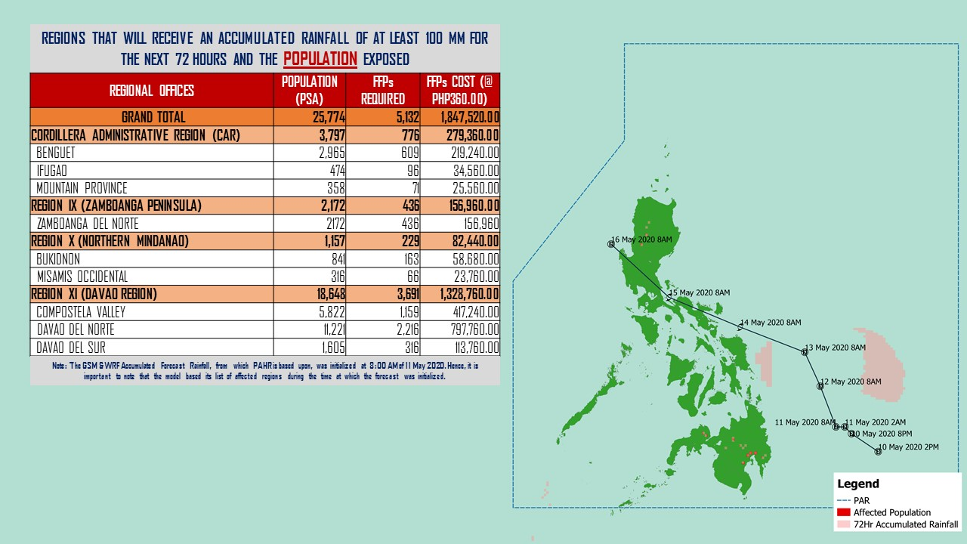
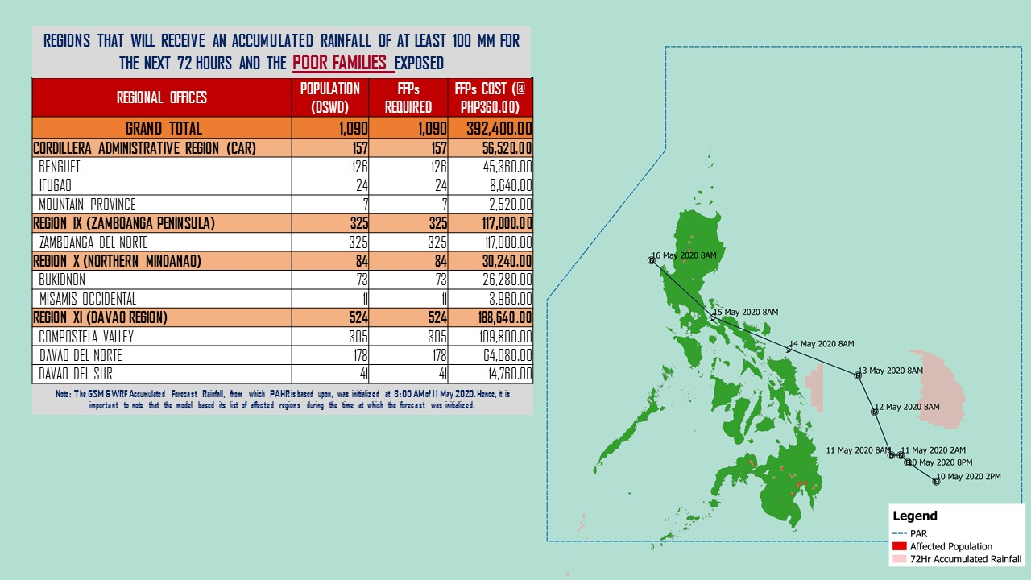

Source: DRMB-DROMIC GIS Specialists
Status of Prepositioned Resources: Stockpile and Standby Funds
The DSWD Central Office (CO), Field Offices (FOs), and National Resource Operations Center (NROC) have stockpiles and standby funds amounting to ₱1,202,943,270.39 with breakdown as follows (see Table 2):

- Standby Funds
A total of ₱244,927,720.96 standby funds in the CO and FOs. Of the said amount, ₱199,914,543.93 is the available Quick Response Fund (QRF) in the CO.

- Stockpiles
A total of 418,493 family food packs (FFPs) amounting to ₱183,475,338.83, other food items amounting to ₱278,031,795.11 and non-food items (FNIs) amounting to ₱496,508,415.49 are available.

Table 2. Available Standby Funds and Stockpiles
Region / Office | Standby Funds | FAMILY FOOD PACKS |  | Other Food Items | Non-Food Relief Items | Total Standby Funds & Stockpile
 |  | Quantity | Total Cost
 | 244,927,720.96 | 418,493 | 183,475,338.83 | 278,031,795.11 | 496,508,415.49 | 1,202,943,270.39
Central Office | 199,914,543.93 | - | - | - | - | 199,914,543.93
NRLMB - NROC | - | 87,965 | 40,132,430.00 | 51,713,127.06 | 273,405,234.98 | 365,250,792.04
NRLMB - VDRC | - | 49,709 | 23,398,026.30 | 14,078,695.04 | 8,740,010.50 | 46,216,731.84
I | 3,000,000.00 | 21,751 | 9,491,914.14 | 1,666,630.00 | 39,617,593.15 | 53,776,137.29
II | 2,700,138.89 | 21,915 | 8,981,483.00 | 12,626,075.10 | 5,510,398.95 | 29,818,095.94
III | 926,720.64 | 3,656 | 1,980,053.04 | 4,740,971.72 | 5,510,398.95 | 13,158,144.35
CALABARZON | 3,000,000.00 | 6,261 | 2,367,530.00 | 7,901,624.00 | 5,100,261.58 | 18,369,415.58
MIMAROPA | 3,069,989.19 | 13,467 | 6,060,150.00 | 4,313,203.00 | 5,009,477.50 | 18,452,819.69
V | 3,001,050.00 | 3,224 | 1,215,489.70 | 5,734,678.09 | 29,684,861.91 | 39,636,079.70
VI | 3,000,851.68 | 18,298 | 8,663,140.00 | 48,660,483.77 | 6,853,499.39 | 67,177,974.84
VII | 3,000,015.14 | 47,479 | 18,908,089.42 | 37,491,733.51 | 74,048.00 | 59,473,886.07
VIII | 3,001,454.16 | 4,814 | 2,643,222.98 | 1,593,189.54 | 19,362,680.38 | 26,600,547.06
IX | 3,000,000.00 | 30,361 | 15,589,638.00 | 8,782,570.00 | 14,357,924.59 | 41,730,132.59
X | 3,106,997.00 | 46,991 | 18,698,198.79 | 37,791,044.43 | 19,741,365.19 | 79,337,605.41
XI | 3,000,000.00 | 16,712 | 6,185,946.80 | 6,724,958.90 | 23,839,069.26 | 39,749,974.96
XII | 3,000,701.68 | 3,937 | 1,775,587.00 | 10,289,125.49 | 12,876,448.72 | 27,941,862.89
CARAGA | 3,000,000.00 | 15,279 | 5,550,167.70 | 10,935,422.52 | 3,258,445.70 | 22,744,035.92
NCR | 2,200,300.00 | 1,440 | 635,500.80 | 1,789,491.78 | 9,799,152.16 | 14,424,444.74
CAR | 3,004,958.65 | 25,234 | 11,198,771.16 | 11,198,771.16 | 13,767,544.58 | 39,170,045.55
Note: The Inventory Summary is as of 11 May 2020, 6PM.
Source: DRMB and NRLMB

Situational Reports

DSWD-DRMB
DATE | SITUATIONS / ACTIONS UNDERTAKEN
12 May 2020 | - The Disaster Response Management Bureau (DRMB) is on BLUE alert status and is closely coordinating with the concerned field offices for significant disaster response updates  - All QRT members and emergency equipment are on standby and ready for deployment.
11 May 2020 | - DRMB participated in the Online Pre-Disaster Risk Assessment Meeting on Tropical Depression “AMBO” on 11 May 2020 with other response cluster member agencies. Further meetings shall be conducted on the implementation of COVID-19 protocols during the response efforts on TD “Ambo”.

DSWD-FO I
DATE | SITUATIONS / ACTIONS UNDERTAKEN
12 May 2020 | - DSWD-FO I is in close coordination with the Regional Disaster Risk Reduction and Management Council I and is closely monitoring the possible effects of Tropical Depression “AMBO”. Likewise, Provincial Operations Offices (POOs) are in close coordination with the different Provincial/City/Municipal Disaster Risk Reduction and Management Councils (P/C/MDRRMCs) and Provincial/City/Municipal Social Welfare and Development Offices (P/C/MSWDOs) to monitor the adverse effects that may be brought by the weather disturbance.

DSWD-FO CALABARZON
DATE | SITUATIONS / ACTIONS UNDERTAKEN
11 May 2020 | - DSWD-FO CALABARZON is in coordination with the National Food Authority (NFA) to facilitate the hauling of NFA Rice for the production of relief good in preparation to any untoward incidents.  - DSWD-FO CALABARZON Emergency Operations Center is already activated to monitor the possible effects of TD “Ambo”.  - DSWD-FO CALABARZON Disaster Response Management Division (DRMD) is in constant communication with the Local Social Welfare and Development Offices (LSWDOs) with pre-disaster assessments being conducted.  - DRMD conducted close coordination with the Local Government Units (LGUs) with regards to the preparedness efforts undertaken in the Flood, Landslide and Storm Surge prone areas.  - DRMD coordinated with SWAD Team Leaders and Provincial Action Team of the CALABARZON and advised them to monitor and coordinate with the LGUs to gather reports on the possible effects of TD “Ambo”.  - DRMD coordinated with LSWDOs and LDRRMOs and instructed them to be on standby alert and prepare their respective evacuation centers, and family food packs should need arises.  - DRMD coordinated with the RDRRMC IV-A OpCen for updates on the preparedness level of the members of the Response Cluster of the region.  - DSWD-FO CALABARZON informed the member agencies of the response cluster to be on-stand-by alert and be ready for mobilization.

DSWD-FO MIMAROPA
DATE | SITUATIONS / ACTIONS UNDERTAKEN
11 May 2020 | - DSWD-FO MIMAROPA Disaster Response Management Division and Provincial Project Development Officers are alerted to monitor daily local weather condition and ensure provision of information to all concerned offices, divisions, sections, offices.  - Alerted all P/C/M Quick Response Team in five provinces of MIMAROPA to regularly monitor the situations in their areas.  - 24/7 On-call status of the R/P/C/M QRT together with special projects for the possible activation of Operation Center.  - DSWD-MIMAROPA is in close coordination with the Office of Civil Defense (OCD) and RDRRMC MIMAROPA for any warning signal updates for monitoring purposes and response mechanism for areas that will be affected.  - Standby logistical equipment and workforce through coordination with SWADT Offices and concerned LGUs on the management of stranded passengers, if any, in ports and terminals.  - Information and Communication Technology Management Unit (ICTMU) is on standby status to ensure robust communication system.  - All members of Rapid Emergency Telecommunications Team are on on-call and standby status ready for deployment if needed.  - DSWD-MIMAROPA ensures that the Rapid Emergency Telecommunications Equipment (GX Terminal, BGAN Terminals and Satellite Phones) are in good condition and ready for deployment to areas that will experience potential emergencies.  - DSWD-MIMAROPA ensures that there is an on-call truck available for delivery of goods and equipment to areas that will be affected

DSWD-FO V
DATE | SITUATIONS / ACTIONS UNDERTAKEN
11 May 2020 | - DSWD-FO V is in close coordination with LGUs for food ration requirement.  - DSWD-FO V DRMD Disaster Response Management Division (DRMD) continuous to monitor weather updates and information.  - The Resource Operation Section ensures the availability of family food packs and non-food items as need arises.  - DSWD-FO V QRTs are activated.  - PAT and MAT members in the 6 provinces are activated and instructed to coordinate with the P/MDRRMOs, C/MSWDOs for TD Ambo reports.

DSWD-FO VII
DATE | SITUATIONS / ACTIONS UNDERTAKEN
12 May 2020 | - RDRRMC/OCD-7 raised Alert Status Level to Blue as TD Ambo approaches.  - PDRA Meeting for TD Ambo was convened on 11 May 2020. DSWD-FO VII was represented by Marvin Solivio, SWO II of the Disaster Response Management Division (DRMD).  - Continuous monitoring by the DSWD Regional DROMIC Focal for the latest weather updates from PAGASA and cascading the same for widest dissemination to P/C/MATs.  - City and Municipal Action Team and SWAD Offices were alerted and already requested to closely coordinate with their local counterparts and their respective LDRRMC. Field staff were requested to monitor AOR and provide reports and updates to the Regional DROMIC Focal for any impacts.  - Provincial/City/Municipal Quick Response Team is on standby alert and ready for mobilization for any assistance and augmentation support needed from the LGUs.  - Regional Disaster Division is in close coordination with OCD-7 and other members of the RDRRMC for any response mobilization activities/strategies.  - Warehouses in the three island provinces are on ready alert.

DSWD-FO XI
DATE | SITUATIONS / ACTIONS UNDERTAKEN
11 May 2020 | - DSWD-FO XI activated the field office and RPMO’s (SWADTs, PATs, MATs, CATs) Quick Response Team as On-Call duty.  - DSWD-FO XI is in close coordination with all SWADOs and PSWDOs/CSWDO/MSWDOs for monitoring of the situation in the different parts of Davao Region. Personnel in the warehouse are also on alert to ensure the readiness to dispatch relief goods (food and non-food items) at any given time.  - Availability of Disaster Wing Van, vehicles and drivers in the event of relief operation.  - DSWD-FO XI is in close coordination with the Office of Civil Defense (OCD) XI for logistical support monitoring.  - DSWD-FO XI is in close coordination with the staff rendering skeletal duty in the DRMD Office and City/Municipal Action.

DSWD-FO Caraga
DATE | SITUATIONS / ACTIONS UNDERTAKEN
11 May 2020 | - DSWD-FO Caraga attended the PDRA/ERP Meeting through teleconferencing with the Caraga RDRRMC Member agencies to discuss the preparedness and response measures regarding the tropical depression.
*****
The Disaster Response Operations Monitoring and Information Center (DROMIC) of the DSWD-DRMB is closely monitoring the effects of TD “Ambo” and is coordinating with the concerned DSWD Field Offices for any significant updates.

Prepared by: Releasing Officer:

MARIE JOYCE G. RAFANAN RODEL V. CABADDU

