DSWD DROMIC Preparedness for Response Report #4
on Typhoon “Ambo”
as of 14 May 2020, 6PM

Situation Overview
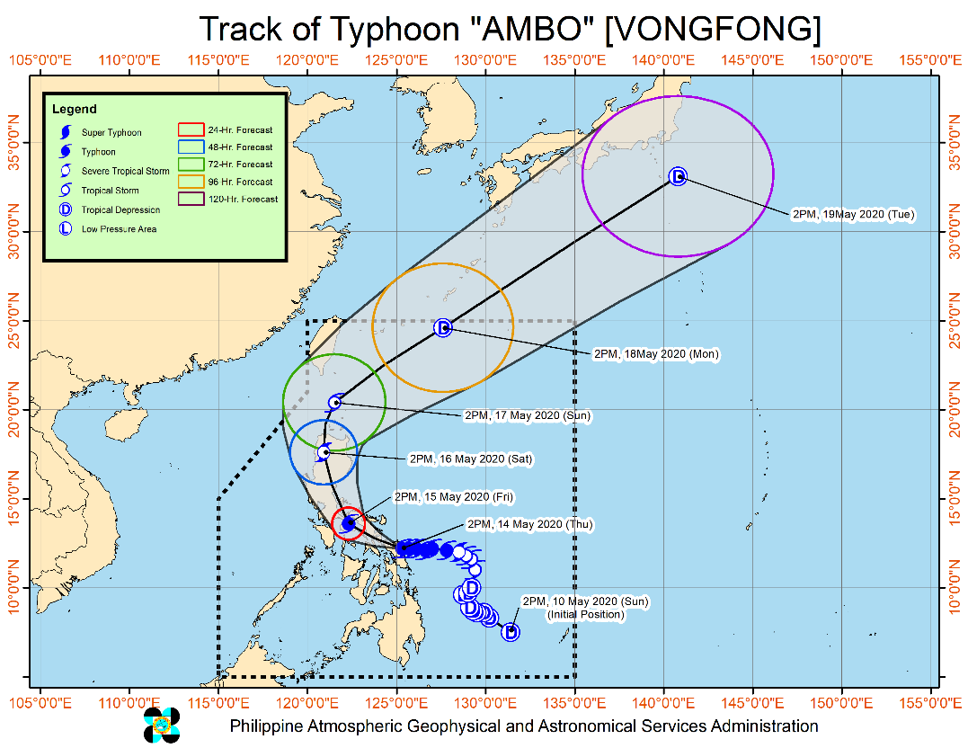
At 4:00 PM today, the eye of Typhoon "AMBO" was located based on all available data including those from Virac Doppler Radar in the vicinity of San Jose De Buan, Samar (12.0 °N, 125.1 °E ) It is moving towards the West at 15 km/h with maximum sustained winds of 155 km/h near the center and gustiness of up to 255 km/h.
- The eyewall of Typhoon "Ambo" is bringing violent winds and heavy to intense rains over the northern portion of Samar and the southern portion of Northern Samar.
- Heavy Rainfall Outlook:
- Tonight (14 May): Heavy to at times intense rains over Samar Provinces, Masbate, and Sorsogon. Moderate to at times heavy rains over Albay, Camarines Sur, Catanduanes, and the rest of Eastern Visayas.
- Tomorrow (15 May): Moderate to heavy with at times intense rains over Bicol Region, Northern Samar, Quezon, Aurora, Marinduque, and Romblon.
- Residents in these areas are advised to take appropriate measures, coordinate with local disaster risk reduction and management offices, and continue monitoring for updates, especially the local rainfall or thunderstorm advisories and heavy rainfall warnings from PAGASA Regional Services Divisions (PRSD). Flooding and rain-induced landslides may occur in highly to very highly susceptible areas during heavy or prolonged rainfall.
- Coastal Water Conditions and Storm Surge Information:
- In the next 24 hours, storm surge of 2.0 to 4.0 meters may be experienced over the coastal areas of Northern Samar, Samar (west coast), Sorsogon, Albay, Catanduanes, Camarines Sur, Camarines Norte, Quezon, and Aurora. Along with large swells, this storm surge may cause potentially life-threatening coastal inundation.
- Sea travel is risky for all types of seacrafts over the seaboards of areas under TCWS.
Source: DOST-PAGASA Severe Weather Bulletin

PREDICTIVE ANALYTICS FOR HUMANITARIAN RESPONSE

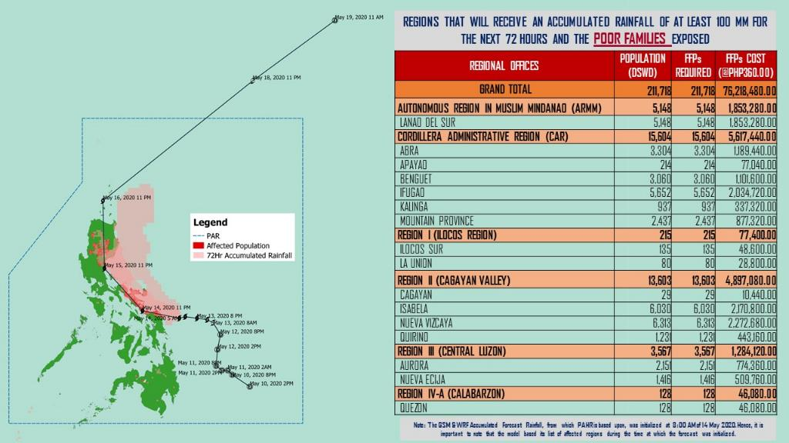

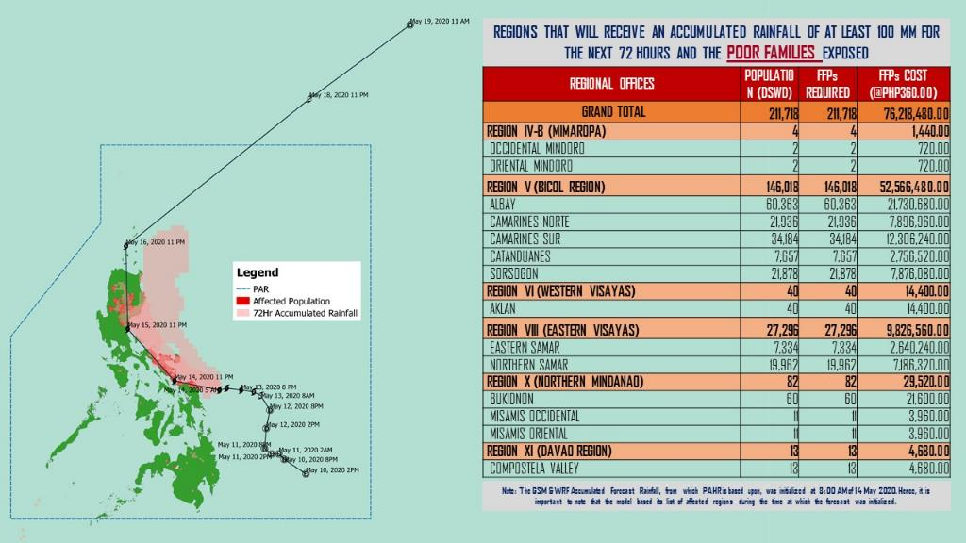
Source: DRMB-DROMIC GIS Specialists
Status of Prepositioned Resources: Stockpile and Standby Funds
The DSWD Central Office (CO), Field Offices (FOs), and National Resource Operations Center (NROC) have stockpiles and standby funds amounting to ₱1,187,276,201.67 with breakdown as follows (see Table 2):

- Standby Funds
A total of ₱239,358,454.96 standby funds in the CO and FOs. Of the said amount, ₱199,914,543.93 is the available Quick Response Fund (QRF) in the CO.

- Stockpiles
A total of 402,879 family food packs (FFPs) amounting to ₱180,214,446.40, other food items amounting to ₱270,137,144.46 and non-food items (FNIs) amounting to ₱497,566,155.85 are available.

Table 2. Available Standby Funds and Stockpiles
Region / Office | Standby Funds | FAMILY FOOD PACKS |  | Other Food Items | Non-Food Relief Items | Total Standby Funds & Stockpile
 |  | Quantity | Total Cost
 | 239,358,454.96 | 402,879 | 180,214,446.40 | 270,137,144.46 | 497,566,155.85 | 1,187,276,201.67
Central Office | 199,914,543.93 | - | - | - | - | 199,914,543.93
NRLMB - NROC | - | 76,537 | 35,183,890.00 | 46,170,820.26 | 274,784,794.34 | 356,139,504.60
NRLMB - VDRC | - | 42,357 | 19,937,439.90 | 11,414,590.40 | 8,418,215.50 | 39,770,245.80
I | 650,455.00 | 24,051 | 10,664,914.14 | 1,011,130.00 | 39,617,593.15 | 51,944,092.29
II | 2,700,138.89 | 22,963 | 8,472,020.26 | 12,363,967.10 | 5,510,398.95 | 29,046,525.20
III | 926,720.64 | 6,157 | 3,334,569.63 | 4,740,971.72 | 5,510,398.95 | 14,512,660.94
CALABARZON | 3,000,000.00 | 6,261 | 2,367,530.00 | 7,901,624.00 | 5,100,261.58 | 18,369,415.58
MIMAROPA | 3,069,989.19 | 13,456 | 6,055,200.00 | 4,313,203.00 | 5,009,477.50 | 18,447,869.69
V | 3,001,050.00 | 3,224 | 1,215,489.70 | 5,299,355.17 | 29,684,861.91 | 39,200,756.78
VI | 3,000,851.68 | 18,628 | 9,201,040.00 | 48,660,483.77 | 6,853,499.39 | 67,715,874.84
VII | 3,000,015.14 | 42,988 | 17,116,270.24 | 39,156,425.22 | 74,024.00 | 59,346,734.60
VIII | 3,001,454.16 | 4,814 | 2,643,222.98 | 1,593,189.54 | 19,362,680.38 | 26,600,547.06
IX | 94,500.00 | 35,997 | 19,095,990.00 | 8,782,570.00 | 14,357,924.59 | 42,330,984.59
X | 3,106,997.00 | 46,991 | 18,698,198.79 | 37,791,044.43 | 19,741,365.19 | 79,337,605.41
XI | 3,000,000.00 | 18,142 | 6,715,261.30 | 6,724,958.90 | 23,839,069.26 | 40,279,289.46
XII | 3,000,701.68 | 3,102 | 1,399,002.00 | 10,289,125.49 | 12,876,448.72 | 27,565,277.89
CARAGA | 3,000,000.00 | 17,305 | 6,280,135.50 | 10,935,422.52 | 3,258,445.70 | 23,474,003.72
NCR | 1,886,079.00 | 1,440 | 635,500.80 | 1,789,491.78 | 9,799,152.16 | 14,110,223.74
CAR | 3,004,958.65 | 18,466 | 11,198,771.16 | 11,198,771.16 | 13,767,544.58 | 39,170,045.55
Note: The Inventory Summary is as of 13 May 2020, 5PM .
Source: DRMB and NRLMB

Situational Reports

DSWD-DRMB
DATE | SITUATIONS / ACTIONS UNDERTAKEN
14 May 2020 | - The Disaster Response Management Bureau (DRMB) is on BLUE alert status and is closely coordinating with the concerned field offices for significant disaster response updates  - All QRT members and emergency equipment are on standby and ready for deployment.
11 May 2020 | - DRMB participated in the Online Pre-Disaster Risk Assessment Meeting on Tropical Depression “AMBO” on 11 May 2020 with other response cluster member agencies. Further meetings shall be conducted on the implementation of COVID-19 protocols during the response efforts on TD “Ambo”.

DSWD-FO CAR
DATE | SITUATIONS / ACTIONS UNDERTAKEN
13 May 2020 | - The DSWD-FO CAR is on RED alert status  - The DRMD is continuously monitoring the situation on ground.  - The Provincial Social Welfare and Development Teams (PSWADT) DRMD PDO IIs are being informed of the situation.  - Continuous coordination by the DRMD PDO IIs assigned in the PSWADTs with the LDRRMOs for updates.  - Rapid Emergency Telecommunications Team (RETT) including the International Maritime/Marine Satellite (INMARSAT) equipment are on standby.

DSWD-FO I
DATE | SITUATIONS / ACTIONS UNDERTAKEN
12 May 2020 | - DSWD-FO I is in close coordination with the Regional Disaster Risk Reduction and Management Council I and is closely monitoring the possible effects of Tropical Depression “AMBO”. Likewise, Provincial Operations Offices (POOs) are in close coordination with the different Provincial/City/Municipal Disaster Risk Reduction and Management Councils (P/C/MDRRMCs) and Provincial/City/Municipal Social Welfare and Development Offices (P/C/MSWDOs) to monitor the adverse effects that may be brought by the weather disturbance.

DSWD-FO II
DATE | SITUATIONS / ACTIONS UNDERTAKEN
13 May 2020 | - The DSWD-FO II is continuously monitoring the weather advisory  - The DSWD-FO II thru Regional Resource Operation Section ensure availability of FNIs at any given time  - The DSWD-FO II ensures ONCALL of the Regional DMRT, SWADTs, P/C/MATS in the event that TS Ambo will accelerate in the Region.

DSWD-FO CALABARZON
DATE | SITUATIONS / ACTIONS UNDERTAKEN
14 May 2020 | - The CALABARZON Regional Response Cluster conducted a Pre-Disaster Risk Assessment through Video Teleconference. The meeting further served as an avenue to identify areas of cooperation between and among Regional Line Agencies (RLAs) and the Local Government Units. The following details were discussed:  - The DSWD FO IV-A as the Vice-Chairperson for disaster response requested all the agencies to include public awareness and public education for disaster reduction in their information education campaign.  - The Provincial Disaster Risk Reduction and Management Officers (PDRRMOs) and Provincial Social Welfare and Development Officers (PSWDOs) of the five (5) provinces of CALABARZON Region were advised to closely monitor the effects of the weather disturbance in their respective Areas of Responsibility, and provide necessary assistance when necessary.  - Convene their respective Local Disaster Risk Reduction and Management Councils and conduct Pre-Disaster Risk Assessments (PDRA), especially for areas with high to very high susceptibility to floods, flash floods, rain-induced landslides and debris flow aided by the scaled geo-hazard maps of Department of Environment and Natural Resources - Mines and Geosciences Bureau (DENR-MGB) and other high-risk areas;  - Prepare/Review/Update their current adopted Contingency Plans for Hydro-meteorological Hazards and evaluate if established local preparedness measures are adequate;  - Closely coordinate with DOST-PAGASA for timely weather updates, and with the DENR-MGB for adequate information on the threats of flooding and rainfall-induced landslides within their respective areas of responsibility;  - Establish early preparedness actions for the rainy season with reference to Operation LISTO Protocols;  - Utilize the 70% component of the Local Disaster Risk Reduction and Management Fund (LDRRMF) for disaster preparedness and risk management activities with reference to NDRRMC, DBM and DILG Joint Memorandum Circular No. 2013-1, dated 25 March 2013, on "Allocation and Utilization of the LDRRMF”.  - Convene a Disaster Preparedness Committee Meeting of the Local Disaster Risk Reduction and Management Council, for the rainy season and prepare evaluate/update the Regional Contingency Plans for Hydro-meteorological Hazards or equivalent.  - DSWD-FO CALABARZON is closely coordinating with RDRRMC IV-A response agencies, and Local Government Units (LGUs) for the possible effects of TY “Ambo” that may require response from the regional level.  - DRMD advised the LSWDOs to closely monitor and oversee the overall conduct of the operations in their respective areas in coordination with their Local Disaster Risk Reduction and Management Offices.  - Continuous coordination with the SWAD Team Leaders and Provincial Action Team of the Region and advised them to monitor and check with the LGUs to gather any reports on the effects of the weather disturbance.  - DSWD-FO CALABARZON coordinated with the LSWDOs and LDRRMOs and instructed them to be on standby alert and prepare their respective evacuation centers, and family food packs should need arises. The LSWDOs were also advised to ensure social distancing should an evacuation center will be activated.  - DSWD-FO CALABARZON coordinated with RDRRMC IV-A Operation Center for updates on the status of the members of the Response Cluster of the region.  - DSWD-FO CALABARZON is continuously monitoring TY “AMBO” thru news reports and social media.

DSWD-FO MIMAROPA
DATE | SITUATIONS / ACTIONS UNDERTAKEN
11 May 2020 | - DSWD-FO MIMAROPA Disaster Response Management Division and Provincial Project Development Officers are alerted to monitor daily local weather condition and ensure provision of information to all concerned offices, divisions, sections, offices.  - Alerted all P/C/M Quick Response Team in five provinces of MIMAROPA to regularly monitor the situations in their areas.  - 24/7 On-call status of the R/P/C/M QRT together with special projects for the possible activation of Operation Center.  - DSWD-MIMAROPA is in close coordination with the Office of Civil Defense (OCD) and RDRRMC MIMAROPA for any warning signal updates for monitoring purposes and response mechanism for areas that will be affected.  - Standby logistical equipment and workforce through coordination with SWADT Offices and concerned LGUs on the management of stranded passengers, if any, in ports and terminals.  - Information and Communication Technology Management Unit (ICTMU) is on standby status to ensure robust communication system.  - All members of Rapid Emergency Telecommunications Team are on on-call and standby status ready for deployment if needed.  - DSWD-MIMAROPA ensures that the Rapid Emergency Telecommunications Equipment (GX Terminal, BGAN Terminals and Satellite Phones) are in good condition and ready for deployment to areas that will experience potential emergencies.  - DSWD-MIMAROPA ensures that there is an on-call truck available for delivery of goods and equipment to areas that will be affected

DSWD-FO V
DATE | SITUATIONS / ACTIONS UNDERTAKEN
14 May 2020 | - DSWD FO V has an in-transit 10,000 Family Food Packs as augmentation support to the existing relief resources of the region.  - On going pre-emptive evacuation in the province of Albay, Camarines Sur and Masbate.  Province Number of Affected Number of ECs Number of Displaced Total Number of Displaced  Inside ECs  Barangays Families Persons Families Persons Families Persons  Total 3 454 1,325 4 454 1,325 454 1,325  Albay 2 388 993 2 388 993 388 993  Camarines Sur 2 66 332 2 66 332 66 332  - DSWD FO V encouraged the LGUs to distribute fresh farm produced products as alternative to Family Food Packs.  - DSWD FO V has recent releases of FFPs as augmentation support to LGUs for COVID 19 which can be distribute and prioritize for the possible TS Ambo affected families.  - DSWD FO V ensures Logistical Assets and Telecommunications Equipment are readily available at any given time.  - DSWD-FO V is in close coordination with LGUs for food ration requirement.  - DSWD-FO V DRMD Disaster Response Management Division (DRMD) continuous to monitor weather updates and information.  - The Resource Operation Section ensures the availability of family food packs and non-food items as need arises.  - DSWD-FO V QRTs are activated.  - PAT and MAT members in the 6 provinces are activated and instructed to coordinate with the P/MDRRMOs, C/MSWDOs for TD Ambo reports.

DSWD-FO VII
DATE | SITUATIONS / ACTIONS UNDERTAKEN
12 May 2020 | - RDRRMC/OCD-7 raised Alert Status Level to Blue as TD Ambo approaches.  - PDRA Meeting for TD Ambo was convened on 11 May 2020. DSWD-FO VII was represented by Marvin Solivio, SWO II of the Disaster Response Management Division (DRMD).  - Continuous monitoring by the DSWD Regional DROMIC Focal for the latest weather updates from PAGASA and cascading the same for widest dissemination to P/C/MATs.  - City and Municipal Action Team and SWAD Offices were alerted and already requested to closely coordinate with their local counterparts and their respective LDRRMC. Field staff were requested to monitor AOR and provide reports and updates to the Regional DROMIC Focal for any impacts.  - Provincial/City/Municipal Quick Response Team is on standby alert and ready for mobilization for any assistance and augmentation support needed from the LGUs.  - Regional Disaster Division is in close coordination with OCD-7 and other members of the RDRRMC for any response mobilization activities/strategies.  - Warehouses in the three island provinces are on ready alert.

DSWD-FO VIII
DATE | SITUATIONS / ACTIONS UNDERTAKEN
13 May 2020 | - City/Municipal Action Teams are alerted to generate report for any eventualities that may arise at their AOR.  - SWAD Teams and DRMD-PDOs assigned in the provinces are alerted to closely coordinate with P/C/MSWDOs and/or P/C/MDRRMOs to submit report on any eventualities that may arise during the emergency.  - Quick Response Teams (QRT) are alerted in case augmentation of workforce is needed at the Provincial and City/Municipal Level.  - Disaster Response and Recovery Section (DRRS) are alerted and in close coordination with the DRRS-PDOs at the Provincial Level to monitor the situation at the ground for a timely response.  - Regional Resource Operations Section (RROS) are also alerted to ensure the readiness of dispatching the Food and Non-Food commodities whenever needed.  - Disaster Response Information Management Section (DRIMS) is monitoring the status of weather condition, collaborated with the DRRS OIC Chief to provide guidance to DRRS-PDOs at the Provincial Level for possible response activity in case the Tropical Storm Ambo intensify or landed in the northeast portion of Eastern Visayas and will communicate to SWAD Teams to ensure data management is established.

DSWD-FO XI
DATE | SITUATIONS / ACTIONS UNDERTAKEN
14 May 2020 | - DSWD-FO XI activated the field office and RPMO’s (SWADTs, PATs, MATs, CATs) Quick Response Team as On-Call duty.  - DSWD-FO XI is in close coordination with all SWADOs and PSWDOs/CSWDO/MSWDOs for monitoring of the situation in the different parts of Davao Region. Personnel in the warehouse are also on alert to ensure the readiness to dispatch relief goods (food and non-food items) at any given time.  - Availability of Disaster Wing Van, vehicles and drivers in the event of relief operation.  - DSWD-FO XI is in close coordination with the Office of Civil Defense (OCD) XI for logistical support monitoring.  - DSWD-FO XI is in close coordination with the staff rendering skeletal duty in the DRMD Office and City/Municipal Action.

DSWD-FO Caraga
DATE | SITUATIONS / ACTIONS UNDERTAKEN
11 May 2020 | - DSWD-FO Caraga attended the PDRA/ERP Meeting through teleconferencing with the Caraga RDRRMC Member agencies to discuss the preparedness and response measures regarding the tropical depression.
*****
The Disaster Response Operations Monitoring and Information Center (DROMIC) of the DSWD-DRMB is closely monitoring the effects of TD “Ambo” and is coordinating with the concerned DSWD Field Offices for any significant updates.

Prepared by: Releasing Officer:

JEM ERIC F. FAMORCAN RODEL V. CABADDU
JAN ERWIN ANDREW I. ONTANILLAS

