DSWD DROMIC Report #1 on the Tornado Incident
in Brgy. Manambong Parte, Bayambang, Pangasinan
as of 03 May 2020, 4PM

SUMMARY

On 27 April 2020, a tornado incident occurred in Brgy. Manambong Parte, Bayambang, Pangasinan.
Source: DSWD-FO I

- Status of Affected Families / Persons
A total of 23 families or 100 persons were affected by the tornado incident in Brgy. Manambong Parte, Bayambang, Pangasinan (see Table 1).

Table 1. Number of Affected Families / Persons
REGION / PROVINCE / MUNICIPALITY |  | NUMBER OF AFFECTED
 |  | Barangays | Families | Persons
GRAND TOTAL |  | 1 | 23 | 100
REGION I |  | 1 | 23 | 100
Pangasinan |  | 1 | 23 | 100
 | Bayambang | 1 | 23 | 100
Note: Ongoing assessment and validation
Source: DSWD-FO I

- Damaged Houses
There are 23 damaged houses; of which, 9 are totally damaged and 14 are partially damaged (see Table 3).

Table 4. Number of Damaged Houses
REGION / PROVINCE / MUNICIPALITY |  | NO. OF DAMAGED HOUSES
 |  | Total | Totally | Partially
GRAND TOTAL |  | 23 | 9 | 14
REGION I |  | 23 | 9 | 14
Pangasinan |  | 23 | 9 | 14
 | Bayambang | 23 | 9 | 14
Note: Ongoing assessment and validation
Source: DSWD-FO I

- Assistance Provided
A total of ₱136,062.94 worth of assistance was provided to the affected families; of which ₱128,794.94 was provided by DSWD and ₱7,268.00 was provided by the LGU (see Table 4).

Table 5. Cost of Assistance Provided to Affected Families / Persons
REGION / PROVINCE / MUNICIPALITY |  | TOTAL COST OF ASSISTANCE
 |  | DSWD | LGU | NGOs | OTHERS | GRAND TOTAL
GRAND TOTAL |  | 128,794.94 | 7,268.00 | - | - | 136,062.94
REGION I |  | 128,794.94 | 7,268.00 | - | - | 136,062.94
Pangasinan |  | 128,794.94 | 7,268.00 | - | - | 136,062.94
 | Bayambang | 128,794.94 | 7,268.00 | - | - | 136,062.94

Source: DSWD-FO I

SITUATIONAL REPORT

DSWD-DRMB
DATE | SITUATIONS / ACTIONS UNDERTAKEN
03 May 2020 | - The Disaster Response Operations Monitoring and Information Center (DROMIC) of the DSWD-DRMB is closely coordinating with DSWD-FO I for any significant disaster response updates.

DSWD-FO I
DATE | SITUATIONS / ACTIONS UNDERTAKEN
03 May 2020 | - DSWD-FO I provided 46 FFPs, 23 Hygiene Kits, 23 Sleeping Kits, and 23 Family Kits amounting to ₱128,794.94 to the population affected by the tornado.  - DSWD-FO I through the Disaster Response Management Division (DRMD) and the Social Welfare and Development (SWAD) Team Leaders of Pangasinan is continuously coordinating with the MSWDO of Bayambang for any significant updates and possible further augmentation support.

*****
The Disaster Response Operations Monitoring and Information Center (DROMIC) of the DSWD-DRMB continues to closely coordinate with DSWD-FO I for significant disaster response updates and assistance provided.

Prepared by:

DIANE C. PELEGRINO

RODEL V. CABADDU
Releasing Officer

PHOTO DOCUMENTATION

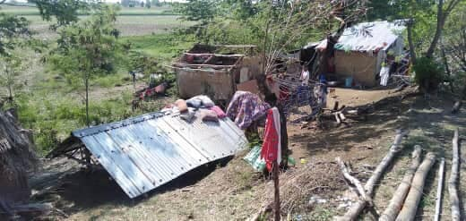
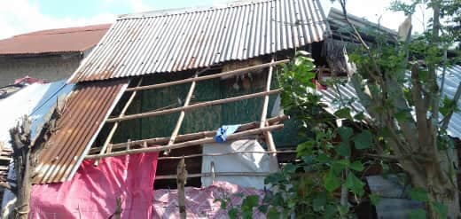
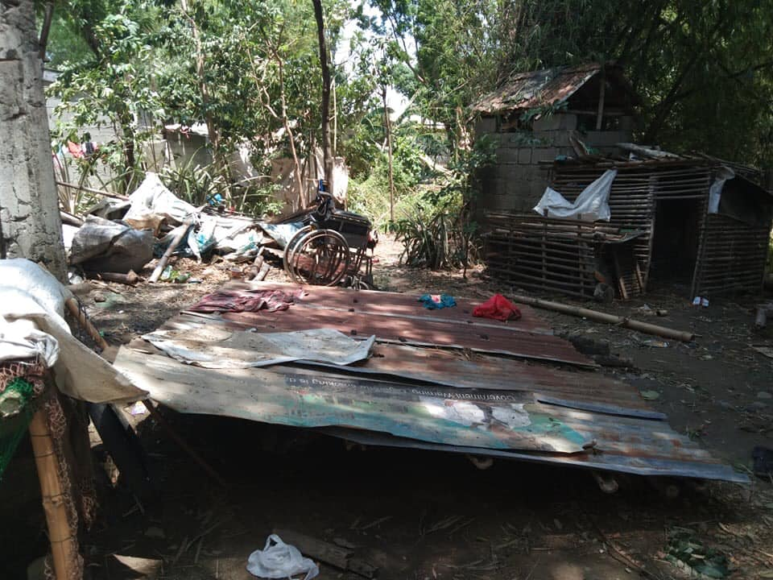

Damaged houses due to the tornado in Brgy. Manambong Parte, Bayambang, Pangasinan

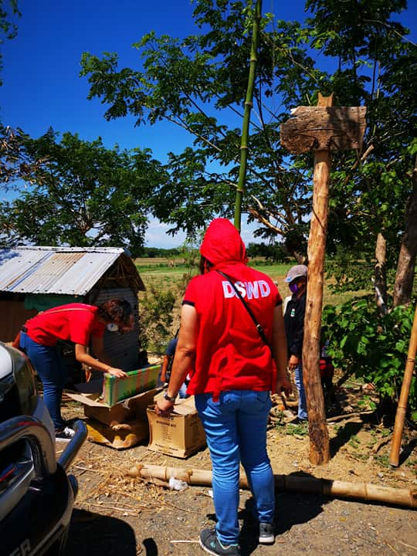
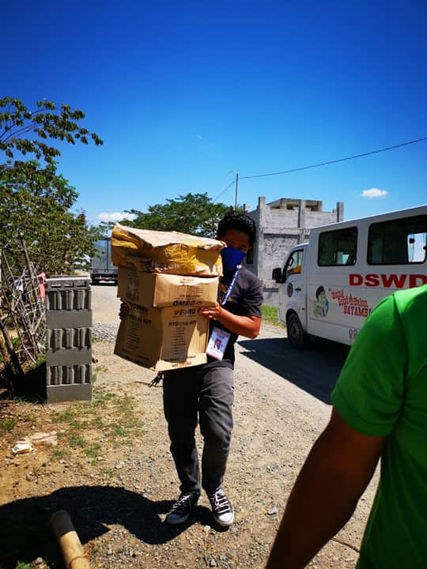

Relief assistance to the population affected by the tornado in Brgy. Manambong Parte,
Bayambang, Pangasinan

