DSWD DROMIC Report #16 on Typhoon “Ambo”
as of 26 May 2020, 6PM

Situation Overview
“VONGFONG” entered the Philippine Area of Responsibility (PAR) on 10 May 2020 and was named “Ambo” as the 1st Philippine tropical cyclone for 2020. On 11 May 2020, “Ambo” slightly intensifies while moving slowly westward over the Philippine Sea. On 14 May 2020, the eye of Typhoon “Ambo” was located based on all available data including those from Virac Doppler Radar in the vicinity of San Jose De Buan, Samar. “Ambo” weakened into a Low Pressure Area and exited PAR on 18 May 2020.
Source: DOST-PAGASA Severe Weather Bulletin

- Status of Affected Families / Persons
A total of 140,147 families or 578,571 persons were affected in 491 barangays in Regions I, II, III, VIII and CAR (see Table 1).

Table 1. Number of Affected Families / Persons
REGION / PROVINCE / MUNICIPALITY |  | NUMBER OF AFFECTED
 |  | Barangays | Families | Persons
GRAND TOTAL |  | 491 | 140,147 | 578,571
REGION I |  | 1 | 3 | 6
Ilocos Norte |  | 1 | 3 | 6
 | Bangui | 1 | 3 | 6
REGION II |  | 2 | 24 | 102
Nueva Vizcaya |  | 2 | 24 | 102
 | Quezon | 2 | 24 | 102
REGION III |  | 35 | 999 | 3,505
Aurora |  | 32 | 952 | 3,364
 | Casiguran | 8 | 64 | 243
 | Dinalungan | 6 | 138 | 501
 | Dingalan | 6 | 663 | 2,345
 | Dipaculao | 6 | 50 | 173
 | Maria Aurora | 6 | 37 | 102
Bulacan |  | 3 | 47 | 141
 | Bulacan | 1 | 30 | 84
 | Obando | 1 | 14 | 44
 | City of San Jose del Monte | 1 | 3 | 13
REGION VIII |  | 450 | 139,084 | 574,815
Eastern Samar |  | 181 | 42,098 | 166,473
 | Arteche | 20 | 4,603 | 18,519
 | Can-Avid | 28 | 5,774 | 22,929
 | Dolores | 46 | 12,665 | 50,660
 | Jipapad | 13 | 2,387 | 8,655
 | Maslog | 12 | 1,363 | 5,452
 | Oras | 42 | 10,491 | 41,964
 | San Policarpo | 17 | 4,753 | 18,103
 | Sulat | 1 | 11 | 42
 | Taft | 1 | 11 | 43
 | Hernani | 1 | 40 | 106
Northern Samar |  | 246 | 95,510 | 402,481
 | Allen | 1 | 308 | 735
 | Biri | 5 | 187 | 828
 | Bobon | 18 | 1,879 | 6,088
 | Capul | 1 | 2,636 | 13,180
 | Catarman (capital) | 8 | 23,259 | 106,151
 | Lavezares | 11 | 806 | 4,030
 | Lope de Vega | 19 | 3,889 | 15,595
 | Mondragon | 1 | 920 | 38,500
 | Rosario | 11 | 2,565 | 10,260
 | San Antonio | 3 | 703 | 9,058
 | San Isidro | 14 | 1,099 | 3,697
 | San Jose | 1 | 5,366 | 21,464
 | San Vicente | 7 | 617 | 2,393
 | Victoria | 16 | 4,121 | 4,881
 | Catubig | 47 | 9,118 | 37,153
 | Gamay | 1 | 7,344 | 16,162
 | Laoang | 1 | 4,175 | 21,959
 | Lapinig | 15 | 3,130 | 13,421
 | Las Navas | 53 | 9,199 | 43,141
 | Mapanas | 1 | 1,760 | 7,040
 | Palapag | 1 | 9,302 | 14,125
 | Pambujan | 1 | 426 | 1,759
 | San Roque | 9 | 951 | 3,861
 | Silvino Lobos | 1 | 1,750 | 7,000
Western Samar |  | 23 | 1,476 | 5,861
 | Matuguinao | 1 | 6 | 24
 | San Jorge | 20 | 1,352 | 5,365
 | Santa Margarita | 1 | 105 | 420
 | Tagapul-an | 1 | 13 | 52
CAR |  | 3 | 37 | 143
Benguet |  | 2 | 34 | 132
 | Itogon | 2 | 34 | 132
Ifugao |  | 1 | 3 | 11
 | Lamut | 1 | 3 | 11
Note: Ongoing assessment and validation being conducted.
Transferred the data to San Jose which was previously reported at San Vicente
The decrease in the number of affected families in Bobon and Mondragon is due to validation conducted.

Source: DSWD-FOs I, II, III, VIII and CAR

- Status of Displaced and Served Families/Persons Inside Evacuation Center
A total of 1,022 families or 3,657 persons took temporary shelter in 72 evacuation centers in Regions I, II, III and CAR. All evacuation centers were reportedly closed. (see Table 2).

Table 2. Number of Served Families / Persons Inside ECs
REGION / PROVINCE / MUNICIPALITY |  | NUMBER OF EVACUATION CENTERS (ECs) |  | NUMBER OF DISPLACED
 |  |  |  | INSIDE ECs
 |  |  |  | Families |  | Persons
 |  | CUM | NOW | CUM | NOW | CUM | NOW
GRAND TOTAL |  | 72 | - | 1,022 | - | 3,657 | -
REGION I |  | 1 | - | 3 | - | 6 | -
Ilocos Norte |  | 1 | - | 3 | - | 6 | -
 | Bangui | 1 | - | 3 | - | 6 | -
REGION II |  | 2 | - | 12 | - | 56 | -
Nueva Vizcaya |  | 2 | - | 12 | - | 56 | -
 | Quezon | 2 | - | 12 | - | 56 | -
REGION III |  | 59 | - | 921 | - | 3,250 | -
Aurora |  | 54 | - | 875 | - | 3,113 | -
 | Casiguran | 8 | - | 44 | - | 187 | -
 | Dinalungan | 7 | - | 96 | - | 350 | -
 | Dingalan | 20 | - | 653 | - | 2,313 | -
 | Dipaculao | 9 | - | 50 | - | 173 | -
 | Maria Aurora | 10 | - | 32 | - | 90 | -
Bulacan |  | 5 | - | 46 | - | 137 | -
 | Bulacan | 1 | - | 30 | - | 84 | -
 | Obando | 2 | - | 14 | - | 44 | -
 | City of San Jose del Monte | 2 | - | 2 | - | 9 | -
CALABARZON |  | 6 | - | 49 | - | 202 | -
Laguna |  | 6 | - | 49 | - | 202 | -
 | City of Calamba | 1 | - | 5 | - | 15 | -
 | Cavinti | 2 | - | 7 | - | 42 | -
 | Kalayaan | 3 | - | 37 | - | 145 | -
CAR |  | 4 | - | 37 | - | 143 | -
Benguet |  | 3 | - | 34 | - | 132 | -
 | Itogon | 3 | - | 34 | - | 132 | -
Ifugao |  | 1 | - | 3 | - | 11 | -
 | Lamut | 1 | - | 3 | - | 11 | -
Note: Ongoing assessment and validation being conducted.
Source: DSWD-FOs I, II, III, CALABARZON and CAR

- Damaged Houses
A total of 57,263 houses were damaged; of which, 7,646 were totally damaged and 49,617 were partially damaged in Region VIII (see Table 3).

Table 3. Number of Damaged Houses
REGION / PROVINCE / MUNICIPALITY |  | NO. OF DAMAGED HOUSES
 |  | Total | Totally | Partially
GRAND TOTAL |  | 57,263 | 7,646 | 49,617
REGION VIII |  | 57,263 | 7,646 | 49,617
Eastern Samar |  | 14,061 | 2,966 | 11,095
 | Arteche | 4,070 | 1,416 | 2,654
 | Can-Avid | 2,952 | 63 | 2,889
 | Jipapad | 2,129 | 321 | 1,808
 | Maslog | 580 | 104 | 476
 | Oras | 788 | 173 | 615
 | San Policarpo | 3,539 | 889 | 2,650
 | Sulat | 3 | - | 3
Northern Samar |  | 41,831 | 4,662 | 37,169
 | Allen | 824 | 84 | 740
 | Biri | 163 | 1 | 162
 | Bobon | 1,879 | 22 | 1,857
 | Capul | 194 | 5 | 189
 | Catarman (capital) | 8,985 | 608 | 8,377
 | Lope de Vega | 1,270 | 15 | 1,255
 | Mondragon | 198 | 5 | 193
 | Rosario | 1,491 | 114 | 1,377
 | San Antonio | 209 | 5 | 204
 | San Isidro | 399 | 13 | 386
 | San Jose | 3,158 | 63 | 3,095
 | San Vicente | 259 | 2 | 257
 | Victoria | 1,293 | 16 | 1,277
 | Catubig | 7,694 | 363 | 7,331
 | Gamay | 5,259 | 1,067 | 4,192
 | Laoang | 405 | 48 | 357
 | Lapinig | 3,796 | 1,832 | 1,964
 | Las Navas | 2,910 | 190 | 2,720
 | Mapanas | 388 | 22 | 366
 | Palapag | 399 | 13 | 386
 | Pambujan | 1 | 1 | -
 | San Roque | 540 | 84 | 456
 | Silvino Lobos | 117 | 89 | 28
Western Samar |  | 1,371 | 18 | 1,353
 | Matuguinao | 6 | 2 | 4
 | San Jorge | 1,352 | 16 | 1,336
 | Tagapul-an | 13 | - | 13
Note: The decrease in the number of partially damaged houses in Laoang is due to typographical error.
The decrease in the number of partially damaged houses in Silvino Lobos, Northern Samar is based on the validated report submitted by DSWD-FO VIII.
Source: DSWD-FO VIII

- Assistance Provided
A total of ₱23,089,635.05 worth of assistance was provided to the affected families; of which ₱18,199,813.05 was provided by DSWD and ₱4,889,822.00 from LGUs (see Table 4).
Table 4. Cost of Assistance Provided to Affected Families / Persons
REGION / PROVINCE / MUNICIPALITY |  | COST OF ASSISTANCE
 |  | DSWD | LGU | NGOs | OTHERS | GRAND TOTAL
GRAND TOTAL |  | 18,199,813.05 | 4,889,822.00 | - | - | 23,089,635.05
REGION I |  | - | 900.00 | - | - | 900.00
Ilocos Norte |  | - | 900.00 | - | - | 900.00
 | Bangui | - | 900 | - | - | 900
REGION V |  | 673,510.00 | 4,846,102.00 | - | - | 5,519,612.00
Sorsogon |  | 673,510.00 | 4,846,102.00 | - | - | 5,519,612.00
 | Barcelona | - | 279,017.00 | - | - | 279,017.00
 | Bulan | - | 352,347.00 | - | - | 352,347.00
 | Bulusan | - | 683,088.00 | - | - | 683,088.00
 | Matnog | - | 140,400.00 | - | - | 140,400.00
 | Pilar | - | 3,391,250.00 | - | - | 3,391,250.00
 | City of Sorsogon (capital) | 673,510.00 | - | - | - | 673,510.00
REGION VIII |  | 17,526,303.05 | - | - | - | 17,526,303.05
Eastern Samar |  | 12,613,773.76 | - | - | - | 12,613,773.76
 | Arteche | 2,504,234.70 | - | - | - | 2,504,234.70
 | Can-Avid | 823,605.00 | - | - | - | 823,605.00
 | Dolores | 1,825,108.68 | - | - | - | 1,825,108.68
 | Jipapad | 148,981.00 | - | - | - | 148,981.00
 | Oras | 5,739,930.30 | - | - | - | 5,739,930.30
 | San Policarpo | 1,571,914.08 | - | - | - | 1,571,914.08
Northern Samar |  | 4,912,529.29 | - | - | - | 4,912,529.29
 | Lavezares | 274,535.00 | - | - | - | 274,535.00
 | Rosario | 71,379.10 | - | - | - | 71,379.10
 | Catubig | 1,641,170.23 | - | - | - | 1,641,170.23
 | Gamay | 823,605.00 | - | - | - | 823,605.00
 | Lapinig | 549,070.00 | - | - | - | 549,070.00
 | Las Navas | 1,153,047.00 | - | - | - | 1,153,047.00
 | San Roque | 399,722.96 | - | - | - | 399,722.96
CAR |  | - | 42,820.00 | - | - | 42,820.00
Benguet |  | - | 41,920.00 | - | - | 41,920.00
 | Itogon | - | 41,920.00 | - | - | 41,920.00
Ifugao |  | - | 900.00 | - | - | 900.00
 | Lamut | - | 900.00 | - | - | 900.00
Note: DSWD provided assistance to the families in Sorsogon as part of its pre-emptive efforts.

Source: DSWD-FOs I, V, VIII and CAR

Situational Reports
DSWD-DRMB
DATE | SITUATIONS / ACTIONS UNDERTAKEN
26 May 2020 | - The Disaster Response Management Bureau (DRMB) is on BLUE alert status.  - The DRMB Operations Center (OpCen) is in 24/7 virtual operation to closely monitor and coordinate with the National Resource and Logistics Management Bureau (NRLMB) and DSWD Field Offices for significant updates on response operations relative to Severe Tropical Storm “Ambo”.  - All QRT members and emergency equipment are on standby and ready for deployment.

DSWD-FO NCR
DATE | SITUATIONS / ACTIONS UNDERTAKEN
16 May 2020 | - DSWD-FO NCR submitted their terminal report.  - DSWD-FO NCR coordinated with the Local Government Units (LGUs) of Manila and Muntinlupa City regarding the augmentation assistance needed by the affected families. No resource augmentation was requested by Manila and Muntinlupa City. As discussed, the LGUs will assess and provide the needed assistance of the affected.  - A total of 180 families or 720 persons have pre-emptively evacuated in 4 Evacuation Centers in Region NCR.

DSWD-FO CAR
DATE | SITUATIONS / ACTIONS UNDERTAKEN
21 May 2020 | - DSWD-FO CAR submitted their terminal report.

DSWD-FO I
DATE | SITUATIONS / ACTIONS UNDERTAKEN
21 May 2020 | - DSWD-FO I submitted their terminal report.  - In coordination by the IMT Branch in Ilocos Norte with the MSWDO of Bangui, Ilocos Norte, no further assistance is needed for the affected families per assessment.

DSWD-FO II
DATE | SITUATIONS / ACTIONS UNDERTAKEN
21 May 2020 | - DSWD-FO II submitted their terminal report.

DSWD-FO III
DATE | SITUATIONS / ACTIONS UNDERTAKEN
17 May 2020 | - A total of 28 families or 101 persons have pre-emptively evacuated in 3 Evacuation Centers in Region III.  REGION / PROVINCE / MUNICIPALITY NUMBER OF EVACUATION CENTERS (ECs) NUMBER OF INSIDE ECs  Families Persons  CUM NOW CUM NOW CUM NOW  REGION III 3 - 23 - 101 -  Aurora 3 - 23 - 101 -  Baler (capital) 3 - 23 - 101 -  - DSWD-FO III activated the DRMD Skeletal duty from the Regional Office and DSWD Provincial Extension Officer of the 7 provinces.  - DSWD-FO III is continuously monitoring the weather updates in coordination with the concerned LGUs.  - DSWD-FO III convened Response Cluster Meeting with RDRRMC III Response Cluster.

DSWD-FO CALABARZON
DATE | SITUATIONS / ACTIONS UNDERTAKEN
21 May 2020 | - DSWD-FO CALABARZON submitted their terminal report.  - A total of 7,857 families or 31,151 persons have pre-emptively evacuated in 461 Evacuation Centers in Region CALABARZON.

DSWD-MIMAROPA
DATE | SITUATIONS / ACTIONS UNDERTAKEN
19 May 2020 | - DSWD-FO MIMAROPA submitted their terminal report.  - A total of 207 families or 753 persons have pre-emptively evacuated in 28 Evacuation Centers in Region MIMAROPA. While, 41 families or 174 persons pre-emptively took temporary shelter with their relatives or friends.

DSWD-FO V
DATE | ,SITUATIONS / ACTIONS UNDERTAKEN
17 May 2020 | - DSWD-FO V submitted their terminal report.  - A total of 34,555 families or 135,362 persons have pre-emptively evacuated in 1,374 Evacuation Centers in Region V. While, 6,308 families or 24,619 persons pre-emptively took temporary shelter with their relatives or friends.  - DSWD-FO V provided 521 FFPs to the LGU of Sorsogon City and 912 FFPs amounting to ₱673,510.00 to the LGU of Casiguran, Sorsogon as augmentation support.

DSWD-FO VII
DATE | SITUATIONS / ACTIONS UNDERTAKEN
12 May 2020 | - RDRRMC/OCD-7 raised Alert Status Level to Blue as TD Ambo approaches.  - PDRA Meeting for TD Ambo was convened on 11 May 2020. DSWD-FO VII was represented by Marvin Solivio, SWO II of the Disaster Response Management Division (DRMD).  - Continuous monitoring by the DSWD Regional DROMIC Focal for the latest weather updates from PAGASA and cascading the same for widest dissemination to P/C/MATs.  - City and Municipal Action Team and SWAD Offices were alerted and already requested to closely coordinate with their local counterparts and their respective LDRRMC. Field staff were requested to monitor AOR and provide reports and updates to the Regional DROMIC Focal for any impacts.  - Provincial/City/Municipal Quick Response Team is on standby alert and ready for mobilization for any assistance and augmentation support needed from the LGUs.  - Regional Disaster Division is in close coordination with OCD-7 and other members of the RDRRMC for any response mobilization activities/strategies.  - Warehouses in the three island provinces are on ready alert.

DSWD-FO VIII
DATE | SITUATIONS / ACTIONS UNDERTAKEN
26 May 2020 | - A total of 24,289 families or 101,400 persons have pre-emptively evacuated in 35 Evacuation Centers in Region VIII. All evacuation centers were reported closed.  - DSWD-FO VIII RROC is rendering 24/7 duty to facilitate dispatching of Family Food Packs (FFPs) to areas affected by Typhoon Ambo.  - DSWD-FO VIII DRRS is in close coordination with LGUs for the augmentation of assistance to the affected families in their AOR.  - DSWD-FO VIII DRIMS monitors the weather situation and the established database for reporting. They are also maintaining close coordination with Provincial Action Teams in Northern and Eastern Samar for collection of data.  - DRMD conducted a meeting to plan the response operations in the affected areas.  - DSWD-FO VIII delivered 16,450 FFPs in Northern Samar.  - DSWD-FO VIII delivered 23,654 FFPs in Eastern Samar while 854 FFPs are for delivery.
25 May 2020 | - DSWD-FO VIII delivered 14,950 FFPs in Northern Samar.
24 May 2020 | - DSWD-FO VIII delivered 16,450 FFPs in Northern Samar.  - DSWD-FO VIII delivered 22,454 FFPs in Eastern Samar while 4,154 FFPs are for delivery.
21 May 2020 | - DSWD-FO VIII delivered 14,950 FFPs in Northern Samar while 1,500 FFPs are in transit.  - DSWD-FO VIII delivered 20,059 FFPs in Eastern Samar while 3,795 FFPs are in transit.
20 May 2020 | - DSWD-FO VIII delivered 14,950 FFPs in Northern Samar while 1,500 FFPs are in transit.  - DSWD-FO VIII delivered 13,000 FFPs in Eastern Samar while 9,900 FFPs are in transit.
19 May 2020 | - DSWD-FO VIII delivered 11,950 FFPs in Northern Samar while 4,500 FFPs are in transit.  - DSWD-FO VIII delivered 9,900 FFPs in Eastern Samar while 6,200 FFPs are in transit.
18 May 2020 | - DSWD-FO VIII delivered 8,850 FFPs in Northern Samar while 1,500 FFPs are in transit.  - DSWD-FO VIII delivered 6,700 FFPs in Eastern Samar while 800 FFPs are in transit.  - 3,300 FFPs are for delivery in Eastern Samar.
17 May 2020 | - Prepositioned 1,350 FFPs in Northern Samar.  - 1,100 FFPs from VDRC arrived in Catarman, Northern Samar.  - 6,300 FFPs are in transit going to warehouse in Catarman Northern Samar.  - 1,600 FFPs from VDRC are in transit via C-130 at Mactan going to Catarman Airport.  - DSWD-FO VIII RROC dispatched 2,300 FFPs for Arteche and San Policarpio, Eastern Samar. All were unloaded temporarily in San Policarpio.  - 600 FFPs arrived in Borongan City Aiport from VDRC Cebu.  - 1,500 FFPs in transit going to Dolores, Eastern Samar from VDRC Cebu.  - 1,500 FFPs in transit going to Can-avid, Eastern Samar from VDRC Cebu.

DSWD-FO X
DATE | SITUATIONS / ACTIONS UNDERTAKEN
19 May 2020 | - DSWD-FO X Quick Response Team including the P/MATs are on standby including operational vehicles and telecommunications equipment.  - To date, there are no reports of affected families/persons in Region X.

DSWD-FO XI
DATE | SITUATIONS / ACTIONS UNDERTAKEN
14 May 2020 | - DSWD-FO XI activated the field office and RPMO’s (SWADTs, PATs, MATs, CATs) Quick Response Team as On-Call duty.  - DSWD-FO XI is in close coordination with all SWADOs and PSWDOs/CSWDO/MSWDOs for monitoring of the situation in the different parts of Davao Region. Personnel in the warehouse are also on alert to ensure the readiness to dispatch relief goods (food and non-food items) at any given time.  - Availability of Disaster Wing Van, vehicles and drivers in the event of relief operation.  - DSWD-FO XI is in close coordination with the Office of Civil Defense (OCD) XI for logistical support monitoring.  - DSWD-FO XI is in close coordination with the staff rendering skeletal duty in the DRMD Office and City/Municipal Action.

DSWD-FO CARAGA
DATE | SITUATIONS / ACTIONS UNDERTAKEN
11 May 2020 | - DSWD-FO Caraga attended the PDRA/ERP Meeting through teleconferencing with the Caraga RDRRMC Member agencies to discuss the preparedness and response measures regarding the tropical depression.

*****
The Disaster Response Operations Monitoring and Information Center (DROMIC) of the DSWD-DRMB is closely monitoring the effects of Typhoon “Ambo” and is coordinating with the concerned DSWD Field Offices for any significant updates.

Prepared by:

DIANE C. PELEGRINO
MARIE JOYCE G. RAFANAN

LESLIE R. JAWILI
Releasing Officer

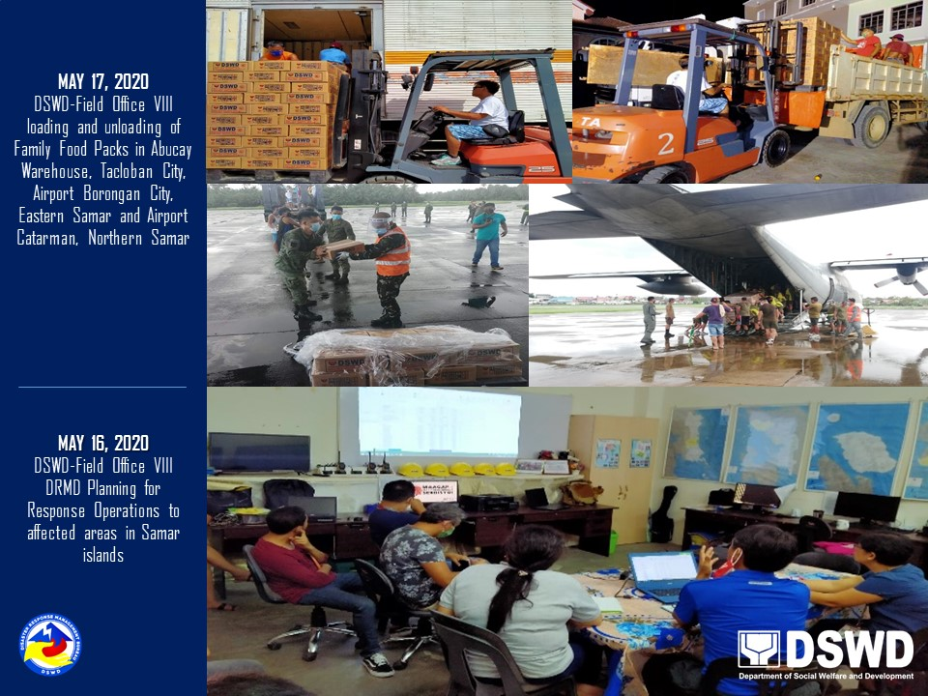
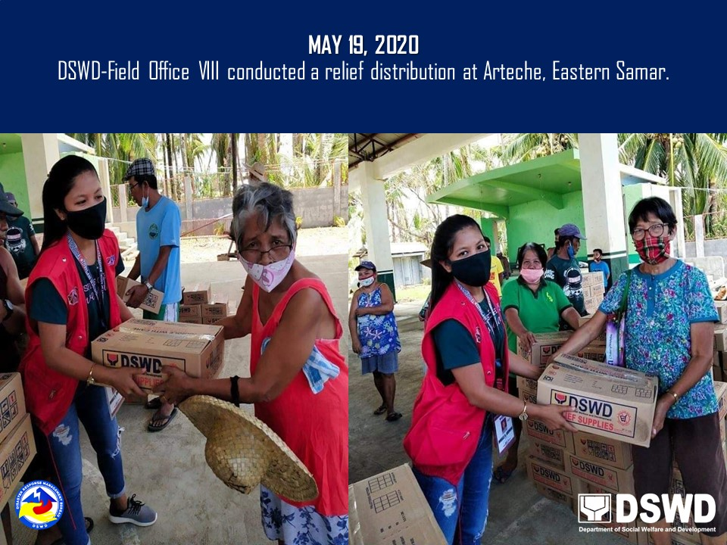
PHOTO DOCUMENTATION

