DSWD DROMIC Report #5 on Typhoon “Ambo”
as of 15 May 2020, 6PM

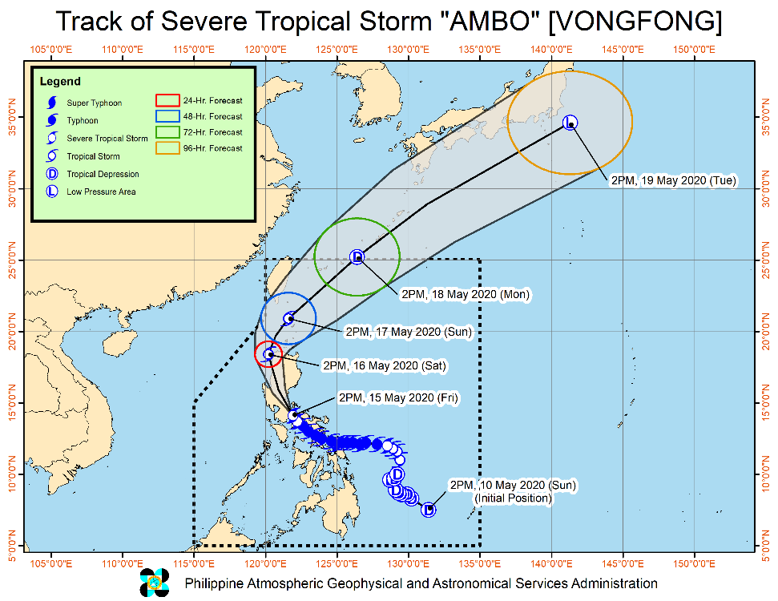
Situation Overview

At 2:00 PM today, "AMBO" WEAKENS INTO A SEVERE TROPICAL STORM AS IT CONTINUES TO MOVE TOWARDS NORTHERN QUEZON - LAGUNA AREA.

Landfall Information:
- Past landfalls: San Policarpo,
Eastern Samar (12:15 PM yesterday); Dalupiri Island, Northern Samar (10:15 PM yesterday); Capul Island, Northern Samar (10:30 PM yesterday); Ticao Island, Masbate (12:00 AM today); Burias Island, Masbate (3:00 AM today); San Andres, Quezon (7:45 AM today).

Heavy Rainfall Outlook:
- Today: Moderate to heavy with at times intense rains over Bicol Region, Quezon, Aurora, Marinduque, Laguna, Rizal, Metro Manila, Bulacan, Nueva Ecija, Nueva Vizcaya, and Quirino.
- Tomorrow (16 May): Moderate to heavy with at times intense rains over Cordillera Administrative Region, Ilocos Region, Aurora, and Nueva Ecija.
Residents in these areas are advised to take appropriate measures, coordinate with local disaster risk reduction and management offices, and continue monitoring for updates, especially the local rainfall or thunderstorm advisories and heavy rainfall warnings from PAGASA Regional Services Divisions (PRSD). Flooding and rain-induced landslides may occur in highly to very highly susceptible areas during heavy or prolonged rainfall.

Coastal Water Conditions:
- Sea travel is risky for all types of seacrafts over the seaboards of areas under Tropical Cyclone Wind Signal.

At 1:00 PM today, the center of Severe Tropical Storm "AMBO" was estimated based on all available data including those from Daet Doppler Radar In the vicinity of Kinagunan Ilaya, Quezon (13.9 °N, 121.9 °E).
Source: DOST-PAGASA Severe Weather Bulletin

- Status of Affected Families / Persons
A total of 5,822 families or 23,060 persons are affected in 3 barangays in Eastern Samar (see Table 1).

Table 1. Number of Affected Families / Persons
REGION / PROVINCE / MUNICIPALITY |  | NUMBER OF AFFECTED
 |  | Barangays | Families | Persons
GRAND TOTAL |  | 3 | 5,822 | 23,060
REGION VIII |  | 3 | 5,822 | 23,060
Eastern Samar |  | 3 | 5,822 | 23,060
 | Can-Avid | 3 | 5,774 | 22,929
 | Taft | - | 8 | 25
 | Hernani | - | 40 | 106
Note: Ongoing assessment and validation being conducted
Source: DSWD-FO VIII

Status of Prepositioned Resources: Stockpile and Standby Funds
The DSWD Central Office (CO), Field Offices (FOs), and National Resource Operations Center (NROC) have stockpiles and standby funds amounting to ₱1,162,723,075.67 with breakdown as follows (see Table 2):

- Standby Funds
A total of ₱239,358,454.96 standby funds in the CO and FOs. Of the said amount, ₱199,914,543.93 is the available Quick Response Fund (QRF) in the CO.

- Stockpiles
A total of 377,359 family food packs (FFPs) amounting to ₱170,856,595.75, other food items amounting to ₱268,660,209.57 and non-food items (FNIs) amounting to ₱483,847,815.39 are available.

Table 2. Available Standby Funds and Stockpiles
Region / Office | Standby Funds | FAMILY FOOD PACKS |  | Other Food Items | Non-Food Relief Items | Total Standby Funds & Stockpile
 |  | Quantity | Total Cost
 | 239,358,454.96 | 377,359 | 170,856,595.75 | 268,660,209.57 | 483,847,815.39 | 1,162,723,075.67
Central Office | 199,914,543.93 | - | - | - | - | 199,914,543.93
NRLMB - NROC | - | 55,322 | 25,266,840.00 | 43,736,826.28 | 262,367,004.14 | 331,370,670.42
NRLMB - VDRC | - | 44,957 | 21,161,259.90 | 10,348,076.40 | 7,935,523.00 | 39,444,859.30
I | 650,455.00 | 23,871 | 10,597,028.94 | 1,011,130.00 | 39,617,593.15 | 51,876,207.09
II | 2,700,138.89 | 23,613 | 9,114,033.88 | 12,335,884.10 | 5,510,398.95 | 29,660,455.82
III | 926,720.64 | 7,139 | 3,866,411.01 | 392,996.25 | 5,510,398.95 | 10,696,526.85
CALABARZON | 3,000,000.00 | 8,122 | 3,063,544.00 | 7,901,624.00 | 5,100,261.58 | 19,065,429.58
MIMAROPA | 3,069,989.19 | 13,456 | 6,055,200.00 | 4,313,203.00 | 5,009,477.50 | 18,447,869.69
V | 3,001,050.00 | 3,224 | 1,215,489.70 | 5,299,355.17 | 29,684,861.91 | 39,200,756.78
VI | 3,000,851.68 | 11,211 | 5,861,080.00 | 48,660,483.77 | 6,853,499.39 | 64,375,914.84
VII | 3,000,015.14 | 40,723 | 16,212,580.54 | 39,515,877.22 | 74,024.00 | 58,802,496.90
VIII | 3,001,454.16 | 4,814 | 2,643,222.98 | 1,689,189.54 | 19,362,680.38 | 26,696,547.06
IX | 94,500.00 | 35,644 | 18,903,252.00 | 8,782,570.00 | 14,357,924.59 | 42,138,246.59
X | 3,106,997.00 | 53,491 | 22,093,558.79 | 43,735,223.99 | 19,741,365.19 | 88,677,144.97
XI | 3,000,000.00 | 13,897 | 5,143,974.55 | 6,724,958.90 | 23,839,069.26 | 38,708,002.71
XII | 3,000,701.68 | 2,043 | 921,393.00 | 10,289,125.49 | 12,876,448.72 | 27,087,668.89
CARAGA | 3,000,000.00 | 19,035 | 6,903,454.50 | 10,935,422.52 | 3,258,445.70 | 24,097,322.72
NCR | 1,886,079.00 | 1,440 | 635,500.80 | 1,789,491.78 | 9,799,152.16 | 14,110,223.74
CAR | 3,004,958.65 | 15,357 | 11,198,771.16 | 11,198,771.16 | 12,949,686.82 | 38,352,187.79
Note: The Inventory Summary is as of 15 May 2020, 12NN .
Source: DRMB and NRLMB

Situational Reports
DSWD-DRMB
DATE | SITUATIONS / ACTIONS UNDERTAKEN
15 May 2020 | - The Disaster Response Management Bureau (DRMB) is on BLUE alert status.  - The DRMB Operations Center (OpCen) is in 24/7 virtual operation to closely monitor and coordinate with the National Resource and Logistics Management Bureau (NRLMB) and DSWD Field Offices for significant updates on response operations relative to Severe Tropical Storm “Ambo”..  - All QRT members and emergency equipment are on standby and ready for deployment.

DSWD-FO NCR
DATE | SITUATIONS / ACTIONS UNDERTAKEN
15 May 2020 | - DSWD-FO NCR Disaster Response Management Division and the FO Quick Response Teams are on standby-alert and/or already activated for any eventualities that might happen due to the said Typhoon.  - DSWD-FO NCR FO is continuously coordinating with the Local Social Welfare and Development Offices of the 17 LGUs in Metro Manila with regard to any augmentation assistance needed by the affected families.

DSWD-FO CAR
DATE | SITUATIONS / ACTIONS UNDERTAKEN
14 May 2020 | - DSWD-FO CAR DRMD identified strategic locations in the regions for the prepositioning of relief resources. DRMD is currently identifying and coordinating with other agencies/organizations for warehouses.  - DRMD is continuously monitoring the situation on ground.  - Delta 4 QRT is on duty at the DSWD FO CAR Operations Center.  - Provincial Social Welfare and Development Teams (PSWADT) DRMD PDO IIs were informed about the situation.  - Municipal Action Teams are on duty.  - Continuous coordination by the DRMD PDO IIs assigned in the PSWADTs with the LDRRMOs for updates.  - Rapid Emergency Telecommunications Team (RETT) including the International Maritime/Marine Satellite (INMARSAT) equipment are on standby.  - DSWD-FO CAR Regional Management Committee convened and planned the next course of action for the following weeks.  - Simultaneous repacking of family food packs were conducted in various production hubs within the region.  - DSWD-FO CAR Operations Center is on RED ALERT.  - Conducted Predictive Analytics for the needs of the exposed population in coordination with DROMIC Central Office.  - DSWD-FO CAR is in close coordination with Cordillera Regional Disaster Risk Reduction and Management Council Emergency Operations Center for updates.  - Coordinated the forecast of risks with DROMIC Central Office.

DSWD-FO I
DATE | SITUATIONS / ACTIONS UNDERTAKEN
12 May 2020 | - DSWD-FO I is in close coordination with the Regional Disaster Risk Reduction and Management Council I and is closely monitoring the possible effects of Tropical Depression “AMBO”. Likewise, Provincial Operations Offices (POOs) are in close coordination with the different Provincial/City/Municipal Disaster Risk Reduction and Management Councils (P/C/MDRRMCs) and Provincial/City/Municipal Social Welfare and Development Offices (P/C/MSWDOs) to monitor the adverse effects that may be brought by the weather disturbance.

DSWD-FO II
DATE | SITUATIONS / ACTIONS UNDERTAKEN
15 May 2020 | - The Regional Disaster Management Team SWADTs/P/C/MATs of the provinces of Cagayan, Isabela, Quirino, Batanes and Nueva Vizcaya are hereby directed to continuously monitor possible effects of Typhon “Ambo” per Area of Responsibilities (AOR). Likewise, all are directed to render 24/7 duty starting tonight to continuously monitor affected families or individuals for possible flashflood.  - DMRD through the Regional Resource Operations Section ensure availability of Food and Non-Food Items at any given time.  - DSWD-FO II is in close coordination with Regional/City/Municipal Disaster Risk Reduction and Management Council (R/P/C/MDRRMC) in any concerns that needs to be addressed.  - DSWD-FO II coordinated with SWADTs and PAT/C/MATs to continuously monitor and coordinate with the LGUs to gather report on the [possible effects pf Typhoon “Ambo”/.  - SWADTs/Provincial Operations Offices (POOs)/C/MAYs is closely coordinating with their respective Provincial/City/Municipal Disaster Risk Reduction and Management Council (P/C/NDRRMCs) to get update on adverse effects brought by this weather disturbance.

DSWD-FO III
DATE | SITUATIONS / ACTIONS UNDERTAKEN
14 May 2020 | - DSWD-FO III activated the DRMD Skeletal duty from the Regional Office and DSWD Provincial Extension Officer of the 7 provinces.  - DSWD-FO III attended Pre-Disaster Risk Assessment (PDRA) for Typhoon Ambo.  - DSWD-FO III is continuously monitoring the weather updates in coordination with the concerned LGUs.

DSWD-FO CALABARZON
DATE | SITUATIONS / ACTIONS UNDERTAKEN
15 May 2020 | - There are 288 families or 1,081 persons who have pre-emptively evacuated in 16 Evacuation Centers in Region CALABARZON.  REGION / PROVINCE / MUNICIPALITY NUMBER OF EVACUATION CENTERS (ECs) INSIDE ECs  Families Persons  CALABARZON 16 288 1,081  Quezon 16 288 1,081  Alabat 2 41 161  Catanauan 2 11 65  General Luna 2 5 11  Mauban 3 58 241  Mulanay 1 27 75  Panukulan 1 9 45  Quezon 1 19 79  San Andres 1 10 35  Sariaya 3 108 369  - DSWD-FO CALABARZON through the Disaster Response Management Division (DRMD) provided technical assistance to LGUs with opened evacuation centers on Camp Coordination and Camp Management, the LSWDOs were also reminded to practice social distancing in the evacuation center.  - The LGUs of CALABARZON Region are continuously providing reports on the status of the pre-emptive evacuations.  - DRMD is continuously coordinating with LGUs in flood, landslide and storm surge prone areas for their ongoing response efforts.  - Provincial Quick Response Teams and Municipal Actions Teams were requested to closely coordinate with their LDRRMCs and/or LSWDOs. Field Staff were requested to monitor the AOR and provide reports and updates to the Emergency Operations Center.  - The island municipalities of Quezon (Alabat, Burdeos, Jomalig, Panukulan, Patnanungan, Perez, Polilio and Quezon) were advised to utilized the Family Food Packs (FFPs) pre-positioned to their respective municipalities for COVID-19 response operations to utilized the FFPs for Typhoon “Ambo” should need arises.  - DRMD is closely coordinating with PSWDOs, PDRRMOs, MSWDOs and MDRRMOs for updates and developments on the possible effects of the typhoon.  - DRMD informed member agencies of the response cluster to be on stand-by alert status and ready for mobilization in case situation arises during the video teleconference held last May 14, 2020.

DSWD-MIMAROPA
DATE | SITUATIONS / ACTIONS UNDERTAKEN
11 May 2020 | - DSWD-FO MIMAROPA Disaster Response Management Division and Provincial Project Development Officers are alerted to monitor daily local weather condition and ensure provision of information to all concerned offices, divisions, sections, offices.  - Alerted all P/C/M Quick Response Team in five provinces of MIMAROPA to regularly monitor the situations in their areas.  - 24/7 On-call status of the R/P/C/M QRT together with special projects for the possible activation of Operation Center.  - DSWD-MIMAROPA is in close coordination with the Office of Civil Defense (OCD) and RDRRMC MIMAROPA for any warning signal updates for monitoring purposes and response mechanism for areas that will be affected.  - Standby logistical equipment and workforce through coordination with SWADT Offices and concerned LGUs on the management of stranded passengers, if any, in ports and terminals.  - Information and Communication Technology Management Unit (ICTMU) is on standby status to ensure robust communication system.  - All members of Rapid Emergency Telecommunications Team are on on-call and standby status ready for deployment if needed.  - DSWD-MIMAROPA ensures that the Rapid Emergency Telecommunications Equipment (GX Terminal, BGAN Terminals and Satellite Phones) are in good condition and ready for deployment to areas that will experience potential emergencies.  - DSWD-MIMAROPA ensures that there is an on-call truck available for delivery of goods and equipment to areas that will be affected

DSWD-FO V
DATE | ,SITUATIONS / ACTIONS UNDERTAKEN
15 May 2020 | - There are 9,435 families or 35,489 persons who have pre-emptively evacuated in Region V.  REGION / PROVINCE / MUNICIPALITY Brgys Families Persons  GRAND TOTAL 245 9,435 35,489  REGION V 245 9,435 35,489  Albay 87 4,302 15,278  Camarines Norte 16 144 500  Camarines Sur 1 66 332  Catanduanes 12 178 817  Masbate 71 2,719 10,398  Sorsogon 58 2,026 8,164  - DSWD-FO V encouraged the LGUs to distribute fresh farm produced products as alternative to family food packs.  - DRMD continuous to monitor weather updates and information.  - Resource Operation Section ensures the availability of family food packs and non-food items as need arises.  - DSWD-FO V QRTs are activated.  - 6 Provincial Action Teams and 114 C/Municipal actions teams were activated and instructed to coordinate with the P/MDRRMOs, C/MSWDOs for TY Ambo reports and updates.  - P/C/MATs attended the P/C/MDRRMC meetings regarding LGUs’ preparedness on TY Ambo.  - The MAT of Baleno, Placer, Esperanza & Aroroy in the province of Masbate assisted the LGU in the profiling of evacuees.

DSWD-FO VII
DATE | SITUATIONS / ACTIONS UNDERTAKEN
12 May 2020 | - RDRRMC/OCD-7 raised Alert Status Level to Blue as TD Ambo approaches.  - PDRA Meeting for TD Ambo was convened on 11 May 2020. DSWD-FO VII was represented by Marvin Solivio, SWO II of the Disaster Response Management Division (DRMD).  - Continuous monitoring by the DSWD Regional DROMIC Focal for the latest weather updates from PAGASA and cascading the same for widest dissemination to P/C/MATs.  - City and Municipal Action Team and SWAD Offices were alerted and already requested to closely coordinate with their local counterparts and their respective LDRRMC. Field staff were requested to monitor AOR and provide reports and updates to the Regional DROMIC Focal for any impacts.  - Provincial/City/Municipal Quick Response Team is on standby alert and ready for mobilization for any assistance and augmentation support needed from the LGUs.  - Regional Disaster Division is in close coordination with OCD-7 and other members of the RDRRMC for any response mobilization activities/strategies.  - Warehouses in the three island provinces are on ready alert.

DSWD-FO VIII
DATE | SITUATIONS / ACTIONS UNDERTAKEN
15 May 2020 | - DSWD-FO VIII advised Provincial/City/Municipal Action Teams to closely coordinate and gather data at the Local Government Units and other partner agencies/offices. Moreover, attended the RDRRMC Meeting to discuss updates, issues and concerns in relation to Typhoon Ambo.  - Disaster Response and Recovery Section (DRRS) is alerted in case relief operations is needed.  - Disaster Response Information Management Section (DRIMS) is monitoring the weather situation, closely coordinating with the PDOs assigned at the field.  - Regional Resource Operations Section (RROS) are also alerted to ensure the readiness of dispatching the Food and Non-Food commodities whenever needed.  - Currently, requested 20K FFPs at VDRC and 2 trucks from Northern Samar picked up today the additional 1,100 FFPs to prepositioned in strategic area in Northern Samar. Likewise, 1,000 FFPs were loaded and transported on May 14, 2020 to prepositioned in Eastern Samar.

DSWD-FO X
DATE | SITUATIONS / ACTIONS UNDERTAKEN
15 May 2020 | - DSWD-FO X has 914 updated Quick Response Team members including P/MAT.  - DSWD-FO X has provided report on the updated list of their warehouse, available operational vehicles/trucks and telecommunications equipment.

DSWD-FO XI
DATE | SITUATIONS / ACTIONS UNDERTAKEN
14 May 2020 | - DSWD-FO XI activated the field office and RPMO’s (SWADTs, PATs, MATs, CATs) Quick Response Team as On-Call duty.  - DSWD-FO XI is in close coordination with all SWADOs and PSWDOs/CSWDO/MSWDOs for monitoring of the situation in the different parts of Davao Region. Personnel in the warehouse are also on alert to ensure the readiness to dispatch relief goods (food and non-food items) at any given time.  - Availability of Disaster Wing Van, vehicles and drivers in the event of relief operation.  - DSWD-FO XI is in close coordination with the Office of Civil Defense (OCD) XI for logistical support monitoring.  - DSWD-FO XI is in close coordination with the staff rendering skeletal duty in the DRMD Office and City/Municipal Action.
DSWD-FO CARAGA
DATE | SITUATIONS / ACTIONS UNDERTAKEN
11 May 2020 | - DSWD-FO Caraga attended the PDRA/ERP Meeting through teleconferencing with the Caraga RDRRMC Member agencies to discuss the preparedness and response measures regarding the tropical depression.

*****
The Disaster Response Operations Monitoring and Information Center (DROMIC) of the DSWD-DRMB is closely monitoring the effects of Typhoon “Ambo” and is coordinating with the concerned DSWD Field Offices for any significant updates.

Prepared by:

DIANE C. PELEGRINO
MARIE JOYCE G. RAFANAN

RODEL V. CABADDU
Releasing Officer

