DSWD DROMIC Terminal Report on the Tornado Incident
in Brgy. Manambong Parte, Bayambang, Pangasinan
28 May 2020, 6PM

This is the final report on the tornado incident that occurred in Brgy. Manambong Parte, Bayambang, Pangasinan on 27 April 2020.

SUMMARY

- Status of Affected Families / Persons
A total of 23 families or 100 persons were affected by the tornado incident in Brgy. Manambong Parte, Bayambang, Pangasinan (see Table 1).

Table 1. Number of Affected Families / Persons
REGION / PROVINCE / MUNICIPALITY |  | NUMBER OF AFFECTED
 |  | Barangays | Families | Persons
GRAND TOTAL |  | 1 | 23 | 100
REGION I |  | 1 | 23 | 100
Pangasinan |  | 1 | 23 | 100
 | Bayambang | 1 | 23 | 100
Source: DSWD-FO I

- Status of Displaced Families / Persons Outside Evacuation Center
A total of 23 families or 100 persons have temporarily stayed with their relatives and/or friends (see Table 2).

Table 2. Number of Displaced Families / Persons Outside Evacuation Center
REGION / PROVINCE / MUNICIPALITY |  | OUTSIDE ECs
 |  | Families |  | Persons
 |  | CUM | NOW | CUM | NOW
GRAND TOTAL |  | 23 | - | 100 | -
REGION I |  | 23 | - | 100 | -
Pangasinan |  | 23 | - | 100 | -
 | Bayambang | 23 | - | 100 | -
Source: DSWD-FO I

- Damaged Houses
There were 23 damaged houses; of which, 9 were totally damaged and 14 were partially damaged (see Table 3).

Table 3. Number of Damaged Houses
REGION / PROVINCE / MUNICIPALITY |  | NO. OF DAMAGED HOUSES
 |  | Total | Totally | Partially
GRAND TOTAL |  | 23 | 9 | 14
REGION I |  | 23 | 9 | 14
Pangasinan |  | 23 | 9 | 14
 | Bayambang | 23 | 9 | 14
Source: DSWD-FO I

- Assistance Provided
A total of ₱233,062.94 worth of assistance was provided to the affected families; of which ₱128,794.94 was provided by DSWD and ₱104,268.00 was provided by LGU (see Table 4).

Table 4. Cost of Assistance Provided to Affected Families / Persons
REGION / PROVINCE / MUNICIPALITY |  | TOTAL COST OF ASSISTANCE
 |  | DSWD | LGU | NGOs | OTHERS | GRAND TOTAL
GRAND TOTAL |  | 128,794.94 | 104,268.00 | - | - | 233,062.94
REGION I |  | 128,794.94 | 104,268.00 | - | - | 233,062.94
Pangasinan |  | 128,794.94 | 104,268.00 | - | - | 233,062.94
 | Bayambang | 128,794.94 | 104,268.00 | - | - | 233,062.94
Source: DSWD-FO I

SITUATIONAL REPORT

DSWD-FO I
DATE | SITUATIONS / ACTIONS UNDERTAKEN
28 May 2020 | - DSWD-FO I submitted their terminal report.  - DSWD-FO I provided 46 FFPs, 23 Hygiene Kits, 23 Sleeping Kits, and 23 Family Kits amounting to ₱128,794.94 to the affected families.

*****
The Disaster Response Operations Monitoring and Information Center (DROMIC) of the DSWD-DRMB continues to closely coordinate with DSWD-FO I for any request of Technical Assistance and Resource Augmentation (TARA).

Prepared by:

MARIE JOYCE G. RAFANAN

LESLIE R. JAWILI
Releasing Officer

PHOTO DOCUMENTATION

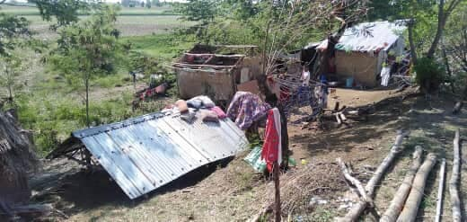
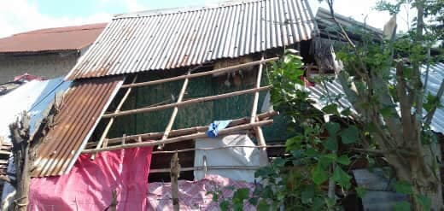
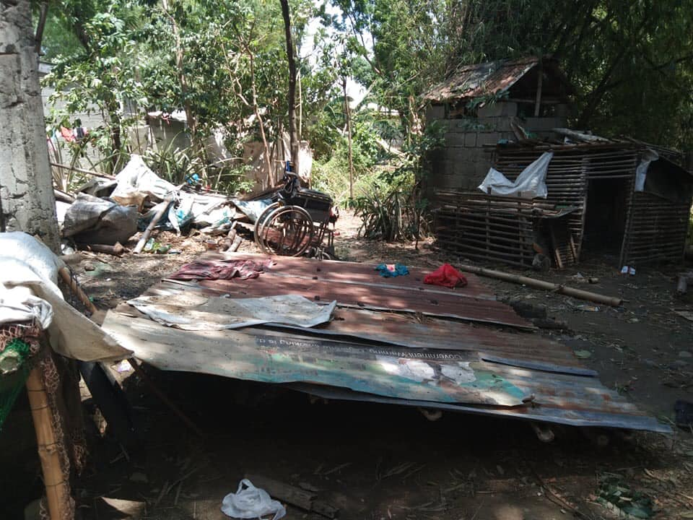

Damaged houses due to the tornado incident in Brgy. Manambong Parte,
Bayambang, Pangasinan

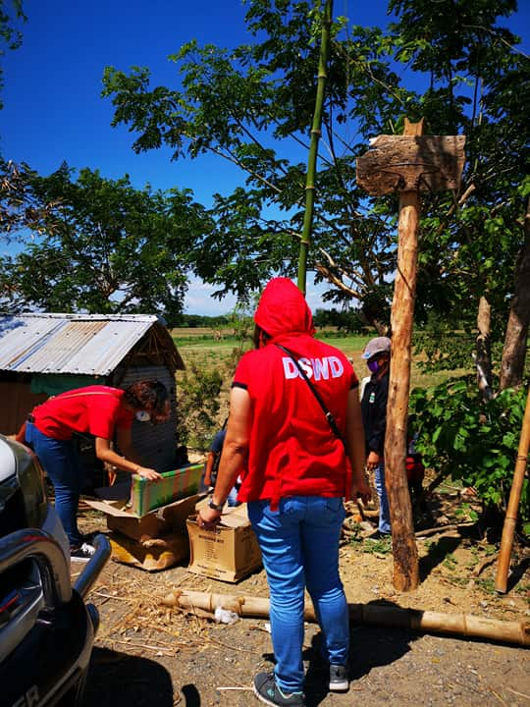
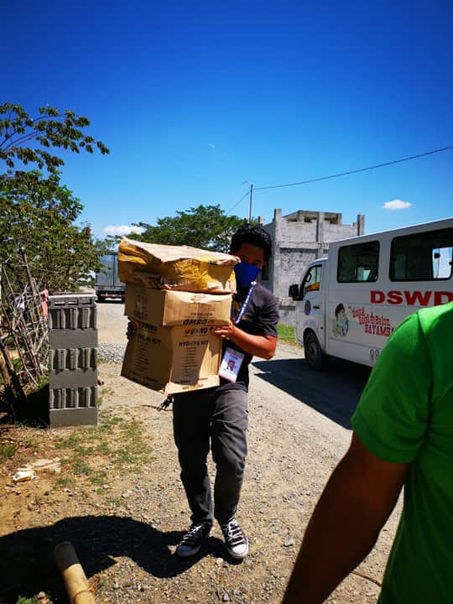

Relief assistance to the families affected by the tornado in Brgy. Manambong Parte,
Bayambang, Pangasinan

