DSWD DROMIC Report #1 on
the Flashflood Incident in Koronadal City
as of 29 July 2020, 4PM

SUMMARY

On 28 July 2020 at around 3:00 PM, a flashflood incident occurred in Barangays San Isidro, Assumption and Zone III in Koronadal City caused by heavy rainfall due to the Low Pressure Area (LPA).
Source: DSWD-FO XII

- Status of Affected Families / Persons
A total of 149 families or 895 persons in 3 barangays were affected by the flashflood incident in Koronadal City, South Cotabato (see Table 1).

Table 1. Number of Affected Families / Persons
REGION / PROVINCE / MUNICIPALITY |  | NUMBER OF AFFECTED
 |  | Barangays | Families | Persons
GRAND TOTAL |  | 3 | 149 | 895
REGION XII |  | 3 | 149 | 895
South Cotabato |  | 3 | 149 | 895
 | City of Koronadal (capital) | 3 | 149 | 895
Note: Ongoing assessment and validation being conducted.
Source: DSWD-FO XII

SITUATIONAL REPORT

DSWD-DRMB
DATE | SITUATIONS / ACTIONS UNDERTAKEN
29 July 2020 | - The Disaster Response Operations Monitoring and Information Center (DROMIC) of the DSWD-DRMB is closely coordinating with DSWD-FO XII for significant reports on the status of affected families, assistance, and relief efforts.

DSWD-FO XII
DATE | SITUATIONS / ACTIONS UNDERTAKEN
29 July 2020 | - DSWD-FO XII conducted validation and actual monitoring in the area and is in close coordination with the City Social Welfare and Development Office of Koronadal City.  - DSWD-FO XII and the Local Government Unit (LGU) of the City has initially provided food packs and beddings to the displaced families.

*****
The Disaster Response Operations Monitoring and Information Center (DROMIC) of the DSWD-DRMB is closely coordinating with DSWD-FO XII for any significant disaster response updates.

Prepared by:

MARIEL B. FERRARIZ CLARRIE MAE A. CASTILLO
Releasing Officer

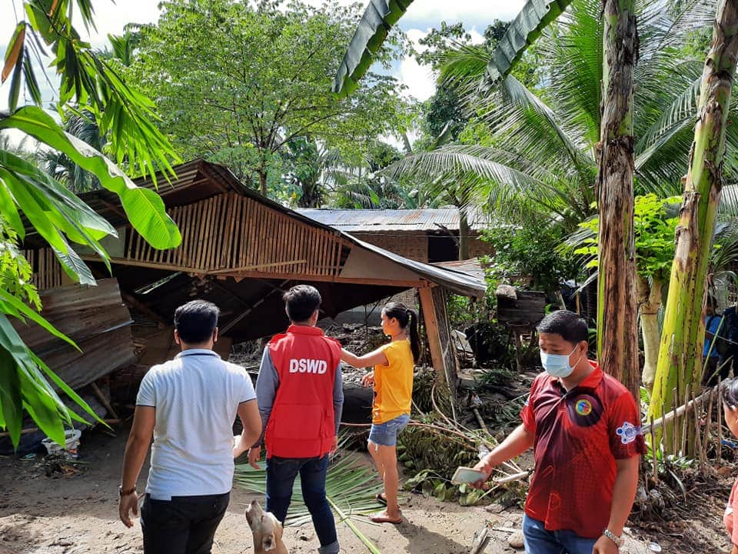
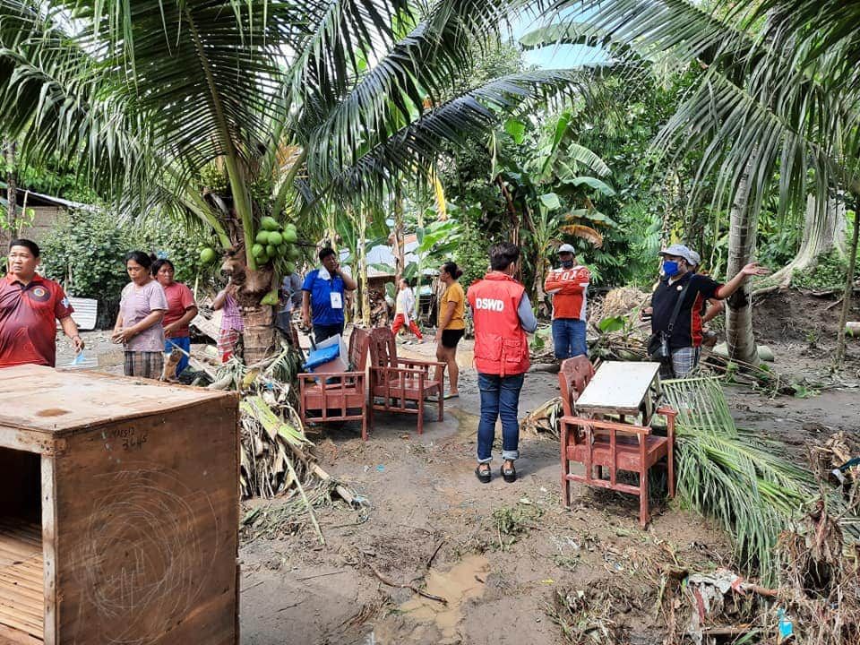
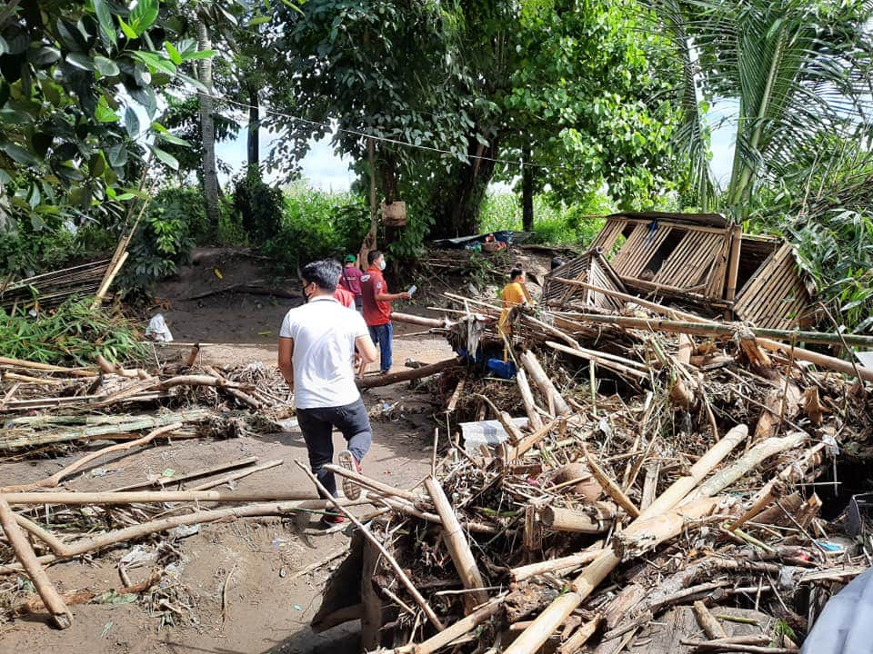
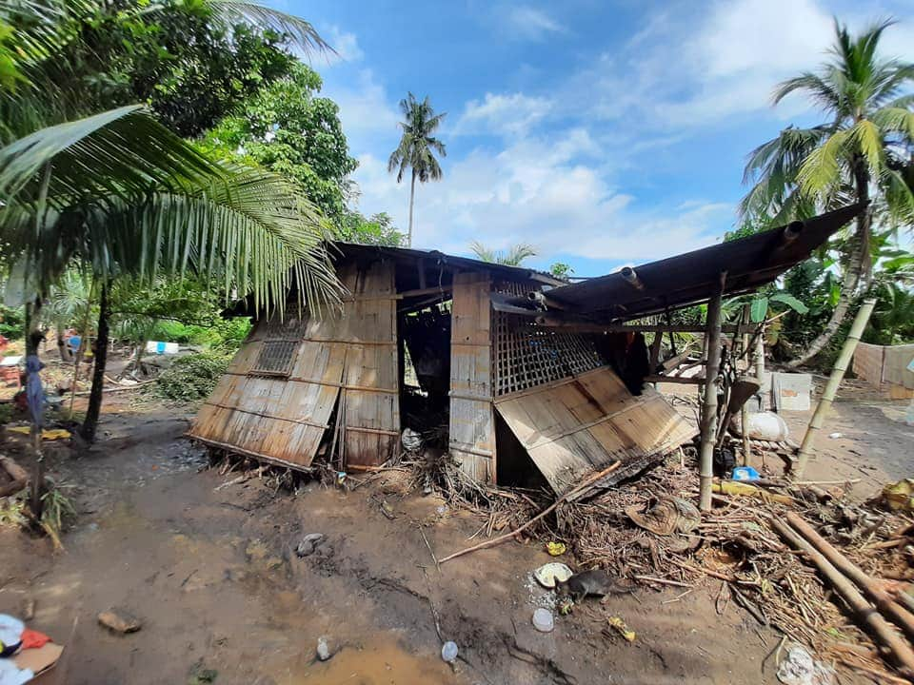
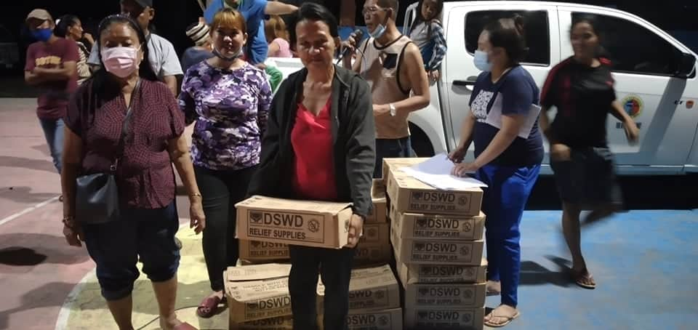
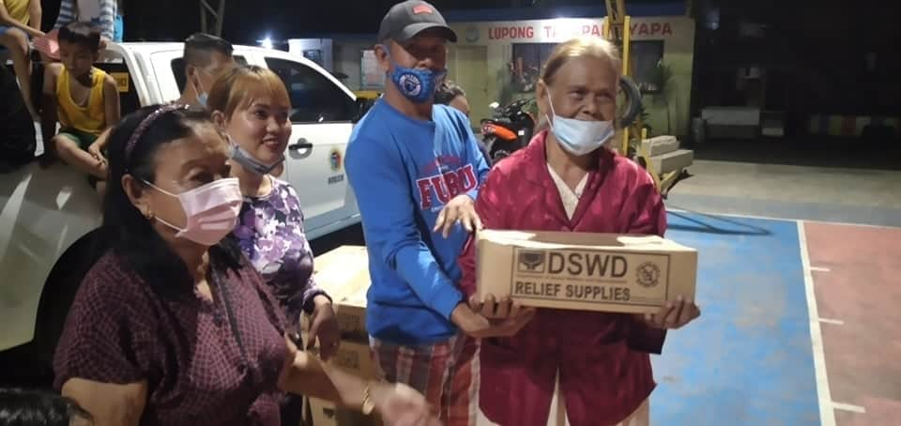
PHOTO DOCUMENTATION
Actual Validation and Monitoring in the area.

Distribution of Family Food Packs to the displaced families

