DSWD DROMIC Report #2 on
the Flashflood Incident in Koronadal City
as of 31 July 2020, 4PM

SUMMARY

On 28 July 2020 at around 3:00 PM, a flashflood incident occurred in Barangays San Isidro, Zone III and GPS wherein a landslide incident also occurred in Barangay Assumption in Koronadal City caused by heavy rainfall due to the Low Pressure Area (LPA).

Source: DSWD-FO XII

- Status of Affected Families / Persons
A total of 214 families or 1,070 persons in 4 barangays were affected by the flashflood incident in Koronadal City, South Cotabato (see Table 1).

Table 1. Number of Affected Families / Persons
REGION / PROVINCE / MUNICIPALITY |  | NUMBER OF AFFECTED
 |  | Barangays | Families | Persons
GRAND TOTAL |  | 4 | 214 | 1,070
REGION XII |  | 4 | 214 | 1,070
South Cotabato |  | 4 | 214 | 1,070
 | City of Koronadal (capital) | 4 | 214 | 1,070
Note: Ongoing assessment and validation being conducted.
Source: DSWD-FO XII

- Status of Affected Families / Persons
  - Inside Evacuation Center
There are 48 families or 240 persons currently taking temporary shelter in 3 evacuation centers in Koronadal City, South Cotabato (see Table 2).

Table 2. Number of Displaced Families / Persons Inside Evacuation Centers
REGION / PROVINCE / MUNICIPALITY |  | NUMBER OF EVACUATION CENTERS (ECs) |  | NUMBER OF DISPLACED
 |  |  |  | INSIDE ECs
 |  |  |  | Families |  | Persons
 |  | CUM | NOW | CUM | NOW | CUM | NOW
GRAND TOTAL |  | 3 | 3 | 86 | 48 | 430 | 240
REGION XII |  | 3 | 3 | 86 | 48 | 430 | 240
South Cotabato |  | 3 | 3 | 86 | 48 | 430 | 240
 | City of Koronadal (capital) | 3 | 3 | 86 | 48 | 430 | 240
Note: Ongoing assessment and validation being conducted.
Source: DSWD-FO XII

- Outside Evacuation Center
There are 95 families or 475 persons temporarily staying with their relatives and/or friends (see Table 3).

Table 3. Number of Displaced Families / Persons Outside Evacuation Centers
REGION / PROVINCE / MUNICIPALITY |  | NUMBER OF DISPLACED
 |  | OUTSIDE ECs
 |  | Families |  | Persons
 |  | CUM | NOW | CUM | NOW
GRAND TOTAL |  | 95 | 95 | 475 | 475
REGION XII |  | 95 | 95 | 475 | 475
South Cotabato |  | 95 | 95 | 475 | 475
 | City of Koronadal (capital) | 95 | 95 | 475 | 475
Note: Ongoing assessment and validation being conducted.
Source: DSWD-FO XII

- Damaged Houses
16 houses were totally damaged by the incident (see Table 3).

Table 3. Number of Damaged Houses
REGION / PROVINCE / MUNICIPALITY |  | NO. OF DAMAGED HOUSES
 |  | Total | Totally | Partially
GRAND TOTAL |  | 16 | 16 | -
REGION XII |  | 16 | 16 | -
South Cotabato |  | 16 | 16 | -
 | City of Koronadal (capital) | 16 | 16 | -

SITUATIONAL REPORT

DSWD-DRMB
DATE | SITUATIONS / ACTIONS UNDERTAKEN
31 July 2020 | - The Disaster Response Operations Monitoring and Information Center (DROMIC) of the DSWD-DRMB is closely coordinating with DSWD-FO XII for significant reports on the status of affected families, assistance, and relief efforts.

DSWD-FO XII
DATE | SITUATIONS / ACTIONS UNDERTAKEN
31 July 2020 | - DSWD-FO XII conducted validation and actual monitoring in the area and is in close coordination with the City Social Welfare and Development Office of Koronadal City.  - DSWD-FO XII and the Local Government Unit (LGU) of the City has initially provided food packs and beddings to the displaced families.

*****
The Disaster Response Operations Monitoring and Information Center (DROMIC) of the DSWD-DRMB is closely coordinating with DSWD-FO XII for any significant disaster response updates.

Prepared by:

MARIEL B. FERRARIZ CLARRIE MAE A. CASTILLO
Releasing Officer

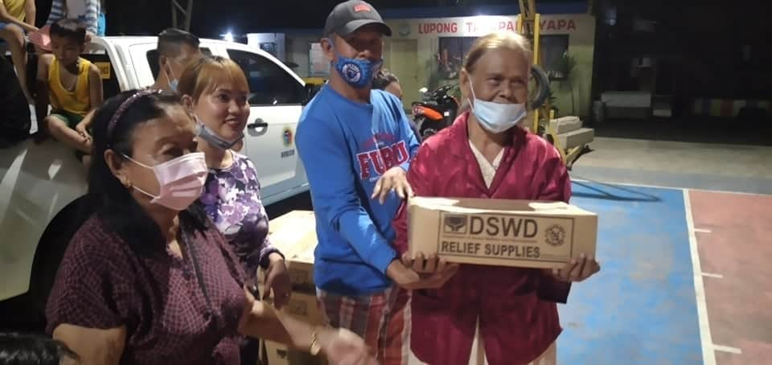
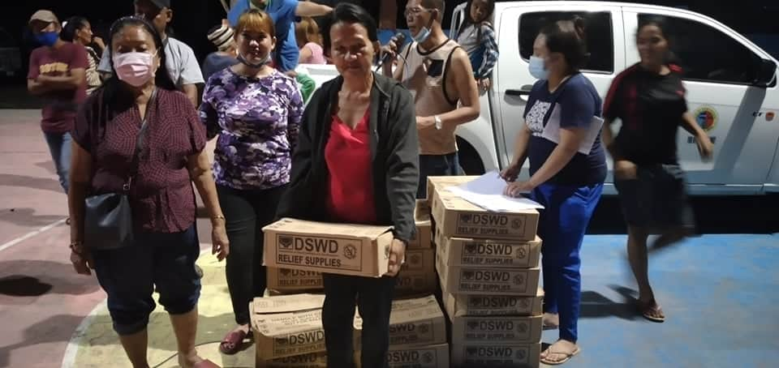
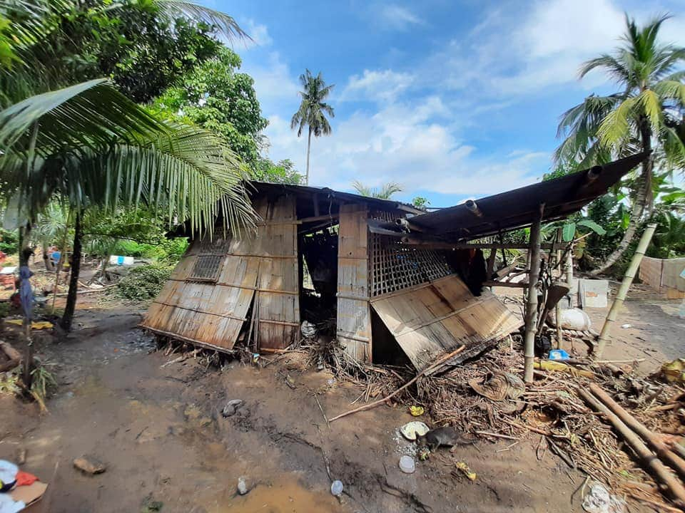
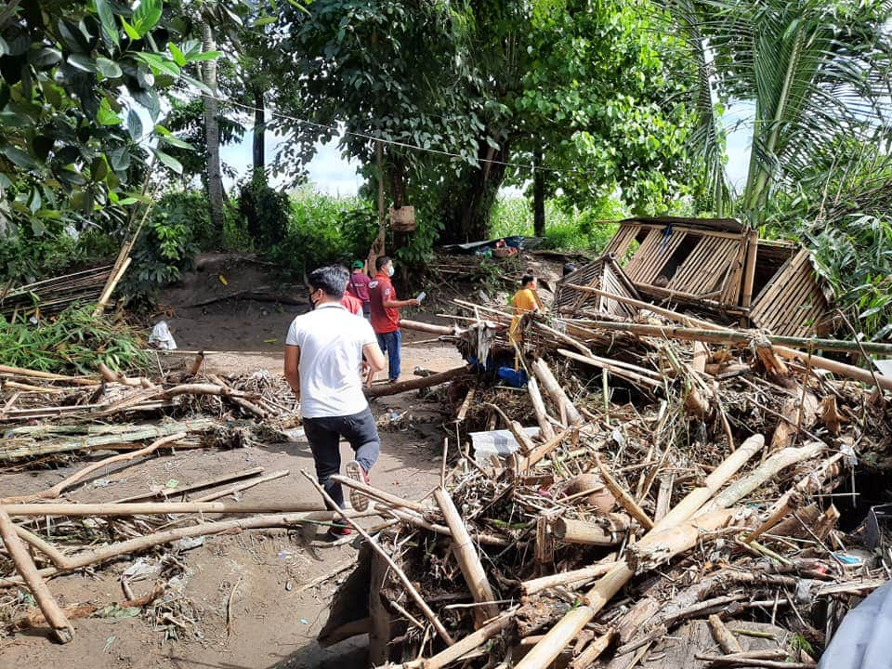
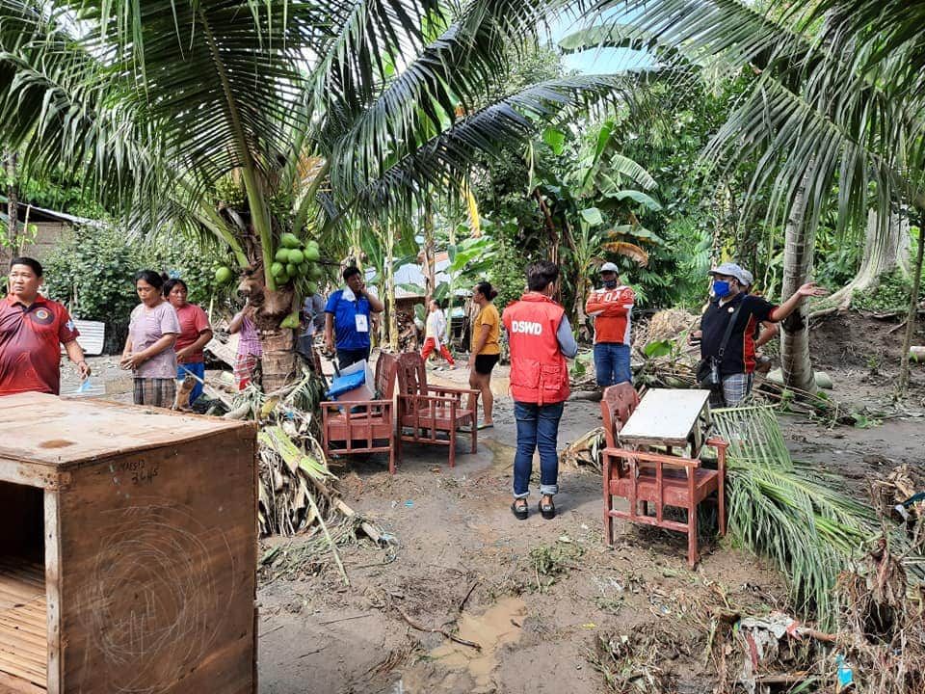
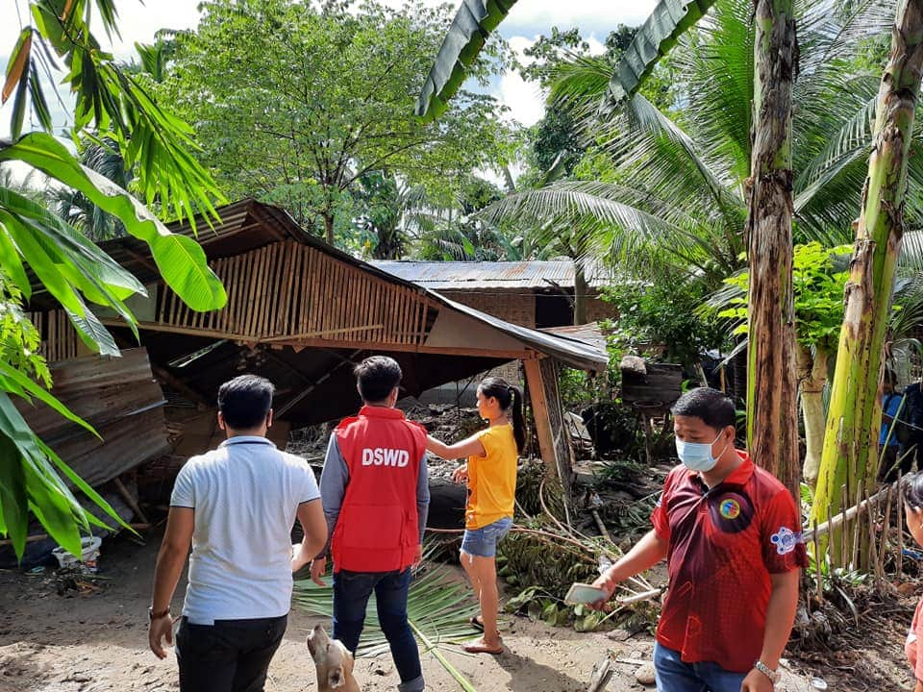
PHOTO DOCUMENTATION
Distribution of Family Food Packs to the displaced families
Actual Validation and Monitoring in the area.

