DSWD DROMIC Report #2 on the Oil Spill Incident in
Brgy. Obrero, Lapuz, Iloilo City
as of 07 July 2020, 6PM

SUMMARY

On 03 July 2020 at 2:45 PM, an oil spill incident caused by an explosion occurred at AC Energy’s Power Barge 102 in Brgy. Obrero, Lapuz, Iloilo City. The incident was declared fire out at 3PM.
Source: DSWD-FO VI

- Status of Affected Families / Persons
A total of 248 families or 931 persons were affected in Brgy. Obrero, Lapuz, Iloilo City (see Table 1).

Table 1. Number of Affected Families / Persons
REGION/PROVINCE/MUNICIPALITY |  | NUMBER OF AFFECTED
 |  | Barangays | Families | Persons
GRAND TOTAL |  | 1 | 248 | 931
REGION VI |  | 1 | 248 | 931
Iloilo |  | 1 | 248 | 931
 | Iloilo City (capital) | 1 | 248 | 931
Note: Ongoing assessment and validation being conducted.
Source: DSWD-FO VI

- Status of Displaced Families / Persons Outside Evacuation Center
248 families or 931 persons are taking temporary shelter in 4 evacuation centers in Brgy. Obrero, Lapuz, Iloilo City (see Table 2).

Table 2. Number of Displaced Families / Persons Outside Evacuation Center
REGION / PROVINCE / MUNICIPALITY |  | NUMBER OF EVACUATION CENTERS (ECs) |  | NUMBER OF DISPLACED
 |  |  |  | INSIDE ECs
 |  |  |  | Families |  | Persons
 |  | CUM | NOW | CUM | NOW | CUM | NOW
GRAND TOTAL |  | 4 | 4 | 248 | 248 | 931 | 931
REGION VI |  | 4 | 4 | 248 | 248 | 931 | 931
Iloilo |  | 4 | 4 | 248 | 248 | 931 | 931
 | Iloilo City (capital) | 4 | 4 | 248 | 248 | 931 | 931
Note: Ongoing assessment and validation being conducted.
Source: DSWD-FO VI

- Assistance Provided
A total of ₱718,528.00 worth of assistance was provided to the affected families; of which, ₱413,730.00 from DSWD and ₱304,798.00 from LGU (see Table 3).

Table 3. Cost of Assistance Provided to Affected Families / Persons
REGION / PROVINCE / MUNICIPALITY |  | COST OF ASSISTANCE
 |  | DSWD | LGU | NGOs | OTHERS | GRAND TOTAL
GRAND TOTAL |  | 413,730.00 | 304,798.00 | - | - | 718,528.00
REGION VI |  | 413,730.00 | 304,798.00 | - | - | 718,528.00
Iloilo |  | 413,730.00 | 304,798.00 | - | - | 718,528.00
 | Iloilo City (capital) | 413,730.00 | 304,798.00 | - | - | 718,528.00
Source: DSWD-FO VI
SITUATIONAL REPORT

DSWD-DRMB
DATE | SITUATIONS / ACTIONS UNDERTAKEN
07 July 2020 | - The Disaster Response Operations Monitoring and Information Center (DROMIC) of the DSWD-DRMB is closely coordinating with DSWD-FO VI for significant reports on the status of affected families, assistance, and relief efforts.

DSWD-FO VI
DATE | SITUATIONS / ACTIONS UNDERTAKEN
07 July 2020 | - DSWD-FO VI provided 120 family food packs, 120 hygiene kits, and 120 comforters to the affected families.  - The local government unit of Iloilo City provided food assistance amounting to ₱64,325.00 and non-food assistance amounting to ₱228,750.00.  - Technical assistance was also provided to the CSWDO and Barangay Obrero Officials for Camp Coordination and Camp Management to organize operations in the evacuation center.  - In observance of standard health protocols amid the COVID-19 pandemic, signages were installed in the evacuation center for health reminders and safety measures.  - DSWD-FO VI visited the newly opened evacuation centers for ocular inspection.  - DSWD-FO VI is in close coordination with the CSWDO for additional requests for food and non-food assistance.

*****
The Disaster Response Operations Monitoring and Information Center (DROMIC) of the DSWD-DRMB is closely coordinating with DSWD-FO VI for any significant disaster response updates.

Prepared by:

MARIE JOYCE G. RAFANAN

MARC LEO L. BUTAC
Releasing Officer

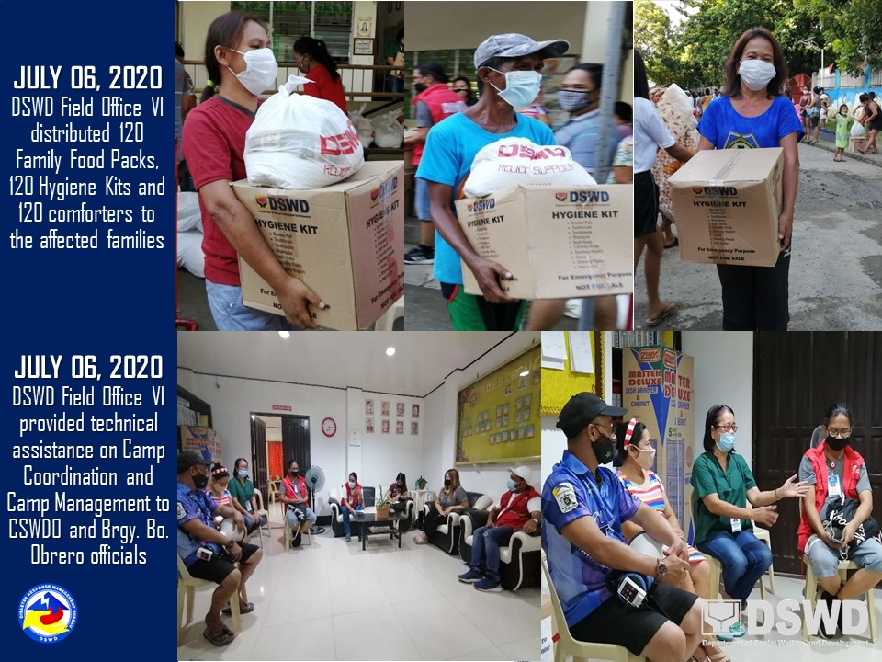
PHOTO DOCUMENTATION

