DSWD DROMIC Report #3 on
the Flashflood Incident in Koronadal City
as of 07 August 2020, 6PM

SUMMARY

On 28 July 2020 at around 3 PM, a flashflood incident occurred in Barangays San Isidro, Zone III and GPS wherein a landslide incident also occurred in Brgy. Assumption in Koronadal City caused by heavy rainfall due to the Low Pressure Area (LPA).
Source: DSWD-FO XII

- Status of Affected Families / Persons
A total of 1,183 families or 5,915 persons in 8 barangays were affected by the flashflood incident in Koronadal City, South Cotabato (see Table 1).

Table 1. Number of Affected Families / Persons
REGION/PROVINCE/MUNICIPALITY |  | NUMBEROFAFFECTED
 |  | Barangays | Families | Persons
GRANDTOTAL |  | 8 | 1,183 | 5,915
REGION XII |  | 8 | 1,183 | 5,915
South Cotabato |  | 8 | 1,183 | 5,915
 | City of Koronadal (capital) | 8 | 1,183 | 5,915
Note: Ongoing assessment and validation being conducted.
Source: DSWD-FO XII

- Status of Affected Families / Persons
  - Inside Evacuation Center
There are 48 families or 240 persons currently taking temporary shelter in 2 evacuation centers in Koronadal City, South Cotabato (see Table 2).

Table 2. Number of Displaced Families / Persons Inside Evacuation Centers
REGION / PROVINCE / MUNICIPALITY |  | NUMBER OF EVACUATION CENTERS (ECs) |  | NUMBER OF DISPLACED
 |  |  |  | INSIDE ECs
 |  |  |  | Families |  | Persons
 |  | CUM | NOW | CUM | NOW | CUM | NOW
GRAND TOTAL |  | 3 | 2 | 86 | 48 | 430 | 240
REGION XII |  | 3 | 2 | 86 | 48 | 430 | 240
South Cotabato |  | 3 | 2 | 86 | 48 | 430 | 240
 | City of Koronadal (capital) | 3 | 2 | 86 | 48 | 430 | 240
Note: Ongoing assessment and validation being conducted.
Source: DSWD-FO XII

- Outside Evacuation Center
There are 95 families or 475 persons temporarily staying with their relatives and/or friends (see Table 3).

Table 3. Number of Displaced Families / Persons Outside Evacuation Centers
REGION / PROVINCE / MUNICIPALITY |  | NUMBER OF DISPLACED
 |  | OUTSIDE ECs
 |  | Families |  | Persons
 |  | CUM | NOW | CUM | NOW
GRAND TOTAL |  | 95 | 95 | 475 | 475
REGION XII |  | 95 | 95 | 475 | 475
South Cotabato |  | 95 | 95 | 475 | 475
 | City of Koronadal (capital) | 95 | 95 | 475 | 475
Note: Ongoing assessment and validation being conducted.
Source: DSWD-FO XII

- Damaged Houses
16 Houses were totally damaged due to the flashflood incident (see Table 4).

Table 4. Number of Damaged Houses
REGION / PROVINCE / MUNICIPALITY |  | NO. OF DAMAGED HOUSES
 |  | Total | Totally | Partially
GRAND TOTAL |  | 16 | 16 | -
REGION XII |  | 16 | 16 | -
South Cotabato |  | 16 | 16 | -
 | City of Koronadal (capital) | 16 | 16 | -
Note: Ongoing assessment and validation being conducted.
Source: DSWD-FO XII

- Assistance Provided
A total of ₱650,000.00 worth of assistance was provided by DSWD to the affected families (see Table 5).

Table 5. Cost of Assistance Provided to Affected Families / Persons
REGION / PROVINCE / MUNICIPALITY |  | TOTAL COST OF ASSISTANCE
 |  | DSWD | LGU | NGOs | OTHERS | GRAND TOTAL
GRAND TOTAL |  | 650,000.00 | - | - | - | 650,000.00
REGION XII |  | 650,000.00 | - | - | - | 650,000.00
South Cotabato |  | 650,000.00 | - | - | - | 650,000.00
 | City of Koronadal (capital) | 650,000.00 | - | - | - | 650,000.00
Source: DSWD-FO XII

SITUATIONAL REPORT

DSWD-DRMB
DATE | SITUATIONS / ACTIONS UNDERTAKEN
07 August 2020 | - The Disaster Response Operations Monitoring and Information Center (DROMIC) of the DSWD-DRMB is closely coordinating with DSWD-FO XII for significant reports on the status of affected families, assistance, and relief efforts.

DSWD-FO XII
DATE | SITUATIONS / ACTIONS UNDERTAKEN
07 August 2020 | - DSWD-FO XII released 1,183 family food packs to the Local Government Unit of Koronadal City. Laminated sacks and plastic mats were also provided to the affected families.

*****
The Disaster Response Operations Monitoring and Information Center (DROMIC) of the DSWD-DRMB is closely coordinating with DSWD-FO XII for any significant disaster response updates.

Prepared by:

MARIE JOYCE G. RAFANAN

MARC LEO L. BUTAC
Releasing Officer
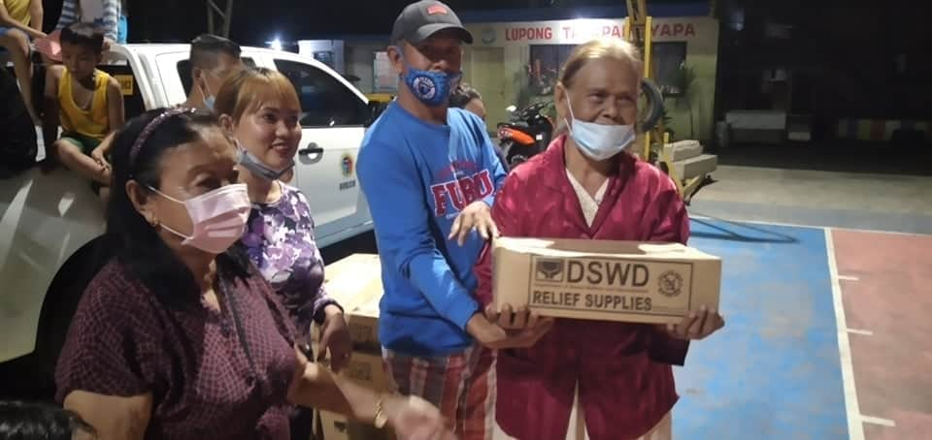
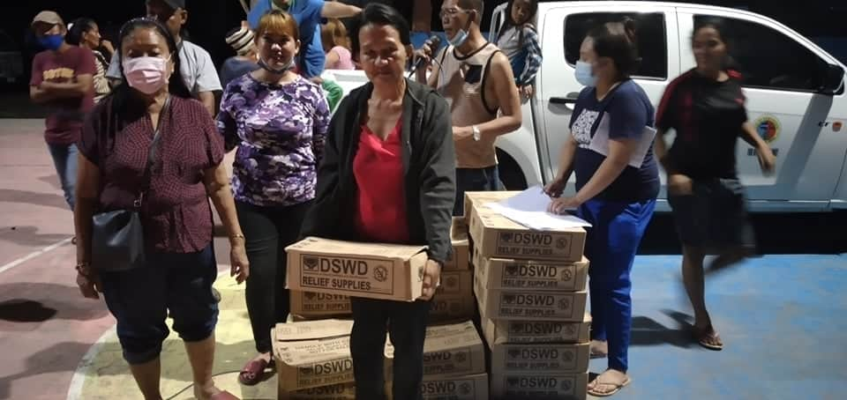
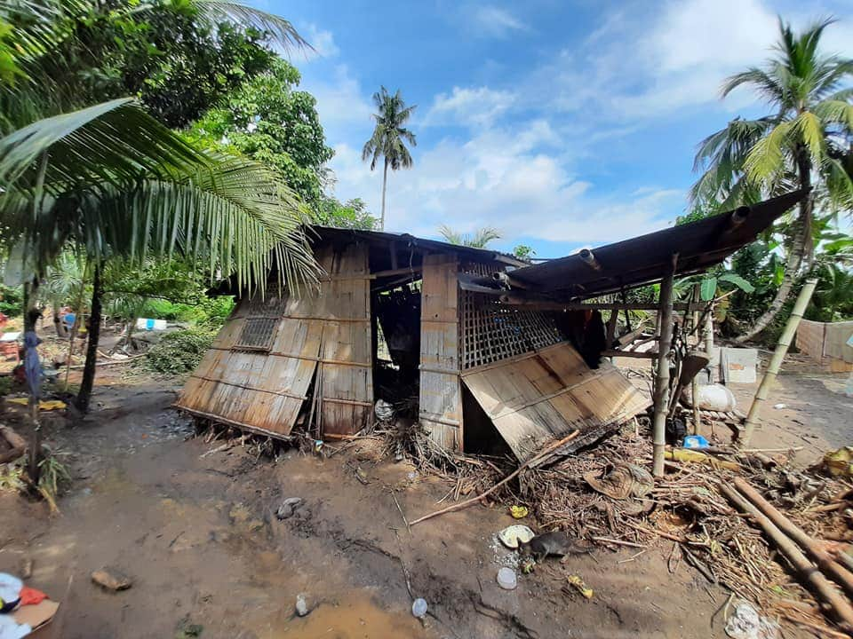
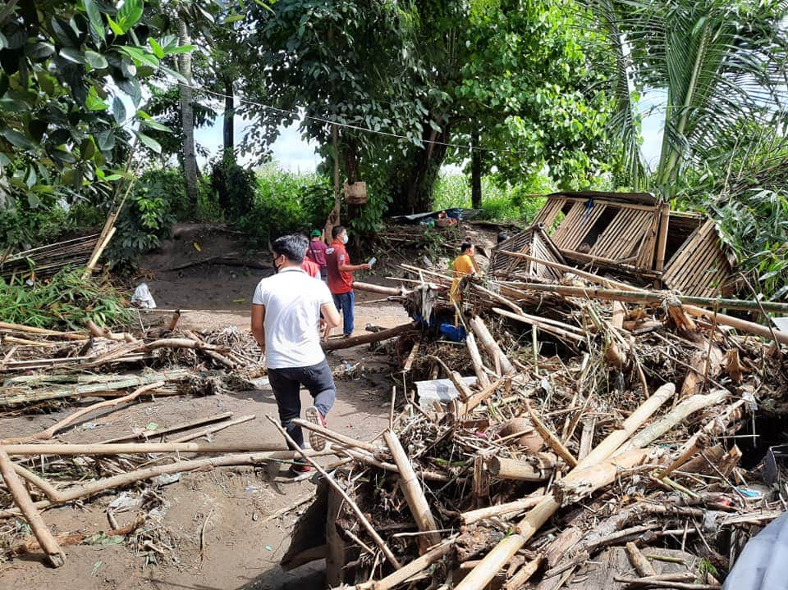
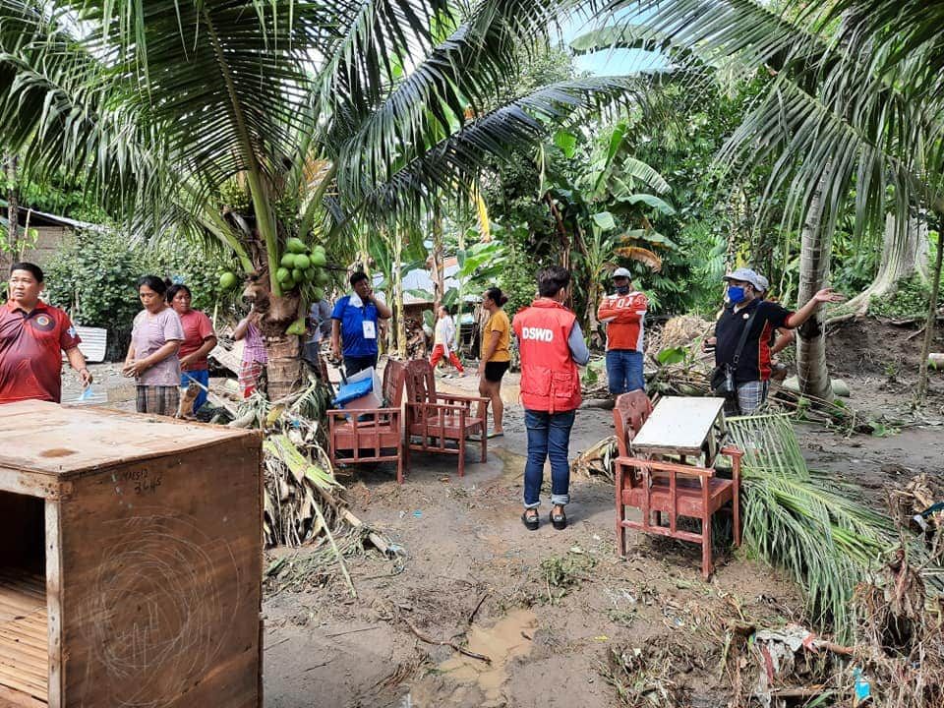
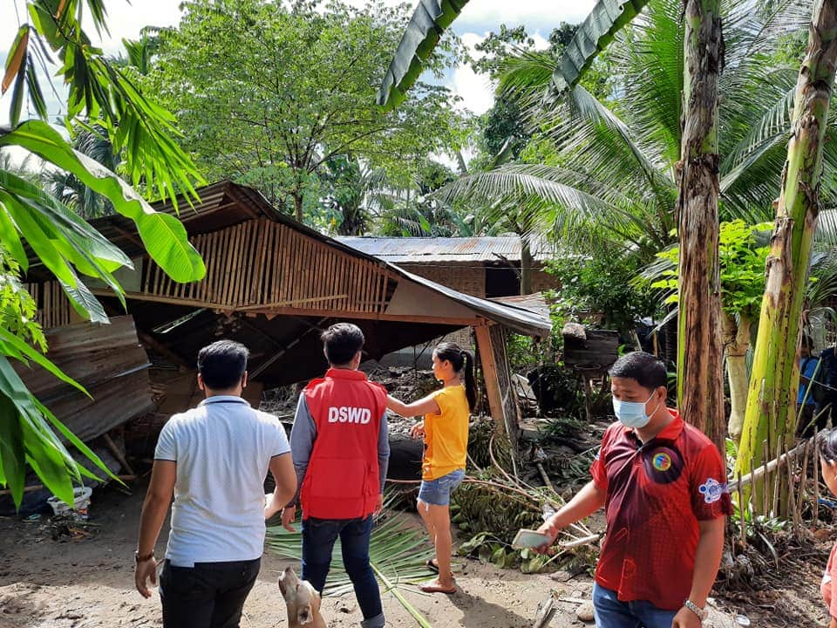
PHOTO DOCUMENTATION
Distribution of Family Food Packs to the displaced families
Actual Validation and Monitoring in the area.

