DSWD DROMIC Report #38 on the
Ms 6.9 Earthquake Incident in Matanao, Davao del Sur
as of 01 July 2020, 4PM

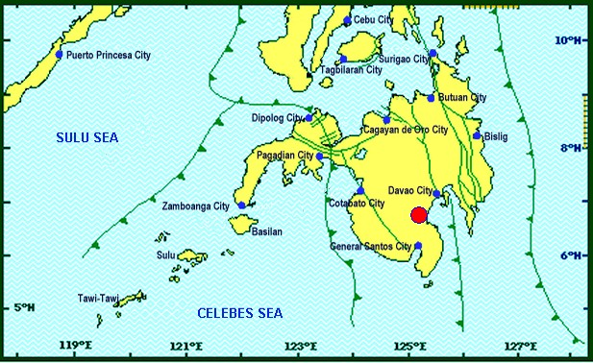
Situation Overview

On 15 December 2019 at 2:11 PM, a 6.9 magnitude earthquake jolted the municipality of Matanao, Davao del Sur (06.74°N, 125.20°E - 005 km N 72°W) with a tectonic origin and a depth of focus of 3 km.

Source: DOST-PHIVOLCS Earthquake Bulletin

- Status of Affected Families / Persons
A total of 87,094 families or 397,080 persons were affected by the earthquake incident in 230 barangays in Regions XI and XII (see Table 1).

Table 1. Number of Affected Families / Persons
REGION / PROVINCE / MUNICIPALITY |  | NUMBER OF AFFECTED
 |  | Barangays | Families | Persons
GRAND TOTAL |  | 230 | 87,094 | 397,080
REGION XI |  | 219 | 86,729 | 395,425
Davao del Sur |  | 219 | 86,729 | 395,425
 | Bansalan | 25 | 6,993 | 32,638
 | City of Digos (capital) | 25 | 3,666 | 18,300
 | Hagonoy | 21 | 9,223 | 32,254
 | Kiblawan | 30 | 13,938 | 67,626
 | Magsaysay | 22 | 15,940 | 75,596
 | Malalag | 15 | 10,937 | 54,685
 | Matanao | 33 | 14,477 | 59,587
 | Padada | 17 | 7,421 | 37,105
 | Santa Cruz | 6 | 661 | 3,499
 | Sulop | 25 | 3,473 | 14,135
REGION XII |  | 11 | 365 | 1,655
North Cotabato |  | 3 | 37 | 185
 | M'lang | 3 | 37 | 185
Sarangani |  | 5 | 175 | 705
 | Malungon | 5 | 175 | 705
Sultan Kudarat |  | 3 | 153 | 765
 | Columbio | 3 | 153 | 765
Note: The change in the number of affected persons in Davao del Sur is based on the validated report submitted by DSWD-FO XI. Thus, ongoing assessment and validation being conducted.
Source: DSWD-FOs XI and XII

- Status of Displaced Families / Persons
- Inside Evacuation Centers
There are 2,132 families or 7,786 persons taking temporary shelter in 24 evacuation centers in Region XI (see Table 2).

Table 2. Number of Displaced Families / Persons Inside Evacuation Centers
REGION / PROVINCE / MUNICIPALITY |  | NUMBER OF EVACUATION CENTERS (ECs) |  | NUMBER OF DISPLACED
 |  |  |  | INSIDE ECs
 |  |  |  | Families |  | Persons
 |  | CUM | NOW | CUM | NOW | CUM | NOW
GRAND TOTAL |  | 117 | 24 | 14,112 | 2,132 | 58,443 | 7,786
REGION XI |  | 113 | 24 | 13,898 | 2,132 | 57,418 | 7,786
Davao del Sur |  | 113 | 24 | 13,898 | 2,132 | 57,418 | 7,786
 | Bansalan | 12 | 7 | 1,032 | 262 | 3,585 | 786
 | City of Digos (capital) | 15 | 2 | 3,041 | 115 | 14,915 | 345
 | Hagonoy | 5 | 2 | 701 | 126 | 2,346 | 504
 | Kiblawan | 49 | - | 4,301 | - | 17,056 | -
 | Magsaysay | 11 | 10 | 1,526 | 1,445 | 5,722 | 5,422
 | Malalag | 4 | - | 562 | - | 2,017 | -
 | Matanao | 16 | 3 | 2,660 | 184 | 11,533 | 729
 | Padada | 1 | - | 75 | - | 244 | -
REGION XII |  | 4 | - | 214 | - | 1,025 | -
Sarangani |  | 3 | - | 61 | - | 260 | -
 | Malungon | 3 | - | 61 | - | 260 | -
Sultan Kudarat |  | 1 | - | 153 | - | 765 | -
 | Columbio | 1 | - | 153 | - | 765 | -
Note: The change in the number of displaced persons in Davao del Sur is based on the validated report submitted by DSWD-FO XI. Thus, ongoing assessment and validation being conducted.
Source: DSWD-FOs XI and XII

- Outside Evacuation Centers
There are 25,191 families or 106,822 persons currently staying with their relatives and/or friends, or in open spaces (see Table 3).

Table 3. Number of Displaced Families / Persons Outside Evacuation Centers
REGION / PROVINCE / MUNICIPALITY |  | NUMBER OF DISPLACED
 |  | OUTSIDE ECs
 |  | Families |  | Persons
 |  | CUM | NOW | CUM | NOW
GRAND TOTAL |  | 25,565 | 25,191 | 108,573 | 106,822
REGION XI |  | 25,451 | 25,191 | 108,128 | 106,822
Davao del Sur |  | 25,451 | 25,191 | 108,128 | 106,822
 | Bansalan | 3,762 | 3,596 | 17,374 | 16,790
 | City of Digos (capital) | 495 | 470 | 2,400 | 2,023
 | Hagonoy | 8,642 | 8,642 | 30,376 | 30,376
 | Kiblawan | 2,758 | 2,758 | 12,137 | 12,137
 | Magsaysay | 247 | 247 | 1,235 | 1,235
 | Malalag | 7,486 | 7,417 | 37,430 | 37,085
 | Matanao | 940 | 940 | 3,010 | 3,010
 | Padada | 926 | 926 | 2,996 | 2,996
 | Santa Cruz | 195 | 195 | 1,170 | 1,170
REGION XII |  | 114 | - | 445 | -
Sarangani |  | 114 | - | 445 | -
 | Malungon | 114 | - | 445 | -
Note: The change in the number of displaced persons in Davao del Sur is based on the validated report submitted by DSWD-FO XI. Thus, ongoing assessment and validation being conducted.
Source: DSWD-FOs XI and XII

- Damaged Houses
There are 47,635 damaged houses; of which, 8,386 are totally damaged and 39,367 are partially damaged (see Table 4).

Table 4. Number of Damaged Houses
REGION / PROVINCE / MUNICIPALITY |  | NO. OF DAMAGED HOUSES
 |  | Total | Totally | Partially
GRAND TOTAL |  | 47,635 | 8,386 | 39,367
REGION XI |  | 47,603 | 8,386 | 39,335
Davao del Sur |  | 47,603 | 8,386 | 39,335
 | Bansalan | 5,729 | 1,936 | 3,793
 | City of Digos (capital) | 1,237 | 289 | 948
 | Hagonoy | 8,866 | 775 | 8,091
 | Kiblawan | 4,142 | 523 | 3,619
 | Magsaysay | 7,774 | 2,530 | 5,244
 | Malalag | 2,430 | 111 | 2,319
 | Matanao | 10,461 | 1,612 | 8,967
 | Padada | 3,311 | 347 | 2,964
 | Santa Cruz | 195 | 1 | 194
 | Sulop | 3,458 | 262 | 3,196
REGION XII |  | 32 | - | 32
North Cotabato |  | 32 | - | 32
 | M'lang | 32 | - | 32
Note: The change in the number of damaged houses in Davao del Sur is based on the validated report submitted by DSWD-FO XI. Thus, ongoing assessment and validation being conducted.
Source: DSWD-FOs XI and XII

- Assistance Provided
A total of ₱46,065,773.57 worth of assistance was provided by DSWD to the affected families (see Table 5).

Table 5. Cost of Assistance Provided to Affected Families / Persons
REGION / PROVINCE / MUNICIPALITY |  | COST OF ASSISTANCE
 |  | DSWD | LGU | NGOs | OTHERS | GRAND TOTAL
GRAND TOTAL |  | 46,065,773.57 | - | - | - | 46,065,773.57
REGION XI |  | 45,726,383.57 | - | - | - | 45,726,383.57
Davao del Sur |  | 45,726,383.57 | - | - | - | 45,726,383.57
 | Bansalan | 1,522,757.50 | - | - | - | 1,522,757.50
 | City of Digos (capital) | 12,630,317.66 | - | - | - | 12,630,317.66
 | Hagonoy | 6,045,646.78 | - | - | - | 6,045,646.78
 | Kiblawan | 5,450,863.70 | - | - | - | 5,450,863.70
 | Magsaysay | 5,033,899.00 | - | - | - | 5,033,899.00
 | Malalag | 5,871,264.67 | - | - | - | 5,871,264.67
 | Matanao | 3,691,677.84 | - | - | - | 3,691,677.84
 | Padada | 4,438,723.92 | - | - | - | 4,438,723.92
 | Sulop | 1,041,232.50 | - | - | - | 1,041,232.50
REGION XII |  | 339,390.00 | - | - | - | 339,390.00
Sultan Kudarat |  | 339,390.00 | - | - | - | 339,390.00
 | Columbio | 339,390.00 | - | - | - | 339,390.00
Source: DSWD-FOs XI and XII

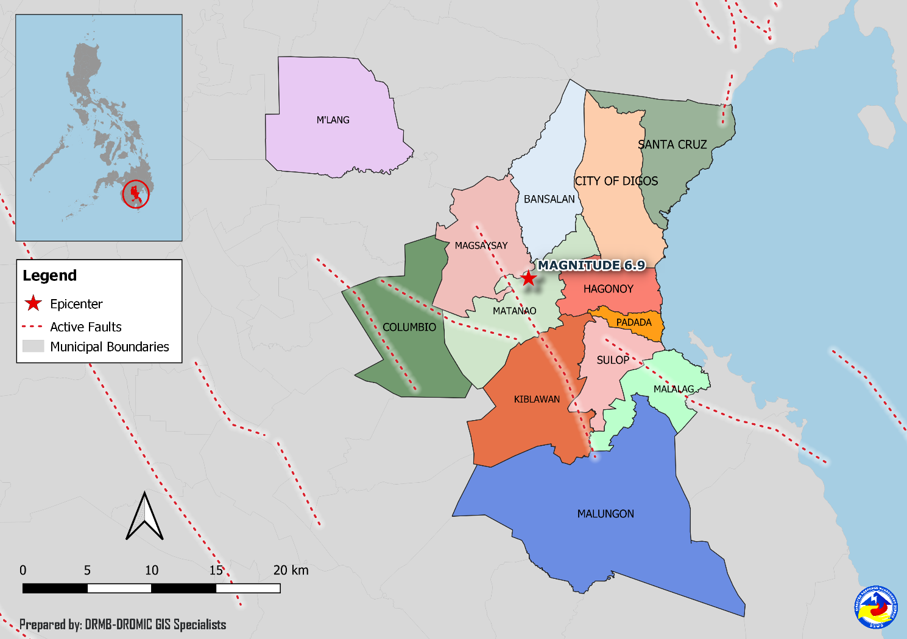
DSWD DISASTER RESPONSE INFORMATION

Situational Reports

DSWD-DRMB
DATE | SITUATIONS / ACTIONS UNDERTAKEN
01 July 2020 | - The Disaster Response Management Bureau (DRMB) is closely coordinating with the concerned Field Offices for significant disaster response updates.

DSWD-FO XI
DATE | SITUATIONS / ACTIONS UNDERTAKEN
01 July 2020 | - DSWD-FO XI provided 5 sets of Women Friendly Space (WFS) Kit and Children Friendly Space Kit amounting to ₱205,360.48 to the Municipalities of Bansalan, Magsaysay and Matanao Davao del Sur
14 March 2020 | - On March 10, 2020, the Agency commenced the validation of reported damaged houses in Davao del Sur based on the reports provided by the municipalities. Results of the validation will be used as basis for the Early Recovery and Rehabilitation of the affected families.
- March 2020 | - On March 1-2, 2020, the municipality of Magsaysay, Davao del Sur received previously used tents from Digos, Davao del Sur. The tents will be used by affected families with totally damaged houses.

DSWD-FO XII
DATE | SITUATIONS / ACTIONS UNDERTAKEN
09 January 2020 | - DSWD-FO XII submitted their terminal report.
26 December 2019 | - DSWD-FO XII provided 24 family tents to affected families in Malungon, Sarangani.  - 135 families were given financial assistance worth ₱2,400.00 through DSWD Assistance to Individual in Crisis Situation.

*****
The Disaster Response Operations Monitoring and Information Center (DROMIC) of the DSWD-DRMB is closely coordinating with concerned DSWD Field Offices for any significant disaster response updates.

Prepared by:

MARIEL B. FERRARIZ

RODEL V. CABADDU
Releasing Officer

