DSWD DROMIC Terminal Report on
the Flashflood Incident in Koronadal City
16 December 2020, 6PM

SUMMARY

This is the final report on the flashflood incident that occurred in Barangays San Isidro, Zone III and GPS on 28 July 2020 at around 3:00 PM.
Source: DSWD-FO XII

- Status of Affected Families / Persons
A total of 1,183 families or 5,915 persons in 8 barangays were affected by the flashflood incident in Koronadal City, South Cotabato (see Table 1).

Table 1. Number of Affected Families / Persons
REGION/PROVINCE/MUNICIPALITY |  | NUMBEROFAFFECTED
 |  | Barangays | Families | Persons
GRANDTOTAL |  | 8 | 1,183 | 5,915
REGION XII |  | 8 | 1,183 | 5,915
South Cotabato |  | 8 | 1,183 | 5,915
 | City of Koronadal (capital) | 8 | 1,183 | 5,915
Source: DSWD-FO XII

- Status of Affected Families / Persons
  - Inside Evacuation Center
There are 48 families or 240 persons currently taking temporary shelter in 2 evacuation centers in Koronadal City, South Cotabato (see Table 2).

Table 2. Number of Displaced Families / Persons Inside Evacuation Centers
REGION / PROVINCE / MUNICIPALITY |  | NUMBER OF EVACUATION CENTERS (ECs) |  | NUMBER OF DISPLACED
 |  |  |  | INSIDE ECs
 |  |  |  | Families |  | Persons
 |  | CUM | NOW | CUM | NOW | CUM | NOW
GRAND TOTAL |  | 3 | 2 | 86 | 48 | 430 | 240
REGION XII |  | 3 | 2 | 86 | 48 | 430 | 240
South Cotabato |  | 3 | 2 | 86 | 48 | 430 | 240
 | City of Koronadal (capital) | 3 | 2 | 86 | 48 | 430 | 240
Source: DSWD-FO XII

- Outside Evacuation Center
There are 95 families or 475 persons temporarily staying with their relatives and/or friends (see Table 3).

Table 3. Number of Displaced Families / Persons Outside Evacuation Centers
REGION / PROVINCE / MUNICIPALITY |  | NUMBER OF DISPLACED
 |  | OUTSIDE ECs
 |  | Families |  | Persons
 |  | CUM | NOW | CUM | NOW
GRAND TOTAL |  | 95 | 95 | 475 | 475
REGION XII |  | 95 | 95 | 475 | 475
South Cotabato |  | 95 | 95 | 475 | 475
 | City of Koronadal (capital) | 95 | 95 | 475 | 475
Source: DSWD-FO XII

- Damaged Houses
16 Houses were totally damaged due to the flashflood incident (see Table 4).

Table 4. Number of Damaged Houses
REGION / PROVINCE / MUNICIPALITY |  | NO. OF DAMAGED HOUSES
 |  | Total | Totally | Partially
GRAND TOTAL |  | 16 | 16 | -
REGION XII |  | 16 | 16 | -
South Cotabato |  | 16 | 16 | -
 | City of Koronadal (capital) | 16 | 16 | -
Source: DSWD-FO XII

- Assistance Provided
A total of ₱650,000.00 worth of assistance was provided by DSWD to the affected families (see Table 5).

Table 5. Cost of Assistance Provided to Affected Families / Persons
REGION / PROVINCE / MUNICIPALITY |  | TOTAL COST OF ASSISTANCE
 |  | DSWD | LGU | NGOs | OTHERS | GRAND TOTAL
GRAND TOTAL |  | 650,000.00 | - | - | - | 650,000.00
REGION XII |  | 650,000.00 | - | - | - | 650,000.00
South Cotabato |  | 650,000.00 | - | - | - | 650,000.00
 | City of Koronadal (capital) | 650,000.00 | - | - | - | 650,000.00
Source: DSWD-FO XII

SITUATIONAL REPORT

DSWD-FO XII
DATE | SITUATIONS / ACTIONS UNDERTAKEN
16 December 2020 | - DSWD-FO XII submitted their terminal report  - The needs of the displaced families and persons inside evacuation centers shall continuously be provided by the LGU of Koronadal

*****
The Disaster Response Operations Monitoring and Information Center (DROMIC) of the DSWD-DRMB is closely coordinating with DSWD-FO XII for any request of Technical Assistance and Resource Augmentation (TARA).

Prepared by:

MARIEL B. FERRARIZ

JEM ERIC F. FAMORCAN
Releasing Officer

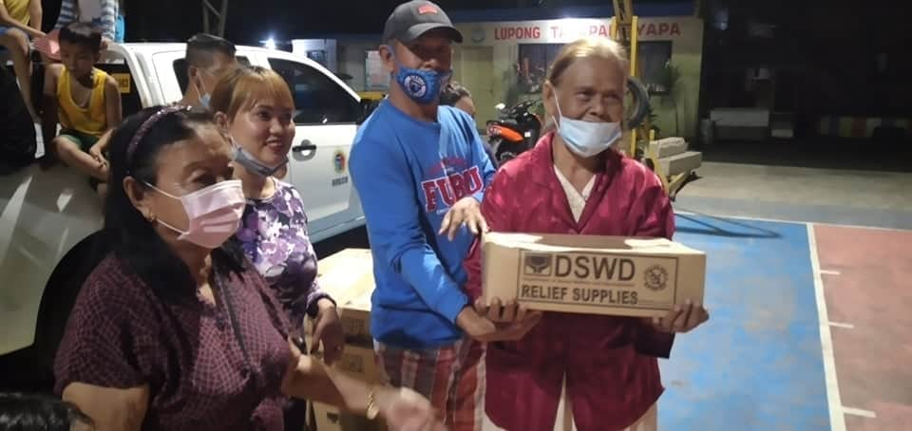
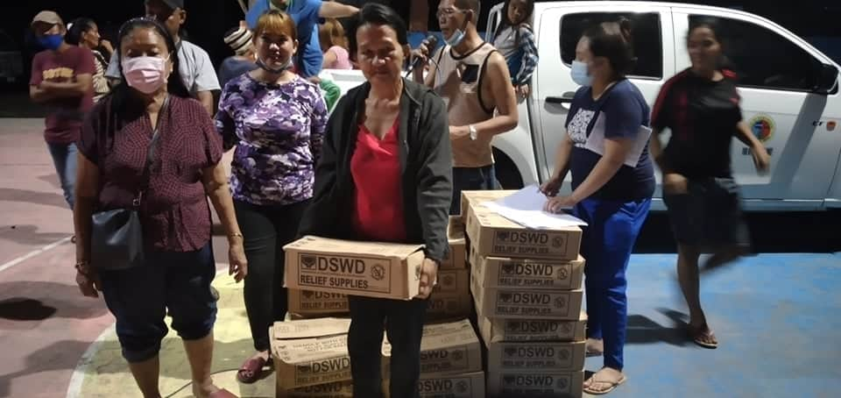
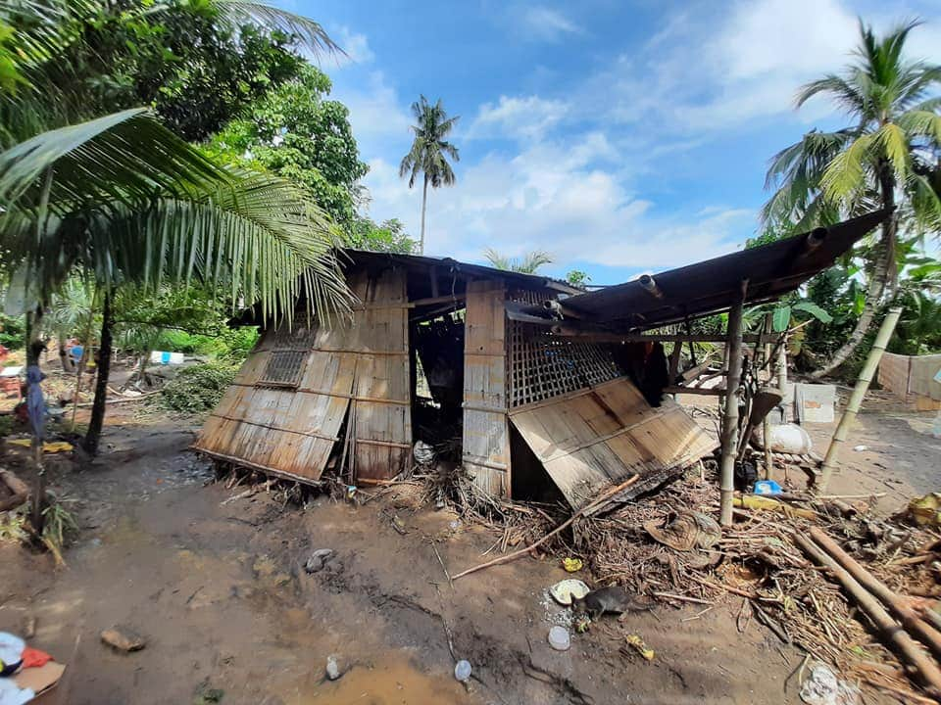
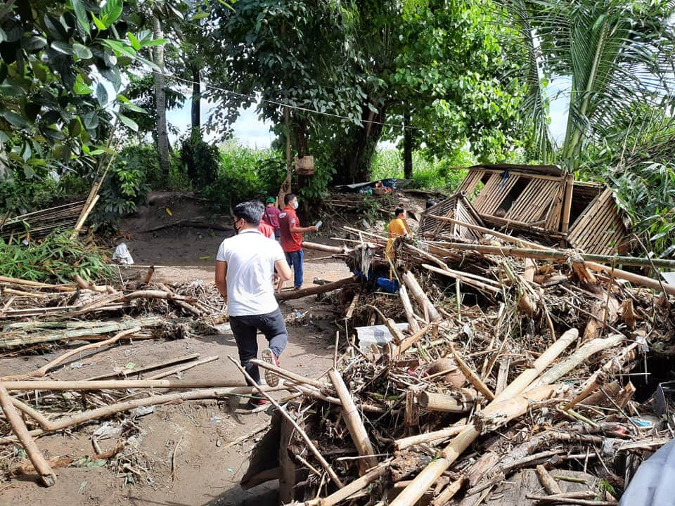
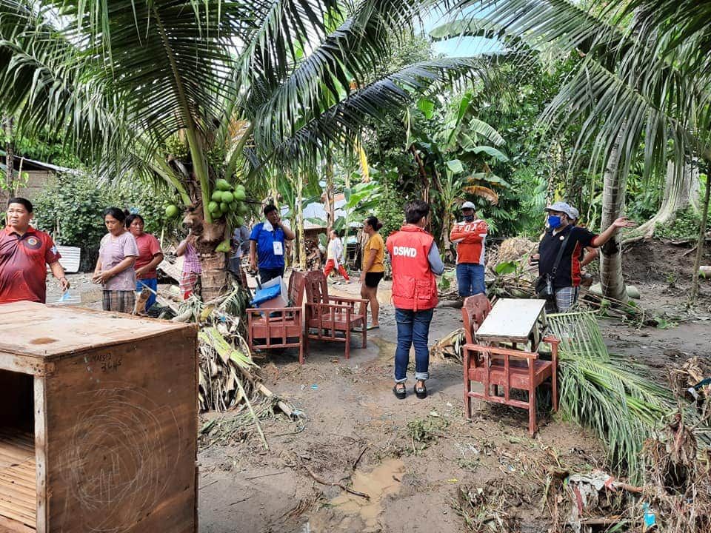
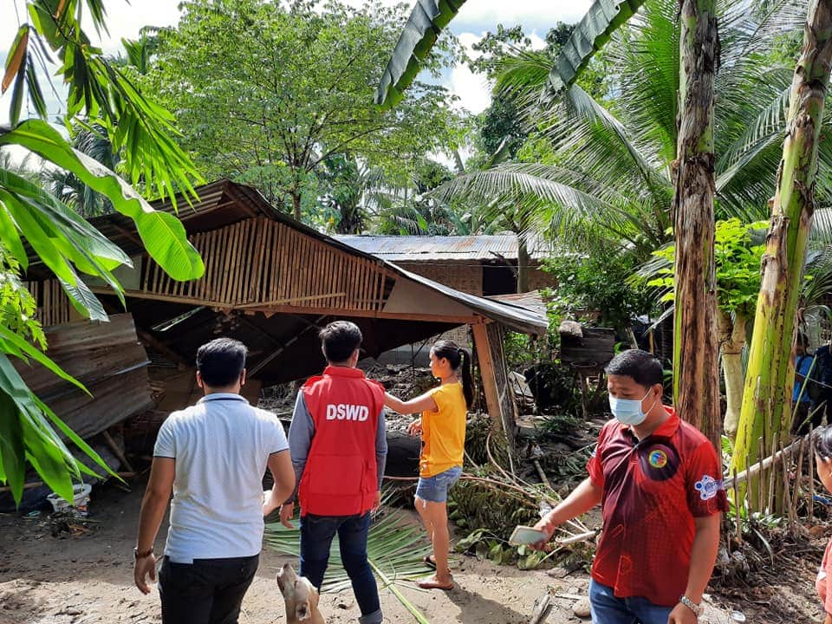
PHOTO DOCUMENTATION
Distribution of Family Food Packs to the displaced families
Actual Validation and Monitoring in the area.

