DSWD DROMIC Report #1 on the
Mw 6.6 Earthquake Incident in Cataingan, Masbate
as of 18 August 2020, 6PM

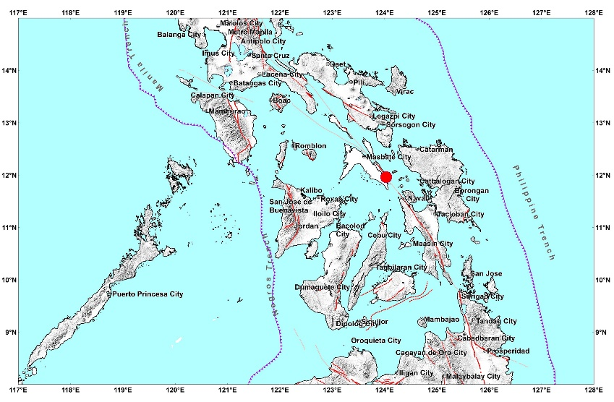

Situation Overview

On 18 August 2020 at 8:03 AM, a 6.6 magnitude earthquake jolted the municipality of Cataingan, Masbate (11.96°N, 124.03°E - 007 km S 29° E) with a tectonic origin and a depth of focus of 21 km. The earthquake was also felt in the neighboring municipalities of Masbate.

Date/Time: | 18 Aug 2020 - 08:03:47 AM
Reported Intensities: | Intensity VII - Cataingan, Masbate  Intensity V - City of Masbate, Masbate; Almagro, and Tagapul-an, Samar;  Intensity IV - Palanas, and San Jacinto, Masbate; City of Sorsogon, Sorsogon; City of Legazpi, Albay; San Andres, Quezon; Mapanas, and Palapag, Northern  Samar; Barugo, Dagami, Dulag, Julita, La Paz, Palo, and Tanauan, Leyte; City of Sagay, Negros Occidental  Intensity III - City of Baybay, Isabel, Javier, and Kananga, Leyte; Ormoc City; Mulanay, Quezon; City of Iloilo  Intensity II - Guinayangan and Lopez, Quezon; President Roxas, Capiz; Patnongon, Patnongon, San Jose de Buenavista, and Tibiao, Antique  Intensity I - Lezo, Aklan; City of Dumaguete, Negros Oriental  Instrumental Intensities:  Intensity V - Masbate City, Masbate  Intensity IV - Palo, Leyte; City of Iloilo; City of Roxas, Capiz; Naval, Biliran;  Intensity III - City of Bago, Negros Occidental; Malinao, Aklan; Pandan, Antique; Jamindan, Capiz; Ormoc City  Intensity II - Gumaca, Quezon; San Jose de Buenavista, Antique; City of Sipalay, Negros Occidental; Valderrama, Antique; Sipocot, Camarines Sur; Talibon,  Bohol; San Francisco, Cebu  Intensity I - Malay, Aklan; City of Gingoog, Misamis Oriental
Expecting Damage: | YES
Expecting Aftershocks: | YES
Source: DOST-PHIVOLCS Earthquake Bulletin

Status of Prepositioned Resources: Stockpile and Standby Funds

The DSWD Central Office (CO), Field Offices (FOs), and National Resource Operations Center (NROC) have stockpiles and standby funds amounting to ₱1,503,322,272.24 with breakdown as follows (see Table 2):

- Standby Funds
A total of ₱662,559,434.57 standby funds in the CO and FOs. Of the said amount, ₱622,533,300.34 is the available Quick Response Fund (QRF) in the CO.

- Stockpiles
A total of 305,063 family food packs (FFPs) amounting to ₱149,450,385.03, other food items amounting to ₱242,108,442.58 and non-food items (FNIs) amounting to ₱449,204,010.06 are available.

Table 2. Available Standby Funds and Stockpiles
Region / Office | Standby Funds | FAMILY FOOD PACKS |  | Other Food Items | Non-Food Relief Items | Total Standby Funds & Stockpile
 |  | Quantity | Total Cost
 | 662,559,434.57 | 305,063 | 149,450,385.03 | 242,108,442.58 | 449,204,010.06 | 1,503,322,272.24
Central Office | 622,533,300.34 | - | - | - | - | 622,533,300.34
NRLMB - NROC | - | 57,683 | 27,747,860.00 | 46,392,760.12 | 246,114,502.99 | 320,255,123.11
NRLMB - VDRC | - | 8,371 | 3,959,483.00 | 10,977,863.98 | 1,047,021.75 | 15,984,368.73
I | 265,455.20 | 16,129 | 8,528,416.04 | 2,820,730.00 | 36,913,928.87 | 48,528,530.11
II | 3,000,838.89 | 18,620 | 8,822,314.54 | 10,680,333.55 | 5,510,398.95 | 28,013,885.93
III | 2,181,900.00 | 17,597 | 6,569,010.48 | 1,337,239.97 | 5,510,398.95 | 15,598,549.40
CALABARZON | 3,000,000.00 | 5,248 | 2,078,208.00 | 7,444,130.00 | 5,100,261.58 | 17,622,599.58
MIMAROPA | 3,000,000.00 | 18,892 | 8,501,400.00 | 2,611,589.00 | 4,732,376.25 | 18,845,365.25
V | 3,001,050.00 | 22,705 | 9,274,982.40 | 3,677,526.03 | 24,926,132.90 | 40,879,691.33
VI | 51.68 | 17,320 | 7,431,854.67 | 48,660,483.77 | 3,394,034.59 | 59,486,424.71
VII | 3,024,851.31 | 7,317 | 3,346,550.24 | 11,901,988.46 | 78,320.00 | 18,351,710.01
VIII | 3,003,550.00 | 24,119 | 12,847,283.40 | 6,648,181.70 | 19,401,330.38 | 41,900,345.48
IX | 0.00 | 21,060 | 11,498,760.00 | 8,782,570.00 | 14,357,924.59 | 34,639,254.59
X | 3,000,724.42 | 39,179 | 24,794,572.29 | 32,936,093.51 | 19,741,385.74 | 80,472,775.96
XI | 3,000,001.00 | 2,611 | 966,461.65 | 14,380,475.00 | 23,872,662.70 | 42,219,600.35
XII | 4,543,701.68 | 6,138 | 3,375,900.00 | 10,289,125.49 | 12,876,448.72 | 31,085,175.89
CARAGA | 3,000,538.05 | 3,527 | 1,206,163.46 | 3,453,170.84 | 3,692,470.55 | 11,352,342.90
NCR | 3,000,439.00 | 1,677 | 921,176.10 | 7,479,060.00 | 9,929,291.41 | 21,329,966.51
CAR | 3,003,033.00 | 16,870 | 7,579,988.76 | 11,635,121.16 | 12,005,119.14 | 34,223,262.06
Note: The Inventory Summary is as of 17 August 2020, 12NN.
Source: DRMB and NRLMB

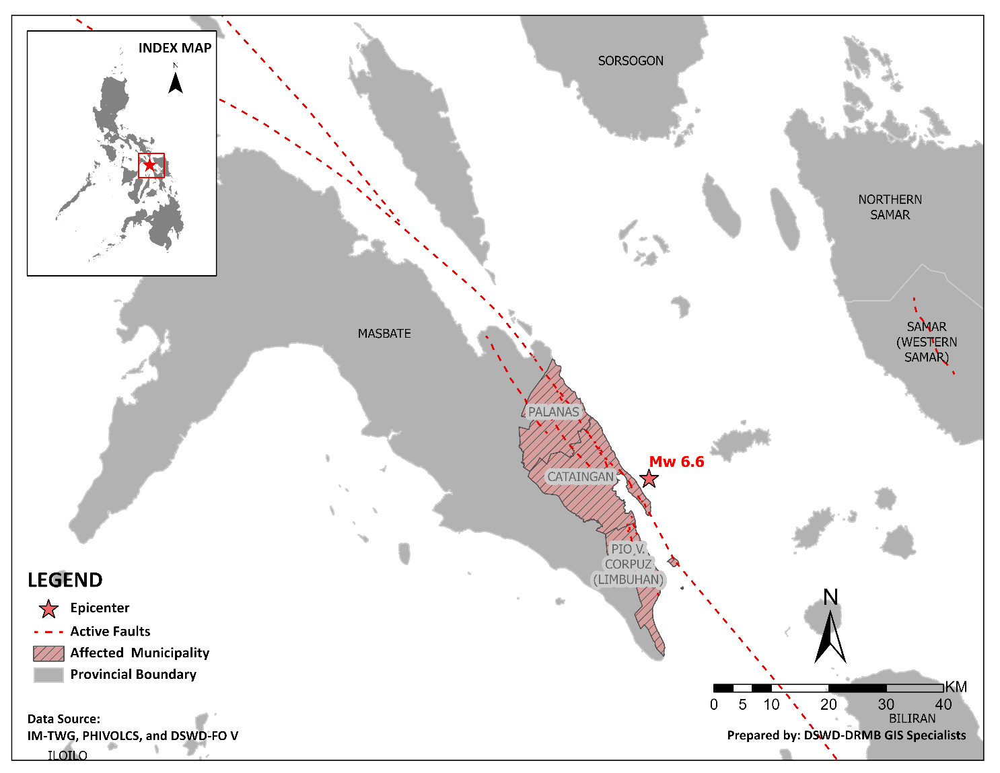
DSWD DISASTER RESPONSE INFORMATION

Situational Reports

DSWD-DRMB
DATE | SITUATIONS / ACTIONS UNDERTAKEN
18 August 2020 | - The Disaster Response Management Bureau (DRMB) is on BLUE alert status.  - DSWD-DRMB Disaster Operations and Support Division (DOSD) continuously facilitates the downloading of funds to DSWD-Field Offices.  - DSWD-DRMB Preparedness for Response Division (PRD) in coordination with other DRMB divisions and concerned offices, is continuously monitoring and updating the status of the Standby Funds.  - DSWD-DRMB DOSD in coordination with other DRMB divisions and concerned offices, is continuously facilitating the replenishment of the Standby Funds.  - DSWD-DRMB is continuously coordinating with DSWD-FO V for significant disaster response updates.  - All QRT members and emergency equipment are on standby and ready for deployment.

DSWD-FO V
DATE | SITUATIONS / ACTIONS UNDERTAKEN
18 August 2020 | - To date, 3 municipalities were affected by the earthquake incident in Masbate; the municipalities of Cataingan, Pio V. Corpuz, and Palanas.  - Number of affected families is yet to be determined. Ongoing assessment and validation are continuously being conducted.  - 14 houses were totally damaged by the earthquake incident.  - DSWD-FO V conducts assessment as to the needs/requirements for possible augmentation.  - The Resource Operation Section ensures the availability of family food packs and non-food items as need arises.  - PAT and MAT members in Masbate Province are activated and instructed to coordinate with the P/MDRRMOs, C/MSWDOs for significant reports and updates on the 6.6 magnitude earthquake.  - DSWD-FO V DRMD continuous to monitor updates and information relative to the 6.6 magnitude earthquake.

*****
The Disaster Response Operations Monitoring and Information Center (DROMIC) of the DSWD-DRMB is closely coordinating with DSWD-FO V for any significant updates and actions taken relative to 6.6 earthquake incident in Cataingan, Masbate.

Prepared by:

MARIE JOYCE G. RAFANAN

LESLIE R. JAWILI
Releasing Officer

