DSWD DROMIC Report #5 on the
Mw 6.6 Earthquake Incident in Cataingan, Masbate
as of 22 August 2020, 6PM

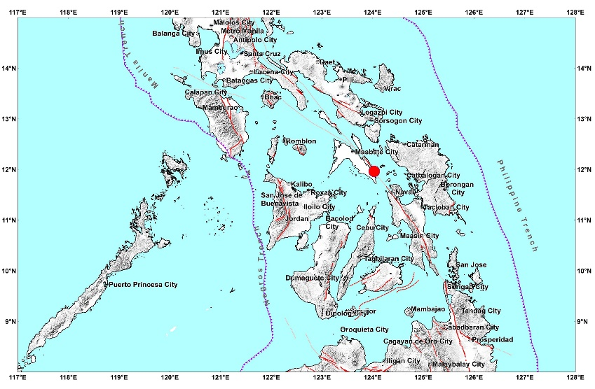

Situation Overview

On 18 August 2020 at 8:03 AM, a 6.6 magnitude earthquake jolted the municipality of Cataingan, Masbate (11.96°N, 124.03°E - 007 km S 29° E) with a tectonic origin and a depth of focus of 21 km. The earthquake was also felt in the neighboring municipalities of Masbate.

Date/Time: | 18 Aug 2020 - 08:03:47 AM
Reported Intensities: | Intensity VII - Cataingan, Masbate  Intensity V - City of Masbate, Masbate; Almagro, and Tagapul-an, Samar;  Intensity IV - Palanas, and San Jacinto, Masbate; City of Sorsogon, Sorsogon; City of Legazpi, Albay; San Andres, Quezon; Mapanas, and Palapag, Northern  Samar; Barugo, Dagami, Dulag, Julita, La Paz, Palo, and Tanauan, Leyte; City of Sagay, Negros Occidental  Intensity III - City of Baybay, Isabel, Javier, and Kananga, Leyte; Ormoc City; Mulanay, Quezon; City of Iloilo  Intensity II - Guinayangan and Lopez, Quezon; President Roxas, Capiz; Patnongon, Patnongon, San Jose de Buenavista, and Tibiao, Antique  Intensity I - Lezo, Aklan; City of Dumaguete, Negros Oriental  Instrumental Intensities:  Intensity V - Masbate City, Masbate  Intensity IV - Palo, Leyte; City of Iloilo; City of Roxas, Capiz; Naval, Biliran;  Intensity III - City of Bago, Negros Occidental; Malinao, Aklan; Pandan, Antique; Jamindan, Capiz; Ormoc City  Intensity II - Gumaca, Quezon; San Jose de Buenavista, Antique; City of Sipalay, Negros Occidental; Valderrama, Antique; Sipocot, Camarines Sur; Talibon,  Bohol; San Francisco, Cebu  Intensity I - Malay, Aklan; City of Gingoog, Misamis Oriental
Expecting Damage: | YES
Expecting Aftershocks: | YES
Source: DOST-PHIVOLCS Earthquake Bulletin

- Status of Affected Families / Persons
There are 803 families or 3,350 persons affected by the earthquake incident in 40 Barangays in Masbate Province (see Table 1).

Table 1. Number of Affected Families / Persons

REGION / PROVINCE / MUNICIPALITY |  | NUMBER OF AFFECTED
 |  | Barangays | Families | Persons
GRAND TOTAL |  | 40 | 803 | 3,350
REGION V |  | 40 | 803 | 3,350
Masbate |  | 40 | 803 | 3,350
 | Cataingan | 15 | 346 | 1,468
 | Cawayan | 2 | 10 | 50
 | Esperanza | 3 | 13 | 56
 | Palanas | 7 | 99 | 491
 | Pio V. Corpuz (Limbuhan) | 13 | 335 | 1,285
Note: Ongoing assessment and validation are continuously being conducted.
Source: DSWD-FO V

- Status of Displaced Families / Persons Inside Evacuation Center
There are 253 families or 1,039 persons taking temporary shelter in 11 evacuation centers (see Table 2).

Table 2. Number of Displaced Families / Persons Inside Evacuation Centers
REGION / PROVINCE / MUNICIPALITY |  | NUMBER OF EVACUATION CENTERS (ECs) |  | NUMBER OF DISPLACED
 |  |  |  | INSIDE ECs
 |  |  |  | Families |  | Persons
 |  | CUM | NOW | CUM | NOW | CUM | NOW
GRAND TOTAL |  | 11 | 11 | 253 | 253 | 1,039 | 1,039
REGION V |  | 11 | 11 | 253 | 253 | 1,039 | 1,039
Masbate |  | 11 | 11 | 253 | 253 | 1,039 | 1,039
 | Cataingan | 7 | 7 | 137 | 137 | 540 | 540
 | Pio V. Corpuz (Limbuhan) | 4 | 4 | 116 | 116 | 499 | 499
Note: Ongoing assessment and validation are continuously being conducted.
Source: DSWD-FO V

- Damaged Houses
There are 626 damaged houses; of which, 66 are totally damaged and 560 are partially damaged (see Table 3).

Table 3. Number of Damaged Houses
REGION / PROVINCE / MUNICIPALITY |  | NO. OF DAMAGED HOUSES
 |  | Total | Totally | Partially
GRAND TOTAL |  | 626 | 66 | 560
REGION V |  | 626 | 66 | 560
Masbate |  | 626 | 66 | 560
 | Cataingan | 203 | 48 | 155
 | Cawayan | 10 | - | 10
 | Esperanza | 13 | - | 13
 | Palanas | 99 | 6 | 93
 | Pio V. Corpuz (Limbuhan) | 301 | 12 | 289
Note: Ongoing assessment and validation are continuously being conducted.
Source: DSWD-FO V

- Assistance Provided
A total of ₱590,478.36 worth of assistance was provided by DSWD to the affected families (see Table 4).

Table 4. Cost of Assistance Provided to Affected Families / Persons
REGION / PROVINCE / MUNICIPALITY |  | COST OF ASSISTANCE
 |  | DSWD | LGU | NGOs | OTHERS | GRAND TOTAL
GRAND TOTAL |  | 590,478.36 | - | - | - | 590,478.36
REGION V |  | 590,478.36 | - | - | - | 590,478.36
Masbate |  | 590,478.36 | - | - | - | 590,478.36
 | Cataingan | 366,058.60 | - | - | - | 366,058.60
 | Palanas | 83,419.76 | - | - | - | 83,419.76
 | Pio V. Corpuz (Limbuhan) | 141,000.00 | - | - | - | 141,000.00
Source: DSWD-FO V

Status of Prepositioned Resources: Stockpile and Standby Funds

The DSWD Central Office (CO), Field Offices (FOs), and National Resource Operations Center (NROC) have stockpiles and standby funds amounting to ₱1,473,491,509.99 with breakdown as follows (see Table 2):

- Standby Funds
A total of ₱663,107,684.85 standby funds in the CO and FOs. Of the said amount, ₱619,916,550.34 is the available Quick Response Fund (QRF) in the CO.

- Stockpiles
A total of 292,941 family food packs (FFPs) amounting to ₱144,009,440.44, other food items amounting to ₱219,165,266.40 and non-food items (FNIs) amounting to ₱447,209,118.30 are available.

Table 2. Available Standby Funds and Stockpiles
Region / Office | Standby Funds | FAMILY FOOD PACKS |  | Other Food Items | Non-Food Relief Items | Total Standby Funds & Stockpile
 |  | Quantity | Total Cost
 | 663,107,684.85 | 292,941 | 144,009,440.44 | 219,165,266.40 | 447,209,118.30 | 1,473,491,509.99
Central Office | 619,916,550.34 | - | - | - | - | 619,916,550.34
NRLMB - NROC | - | 47,060 | 25,308,485.00 | 38,534,953.20 | 250,011,497.99 | 313,854,936.19
NRLMB - VDRC | - | 6,840 | 3,235,320.00 | 6,610,668.50 | 103,159.75 | 9,949,148.25
I | 3,000,455.20 | 14,840 | 7,111,095.88 | 2,820,730.00 | 33,193,904.11 | 46,126,185.19
II | 3,000,838.89 | 18,797 | 8,185,883.70 | 5,187,185.93 | 5,510,398.95 | 21,884,307.47
III | 2,181,900.00 | 22,556 | 8,394,701.42 | 723,257.51 | 5,510,398.95 | 16,810,257.88
CALABARZON | 3,000,000.00 | 2,483 | 983,268.00 | 7,444,130.00 | 5,100,261.58 | 16,527,659.58
MIMAROPA | 3,000,000.00 | 18,356 | 8,260,200.00 | 2,611,589.00 | 4,732,376.25 | 18,604,165.25
V | 3,001,050.00 | 21,155 | 8,633,534.04 | 3,697,526.03 | 24,378,132.90 | 39,710,242.97
VI | 51.68 | 17,774 | 7,502,325.67 | 48,660,483.77 | 3,394,034.59 | 59,556,895.71
VII | 3,024,851.31 | 7,291 | 3,292,536.12 | 8,047,249.76 | 78,320.00 | 14,442,957.19
VIII | 3,003,550.00 | 23,452 | 12,533,326.50 | 6,648,181.70 | 19,401,330.38 | 41,586,388.58
IX | 3,000,000.00 | 21,943 | 11,980,878.00 | 8,782,570.00 | 13,677,924.59 | 37,441,372.59
X | 3,000,724.42 | 33,763 | 22,121,231.70 | 32,936,093.51 | 19,741,385.74 | 77,799,435.37
XI | 3,000,001.00 | 6,411 | 2,373,031.65 | 13,655,475.00 | 23,872,662.70 | 42,901,170.35
XII | 4,543,701.68 | 6,014 | 3,307,700.00 | 10,289,125.49 | 12,876,448.72 | 31,016,975.89
CARAGA | 3,000,538.05 | 3,527 | 1,206,163.46 | 3,776,365.84 | 3,692,470.55 | 11,675,537.90
NCR | 3,000,439.00 | 1,677 | 921,176.10 | 7,479,060.00 | 9,929,291.41 | 21,329,966.51
CAR | 433,033.28 | 19,002 | 8,658,583.20 | 11,260,621.16 | 12,005,119.14 | 32,357,356.78
Note: The Inventory Summary is as of 20 August 2020, 12NN.
Source: DRMB and NRLMB

DSWD DISASTER RESPONSE INFORMATION
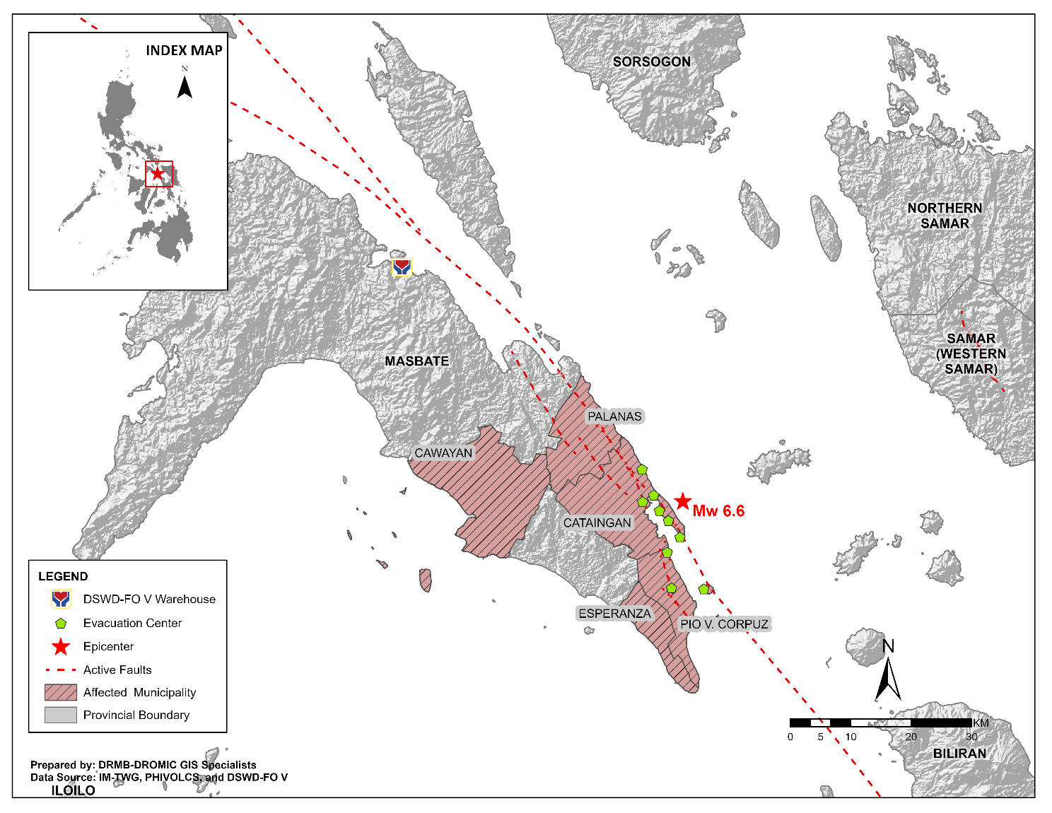

Situational Reports

DSWD-DRMB
DATE | SITUATIONS / ACTIONS UNDERTAKEN
22 August 2020 | - The Disaster Response Management Bureau (DRMB) is on BLUE alert status.  - DSWD-DRMB Disaster Operations and Support Division (DOSD) continuously facilitates the downloading of funds to DSWD-Field Offices.  - DSWD-DRMB Preparedness for Response Division (PRD) in coordination with other DRMB divisions and concerned offices, is continuously monitoring and updating the status of the Standby Funds.  - DSWD-DRMB DOSD in coordination with other DRMB divisions and concerned offices, is continuously facilitating the replenishment of the Standby Funds.  - DSWD-DRMB is continuously coordinating with DSWD-FO V for significant disaster response updates.  - All QRT members and emergency equipment are on standby and ready for deployment.

DSWD-FO V
DATE | SITUATIONS / ACTIONS UNDERTAKEN
22 August 2020 | - DSWD-FO V released 1,103 family food packs, 11 rolls of laminated sacks and 4 tents amounting to a total of ₱590,478.36 as augmentation support to LGUs of Cataingan, Palanas and Pio V. Corpuz.  - DSWD-FO V extended ₱5,000.00 worth of financial assistance thru AICS to each family with totally damaged houses in Cataingan, Pio V. Corpuz and Palanas, Masbate. A total of ₱230,000.00 was provided to 46 families.  - DSWD-FO V in coordination with the Philippine Navy transported additional 1,000 family food packs amounting to ₱412,980.00 to Masbate.  - DSWD FO V conducted Critical Incident Stress Debriefing (CISD) to the residents of Brgy. Matayum who are affected with by the Earthquake.  - DSWD-FO V continuously conducts assessment as to the needs of the affected families for possible augmentation.  - The Resource Operation Section ensures the availability of family food packs and non-food items as need arises.  - PAT and MAT members in Masbate Province are activated and instructed to coordinate with the P/MDRRMOs, C/MSWDOs for significant reports and updates on the 6.6 magnitude earthquake.  - DSWD-FO V DRMD continuous to monitor updates and information relative to the 6.6 magnitude earthquake.

*****
The Disaster Response Operations Monitoring and Information Center (DROMIC) of the DSWD-DRMB is closely coordinating with DSWD-FO V for any significant updates and actions taken relative to 6.6 earthquake incident in Cataingan, Masbate.

Prepared by:

JOANNA CAMILLE R. JACINTO

JEM ERIC F. FAMORCAN
Releasing Officer

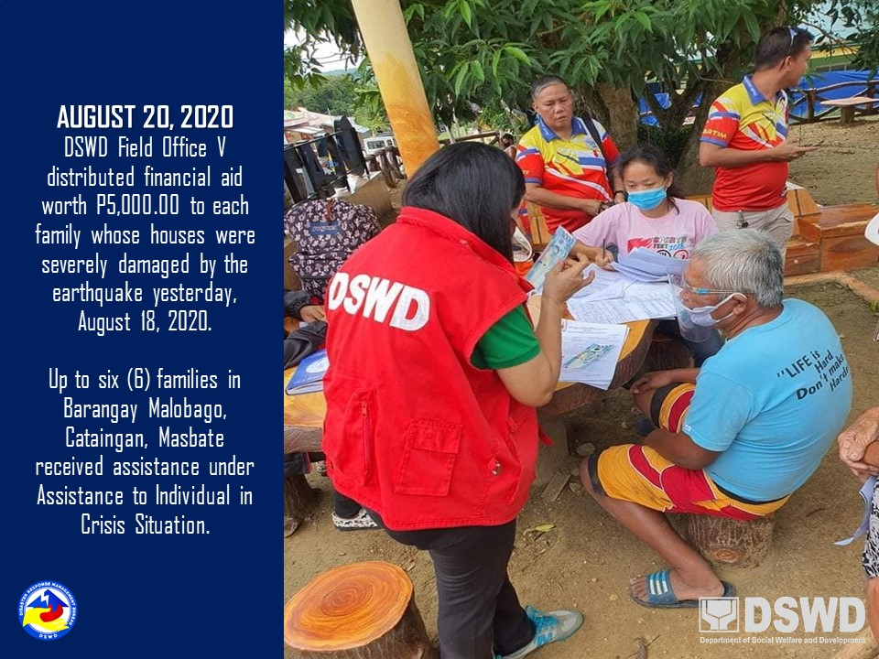
PHOTO DOCUMENTATION

