DSWD DROMIC Terminal Report on the
Mw 6.6 Earthquake Incident in Cataingan, Masbate
09 September 2020, 4PM

Situation Overview

This is the final report on the 6.6 magnitude earthquake on 18 August 2020 at 8:03 AM thath jolted the municipality of Cataingan, Masbate (11.96°N, 124.03°E - 007 km S 29° E) with a tectonic origin and a depth of focus of 21 km. The earthquake was also felt in the neighboring municipalities of Masbate.
Source: DOST-PHIVOLCS Earthquake Bulletin

- Status of Affected Families / Persons
A total of 1,524 families or 6,474 persons were affected by the earthquake incident in 58 Barangays in Masbate Province (see Table 1).

Table 1. Number of Affected Families / Persons
REGION / PROVINCE / MUNICIPALITY |  | NUMBER OF AFFECTED
 |  | Barangays | Families | Persons
GRAND TOTAL |  | 58 | 1,524 | 6,474
REGION V |  | 58 | 1,524 | 6,474
Masbate |  | 58 | 1,524 | 6,474
 | Cataingan | 27 | 929 | 3,928
 | Cawayan | 2 | 10 | 50
 | Esperanza | 3 | 13 | 56
 | Palanas | 12 | 205 | 933
 | Pio V. Corpuz (Limbuhan) | 14 | 367 | 1,507
Note: The decrease in the figure is based on the final report submitted by the Field Office Region V
Source: DSWD-FO V

- Status of Displaced Families / Persons
  - Inside Evacuation Center
A total of 327 families or 1,327 persons took temporary shelter in 15 evacuation centers (see Table 2).

Table 2. Number of Displaced Families / Persons Inside Evacuation Centers
REGION / PROVINCE / MUNICIPALITY |  | NUMBER OF EVACUATION CENTERS (ECs) |  | NUMBER OF DISPLACED
 |  |  |  | INSIDE ECs
 |  |  |  | Families |  | Persons
 |  | CUM | NOW | CUM | NOW | CUM | NOW
GRAND TOTAL |  | 15 | - | 327 | - | 1,327 | -
REGION V |  | 15 | - | 327 | - | 1,327 | -
Masbate |  | 15 | - | 327 | - | 1,327 | -
 | Cataingan | 11 | - | 164 | - | 678 | -
 | Pio V. Corpuz (Limbuhan) | 4 | - | 163 | - | 649 | -
Source: DSWD-FO V

  - Outside Evacuation Center
A total of 10 families or 42 persons took temporary shelter with their relatives and/or friends (see Table 3).

Table 3. Number of Displaced Families / Persons Outside Evacuation Centers
REGION / PROVINCE / MUNICIPALITY |  | NUMBER OF DISPLACED
 |  | OUTSIDE ECs
 |  | Families |  | Persons
 |  | CUM | NOW | CUM | NOW
GRAND TOTAL |  | 10 | - | 42 | -
REGION V |  | 10 | - | 42 | -
Masbate |  | 10 | - | 42 | -
 | Cataingan | 10 | - | 42 | -
Source: DSWD-FO V

- Damaged Houses
There are 1,305 damaged houses; of which, 138 are totally damaged and 1,167 are partially damaged (see Table 4).

Table 4. Number of Damaged Houses
REGION / PROVINCE / MUNICIPALITY |  | NO. OF DAMAGED HOUSES
 |  | Total | Totally | Partially
GRAND TOTAL |  | 1,305 | 138 | 1,167
REGION V |  | 1,305 | 138 | 1,167
Masbate |  | 1,305 | 138 | 1,167
 | Cataingan | 796 | 112 | 684
 | Cawayan | 10 | - | 10
 | Esperanza | 13 | - | 13
 | Palanas | 206 | 10 | 196
 | Pio V. Corpuz (Limbuhan) | 280 | 16 | 264
Note: The decrease in the figure is based on the final report submitted by the Field Office Region V
Source: DSWD-FO V

- Assistance Provided
A total of ₱590,478.36 worth of assistance was provided by DSWD to the affected families (see Table 5).

Table 5. Cost of Assistance Provided to Affected Families / Persons
REGION / PROVINCE / MUNICIPALITY |  | COST OF ASSISTANCE
 |  | DSWD | LGU | NGOs | OTHERS | GRAND TOTAL
GRAND TOTAL |  | 590,478.36 | - | - | - | 590,478.36
REGION V |  | 590,478.36 | - | - | - | 590,478.36
Masbate |  | 590,478.36 | - | - | - | 590,478.36
 | Cataingan | 366,058.60 | - | - | - | 366,058.60
 | Palanas | 83,419.76 | - | - | - | 83,419.76
 | Pio V. Corpuz (Limbuhan) | 141,000.00 | - | - | - | 141,000.00
Source: DSWD-FO V

DSWD DISASTER RESPONSE INFORMATION
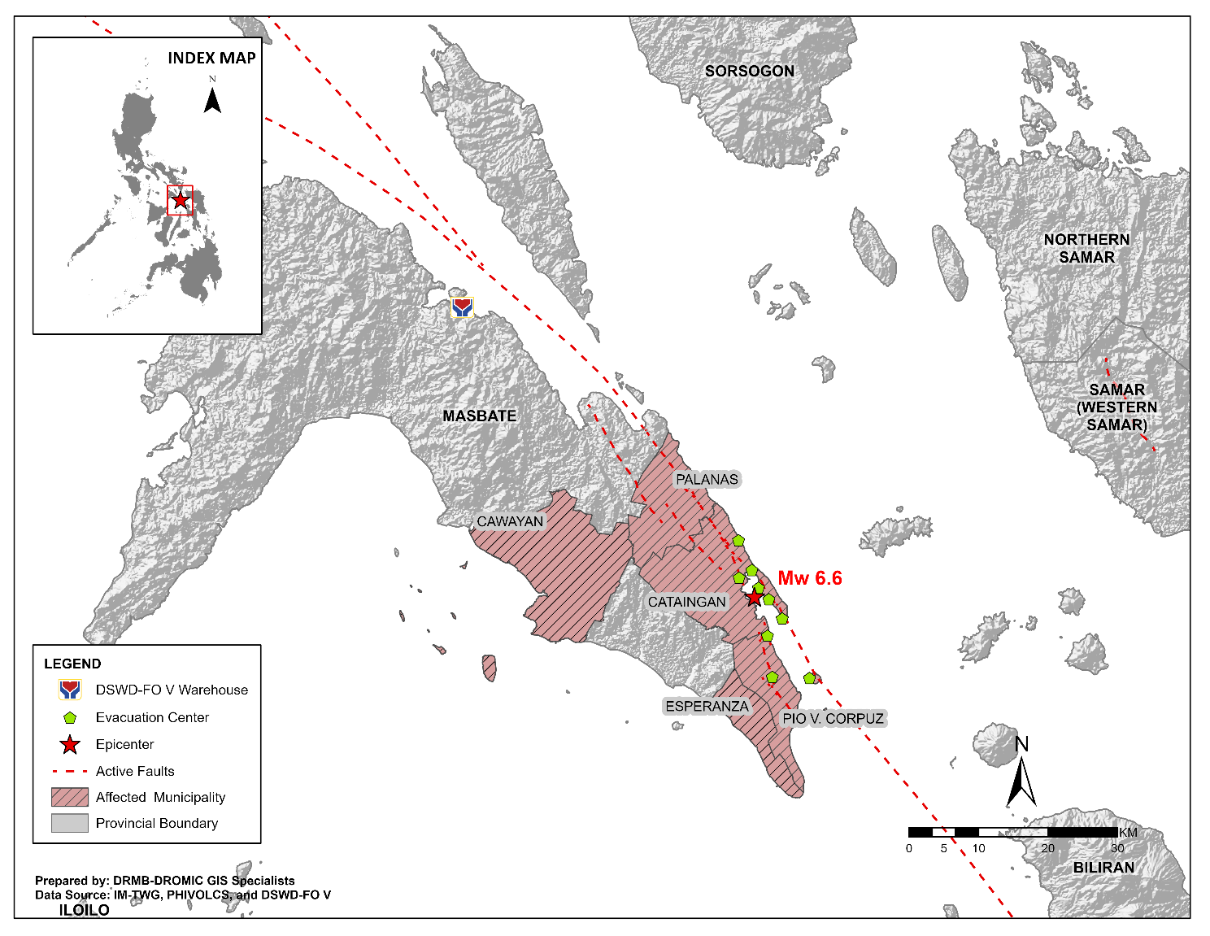

Situational Reports

DSWD-FO V
DATE | SITUATIONS / ACTIONS UNDERTAKEN
08 September 2020 | - DSWD-FO V submitted their terminal report
29 August 2020 | - DSWD-FO V released 1,103 family food packs, 11 rolls of laminated sacks and 4 tents amounting to a total of ₱590,478.36 as augmentation support to LGUs of Cataingan, Palanas and Pio V. Corpuz.  - DSWD-FO V extended ₱5,000.00 worth of financial assistance thru AICS to each family with totally damaged houses in Cataingan, Pio V. Corpuz and Palanas, Masbate. A total of ₱500,000.00 was provided to 100 families.  - DSWD-FO V in coordination with the Philippine Navy transported additional 1,000 family food packs amounting to ₱412,980.00 to Masbate.  - DSWD FO V conducted Critical Incident Stress Debriefing (CISD) to the residents of Brgy. Matayum who are affected with by the Earthquake.  - DSWD-FO V transported 400 family food packs, 10 family tents, 100 rolls laminated sacks for augmentation to LGUs affected in Masbate.  - DSWD-FO V transported additional 2,000 FFPs amounting to Masbate in coordination with the Navy.  - DSWD-FO V continuously conducts assessment as to the needs of the affected families for possible augmentation.  - The Resource Operation Section ensures the availability of family food packs and non-food items as need arises.  - PAT and MAT members in Masbate Province are activated and instructed to coordinate with the P/MDRRMOs, C/MSWDOs for significant reports and updates on the 6.6 magnitude earthquake.  - DSWD-FO V DRMD continuous to monitor updates and information relative to the 6.6 magnitude earthquake.

*****
The Disaster Response Operations Monitoring and Information Center (DROMIC) of the DSWD-DRMB continues to closely coordinate with DSWD-FO V for any request of Technical Assistance and Resource Augmentation (TARA).

Prepared by:
MARIE JOYCE G. RAFANAN
MARIEL B. FERRARIZ

RODEL V. CABADDU
Releasing Officer

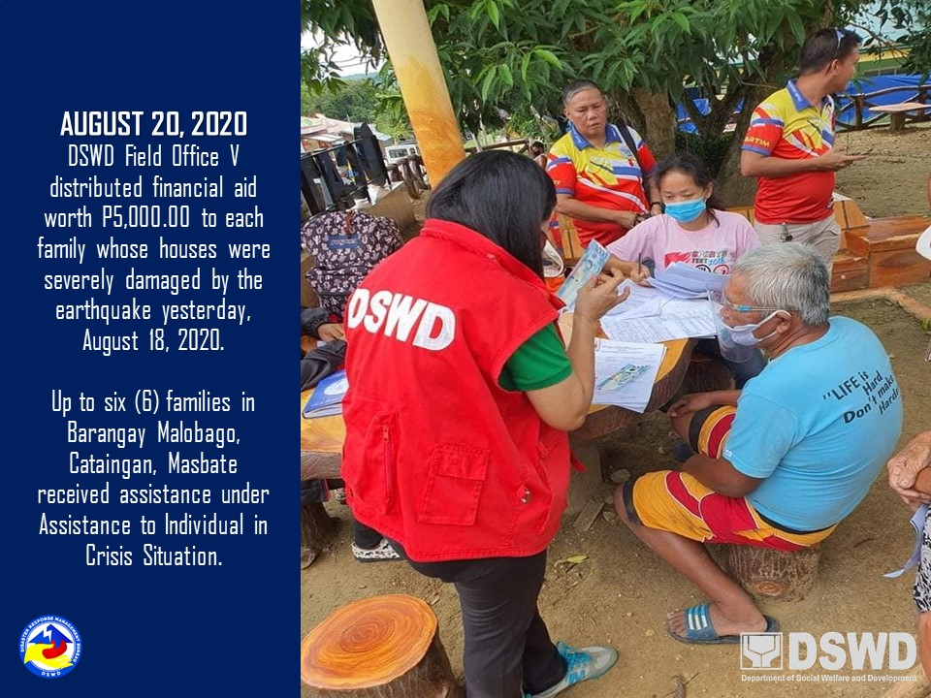
PHOTO DOCUMENTATION

