DSWD DROMIC Preparedness for Response Report #1
on Severe Tropical Storm “GONI” (I.N.)
as of 29 October 2020, 6PM
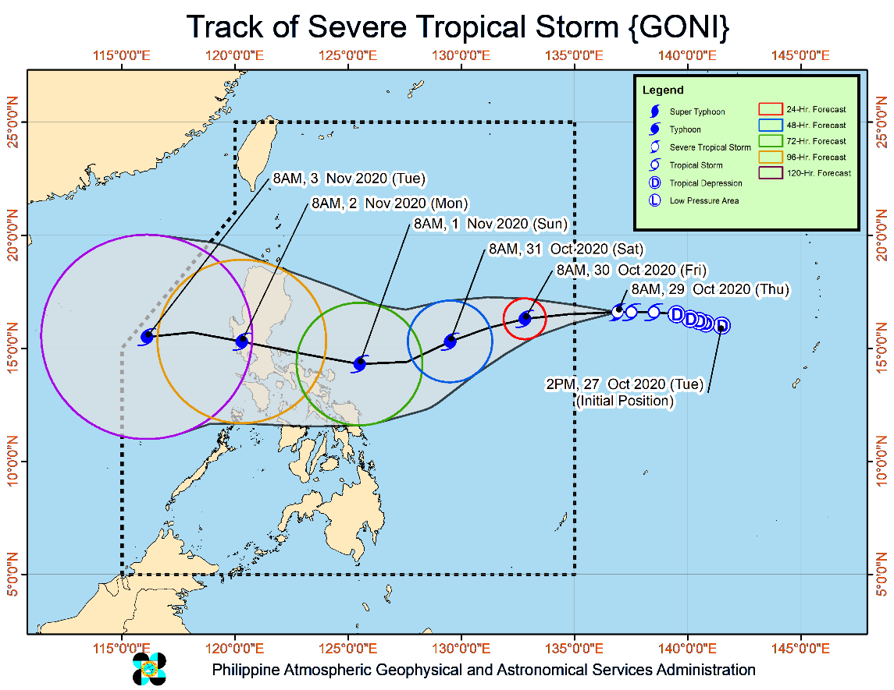
Situation Overview

Issued at 11:00 AM, 29 October 2020, "GONI" INTENSIFIES INTO A SEVERE TROPICAL STORM WHILE MOVING WESTWARD.

- Once inside the PAR, "GONI" will be given local name "ROLLY".
- At 10:00 AM today, the center of Severe Tropical Storm "GONI" was estimated based on all available data at 1,545 km East of Central Luzon (OUTSIDE PAR) (16.6°N,136.6°E).
- Track: Severe Tropical Storm "GONI" will continue to move westward today, then generally southwestward tomorrow morning until Saturday morning. It is forecast to enter the eastern boundary of the Philippine Area of Responsibility (PAR) this afternoon or evening. On the forecast track, "GONI" will begin to move generally westward by Saturday evening, then west-northwestward by Sunday as it moves towards Quezon - Aurora area.
- Intensity: "GONI" intensified into a severe tropical storm at 8:00 AM today. It is forecast to reach typhoon category within 24 hours and will continue to intensify while moving over the Philippine Sea.
- "GONI" has no direct effect yet over any parts of the country. However, as it moves towards eastern sections of Central and Southern Luzon, it may bring heavy rains over those areas starting this Friday or this weekend.
- Tropical Cyclone Wind Signal (TCWS) #1 may be raised over some provinces in Bicol Region and Northern Samar by Friday evening.

Source: DOST-PAGASA Severe Weather Bulletin
PREDICTIVE ANALYTICS FOR HUMANITARIAN RESPONSE
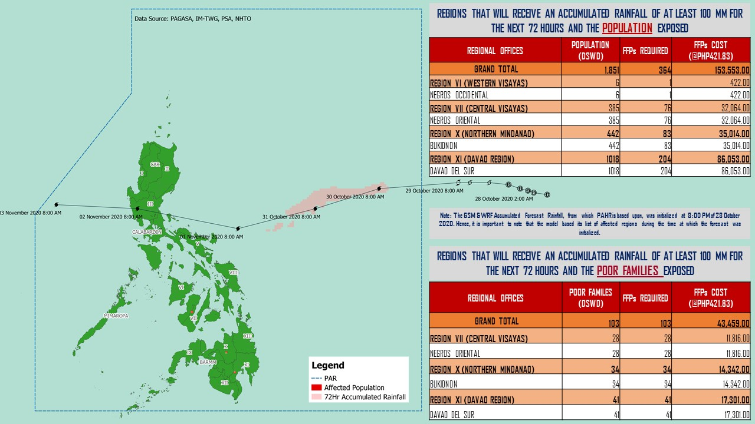

Source: DRMB-DROMIC GIS Specialists
Status of Prepositioned Resources: Stockpile and Standby Funds
The DSWD Central Office (CO), Field Offices (FOs), and National Resource Operations Center (NROC) have stockpiles and standby funds amounting to ₱878,229,958.01 with breakdown as follows (see Table 1):

- Standby Funds
A total of ₱298,929,867.71 standby funds in the CO and FOs. Of the said amount, ₱263,367,817.19 is the available Quick Response Fund (QRF) in the CO.

- Stockpiles
A total of 255,688 family food packs (FFPs) amounting to ₱111,819,494.81, other food items amounting to ₱184,060,510.12 and non-food items (FNIs) amounting to ₱283,420,085.38 are available.

Table 1. Available Standby Funds and Stockpiles
Region / Office | Standby Funds | FAMILY FOOD PACKS |  | Other Food Items | Non-Food Relief Items | Total Standby Funds & Stockpile
 |  | Quantity | Total Cost
 | 298,929,867.71 | 255,688 | 111,819,494.81 | 184,060,510.12 | 283,420,085.38 | 878,229,958.01
Central Office | 263,367,817.19 | - | - | - | - | 263,367,817.19
NRLMB - NROC | - | 4,797 | 2,547,115.00 | 18,037,685.22 | 72,144,625.75 | 92,729,425.97
NRLMB - VDRC | - | 8,147 | 3,628,828.63 | 4,802,925.23 | 2,469,751.20 | 10,901,505.06
I | 3,000,455.20 | 1,621 | 728,659.32 | 2,813,730.00 | 30,898,834.96 | 37,441,679.48
II | 3,000,938.79 | 20,158 | 10,187,730.36 | 2,762,516.01 | 5,510,398.95 | 21,461,584.11
III | 4,205,028.74 | 6,114 | 2,416,502.88 | 4,557,311.71 | 5,022,278.98 | 16,201,122.31
CALABARZON | 0.00 | 10,334 | 2,182,300.00 | 2,075,164.00 | 4,069,663.12 | 8,327,127.12
MIMAROPA | 3,100,744.58 | 29,960 | 13,482,000.00 | 1,765,909.00 | 6,063,498.80 | 24,412,152.38
V | 0.00 | 24,555 | 7,557,459.08 | 1,053,537.41 | 26,499,532.90 | 35,110,529.39
VI | 3,000,051.68 | 33,956 | 12,289,726.94 | 67,792,935.77 | 5,890,820.31 | 88,973,534.70
VII | 3,000,462.71 | 28,086 | 12,242,129.00 | 11,249,937.31 | 78,797.00 | 26,571,326.02
VIII | 3,003,550.00 | 15,331 | 8,333,776.08 | 7,878,269.90 | 19,619,837.45 | 38,835,433.43
IX | 56,000.00 | 7,047 | 3,851,115.03 | 15,614,222.16 | 8,518,245.45 | 28,039,582.64
X | 3,000,724.42 | 25,956 | 14,038,101.50 | 13,863,632.31 | 27,960,690.00 | 58,863,148.23
XI | 3,000,001.00 | 6,043 | 2,236,816.45 | 11,530,225.00 | 19,726,485.36 | 36,493,527.81
XII | 1,757,513.85 | 1,514 | 832,700.00 | 3,289,022.55 | 10,899,586.54 | 16,778,822.94
CARAGA | 3,000,740.55 | 13,292 | 6,907,964.92 | 6,663,746.83 | 16,464,806.17 | 33,037,258.47
NCR | 2,229,439.00 | 2,440 | 1,340,292.00 | 6,222,081.20 | 10,498,500.05 | 20,290,312.25
CAR | 206,400.00 | 16,337 | 7,016,277.62 | 2,087,658.51 | 11,083,732.39 | 20,394,068.52
Note: The Inventory Summary is as of 29 October 2020, 4PM.
Source: DRMB and NRLMB

Situational Reports

DSWD-DRMB
DATE | SITUATIONS / ACTIONS UNDERTAKEN
29 October 2020 | - The Disaster Response Management Bureau (DRMB) is closely coordinating with the concerned field offices for significant disaster response updates  - All QRT members and emergency equipment are on standby and ready for deployment.  - DRMB participated in the Online Pre-Disaster Risk Assessment Meeting on Severe Tropical Storm (STS) “Goni” on 28 October 2020 with other response cluster member agencies. Further meetings shall be conducted on the implementation of COVID-19 protocols during the response efforts on STS “Goni”.

DDSWD-FO NCR
DATE | SITUATIONS / ACTIONS UNDERTAKEN
29 October 2020 | - Continuous provision of Disaster Assistance Family Access Card to requesting LGUs.  - The Quick Response Teams of FO-NCR composed of organic staff from the Field Office and Centers and Residential Care Facilities (C/RCFs) is activated and on standby in response to any eventualities. The assignment of said staff is scheduled per day.  - The Disaster Response Management Division Office is established and identified as the emergency operation center for Tropical Storm Rolly.

DSWD-FO MIMAROPA
DATE | SITUATIONS / ACTIONS UNDERTAKEN
29 October 2020 | - P/C/M QRTs in Five Provinces are alerted to monitor the daily local weather condition and any disturbances that may occur in their areas.  - 24/7 On-call status of the R/P/C/M QRTs together with special projects staff for possible activation of Operation Center.  - Standby logistical equipment and workforce through coordination with SWADT Offices and concerned LGUs on the management of stranded passengers, if any, in ports and terminals.  - Information and Communication Technology Management Unit (ICTMU) is on standby status to ensure robust communication system.  - Ensure that there is an on-call truck available for delivery of goods and equipment to areas that will be affected.

DSWD-FO VII
DATE | SITUATIONS / ACTIONS UNDERTAKEN
29 October 2020 | - Continuous monitoring by the DSWD Regional DROMIC Focal for the latest weather updates from PAGASA and cascading the same for widest dissemination to P/C/MATs.  - City and Municipal Action Team and SWAD Offices were alerted and already requested to closely coordinate with their local counterparts and their respective LDRRMC. Field staff requested to monitor AOR and provide reports and updates to the Regional DROMIC Focal for any impacts.  - Provincial/City/Municipal Quick Response Team is on standby alert and ready for mobilization for any assistance and augmentation support needed from the LGUs.  - Regional Disaster Division is in closed coordination with OCD-7 and other members of the RDRRMC for any response mobilization activities/strategies.  - Warehouses in the three island provinces are on ready alert.

DSWD-FO VIII
DATE | SITUATIONS / ACTIONS UNDERTAKEN
29 October 2020 | - Prepositioned Family Food Packs (FFPs) in Samar Island which can be distributed immediately by the P/C/MATs to Local Government Units that need augmentation support.  - SWAD Teams and DRMD-PDOs assigned in the provinces are alerted and advised to closely coordinate with P/C/MSWDOs and/or P/C/MDRRMOs and immediately report any eventualities that may arise during the period.  - Quick Response Teams (QRT) and Disaster Response Management Division (DRMD) are alerted in case augmentation of workforce is needed.  - Disaster Response Information Management Section (DRIMS) is closely coordinating with SWADTs, QRTs and PDOs for any eventualities on the ground.  - Regional Resource Operations Section (RROS) are also alerted to ensure the readiness of dispatching the Food and Non-Food commodities whenever needed.

*****
The Disaster Response Operations Monitoring and Information Center (DROMIC) of the DSWD-DRMB is closely monitoring the effects of STS “Goni” and is coordinating with the concerned DSWD Field Offices for any significant updates.

Prepared by:

MARIE JOYCE G. RAFANAN

LESLIE R. JAWILI
Releasing Officer

