DSWD DROMIC Preparedness for Response Report #1
on Tropical Depression “Quinta”
as of 24 October 2020, 6PM

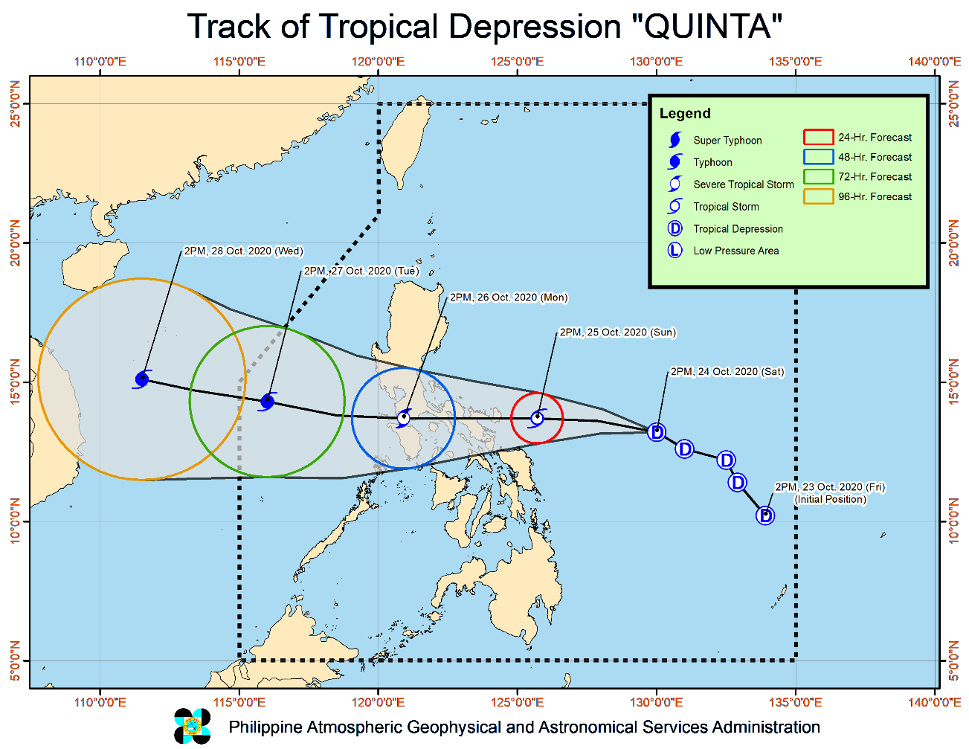
Situation Overview

At 05:00 PM, 24 October 2020, TROPICAL DEPRESSION "QUINTA" MAINTAINS ITS STRENGTH WHILE MOVING WEST-NORTHWESTWARD TOWARDS BICOL REGION.

- Track: Tropical Depression "QUINTA" will move generally west-northwestward today, then will turn westward tomorrow morning through Monday. The center of "QUINTA" is forecast to make landfall over Bicol Region between Sunday evening and Monday early morning, then track westward over the Southern Luzon area on Monday.
- Intensity: "QUINTA" is forecast to steadily intensify to tropical storm category within 12 hours and may reach severe tropical storm category prior to landfall. After crossing the Philippine archipelago, this tropical cyclone may continue intensifying over the West Philippine Sea.
- Rainfall: Today through tomorrow morning, the troughs of both Tropical Depression "QUINTA" and Severe Tropical Storm "SAUDEL" outside the Philippine Area of Responsibility (PAR) will bring light to moderate with at times heavy rains over MIMAROPA, Bicol Region, Visayas, Zamboanga Peninsula, Bangsamoro, Northern Mindanao, Caraga, and Quezon. Moreover, a stationary front currently extending over Extreme Northern Luzon associated with the northeasterly surge will bring moderate to heavy rains over Batanes, Cagayan, and the northern portions of Apayao and Ilocos Norte.
- Strong Winds: Strong to near gale-force winds will be experienced over areas under TCWS #1 within 36 hours of first raising of the wind signal. Based on available meteorological data, TCWS #1 may be raised over Metro Manila, Cavite, Batangas, Laguna, Rizal, Mindoro Provinces, Romblon, and the rest of the municipalities of Quezon in the next bulletin. Strong to gale-force winds associated with the northeasterly surge will be experienced over Batanes, Babuyan Islands, and the northern coastal areas of Ilocos Norte and mainland Cagayan.
At 4:00 PM today, the center of Tropical Depression "QUINTA" was estimated based on all available data at 610 km East of Juban, Sorsogon (13.2 °N, 129.6 °E )

Source: DOST-PAGASA Severe Weather Bulletin

PREDICTIVE ANALYTICS FOR HUMANITARIAN RESPONSE
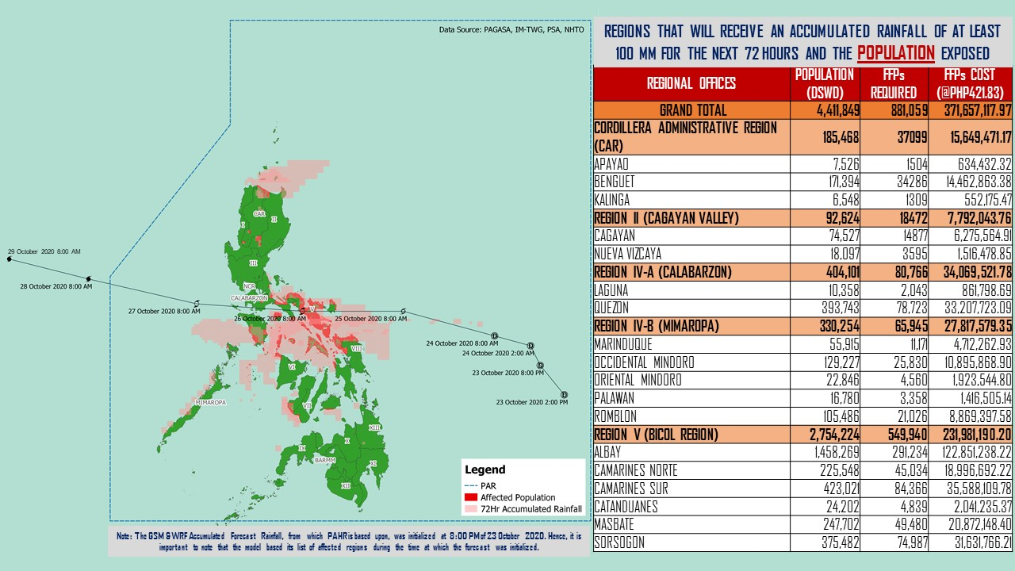
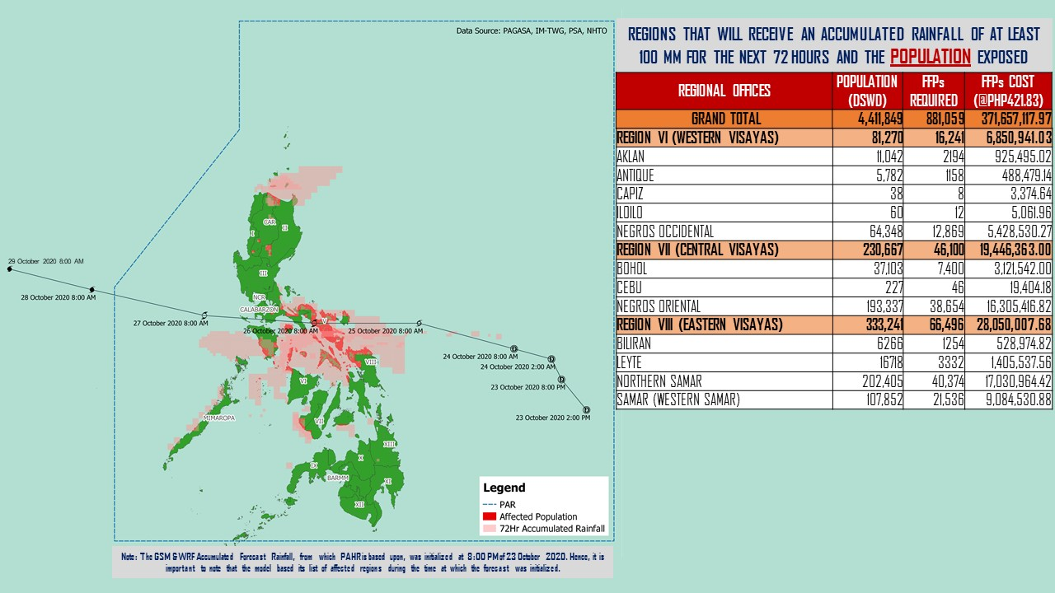

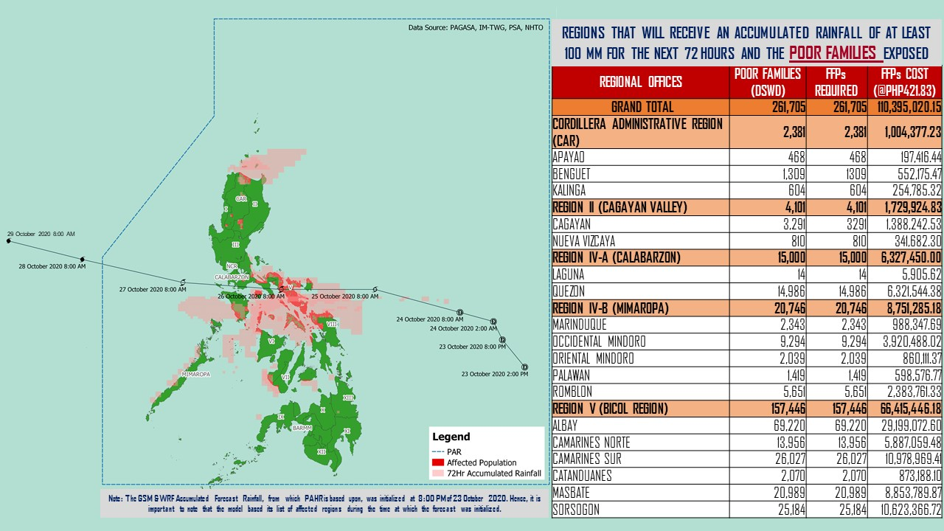

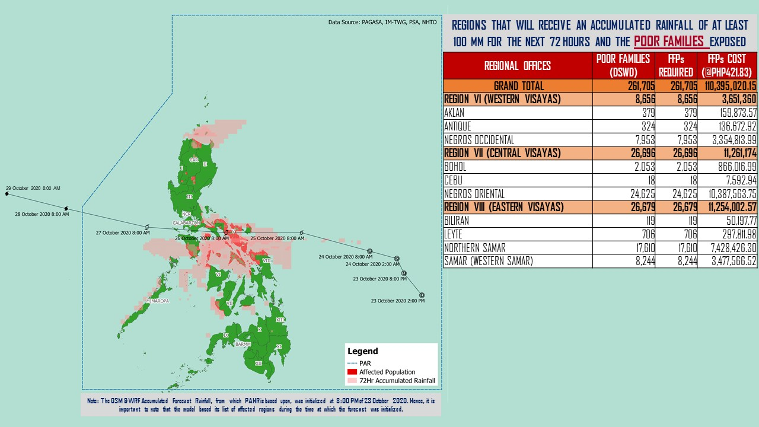

Source: DRMB-DROMIC GIS Specialists
Status of Prepositioned Resources: Stockpile and Standby Funds
The DSWD Central Office (CO), Field Offices (FOs), and National Resource Operations Center (NROC) have stockpiles and standby funds amounting to ₱890,108,205.94 with breakdown as follows (see Table 1):

- Standby Funds
A total of ₱302,882,354.54 standby funds in the CO and FOs. Of the said amount, ₱263,367,817.19 is the available Quick Response Fund (QRF) in the CO.

- Stockpiles
A total of 246,837 family food packs (FFPs) amounting to ₱110,510,221.57, other food items amounting to ₱195,107,752.68 and non-food items (FNIs) amounting to ₱281,607,877.15 are available.

Table 1. Available Standby Funds and Stockpiles
Region / Office | Standby Funds | FAMILY FOOD PACKS |  | Other Food Items | Non-Food Relief Items | Total Standby Funds & Stockpile
 |  | Quantity | Total Cost
 | 302,882,354.54 | 246,837 | 110,510,221.57 | 195,107,752.68 | 281,607,877.15 | 890,108,205.94
Central Office | 263,367,817.19 | - | - | - | - | 263,367,817.19
NRLMB - NROC | - | 5,050 | 2,420,550.00 | 22,219,292.88 | 72,856,098.39 | 97,495,941.27
NRLMB - VDRC | - | 8,847 | 3,935,631.63 | 7,007,812.43 | 103,159.75 | 11,046,603.81
I | 490,455.20 | 1,821 | 830,659.32 | 2,813,730.00 | 31,166,997.46 | 35,301,841.98
II | 3,000,938.79 | 17,317 | 8,855,191.11 | 3,141,266.01 | 5,510,398.95 | 20,507,794.86
III | 4,205,028.74 | 7,523 | 2,988,809.70 | 5,398,151.71 | 5,294,121.88 | 17,886,112.03
CALABARZON | 3,000,000.00 | 7,784 | 1,643,576.00 | 3,376,598.98 | 4,069,663.12 | 12,089,838.10
MIMAROPA | 3,100,744.58 | 30,451 | 13,702,950.00 | 1,765,909.00 | 5,879,198.80 | 24,448,802.38
V | 3,000,000.00 | 14,555 | 4,604,759.08 | 1,053,537.41 | 26,420,032.90 | 35,078,329.39
VI | 3,000,051.68 | 30,329 | 10,984,286.94 | 48,660,483.77 | 5,890,820.31 | 68,535,642.70
VII | 3,000,462.71 | 17,435 | 7,723,799.20 | 15,601,493.94 | 78,198.00 | 26,403,953.85
VIII | 3,003,550.00 | 17,831 | 9,724,976.08 | 6,648,181.70 | 19,619,830.38 | 38,996,538.16
IX | 56,000.00 | 10,030 | 5,481,294.70 | 15,614,222.16 | 8,518,245.45 | 29,669,762.31
X | 3,000,724.42 | 39,408 | 21,755,647.42 | 31,174,169.86 | 27,940,054.89 | 83,870,596.59
XI | 3,000,001.00 | 5,293 | 1,959,203.95 | 12,292,725.00 | 19,758,485.36 | 37,010,415.31
XII | 1,449,000.68 | 2,214 | 1,217,700.00 | 3,885,006.55 | 10,899,586.54 | 17,451,293.77
CARAGA | 3,000,740.55 | 13,892 | 4,519,439.08 | 5,239,330.83 | 16,589,961.17 | 29,349,471.63
NCR | 3,000,439.00 | 1,677 | 921,176.10 | 7,479,060.00 | 9,929,291.41 | 21,329,966.51
CAR | 206,400.00 | 15,380 | 7,240,571.26 | 1,736,780.45 | 11,083,732.39 | 20,267,484.10
Note: The Inventory Summary is as of 24 October 2020, 4PM.
Source: DRMB and NRLMB

Situational Reports

DSWD-DRMB
DATE | SITUATIONS / ACTIONS UNDERTAKEN
24 October 2020 | - The Disaster Response Management Bureau (DRMB) is on BLUE alert status and is closely coordinating with the concerned field offices for significant disaster response updates  - All QRT members and emergency equipment are on standby and ready for deployment.  - DRMB participated in the Online Pre-Disaster Risk Assessment Meeting on Tropical Depression “Quinta” on 24 October 2020 with other response cluster member agencies. Further meetings shall be conducted on the implementation of COVID-19 protocols during the response efforts on TD “Quinta”.

DSWD-FO CAR
DATE | SITUATIONS / ACTIONS UNDERTAKEN
- October 2020 | - DSWD-FO CAR DRMD are on standby to render duty at the Operations Center and monitor the status on the ground as well as the alert status and weather updates.  - The Provincial Social Welfare and Development Teams (PSWADT) DRMD PDO IIs were informed of the situation.  - Municipal Action Teams are on standby.  - Continuous coordination by the DRMD PDO IIs assigned in the PSWADTs with the LDRRMOs for updates.  - Rapid Emergency Telecommunications Team (RETT) including the International Maritime/Marine Satellite (INMARSAT) equipment are on standby.  - DSWD-FO CAR DRMD prepared reports for the weather disturbance and shared it to the end users.  - The Operations Center is on RED ALERT since 16 March 2020.  - Pre-disaster Risk Assessment Meeting via video teleconferencing attended by Ms. Mary Ann G. Buclao.  - Close coordination with Cordillera Regional Disaster Risk Reduction and Management Council Emergency Operations Center for updates.  - QRT and Delta Teams were on standby for possible deployment.  - Cascaded the susceptibility map to Provincial SWAD Teams for their guidance.  - Evacuations Center Updated for dissemination to SWADs.
DSWD-FO MIMAROPA
DATE | SITUATIONS / ACTIONS UNDERTAKEN
- October 2020 | - DSWD-FO MIMAROPA Disaster Response Management Division and SWADT Offices are alerted to monitor daily local weather condition and ensure provision of information to all concerned offices, divisions, sections, offices.  - 24/7 On-call status of the R/P/C/M QRTs together with special projects staff for possible activation of Operation Center.  - Close coordination with the Office of Civil Defense (OCD) and RDRRMC MIMAROPA for any warning signal updates for monitoring purposes and response mechanism for areas that will be affected.  - Standby logistical equipment and workforce through coordination with SWADT Offices and concerned LGUs on the management of stranded passengers, if any, in ports and terminals.  - Information and Communication Technology Management Unit (ICTMU) is on standby status to ensure robust communication system.  - Ensure that there is an on-call truck available for delivery of goods and equipment to areas that will be affected.

DSWD-FO V
DATE | SITUATIONS / ACTIONS UNDERTAKEN
24 October 2020 | - DSWD-FO V continuous to monitor weather updates and information.  - The Resource Operation Section ensures the availability of family food packs and non-food items as need arises.  - DSWD-FO V QRTs are alerted.  - PAT and MAT members in the 6 provinces are activated and instructed to coordinate with the P/MDRRMOs, C/MSWDOs for reports and updates.

*****
The Disaster Response Operations Monitoring and Information Center (DROMIC) of the DSWD-DRMB is closely monitoring the effects of TD “Quinta” and is coordinating with the concerned DSWD Field Offices for any significant updates.

Prepared by:

MARIE JOYCE G. RAFANAN

LESLIE R. JAWILI
Releasing Officer

