DSWD DROMIC Preparedness for Response Report #2 on Typhoon “Rolly”
as of 30 October 2020, 6PM
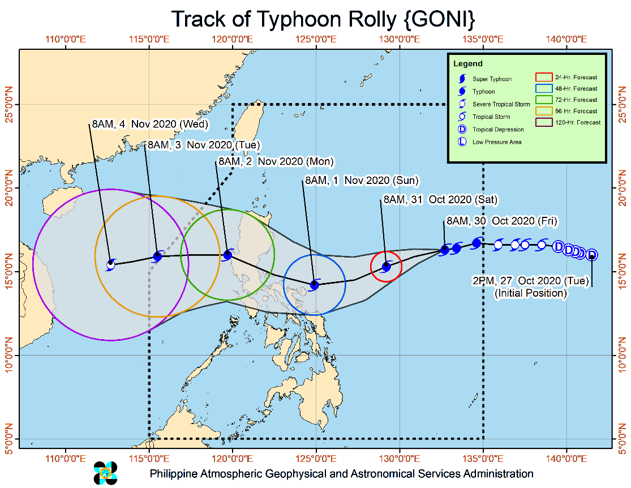
Situation Overview

Issued at 05:00 pm, 30 October 2020, TYPHOON "ROLLY" INTENSIFIES FURTHER AS IT MOVES WESTWARD OVER THE PHILIPPINE SEA.

- Track: "ROLLY" is forecast to move west-southwestward this afternoon until tomorrow evening. Afterwards, the typhoon will turn west-northwestward as it moves over the sea off the coast of Bicol Region towards the eastern coast of Aurora-Quezon area. On the forecast track, the center of the eye of "ROLLY" is likely to make landfall over the Aurora-Quezon area on Sunday evening or Monday early morning.
- Intensity: The typhoon is forecast to continuously intensify over the Philippine Sea and is likely to make landfall at intensity of 175-195 km/h.
- Rainfall: Today through tomorrow morning, the trough of the typhoon and the northeasterly surface windflow will bring light to moderate with at times heavy rains over Bicol Region, Eastern and Central Visayas, Caraga, Northern Mindanao, Zamboanga Peninsula, Batanes, Cagayan, Isabela. The typhoon will likely bring heavy to intense rains over Northern and Central Luzon and Bicol Region, especially those areas along the track of "ROLLY", beginning tomorrow or Sunday.
- Strong winds: Strong breeze to near gale conditions will be experienced in areas under Tropical Cyclone Wind Signal (TCWS) #1 within 36 hours of the raising of the wind signal. TCWS #1 may be raised over the northern portion of Northern Samar and the rest of Bicol Region in the next bulletin. Given that it is likely for this typhoon to continue intensifying prior to landfall, the highest possible TCWS that will be raised throughout the passage of this typhoon will be TCWS #4 (associated with destructive to very destructive typhoon-force winds).
- Storm surge: A storm surge of up to 2.0 m may be experienced over the coastal areas of Aurora, Quezon, Marinduque, Bicol Region, and Northern Samar.
At 4:00 PM today, the eye of Typhoon "ROLLY" was located based on all available data at 980 km East of Casiguran, Aurora (16.2 °N, 131.3 °E )
Source: DOST-PAGASA Severe Weather Bulletin
PREDICTIVE ANALYTICS FOR HUMANITARIAN RESPONSE
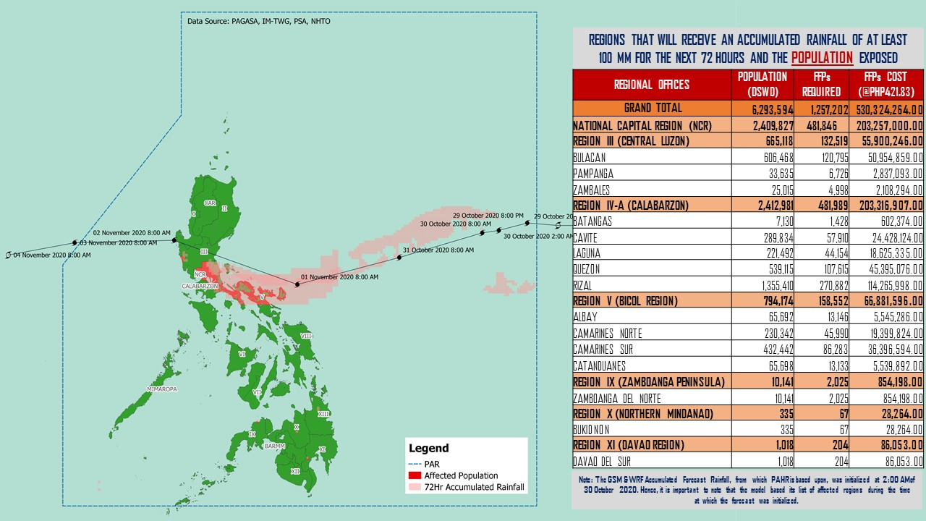

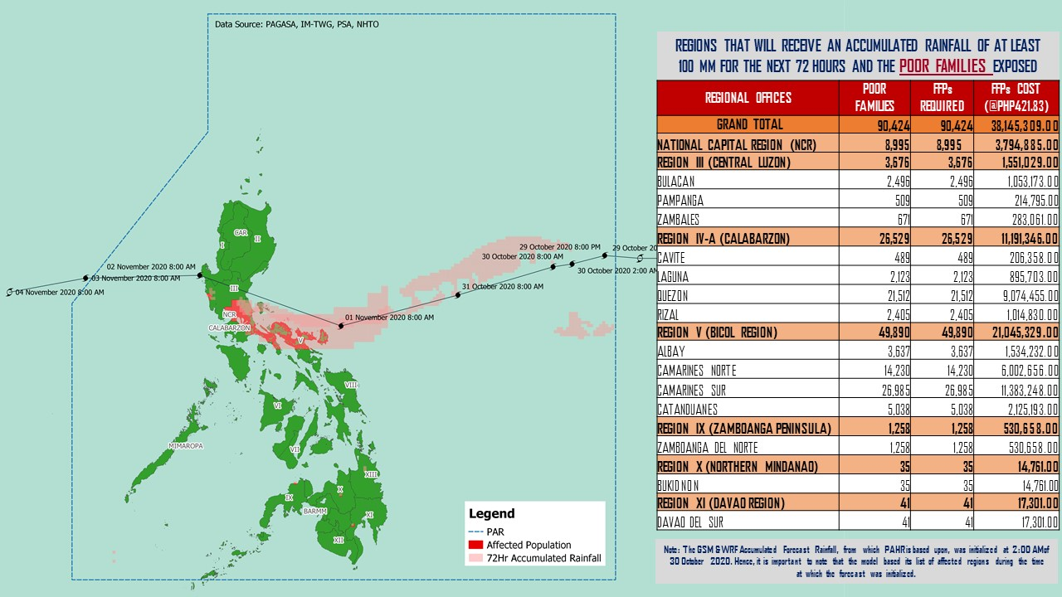

Source: DRMB-DROMIC GIS Specialists

Status of Prepositioned Resources: Stockpile and Standby Funds
The DSWD Central Office (CO), Field Offices (FOs), and National Resource Operations Center (NROC) have stockpiles and standby funds amounting to ₱879,862,791.17 with breakdown as follows (see Table 1):

- Standby Funds
A total of ₱301,902,360.71 standby funds in the CO and FOs. Of the said amount, ₱263,367,817.19 is the available Quick Response Fund (QRF) in the CO.

- Stockpiles
A total of 252,114 family food packs (FFPs) amounting to ₱112,300,467.89, other food items amounting to ₱185,703,434.20 and non-food items (FNIs) amounting to ₱279,956,528.38 are available.

Table 1. Available Standby Funds and Stockpiles
Region / Office | Standby Funds | FAMILY FOOD PACKS |  | Other Food Items | Non-Food Relief Items | Total Standby Funds & Stockpile
 |  | Quantity | Total Cost
 | 301,902,360.71 | 252,114 | 112,300,467.89 | 185,703,434.20 | 279,956,528.38 | 879,862,791.17
Central Office | 263,367,817.19 | - | - | - | - | 263,367,817.19
NRLMB - NROC | - | 5,797 | 3,164,115.00 | 18,037,685.22 | 72,110,668.75 | 93,312,468.97
NRLMB - VDRC | - | 10,247 | 4,549,237.63 | 3,755,227.33 | 2,469,751.20 | 10,774,216.16
I | 3,000,455.20 | 1,621 | 728,659.32 | 2,813,730.00 | 30,898,834.96 | 37,441,679.48
II | 3,000,938.79 | 20,158 | 10,187,730.36 | 2,762,516.01 | 5,510,398.95 | 21,461,584.11
III | 4,205,028.74 | 7,344 | 3,053,600.38 | 3,940,374.21 | 5,022,278.98 | 16,221,282.31
CALABARZON | 0.00 | 7,634 | 2,643,864.00 | 5,235,748.48 | 4,069,663.12 | 11,949,275.60
MIMAROPA | 2,882,244.58 | 29,724 | 13,375,800.00 | 2,061,634.00 | 6,003,498.80 | 24,323,177.38
V | 0.00 | 23,552 | 7,282,080.14 | 1,053,537.41 | 26,499,532.90 | 34,835,150.45
VI | 3,000,051.68 | 33,956 | 12,289,726.94 | 67,792,935.77 | 5,890,820.31 | 88,973,534.70
VII | 3,000,462.71 | 28,086 | 12,242,129.00 | 11,101,187.31 | 78,797.00 | 26,422,576.02
VIII | 3,194,543.00 | 15,228 | 8,278,498.04 | 7,878,269.90 | 19,619,837.45 | 38,971,148.39
IX | 56,000.00 | 7,047 | 3,851,115.03 | 15,614,222.16 | 8,518,245.45 | 28,039,582.64
X | 3,000,724.42 | 25,458 | 13,758,723.50 | 13,863,632.31 | 27,960,690.00 | 58,583,770.23
XI | 3,000,001.00 | 4,593 | 1,700,098.95 | 11,530,225.00 | 16,356,885.36 | 32,587,210.31
XII | 1,757,513.85 | 1,514 | 832,700.00 | 3,289,022.55 | 10,899,586.54 | 16,778,822.94
CARAGA | 3,000,740.55 | 11,378 | 6,005,819.98 | 6,663,746.83 | 16,464,806.17 | 32,135,113.53
NCR | 2,229,439.00 | 2,440 | 1,340,292.00 | 6,222,081.20 | 10,498,500.05 | 20,290,312.25
CAR | 3,206,400.00 | 16,337 | 7,016,277.62 | 2,087,658.51 | 11,083,732.39 | 23,394,068.52
Note: The Inventory Summary is as of 30 October 2020, 4PM.
Source: DRMB and NRLMB

Situational Reports

DSWD-DRMB
DATE | SITUATIONS / ACTIONS UNDERTAKEN
30 October 2020 | - The Disaster Response Management Bureau (DRMB) is closely coordinating with the concerned field offices for significant disaster response updates  - All QRT members and emergency equipment are on standby and ready for deployment.  - DRMB participated in the Online Pre-Disaster Risk Assessment Meeting on Typhoon “Rolly” on 30 October 2020 with other response cluster member agencies. Further meetings shall be conducted on the implementation of COVID-19 protocols during the response efforts on Typhoon “Rolly”.

DDSWD-FO NCR
DATE | SITUATIONS / ACTIONS UNDERTAKEN
29 October 2020 | - Continuous provision of Disaster Assistance Family Access Card to requesting LGUs.  - The Quick Response Teams of FO-NCR composed of organic staff from the Field Office and Centers and Residential Care Facilities (C/RCFs) is activated and on standby in response to any eventualities. The assignment of said staff is scheduled per day.  - The Disaster Response Management Division Office is established and identified as the emergency operation center for Tropical Storm Rolly.

DSWD-FO MIMAROPA
DATE | SITUATIONS / ACTIONS UNDERTAKEN
29 October 2020 | - P/C/M QRTs in Five Provinces are alerted to monitor the daily local weather condition and any disturbances that may occur in their areas.  - 24/7 On-call status of the R/P/C/M QRTs together with special projects staff for possible activation of Operation Center.  - Standby logistical equipment and workforce through coordination with SWADT Offices and concerned LGUs on the management of stranded passengers, if any, in ports and terminals.  - Information and Communication Technology Management Unit (ICTMU) is on standby status to ensure robust communication system.  - Ensure that there is an on-call truck available for delivery of goods and equipment to areas that will be affected.

DSWD-FO VI
DATE | SITUATIONS / ACTIONS UNDERTAKEN
30 October 2020 | - All QRT members are on standby and ready for augmentation if needed, following the new normal protocols of the agency.  - DSWD-FO VI conducted TA provision to Provincial LGUs and SWAD Offices on DROMIC Reporting.  - DSWD-FO VI issued a total of 150 vests, 50 GO Bags, 50 survival bags and 50 sleeping kits to QRT members in the region and field staff.

DSWD-FO VII
DATE | SITUATIONS / ACTIONS UNDERTAKEN
29 October 2020 | - Continuous monitoring by the DSWD Regional DROMIC Focal for the latest weather updates from PAGASA and cascading the same for widest dissemination to P/C/MATs.  - City and Municipal Action Team and SWAD Offices were alerted and already requested to closely coordinate with their local counterparts and their respective LDRRMC. Field staff requested to monitor AOR and provide reports and updates to the Regional DROMIC Focal for any impacts.  - Provincial/City/Municipal Quick Response Team is on standby and ready for mobilization for any augmentation support needed from the LGUs.  - Regional Disaster Division is in close coordination with OCD-7 and other RDRRMC members for any response mobilization activities/strategies.  - Warehouses in the three island provinces are on ready alert.

DSWD-FO VIII
DATE | SITUATIONS / ACTIONS UNDERTAKEN
29 October 2020 | - Prepositioned FFPs in Samar Island which can be distributed immediately by the P/C/MATs to LGUs that need augmentation support.  - SWAD Teams and DRMD-PDOs assigned in the provinces are alerted and advised to closely coordinate with P/C/MSWDOs and/or P/C/MDRRMOs and immediately report any eventualities that may arise during the period.  - Quick Response Teams (QRT) and Disaster Response Management Division (DRMD) are alerted in case augmentation of workforce is needed.  - Disaster Response Information Management Section is closely coordinating with SWADTs, QRTs and PDOs for any eventualities on the ground.  - Regional Resource Operations Section (RROS) are also alerted to ensure the readiness of dispatching the Food and Non-Food commodities whenever needed.

DSWD-FO X
DATE | SITUATIONS / ACTIONS UNDERTAKEN
30 October 2020 | - DSWD FO-X DRMD continuously monitor the weather condition and in constant coordination with the LGUs for possible augmentation and for further updates on Typhoon “Rolly”.

*****
The Disaster Response Operations Monitoring and Information Center (DROMIC) of the DSWD-DRMB is closely monitoring the effects of Typhoon “Rolly” and is coordinating with the concerned DSWD Field Offices for any significant updates.

Prepared by:

MARIE JOYCE G. RAFANAN

LESLIE R. JAWILI
Releasing Officer

