DSWD DROMIC Preparedness for Response Report #3 on Typhoon “Rolly”
as of 31 October 2020, 6PM
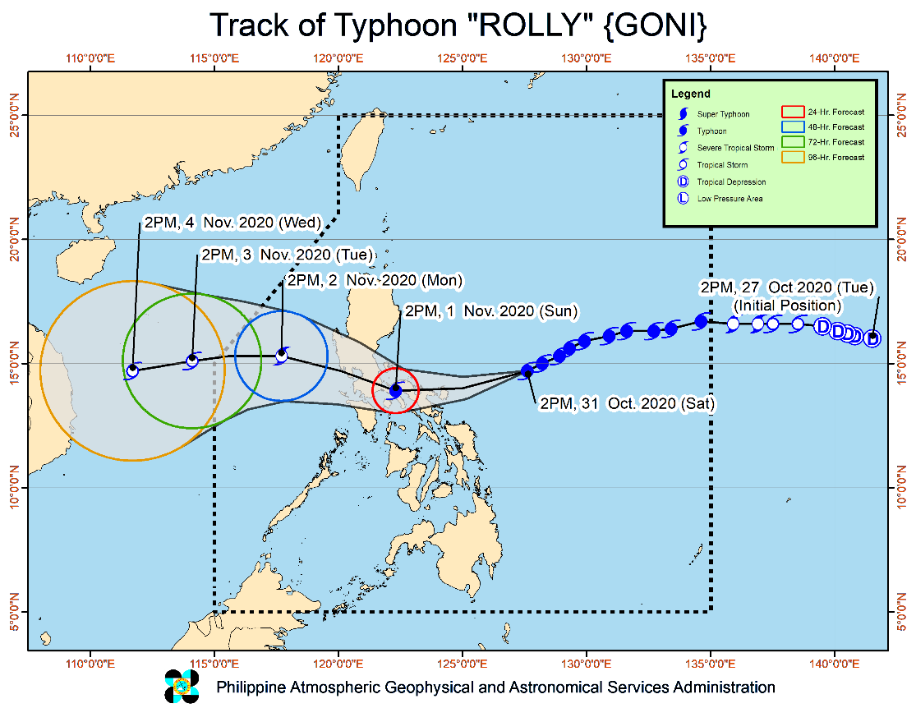
Situation Overview

Issued at 05:00 pm, 31 October 2020, TYPHOON "ROLLY" CONTINUES TO MAINTAIN ITS STRENGTH AS IT MOVES TOWARDS BICOL REGION.
- Track: On the forecast track, the center of the eye of the typhoon is forecast to pass over Catanduanes - mainland Camarines Provinces area tomorrow morning, and over mainland Quezon tomorrow afternoon. Violent winds and intense rainfall associated with the inner rainband-eyewall region will be experienced over Catanduanes, Camarines Provinces tomorrow early morning through afternoon and over Quezon tomorrow afternoon through evening. After crossing the Southern Luzon - Metro Manila area, the center of "ROLLY" is forecast to exit the mainland Luzon landmass on Monday early morning.
- Intensity: "ROLLY" is likely to remain a typhoon category (185-205 km/h) by the time it makes landfall. While traversing over Luzon, "ROLLY" is forecast to weaken considerably and emerge as a severe tropical storm or minimal typhoon over the West Philippine Sea.
- Rainfall: Today, the outer rainbands of "ROLLY" will bring light to moderate with at times heavy rains over Bicol Region and Eastern Visayas. Beginning tomorrow early morning, the passage of Typhoon "ROLLY" will bring heavy to intense rains over Metro Manila, Bicol Region, CALABARZON, Aurora, Bulacan, Zambales, Bataan, Marinduque, Romblon, Occidental Mindoro, and Oriental Mindoro. Moderate to heavy rains with at times intense rains (especially the eastern sections of Northern and Central Luzon) will be experienced over Cagayan Valley, Cordillera Administrative Region, Ilocos Region, and the rest of Central Luzon. Flooding (including flash floods), rain-induced landslides, and sediment-laden streamflows (i.e. lahar) may occur during heavy or prolonged rainfall especially in areas that are highly or very highly susceptible to these hazards. PAGASA Regional Services Divisions may issue local thunderstorm/rainfall advisories and heavy rainfall warnings as appropriate.
- Strong winds: Destructive typhoon-force winds will be experienced in areas under Tropical Cyclone Wind Signals (TCWS) #3, damaging gale- to storm-force winds in areas under TCWS #2, and strong breeze to near gale conditions in areas under TCWS #1. Based on the intensity forecast, the highest possible wind signal to be raised will be TCWS #4 (for very destructive typhoon-force winds). Potential impacts of the wind conditions to structures and vegetation under each wind signal are detailed in the TCWS section of this bulletin. Elsewhere, strong breeze to near gale conditions due to the northeasterlies will be experienced over Batanes, Babuyan Islands, Ilocos Norte, Apayao, and the coastal and mountainous areas of Cagayan and Isabela (that are not under TCWS #1).
- Storm surge: There is a high risk of storm surge of more than 3.0 m over the northern coastal areas of Quezon including Polillo Islands, Camarines Provinces, and Catanduanes; 2.1 to 3.0 m over the coastal areas of Manila, Cavite, Bulacan, Pampanga, Bataan, the southeastern coastal area of Batangas and the southwestern coastal area of Quezon; 1.0 to 2.0 m over the coastal areas of Aurora, Zambales, Occidental Mindoro, the rest of the coastal areas of Bicol Region, Batangas, and Quezon in the next 24 hours which may result in life-threatening and damaging coastal inundation. This storm surge may be accompanied by swells and breaking waves reaching the coast. For more information, please refer to Storm Surge Warning #1 issued at 2PM today posted on PAGASAâ€™s official website.
At 4:00 PM today, the eye of Typhoon "ROLLY" was located based on all available data at 345 km East Northeast of Virac, Catanduanes (14.5 °N, 127.3 °E )
Source: DOST-PAGASA Severe Weather Bulletin

PREDICTIVE ANALYTICS FOR HUMANITARIAN RESPONSE

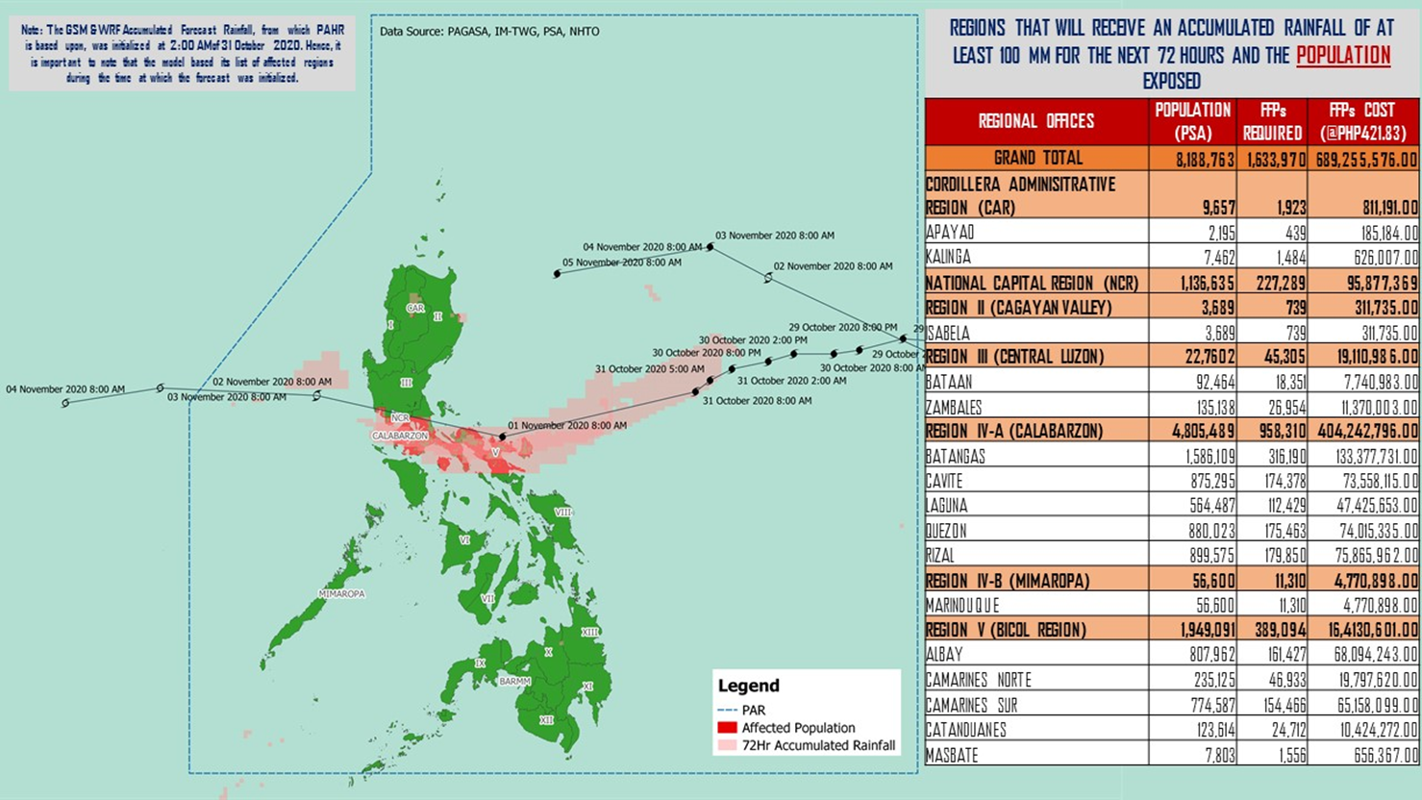

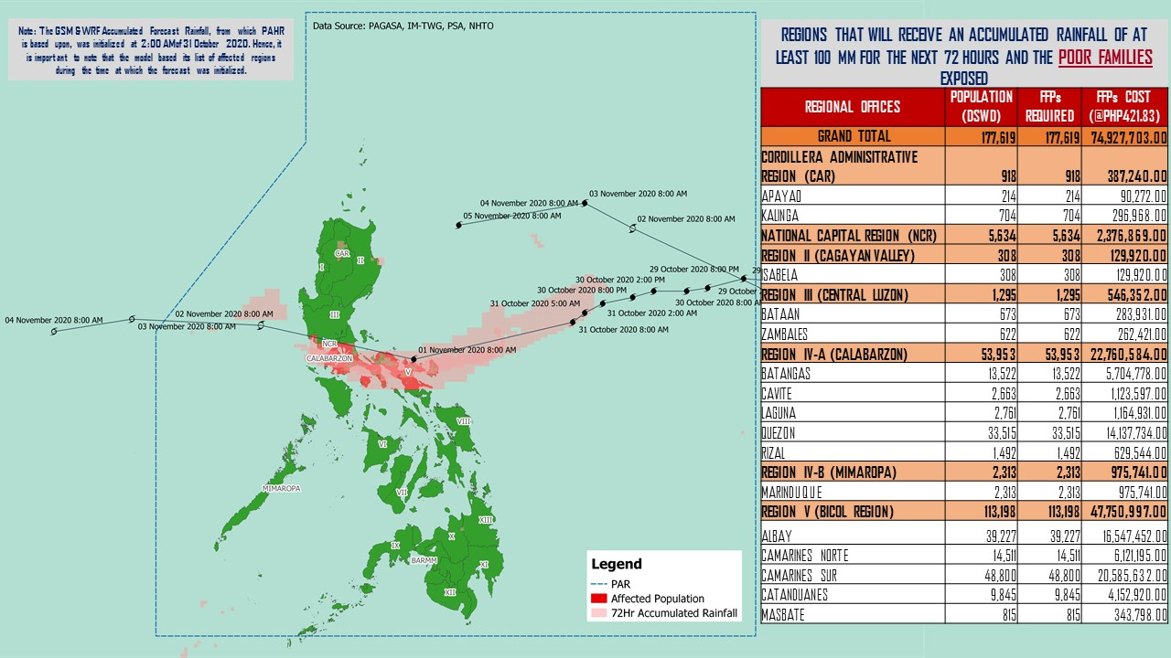

Source: DRMB-DROMIC GIS Specialists

Status of Prepositioned Resources: Stockpile and Standby Funds
The DSWD Central Office (CO), Field Offices (FOs), and National Resource Operations Center (NROC) have stockpiles and standby funds amounting to ₱884,708,868.60 with breakdown as follows (see Table 1):

- Standby Funds
A total of ₱304,902,360.70 standby funds in the CO and FOs. Of the said amount, ₱263,367,817.19 is the available Quick Response Fund (QRF) in the CO.

- Stockpiles
A total of 260,164 family food packs (FFPs) amounting to ₱115,894,095.40, other food items amounting to ₱ 183,955,884.10 and non-food items (FNIs) amounting to ₱279,956,528.40 are available.

Table 1. Available Standby Funds and Stockpiles
Region / Office | Standby Funds | FAMILY FOOD PACKS |  | Other Food Items | Non-Food Relief Items | Total Standby Funds & Stockpile
 |  | Quantity | Total Cost
 | 304,902,360.70 | 260,164 | 115,894,095.40 | 183,955,884.10 | 279,956,528.40 | 884,708,868.60
Central Office | 263,367,817.19 | - | - | - | - | 263,367,817.20
NRLMB - NROC | - | 4,797 | 2,803,315.00 | 18,023,333.22 | 72,110,668.75 | 92,937,316.97
NRLMB - VDRC | - | 10,247 | 4,549,237.63 | 3,755,227.33 | 2,469,751.20 | 10,774,216.16
I | 3,000,455.20 | 1,621 | 728,659.32 | 2,813,730.00 | 30,898,834.96 | 37,441,679.48
II | 3,000,938.79 | 20,158 | 10,187,730.36 | 2,762,516.01 | 5,510,398.95 | 21,461,584.11
III | 4,205,028.74 | 11,914 | 5,407,227.88 | 2,272,186.71 | 5,022,278.98 | 16,906,722.31
CALABARZON | 3,000,000.00 | 7,634 | 2,643,864.00 | 5,735,748.48 | 4,069,663.12 | 15,449,275.60
MIMAROPA | 2,882,244.58 | 29,724 | 13,375,800.00 | 2,061,634.00 | 6,003,498.80 | 24,323,177.38
V | 0.00 | 23,552 | 7,282,080.14 | 1,053,537.41 | 26,499,532.90 | 34,835,150.45
VI | 3,000,051.68 | 33,956 | 12,289,726.94 | 67,792,935.77 | 5,890,820.31 | 88,973,534.70
VII | 3,000,462.71 | 32,566 | 13,842,929.00 | 10,536,176.71 | 78,797.00 | 27,458,365.42
VIII | 3,194,543.00 | 15,228 | 8,278,498.04 | 7,878,269.90 | 19,619,837.45 | 38,971,148.39
IX | 56,000.00 | 7,047 | 3,851,115.03 | 15,614,222.16 | 8,518,245.45 | 28,039,582.64
X | 3,000,724.42 | 25,458 | 13,758,723.50 | 13,863,632.31 | 27,960,690.00 | 58,583,770.23
XI | 3,000,001.00 | 4,593 | 1,700,098.95 | 11,530,225.00 | 16,356,885.36 | 32,587,210.31
XII | 1,757,513.85 | 1,514 | 832,700.00 | 3,289,022.55 | 10,899,586.54 | 16,778,822.94
CARAGA | 3,000,740.55 | 11,378 | 6,005,819.98 | 6,663,746.83 | 16,464,806.17 | 32,135,113.53
NCR | 2,229,439.00 | 2,440 | 1,340,292.00 | 6,222,081.20 | 10,498,500.05 | 20,290,312.25
CAR | 3,206,400.00 | 16,337 | 7,016,277.62 | 2,087,658.51 | 11,083,732.39 | 23,394,068.52
Note: The Inventory Summary is as of 31 October 2020, 4PM.
Source: DRMB and NRLMB

Situational Reports

DSWD-DRMB
DATE | SITUATIONS / ACTIONS UNDERTAKEN
31 October 2020 | - The Disaster Response Management Bureau (DRMB) is on BLUE alert status and is closely coordinating with the concerned field offices for significant disaster response updates  - All QRT members and emergency equipment are on standby and ready for deployment.  - DRMB participated in the Online Pre-Disaster Risk Assessment Meeting on Typhoon “Rolly” on 31 October 2020 with other response cluster member agencies. Further meetings shall be conducted on the implementation of COVID-19 protocols during the response efforts on Typhoon “Rolly”.  - The Undersecretary of DSWD-DRMG activated the response cluster in connection to Typhoon “Rolly” effective 31 October 2020, 5:00 PM

DSWD-FO CAR
DATE | SITUATIONS / ACTIONS UNDERTAKEN
31 October 2020 | - DSWD-FO CAR DRMD are on standby to render duty at the Operations Center and monitor the status on the ground as well as the alert status and weather updates.  - The Provincial Social Welfare and Development Teams (PSWADT) DRMD PDO IIs were informed of the situation.  - Municipal Action Teams are on standby.  - Continuous coordination by the DRMD PDO IIs assigned in the PSWADTs with the LDRRMOs for updates.  - Rapid Emergency Telecommunications Team (RETT) including the International Maritime/Marine Satellite (INMARSAT) equipment are on standby.  - DSWD-FO CAR DRMD prepared reports for the weather disturbance and shared it to the end users.  - The Operations Center is on RED ALERT since 16 March 2020.  - Pre-disaster Risk Assessment Meeting via video teleconferencing attended by Ms. Mary Ann G. Buclao.  - Close coordination with Cordillera Regional Disaster Risk Reduction and Management Council Emergency Operations Center for updates.  - QRT and Delta Teams were on standby for possible deployment.  - Cascaded the susceptibility map to Provincial SWAD Teams for their guidance.  - Evacuations Center Updated for dissemination to SWADs.

DDSWD-FO NCR
DATE | SITUATIONS / ACTIONS UNDERTAKEN
29 October 2020 | - Continuous provision of Disaster Assistance Family Access Card to requesting LGUs.  - The Quick Response Teams of FO-NCR composed of organic staff from the Field Office and Centers and Residential Care Facilities (C/RCFs) is activated and on standby in response to any eventualities. The assignment of said staff is scheduled per day.  - The Disaster Response Management Division Office is established and identified as the emergency operation center for Tropical Storm Rolly.

DSWD-FO MIMAROPA
DATE | SITUATIONS / ACTIONS UNDERTAKEN
29 October 2020 | - P/C/M QRTs in Five Provinces are alerted to monitor the daily local weather condition and any disturbances that may occur in their areas.  - 24/7 On-call status of the R/P/C/M QRTs together with special projects staff for possible activation of Operation Center.  - Standby logistical equipment and workforce through coordination with SWADT Offices and concerned LGUs on the management of stranded passengers, if any, in ports and terminals.  - Information and Communication Technology Management Unit (ICTMU) is on standby status to ensure robust communication system.  - Ensure that there is an on-call truck available for delivery of goods and equipment to areas that will be affected.

DSWD-FO V
DATE | SITUATIONS / ACTIONS UNDERTAKEN
31 October 2020 | - DSWD-FO V continuous to monitor weather updates and information.  - DSWD-FO V has ongoing procurement of 30,000 family food packs  - The Resource Operation Section ensures the availability of family food packs and non-food items as need arises.  - DSWD-FO V QRTs are alerted.  - PAT and MAT members in the 6 provinces are activated and instructed to coordinate with the P/MDRRMOs, C/MSWDOs for reports and updates.

DSWD-FO VI
DATE | SITUATIONS / ACTIONS UNDERTAKEN
30 October 2020 | - All QRT members are on standby and ready for augmentation if needed, following the new normal protocols of the agency.  - DSWD-FO VI conducted TA provision to Provincial LGUs and SWAD Offices on DROMIC Reporting.  - DSWD-FO VI issued a total of 150 vests, 50 GO Bags, 50 survival bags and 50 sleeping kits to QRT members in the region and field staff.

DSWD-FO VII
DATE | SITUATIONS / ACTIONS UNDERTAKEN
31 October 2020 | - In a memorandum issued by OCD-7 Regional Director, alert level status of the RDRRMC-7 has now been raised to BLUE, thereby activating the Response Clusters. Agencies under this cluster have been directed to do and prepare according to each cluster mandates.  - In a notice issued today, PCG-Cebu has ordered the suspension of sea travels from the island province to Luzon and parts of the Visayas that will be affected by Typhoon Rolly.  - Local authorities in the Region are already preparing for the possible effects of heavy rains caused by the trough of TY Rolly. Local Disaster teams are continuously monitoring hazard prone areas, especially residential sites near rivers and other waterways. Rescue equipment, vehicles and personnel are on standby ready for deployment if the need arises.
29 October 2020 | - Continuous monitoring by the DSWD Regional DROMIC Focal for the latest weather updates from PAGASA and cascading the same for widest dissemination to P/C/MATs.  - City and Municipal Action Team and SWAD Offices were alerted and already requested to closely coordinate with their local counterparts and their respective LDRRMC. Field staff requested to monitor AOR and provide reports and updates to the Regional DROMIC Focal for any impacts.  - Provincial/City/Municipal Quick Response Team is on standby and ready for mobilization for any augmentation support needed from the LGUs.  - Regional Disaster Division is in close coordination with OCD-7 and other RDRRMC members for any response mobilization activities/strategies.  - Warehouses in the three island provinces are on ready alert.

DSWD-FO VIII
DATE | SITUATIONS / ACTIONS UNDERTAKEN
29 October 2020 | - Prepositioned FFPs in Samar Island which can be distributed immediately by the P/C/MATs to LGUs that need augmentation support.  - SWAD Teams and DRMD-PDOs assigned in the provinces are alerted and advised to closely coordinate with P/C/MSWDOs and/or P/C/MDRRMOs and immediately report any eventualities that may arise during the period.  - Quick Response Teams (QRT) and Disaster Response Management Division (DRMD) are alerted in case augmentation of workforce is needed.  - Disaster Response Information Management Section is closely coordinating with SWADTs, QRTs and PDOs for any eventualities on the ground.  - Regional Resource Operations Section (RROS) are also alerted to ensure the readiness of dispatching the Food and Non-Food commodities whenever needed.

DSWD-FO X
DATE | SITUATIONS / ACTIONS UNDERTAKEN
30 October 2020 | - DSWD FO-X DRMD continuously monitor the weather condition and in constant coordination with the LGUs for possible augmentation and for further updates on Typhoon “Rolly”.

*****
The Disaster Response Operations Monitoring and Information Center (DROMIC) of the DSWD-DRMB is closely monitoring the effects of Typhoon “Rolly” and is coordinating with the concerned DSWD Field Offices for any significant updates.

Prepared by:

MARIEL B. FERRARIZ
CLARRIE MAE A. CASTILLO

RODEL V. CABADDU
Releasing Officer

PHOTO DOCUMENTATION
