DSWD DROMIC Preparedness for Response Report #4 on Typhoon “Rolly”
as of 01 November 2020, 6PM

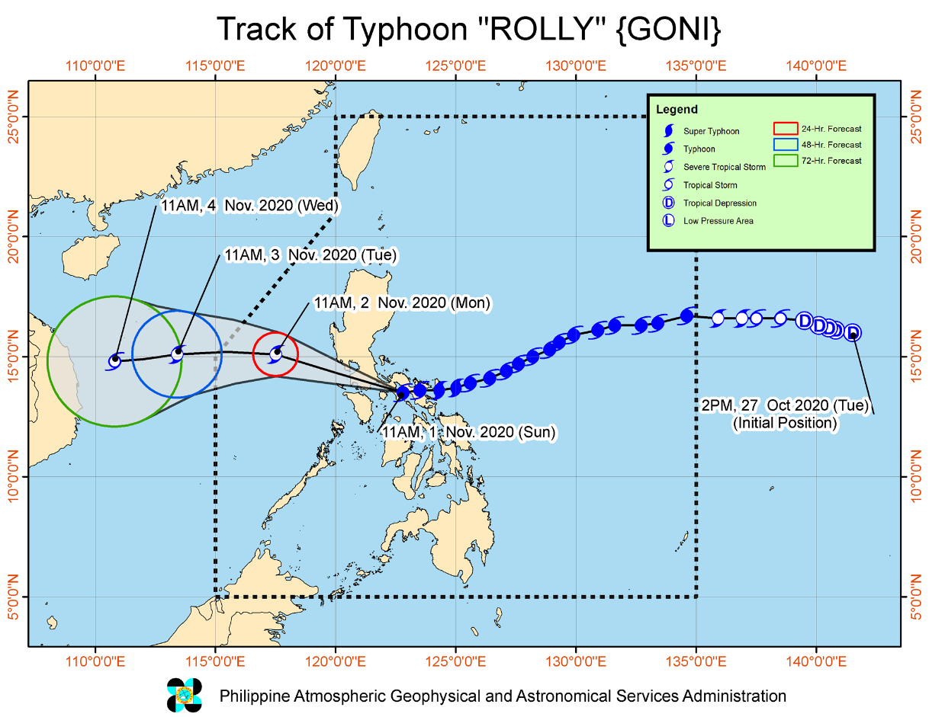
Situation Overview

Issued at 02:00 pm, 1 November 2020, "ROLLY" FURTHER WEAKENS AND IS NOW OVER MONGPONG PASS. Violent winds and intense rainfall associated with the region of the eyewall and inner rainbands of the typhoon is prevailing or expected within the next 12 hours over the Marinduque, Laguna, the eastern portion of Batangas, and Cavite. This a particularly dangerous situation for these areas.

- Track and intensity outlook:
The center of the eye of Typhoon "ROLLY" made its third landfall in the vicinity of San Narciso, Quezon (13.5°N,122.6°E) at 12:00 PM today.
- The center of this typhoon will continue to move over the Marinduque-Central Quezon this afternoon and towards Batangas-Cavite area late afternoon through evening. Between 4:00 to 7:00 PM, the center of the eye of “ROLLY” is located around 70 km south of Metro Manila. “ROLLY” is forecast to exit the mainland Luzon landmass and emerge over the West Philippine Sea tonight. During its traverse of Southern Luzon, “ROLLY” is forecast to weaken but will emerge as a typhoon over the West Philippine Sea.
- Rainfall: Today, the passage of Typhoon “ROLLY” will bring heavy to intense rains over CALABARZON, Metro Manila, Marinduque, Romblon, Mindoro Provinces, Bataan, Bulacan, Aurora, and the eastern portions of mainland Cagayan and Isabela. Moderate to heavy rains rains will be experienced over Cordillera Administrative Region, and the rest of mainland Cagayan Valley and Central Luzon. Light to moderate with at times heavy rains will be experienced over Zamboanga Peninsula, Bangsamoro, Western Visayas and the rest of Luzon. Flooding (including flash floods), rain-induced landslides, and sediment-laden streamflows (i.e. lahar) may occur during heavy or prolonged rainfall especially in areas that are highly or very highly susceptible to these hazards. PAGASA Regional Services Divisions may issue local thunderstorm/rainfall advisories and heavy rainfall warnings as appropriate.
- Strong winds: Very destructive to devastating typhoon-force winds will be experienced in areas under Tropical Cyclone Wind Signals (TCWS) #4, destructive typhoon-force winds in areas under TCWS #3, damaging gale- to storm-force winds in areas under TCWS #2, and strong breeze to near gale conditions in areas under TCWS #1. Potential impacts of the wind conditions to structures and vegetation under each wind signal are detailed in the TCWS section of this bulletin. Elsewhere, strong breeze to near gale conditions due to the northeasterlies will be experienced over the rest of Northern Luzon that are not under TCWS #1.
- Storm surge: In the next 24 hours, there is a high risk of storm surge of up to 3.0 m over the northern coastal areas of Quezon including Polillo Islands, coastal areas of Metro Manila, Cavite, Bulacan, Pampanga, Bataan, the southeastern coastal area of Batangas (facing Tayabas Bay), and most of the southern coastal areas of Quezon; up to 2.0 m over the coastal areas of Marinduque, Lubang Island, Albay, Masbate (including Ticao and Burias Islands), the northern coastal area of Mindoro Provinces, and the remaining coastal areas of Quezon, and Batangas. Moreover, there is also a moderate to high risk of seiche or storm surge over the coastal areas surrounding Laguna de Bay and Taal Lake. These storm surges, which may be accompanied by swells and breaking waves reaching the coast can cause life-threatening and damaging coastal inundation.
- Today, rough to phenomenal seas (2.5 to 16.0 m) will be experienced over the seaboard of areas where TCWS is in effect and rough to very rough seas (2.5 to 5.0 m) over the remaining seaboards of Northern Luzon and the eastern seaboards of Eastern Visayas (that are not under TCWS) and Caraga. Sea travel is risky for all types of seacrafts over these waters, especially those under TCWS.
- Moderate to rough seas (1.2 to 2.5 m) will be experienced over remaining seaboards of the country. Mariners of small seacrafts are advised to take precautionary measures when venturing out to sea. Inexperienced mariners should avoid navigating in these conditions.
- Strength Maximum sustained winds of 175 km/h near the center and gustiness of up to 240 km/h.
- Movement Moving Westward at 25 km/h.

At 1:00 PM today, center of the eye of Typhoon "ROLLY" was located based on all available data at over the coastal waters of Mulanay, Quezon (13.5°N, 122.4°E) with Strength Maximum sustained winds of 175 km/h near the center and gustiness of up to 240 km/h. It is moving Westward at 25 km/h.

Source: DOST-PAGASA Severe Weather Bulletin

PREDICTIVE ANALYTICS FOR HUMANITARIAN RESPONSE

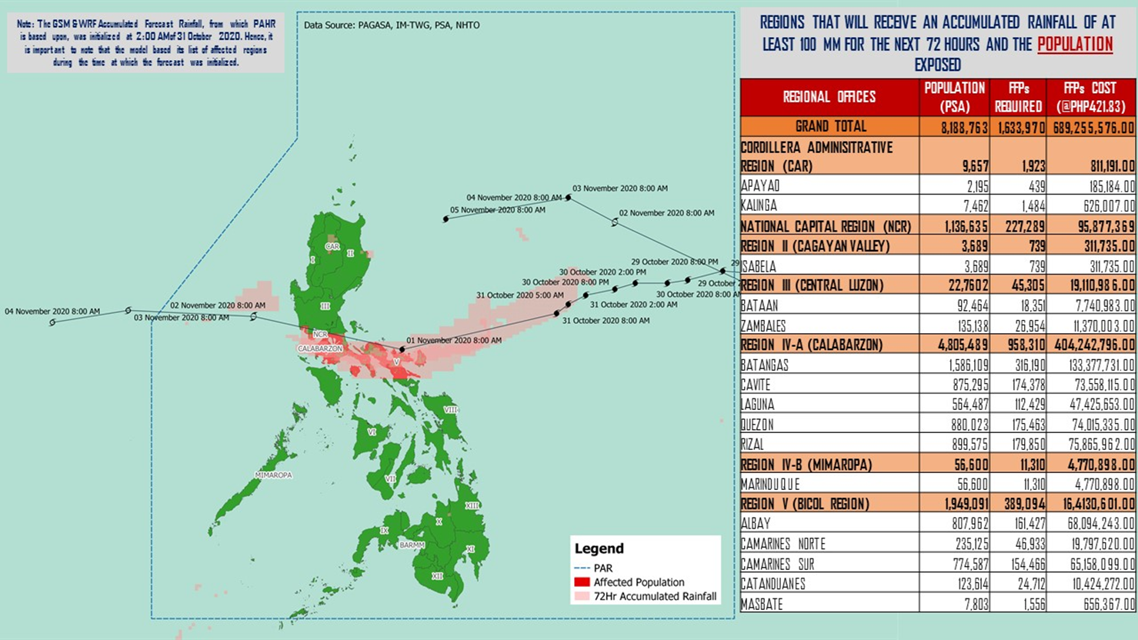

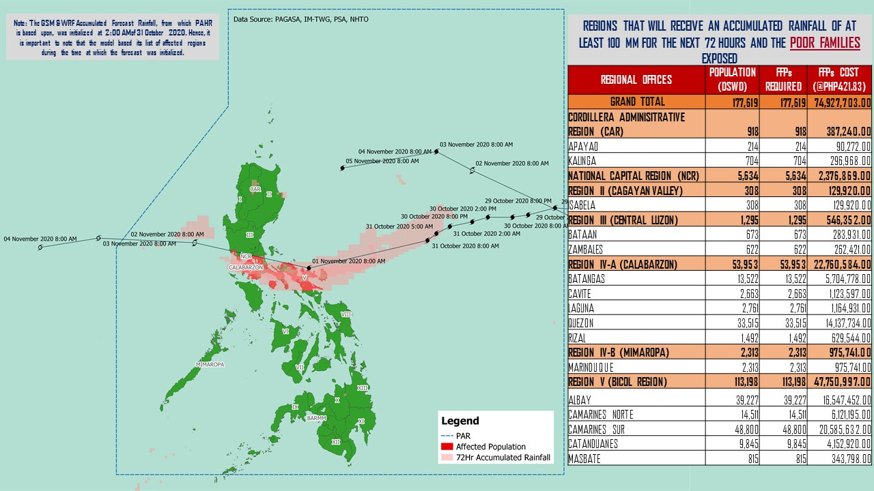

Source: DRMB-DROMIC GIS Specialists

Status of Prepositioned Resources: Stockpile and Standby Funds
The DSWD Central Office (CO), Field Offices (FOs), and National Resource Operations Center (NROC) have stockpiles and standby funds amounting to ₱888,698,461.72 with breakdown as follows (see Table 1):

- Standby Funds
A total of ₱304,902,360.71 standby funds in the CO and FOs. Of the said amount, ₱263,367,817.19 is the available Quick Response Fund (QRF) in the CO.

- Stockpiles
A total of 267,290 family food packs (FFPs) amounting to ₱ 120,547,540.94, other food items amounting to ₱182,667,242.70 and non-food items (FNIs) amounting to ₱280,581,317.38 are available.

Table 1. Available Standby Funds and Stockpiles
Region / Office | Standby Funds | FAMILY FOOD PACKS |  | Other Food Items | Non-Food Relief Items | Total Standby Funds & Stockpile
 |  | Quantity | Total Cost
 | 304,902,360.71 | 267,290 | 120,547,540.94 | 182,667,242.70 | 280,581,317.38 | 888,698,461.72
Central Office | 263,367,817.19 | - | - | - | - | 263,367,817.19
NRLMB - NROC | - | 7,787 | 4,649,365.00 | 17,713,326.82 | 72,736,157.75 | 95,098,849.57
NRLMB - VDRC | - | 10,247 | 4,549,237.63 | 3,755,227.33 | 2,469,751.20 | 10,774,216.16
I | 3,000,455.20 | 1,621 | 728,659.32 | 2,813,730.00 | 30,898,834.96 | 37,441,679.48
II | 3,000,938.79 | 20,158 | 10,187,730.36 | 2,762,516.01 | 5,510,398.95 | 21,461,584.11
III | 4,205,028.74 | 12,441 | 5,681,030.73 | 2,012,085.86 | 5,022,278.98 | 16,920,424.31
CALABARZON | 3,000,000.00 | 7,634 | 2,643,864.00 | 5,735,748.48 | 4,069,663.12 | 15,449,275.60
MIMAROPA | 2,882,244.58 | 29,724 | 13,375,800.00 | 2,061,634.00 | 6,003,498.80 | 24,323,177.38
V | - | 23,052 | 7,117,590.14 | 1,053,537.41 | 26,499,532.90 | 34,670,660.45
VI | 3,000,051.68 | 33,956 | 12,289,726.94 | 67,792,935.77 | 5,890,820.31 | 88,973,534.70
VII | 3,000,462.71 | 33,686 | 14,678,129.00 | 9,817,642.56 | 78,097.00 | 27,574,331.27
VIII | 3,194,543.00 | 20,228 | 11,167,188.04 | 7,878,269.90 | 19,619,837.45 | 41,859,838.39
IX | 56,000.00 | 7,047 | 3,851,115.03 | 15,614,222.16 | 8,518,245.45 | 28,039,582.64
X | 3,000,724.42 | 25,458 | 13,758,723.50 | 13,863,632.31 | 27,960,690.00 | 58,583,770.23
XI | 3,000,001.00 | 4,593 | 1,700,098.95 | 11,530,225.00 | 16,356,885.36 | 32,587,210.31
XII | 1,757,513.85 | 1,514 | 832,700.00 | 3,289,022.55 | 10,899,586.54 | 16,778,822.94
CARAGA | 3,000,740.55 | 11,378 | 6,005,819.98 | 6,663,746.83 | 16,464,806.17 | 32,135,113.53
NCR | 2,229,439.00 | 2,440 | 1,340,292.00 | 6,222,081.20 | 10,498,500.05 | 20,290,312.25
CAR | 3,206,400.00 | 14,326 | 5,990,470.32 | 2,087,658.51 | 11,083,732.39 | 22,368,261.22
Note: The Inventory Summary is as of 1 November 2020, 4PM.
Source: DRMB and NRLMB

Situational Reports

DSWD-DRMB
DATE | SITUATIONS / ACTIONS UNDERTAKEN
01 November 2020 | - The Disaster Response Management Bureau (DRMB) is on BLUE alert status and is closely coordinating with the concerned field offices for significant disaster response updates  - All QRT members and emergency equipment are on standby and ready for deployment.  - The DSWD DRMB received 500 modular tents from International Organization for Migration (IOM) amounting to ₱3,000,000.00
31 October 2020 | - DRMB participated in the Online Pre-Disaster Risk Assessment Meeting on Typhoon “Rolly” on 31 October 2020 with other response cluster member agencies. Further meetings shall be conducted on the implementation of COVID-19 protocols during the response efforts on Typhoon “Rolly”.  - The Undersecretary of DSWD-DRMG activated the response cluster in connection to Typhoon “Rolly” effective 31 October 2020, 5:00 PM

DSWD-FO CAR
DATE | SITUATIONS / ACTIONS UNDERTAKEN
01 November 2020 | - DSWD-FO CAR DRMD are on standby to render duty at the Operations Center and monitor the status on the ground as well as the alert status and weather updates.  - DRMD personnel Headed by Mary Ann G. Buclao attended PDRA via VTC together with the Regional Director Leo L. Quintilla.  - Prepared the Preparedness for Response Report for submission to CO and other line agencies.  - Delta Teams are on alert and standby  - Evacuations Center Updated for dissemination.  - Issued weather advisory DSWD FO CAR staff  - Mr. Andrew Bogenggeng escorted the truck for pick-up of the family tents from Region 1.
31 October 2020 | - DSWD-FO CAR DRMD are on standby to render duty at the Operations Center and monitor the status on the ground as well as the alert status and weather updates.  - The Provincial Social Welfare and Development Teams (PSWADT) DRMD PDO IIs were informed of the situation.  - Municipal Action Teams are on standby.  - Continuous coordination by the DRMD PDO IIs assigned in the PSWADTs with the LDRRMOs for updates.  - Rapid Emergency Telecommunications Team (RETT) including the International Maritime/Marine Satellite (INMARSAT) equipment are on standby.  - DSWD-FO CAR DRMD prepared reports for the weather disturbance and shared it to the end users.  - The Operations Center is on RED ALERT since 16 March 2020.  - Pre-disaster Risk Assessment Meeting via video teleconferencing attended by Ms. Mary Ann G. Buclao.  - Close coordination with Cordillera Regional Disaster Risk Reduction and Management Council Emergency Operations Center for updates.  - QRT and Delta Teams were on standby for possible deployment.  - Cascaded the susceptibility map to Provincial SWAD Teams for their guidance.  - Evacuations Center Updated for dissemination to SWADs.

DSWD-FO I
DATE | SITUATIONS / ACTIONS UNDERTAKEN
01 November 2020 | - DSWD Field Office 1 is closely monitoring the possible effects of Typhoon “ROLLY” through the Department of Science and Technology – Philippine Atmospheric, Geophysical and Astronomical Services Administration (DOST – PAGASA) and close coordination with the Regional Disaster Risk Reduction and Management Council 1 (RDRRMC1). Likewise, Provincial Operations Offices (POOs) are in close coordination with the different Provincial/City/Municipal Disaster Risk Reduction and Management Councils (P/C/MDRRMCs) and Provincial/City/Municipal Social Welfare and Development Offices (P/C/MSWDOs) to monitor the adverse effects that might be brought by the weather disturbance and submission of reports for significant updates.  - DSWD FO 1 staff are on standby for possible augmentation. Likewise, the Field Office ensures availability and readiness of resources.  - The DSWD FO 1 IMT is on duty while other DSWD staff are on standby for possible augmentation.

DSWD-FO II
DATE | SITUATIONS / ACTIONS UNDERTAKEN
01 November 2020 | - The Regional Disaster Management Response Team is already activated on a 24-hour duty. The team started to monitor the status of every municipality in the region through the SWADTs, P/C/MATs coordination with LGUs. Since there were no reported evacuees as of the moment, the DRMT augmented in the packing of relief goods and they were able to pack a total of 800 Family Food Packs (FFPs) as of 11:30 am.  - Continuous monitoring by the SWADTs and P/C/MATS of FO2 with regard to the present weather condition of every municipality in the 5 provinces of Region 2.  - The Disaster Response Management Division thru the Disaster Response Information and Management Section (DRIMS) continuously monitor the weather advisory;  - The Disaster Response Information Management Section (DRIMS) is continuously monitoring the status of the northeaster disturbance thru the PAGASA weather bulletin/advisory.  - SWADTs/Provincial Operations Offices (POOs)/C/MATs closely coordinated with their respective Provincial/City/Municipal Disaster Risk Reduction and Management Councils (P/C/MDRRMCs) that are currently monitoring the adverse effects brought by this weather disturbance.  - In preparation for the possible effects of Typhoon “Rolly” in the region, the FO2 prepositioned 2,000 FFPs on top of the readily available standby stockpile in the satellite warehouses in Cabarroguis, Quirino and Bayombong, Nueva Vizcaya and in Ilagan City SWAD Office.  - The LGU Quezon, Nueva Viscaya provided 3 FFPs amounting to ₱750.00 to the families staying in Evacuation Center.  - As of today, a total of 21 Families and/or 66 Persons in 3 Barangays in Region II conducted Pre-Emptive evacuation.  REGION / PROVINCE / MUNICIPALITY NUMBER OF AFFECTED  Barangays Families Persons  REGION II 3 21 66  Isabela 1 3 10  Quezon 1 3 10  Quirino 2 18 56  Cabarroguis (capital) 1 15 38  Diffun 1 3 18

DSWD-FO III
DATE | SITUATIONS / ACTIONS UNDERTAKEN
01 November 2020 | - Activation of Rapid Deployment Team-Disaster Response Management Division of DSWD Field Office and DSWD Provincial Extension Office Quick Response Team.The Disaster Response Management Division thru the Disaster Response Information and Management Section (DRIMS) continuously monitor the weather advisory;  - Continuous monitoring of weather updates in coordination with the DPEO’s and concerned LGUs.  - Continuous repacking of 2,750 FFPs in the Regional Warehouse.  - Coordinated with NROC for the delivery of additional 2,300 FFPs in the Regional Warehouse and 1,700 FFPs in the Satellite Warehouse in Fort Magsaysay.  - Coordinated with OCD 3 for the delivery of 1,000 FFPs to DPEO Aurora Warehouse.  - Prepared recommendation for provision of additional relief augmentation to LGU Cabanatuan City, Nueva Ecija:  - Hygiene Kit – 200  - Sleeping Kit – 200  - Family Kit – 200

DSWD-FO NCR
DATE | SITUATIONS / ACTIONS UNDERTAKEN
01 November 2020 | - DSWD FO-NCR Quick Response Team (QRT) has a total of 16 Personnel on duty as of reporting time.  - DSWD FO-NCR is continuously coordinating with the 17 LGUs thru its respective Local Social Welfare and Development Office (LSWDOs) regarding necessary augmentation assistance needed by affected families. As of reporting time, please be informed that only Pateros has requested for augmentation and is currently being facilitated by FO-NCR.  - As of today, a total of 896 Families and/or 3,707 Persons in 13 Barangays in NCR conducted Pre-Emptive evacuation.  REGION / PROVINCE / MUNICIPALITY NUMBER OF AFFECTED  Barangays Families Persons  NCR 13 896 3,707  Manila City 4 176 704  Muntinlupa City 4 644 2700  Taguig City 1 8 31  Quezon City 4 68 272
29 October 2020 | - Continuous provision of Disaster Assistance Family Access Card to requesting LGUs.  - The Quick Response Teams of FO-NCR composed of organic staff from the Field Office and Centers and Residential Care Facilities (C/RCFs) is activated and on standby in response to any eventualities. The assignment of said staff is scheduled per day.  - The Disaster Response Management Division Office is established and identified as the emergency operation center for Tropical Storm Rolly.

DSWD-FO MIMAROPA
DATE | SITUATIONS / ACTIONS UNDERTAKEN
29 October 2020 | - P/C/M QRTs in Five Provinces are alerted to monitor the daily local weather condition and any disturbances that may occur in their areas.  - 24/7 On-call status of the R/P/C/M QRTs together with special projects staff for possible activation of Operation Center.  - Standby logistical equipment and workforce through coordination with SWADT Offices and concerned LGUs on the management of stranded passengers, if any, in ports and terminals.  - Information and Communication Technology Management Unit (ICTMU) is on standby status to ensure robust communication system.  - Ensure that there is an on-call truck available for delivery of goods and equipment to areas that will be affected.

DSWD-FO V
DATE | SITUATIONS / ACTIONS UNDERTAKEN
01 November 2020 | - DSWD has 3,000 FFPs and 100 rolls laminated sacks intended for the families in the Province of Catanduanes.  - DSWD will also provide 1,500 FFPs as augmentation support to the families in Brgy. Calaguas, Vinzon, Camarines Norte.  - DSWD-FO V continuous to monitor weather updates and information.  - DSWD-FO V has ongoing procurement of 30,000 family food packs  - The Resource Operation Section ensures the availability of family food packs and non-food items as need arises.  - Requested 20,000 FFPs, 100 rolls laminated sacks and 50 tents from Central Office.  - Resource Operation Section ensures the availability of family food packs and non-food items as need arises.  - PAT and MAT members in the 6 provinces are activated and instructed to coordinate with the P/MDRRMOs, C/MSWDOs for reports and updates.  - As of today, a total of 19,707 Families and/or 71,713 Persons in 298 Barangays in Region V conducted Pre-Emptive evacuation.  REGION / PROVINCE / MUNICIPALITY NUMBER OF AFFECTED  Barangays Families Persons  REGION V 298 19,707 71,713  Albay 139 8,724 31,297  Bacacay 7 308 1,024  Daraga (Locsin) 4 269 1,109  Guinobatan 7 1,178 3,485  Jovellar 2 87 432  Legazpi City (capital) 5 531 1,796  Libon 12 379 1,419  City of Ligao 31 2,704 9,883  Malilipot 12 376 1,439  Malinao 7 414 1,561  Oas 8 107 426  Pio Duran 6 358 1,301  Polangui 3 149 512  Rapu-Rapu 2 68 358  Santo Domingo (Libog) 18 740 2,659  City of Tabaco 9 672 2,519  Tiwi 6 384 1,374  Camarines Norte 9 365 1,255  Basud 2 47 154  Jose Panganiban 1 24 91  Mercedes 1 27 92  Vinzons 5 267 918  Camarines Sur 48 1,946 7,786  Buhi 5 492 1,759  Del Gallego 9 320 1,413  Garchitorena 2 54 256  Magarao 4 54 188  Nabua 6 53 233  Naga City 5 304 1,171  Pasacao 1 42 185  Pili (capital) 3 100 308  Ragay 5 107 412  Sagñay 7 393 1,757  Siruma 1 27 104  Masbate 28 1,078 3,915  Aroroy 2 41 201  Baleno 2 39 123  Cataingan 1 14 53  Cawayan 2 35 130  Claveria 4 284 1,008  Esperanza 8 359 1,323  Mandaon 2 60 171  Pio V. Corpuz (Limbuhan) 4 196 740  Uson 3 50 166  Sorsogon 74 7,594 27,460  Barcelona 15 244 910  Bulusan 5 88 360  Donsol 6 261 1,256  Irosin 1 17 86  Magallanes 4 284 1,347  Prieto Diaz 1 57 225  Santa Magdalena 1 20 119  City of Sorsogon (capital) 41 6,623 23,157

DSWD-FO VI
DATE | SITUATIONS / ACTIONS UNDERTAKEN
30 October 2020 | - All QRT members are on standby and ready for augmentation if needed, following the new normal protocols of the agency.  - DSWD-FO VI conducted TA provision to Provincial LGUs and SWAD Offices on DROMIC Reporting.  - DSWD-FO VI issued a total of 150 vests, 50 GO Bags, 50 survival bags and 50 sleeping kits to QRT members in the region and field staff.

DSWD-FO VII
DATE | SITUATIONS / ACTIONS UNDERTAKEN
31 October 2020 | - In a memorandum issued by OCD-7 Regional Director, alert level status of the RDRRMC-7 has now been raised to BLUE, thereby activating the Response Clusters. Agencies under this cluster have been directed to do and prepare according to each cluster mandates.  - In a notice issued today, PCG-Cebu has ordered the suspension of sea travels from the island province to Luzon and parts of the Visayas that will be affected by Typhoon Rolly.  - Local authorities in the Region are already preparing for the possible effects of heavy rains caused by the trough of TY Rolly. Local Disaster teams are continuously monitoring hazard prone areas, especially residential sites near rivers and other waterways. Rescue equipment, vehicles and personnel are on standby ready for deployment if the need arises.
29 October 2020 | - Continuous monitoring by the DSWD Regional DROMIC Focal for the latest weather updates from PAGASA and cascading the same for widest dissemination to P/C/MATs.  - City and Municipal Action Team and SWAD Offices were alerted and already requested to closely coordinate with their local counterparts and their respective LDRRMC. Field staff requested to monitor AOR and provide reports and updates to the Regional DROMIC Focal for any impacts.  - Provincial/City/Municipal Quick Response Team is on standby and ready for mobilization for any augmentation support needed from the LGUs.  - Regional Disaster Division is in close coordination with OCD-7 and other RDRRMC members for any response mobilization activities/strategies.  - Warehouses in the three island provinces are on ready alert.

DSWD-FO VIII
DATE | SITUATIONS / ACTIONS UNDERTAKEN
- November 2020 | - DSWD-FO VIII attended the Response Cluster Meeting.  - Monitored the arrival of 5,000 FFPs from VDRC Cebu which was requested by the office due to current available stockpile in the region.  - The Regional Resource Operations Center (RROC) is conducting repacking of FFPs.  - Disaster Response Information Management Section is in coordination with SWAD Teams and DRMD PDOs on the ground to collect data and information as to the situation and effect of STY Rolly in Eastern Visayas.
29 October 2020 | - Prepositioned FFPs in Samar Island which can be distributed immediately by the P/C/MATs to LGUs that need augmentation support.  - SWAD Teams and DRMD-PDOs assigned in the provinces are alerted and advised to closely coordinate with P/C/MSWDOs and/or P/C/MDRRMOs and immediately report any eventualities that may arise during the period.  - Quick Response Teams (QRT) and Disaster Response Management Division (DRMD) are alerted in case augmentation of workforce is needed.  - Disaster Response Information Management Section is closely coordinating with SWADTs, QRTs and PDOs for any eventualities on the ground.  - Regional Resource Operations Section (RROS) are also alerted to ensure the readiness of dispatching the Food and Non-Food commodities whenever needed.

DSWD-FO X
DATE | SITUATIONS / ACTIONS UNDERTAKEN
30 October 2020 | - DSWD FO-X DRMD continuously monitor the weather condition and in constant coordination with the LGUs for possible augmentation and for further updates on Typhoon “Rolly”.

*****
The Disaster Response Operations Monitoring and Information Center (DROMIC) of the DSWD-DRMB is closely monitoring the effects of Typhoon “Rolly” and is coordinating with the concerned DSWD Field Offices for any significant updates.

Prepared by:

MARIEL B. FERRARIZ
CLARRIE MAE A. CASTILLO
DIANNE C. PELEGRINO
JEM ERIC F. FAMORCAN

RODEL V. CABADDU
Releasing Officer

PHOTO DOCUMENTATION
