DSWD DROMIC Report #1 on Tropical Depression (TD) “OFEL”
as of 15 October 2020, 6PM

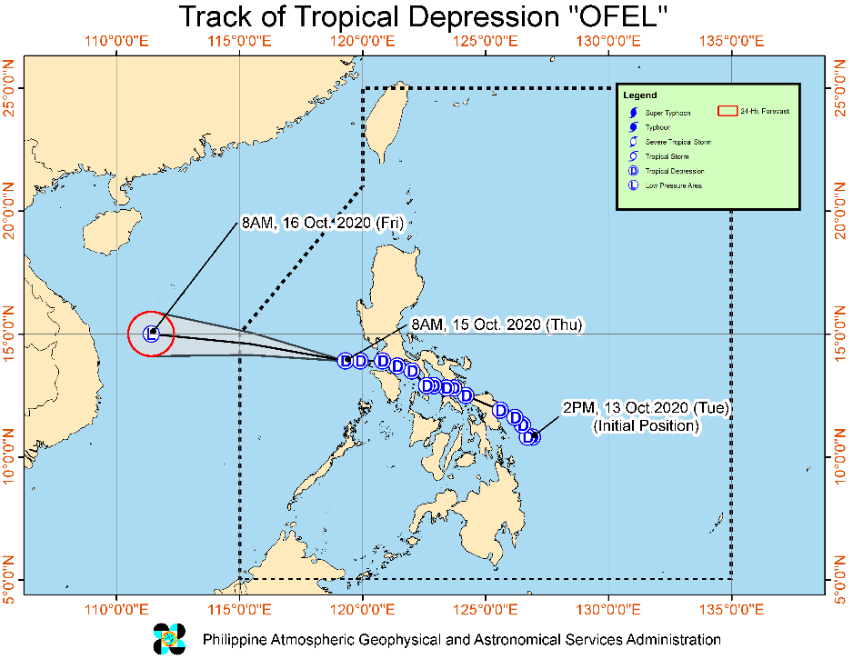
Situation Overview

Issued at 11:00 am today, Tropical Depression “Ofel” continues to move westward over the West Philippine Sea.
- “OFEL” will continue moving westward or west-northwestward over the West Philippine Sea today. There is an increasing likelihood that this tropical depression will weaken into a Low Pressure Area within the next 12 to 24 hours over the West Philippine Sea.
- Rainfall: Today, light to moderate with at times heavy rains over mainland Cagayan Valley, Cordillera Administrative Region, and Central Luzon due to "OFEL" and over Northern Samar, Eastern Samar, Samar, Palawan (including Calamian, Cuyo, and Kalayaan Islands) due to Southwest Monsoon. Flooding (including flashfloods) and rain-induced landslides may occur during heavy or prolonged rainfall especially in areas that are highly or very highly susceptible to these hazards. PAGASA Regional Services Divisions may issue local thunderstorm/rainfall advisories and heavy rainfall warnings as appropriate.
- Winds: No tropical wind signal is in effect. However, occasional gusts may still be experienced over Zambales, Bataan, Cavite, Batangas, Occidental Mindoro, and Palawan (including Calamian and Kalayaan Islands) due to "OFEL" and the Southwest Monsoon. Gusty conditions associated with the northeasterly surface wind flow will also be experienced over Batanes, Babuyan Islands, Cordillera Administrative Region, Aurora, and the coastal and mountainous areas of Ilocos Norte and mainland Cagayan Valley.

Hazards affecting coastal waters:
- Gale Warning is in effect over the entire seaboard of Northern Luzon and the seaboard of Aurora due to rough to very rough seas (2.5 to 4.5 m) associated with the northeasterly surface wind flow. Sea travel is risky over these areas, especially for those using small seacrafts.
- Moderate to rough seas (2.1 to 3.5 m) due to "OFEL" and the Southwest Monsoon will be experienced over the seaboards of Zambales, Bataan, Quezon, Occidental Mindoro, and Palawan (including Calamian and Kalayaan Islands). Those with small seacrafts are advised not to venture out to sea over these areas.

At 10:00 AM today, the center of Tropical Depression "OFEL" was estimated based on all available data at 275 km West of Tanauan City, Batangas (14.1 °N, 118.5 °E )

Source: DOST-PAGASA Severe Weather Bulletin

- Status of Affected Families / Persons
A total of 653 families or 2,459 persons were affected in 53 barangays in Regions CALABARZON and V (see Table 1).

Table 1. Number of Affected Families / Persons
REGION / PROVINCE / MUNICIPALITY |  | NUMBER OF AFFECTED
 |  | Barangays | Families | Persons
GRAND TOTAL |  | 53 | 653 | 2,459
CALABARZON |  | 33 | 500 | 1,786
Quezon |  | 33 | 500 | 1,786
 | Calauag | 3 | 37 | 153
 | Candelaria | 1 | 6 | 22
 | Gumaca | 16 | 350 | 1,224
 | Lopez | 3 | 33 | 121
 | Pitogo | 6 | 64 | 219
 | Plaridel | 4 | 10 | 47
REGION V |  | 20 | 153 | 673
Camarines Norte |  | 9 | 58 | 238
 | Labo | 1 | 25 | 106
 | Mercedes | 1 | 11 | 34
 | San Vicente | 2 | 6 | 30
 | Talisay | 4 | 12 | 50
 | Vinzons | 1 | 4 | 18
Camarines Sur |  | 11 | 95 | 435
 | Buhi | 2 | 40 | 156
 | Del Gallego | 3 | 6 | 63
 | Lupi | 2 | 32 | 133
 | Ragay | 2 | 15 | 76
 | Siruma | 2 | 2 | 7
Note: Ongoing assessment and validation being conducted.
Source: DSWD-FOs CALABARZON and V

- Status of Displaced Families / Persons
- Inside Evacuation Centers
There are 492 families or 1,791 persons taking temporary shelter in 47 evacuation centers in Regions CALABARZON and V (see Table 2).

Table 2. Number of Displaced Families / Persons Inside Evacuation Centers
REGION / PROVINCE / MUNICIPALITY |  | NUMBER OF EVACUATION CENTERS (ECs) |  | NUMBER OF DISPLACED
 |  |  |  | INSIDE ECs
 |  |  |  | Families |  | Persons
 |  | CUM | NOW | CUM | NOW | CUM | NOW
GRAND TOTAL |  | 50 | 47 | 528 | 492 | 1,960 | 1,791
CALABARZON |  | 30 | 30 | 377 | 348 | 1,294 | 1,158
Quezon |  | 30 | 30 | 377 | 348 | 1,294 | 1,158
 | Calauag | 3 | 3 | 37 | 37 | 153 | 153
 | Candelaria | 1 | 1 | 6 | 6 | 2 | 2
 | Gumaca | 13 | 13 | 253 | 224 | 859 | 723
 | Lopez | 4 | 4 | 33 | 33 | 121 | 121
 | Pitogo | 4 | 4 | 39 | 39 | 118 | 118
 | Plaridel | 5 | 5 | 9 | 9 | 41 | 41
REGION V |  | 20 | 17 | 151 | 144 | 666 | 633
Camarines Norte |  | 9 | 7 | 58 | 52 | 238 | 208
 | Labo | 1 | 1 | 25 | 25 | 106 | 106
 | Mercedes | 1 | 1 | 11 | 11 | 34 | 34
 | San Vicente | 2 | - | 6 | - | 30 | -
 | Talisay | 4 | 4 | 12 | 12 | 50 | 50
 | Vinzons | 1 | 1 | 4 | 4 | 18 | 18
Camarines Sur |  | 11 | 10 | 93 | 92 | 428 | 425
 | Buhi | 3 | 3 | 40 | 40 | 156 | 156
 | Del Gallego | 2 | 2 | 6 | 6 | 63 | 63
 | Lupi | 2 | 1 | 32 | 31 | 133 | 130
 | Ragay | 2 | 2 | 15 | 15 | 76 | 76
Note: Ongoing assessment and validation being conducted.
Source: DSWD-FOs CALABARZON and V

- Outside Evacuation Centers
There are 125 families or 465 persons currently staying with their relatives and/or friends in Regions CALABARZON and V (see Table 3).

Table 3. Number of Displaced Families / Persons Outside Evacuation Centers
REGION / PROVINCE / MUNICIPALITY |  | NUMBER OF DISPLACED
 |  | OUTSIDE ECs
 |  | Families |  | Persons
 |  | CUM | NOW | CUM | NOW
GRAND TOTAL |  | 125 | 125 | 465 | 465
CALABARZON |  | 123 | 123 | 458 | 458
Quezon |  | 123 | 123 | 458 | 458
 | Gumaca | 97 | 97 | 351 | 351
 | Pitogo | 25 | 25 | 101 | 101
 | Plaridel | 1 | 1 | 6 | 6
REGION V |  | 2 | 2 | 7 | 7
Camarines Sur |  | 2 | 2 | 7 | 7
 | Siruma | 2 | 2 | 7 | 7
Note: Ongoing assessment and validation being conducted.
Source: DSWD-FOs CALABARZON and V

Status of Prepositioned Resources: Stockpile and Standby Funds

The DSWD Central Office (CO), Field Offices (FOs), and National Resource Operations Center (NROC) have stockpiles and standby funds amounting to ₱1,191,370,122.17 with breakdown as follows (see Table 2):

- Standby Funds
A total of ₱552,440,831.83 standby funds in the CO and FOs. Of the said amount, ₱509,417,539.94 is the available Quick Response Fund (QRF) in the CO.

- Stockpiles
A total of 201,758 family food packs (FFPs) amounting to ₱91,757,640.88, other food items amounting to ₱226,573,713.21 and non-food items (FNIs) amounting to ₱320,597,936.25 are available.

Table 4. Available Standby Funds and Stockpiles
Region / Office | Standby Funds | FAMILY FOOD PACKS |  | Other Food Items | Non-Food Relief Items | Total Standby Funds & Stockpile
 |  | Quantity | Total Cost
 | 552,440,831.83 | 201,758 | 91,757,640.88 | 226,573,713.21 | 320,597,936.25 | 1,191,370,122.17
Central Office | 509,417,539.94 | - | - | - | - | 509,417,539.94
NRLMB - NROC | - | 4,250 | 2,530,050.00 | 32,626,381.18 | 111,736,916.04 | 146,893,347.22
NRLMB - VDRC | - | 3,247 | 1,459,427.63 | 14,145,073.59 | 103,159.75 | 15,707,660.97
I | 3,000,455.20 | 2,858 | 1,223,613.54 | 2,813,730.00 | 31,166,997.46 | 38,204,796.20
II | 3,000,938.79 | 22,279 | 11,081,529.03 | 3,141,266.01 | 5,510,398.95 | 22,734,132.78
III | 2,181,900.00 | 12,112 | 4,733,337.46 | 5,398,151.71 | 5,295,371.88 | 17,608,761.05
CALABARZON | 3,000,000.00 | 7,353 | 2,699,193.00 | 4,465,835.12 | 4,172,292.41 | 14,337,320.53
MIMAROPA | 3,100,744.58 | 26,608 | 11,973,600.00 | 2,611,589.00 | 4,732,376.25 | 22,418,309.83
V | 3,228,250.00 | 17,016 | 5,544,661.30 | 1,053,537.41 | 26,420,032.90 | 36,246,481.61
VI | 3,000,051.68 | 21,199 | 7,918,656.94 | 48,660,483.77 | 5,890,820.31 | 65,470,012.70
VII | 3,000,462.71 | 5,938 | 2,966,223.05 | 24,385,135.74 | 78,198.00 | 30,430,019.50
VIII | 3,003,550.00 | 18,031 | 9,679,527.08 | 6,648,181.70 | 19,619,830.38 | 38,951,089.16
IX | 56,000.00 | 12,908 | 7,054,092.92 | 15,683,126.16 | 9,622,742.28 | 32,415,961.36
X | 3,000,724.42 | 17,455 | 9,270,615.50 | 31,798,961.86 | 27,895,054.53 | 71,965,356.31
XI | 3,000,001.00 | 7,761 | 2,872,734.15 | 12,377,725.00 | 19,758,485.36 | 38,008,945.51
XII | 1,449,000.68 | 351 | 193,050.00 | 5,787,049.72 | 10,891,560.28 | 18,320,660.68
CARAGA | 3,000,740.55 | 4,642 | 2,131,621.58 | 5,250,696.03 | 16,690,675.67 | 27,073,733.83
NCR | 3,000,439.00 | 1,677 | 921,176.10 | 7,479,060.00 | 9,929,291.41 | 21,329,966.51
CAR | 3,000,033.28 | 16,073 | 7,504,531.60 | 2,247,729.21 | 11,083,732.39 | 23,836,026.48
Note: The Inventory Summary is as of 15 October 2020, 4PM.
Source: DRMB and NRLMB

Situational Reports

DSWD-DRMB
DATE | SITUATIONS / ACTIONS UNDERTAKEN
15 October 2020 | - The Disaster Response Management Bureau (DRMB) is on BLUE alert status and is closely coordinating with the concerned Field Offices for significant disaster response updates.  - All QRT members and emergency equipment are on standby and ready for deployment.

DSWD-FO CALABARZON
DATE | SITUATIONS / ACTIONS UNDERTAKEN
15 October 2020 | - DSWD-FO CALABARZON through the Disaster Response Management Division (DRMD) provided technical assistance to LGUs with activated evacuation centers on Camp Coordination and Camp Management, the LSWDOs were also reminded to ensure physical distancing in the evacuation center.  - DSWD-FO CALABARZON DRMD requested the LGUs with activated evacuation centers to conduct rapid damage and needs assessments (RDANA) to identify the immediate needs of the affected families.  - DSWD-FO CALABARZON DRMD continuously coordinating with LGUs in flood, landslide and storm surge prone areas for their ongoing response efforts.  - Provincial Quick Response Teams and Provincial Actions Teams were requested to closely coordinate with their LDRRMCs and/or LSWDOs. Field Staff were requested to monitor the AOR and provide reports and updates to the Emergency Operations Center.  - DSWD-FO CALABARZON DRMD is closely coordinating with LSWDOs, and LDRRMOs for updates and developments on the effects of the weather disturbance.  - DSWD-FO CALABARZON DRMD informed member agencies of the response cluster to be on stand-by alert status and ready for mobilization in case situation arises during the video teleconference held last October 14, 2020.
DSWD-FO MIMAROPA
DATE | SITUATIONS / ACTIONS UNDERTAKEN
15 October 2020 | - DSWD-FO MIMAROPA submitted their terminal report.  - A total of 158 families or 665 persons have pre-emptively evacuated in 9 Evacuation Centers in Oriental Mindoro.  REGION / PROVINCE / MUNICIPALITY NUMBER OF EVACUATION CENTERS (ECs) NUMBER OF DISPLACED  INSIDE ECs  Families Persons  MIMAROPA 9 158 665  Oriental Mindoro 9 158 665  Baco 2 2 6  Bulalacao (San Pedro) 4 140 577  City of Calapan (capital) 2 11 57  Puerto Galera 1 5 25

DSWD-FO V
DATE | SITUATIONS / ACTIONS UNDERTAKEN
15 October 2020 | - DSWD-FO V continuous to monitor weather updates and information.  - Resource Operation Section ensures the availability of family food packs and non-food items as need arises.  - DSWD-FO V QRTs are activated.  - PAT and MAT members in the 6 provinces are activated and instructed to coordinate with the P/MDRRMOs, C/MSWDOs for TD “Ofel” reports and updates.

*****
The Disaster Response Operations Monitoring and Information Center (DROMIC) of the DSWD-DRMB is closely monitoring the effects of TD “Ofel” and is coordinating with the concerned DSWD Field Offices for any significant updates.

Prepared by:

MARIE JOYCE G. RAFANAN

LESLIE R. JAWILI
Releasing Officer

