DSWD DROMIC Report #1 on the Tropical Storm “PEPITO”
as of 21 October 2020, 6PM

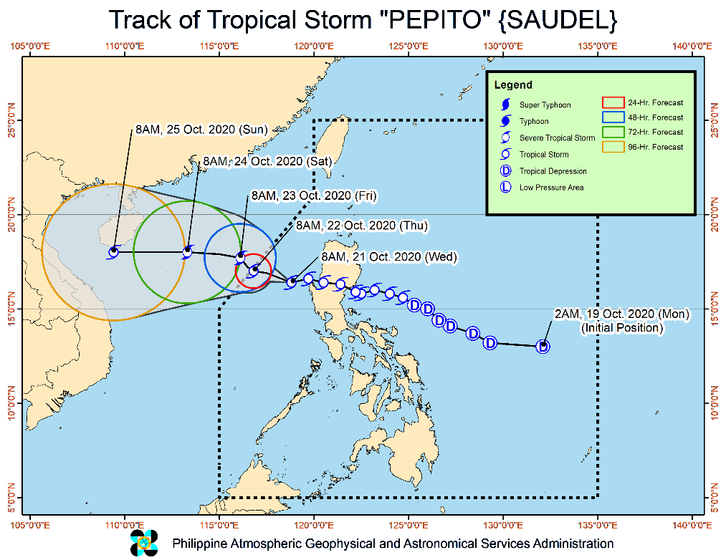
SITUATION OVERVIEW

Issued at 11:00 am today, TROPICAL STORM "PEPITO"
SLIGHTLY INTENSIFIES WHILE MOVING WESTWARD OVER THE WEST PHILIPPINE SEA.

Track and intensity outlook:
- Track: "PEPITO" is forecast to move generally westward or west-northwestward over the West Philippine Sea today, before slowing down and turning northwestward tomorrow. It is forecast to exit the Philippine Area of Responsibility (PAR) tomorrow morning or afternoon. On the forecast track, "PEPITO" will accelerate and turn westward beginning Friday towards the central portion of Vietnam.
- Intensity: "PEPITO" is forecast to gradually intensify over the West Philippine Sea and may reach severe tropical storm category tonight or tomorrow morning.

Hazards affecting land areas:
- Rainfall: Today, light to moderate with at times heavy rains will be experienced over Batanes, Babuyan Islands, Zambales, Bataan, Occidental Mindoro, and Palawan. Flooding (including flash floods) and rain-induced landslides may occur during heavy or prolonged rainfall especially in areas that are highly or very highly susceptible to these hazards. PAGASA Regional Services Divisions may issue local thunderstorm/rainfall advisories and heavy rainfall warnings as appropriate.
- Rainfall: Today, light to moderate with at times heavy rains will be experienced over Batanes, Babuyan Islands, Zambales, Bataan, Occidental Mindoro, and Palawan. Flooding (including flash floods) and rain-induced landslides may occur during heavy or prolonged rainfall especially in areas that are highly or very highly susceptible to these hazards. PAGASA Regional Services Divisions may issue local thunderstorm/rainfall advisories and heavy rainfall warnings as appropriate.
Hazards affecting coastal waters:
- Rough to very rough seas (2.5 to 5.5 m) will be experienced over the areas where TCWS and Gale Warning are in effect. In particular, such conditions are expected over the entire seaboards of Northern and Central Luzon, the seaboard of northern Quezon including Pollilo Islands, and the western seaboards of Batangas, Occidental Mindoro (including Lubang Islands), and Palawan (including Calamian and Kalayaan Islands), Sea travel is risky over these areas, especially for those using small seacrafts.
- Moderate to rough seas (1.5 to 3.0 m) will prevail over the eastern seaboards of southern Quezon, Bicol Region, Eastern Visayas, Caraga, and Davao Region. Those with small seacrafts are advised to take precautionary measures when venturing out to sea. Inexperienced mariners should avoid navigating in these conditions.

Other disturbance being monitored:
- At 10:00 AM today, the Tropical Depression outside the PAR was estimated based on all available data at 1,895 km East Northeast of Extreme Northern Luzon (24.9 °N, 139.8 °E). It has maximum sustained winds of 55 km/h near the center and gustiness of up to 70 km/h. It is currently almost stationary. This disturbance remains unlikely to enter the PAR.
Source: PAGASA Severe Weather Bulletin

- Status of Affected Families / Persons
A total of 5,555 families or 25,268 persons were affected by the Tropical Storm “Pepito” in 117 barangays in Regions II, III and CALABARZON (see Table 1).

Table 1. Number of Affected Families / Persons
REGION / PROVINCE / MUNICIPALITY |  | NUMBER OF AFFECTED
 |  | Barangays | Families | Persons
GRAND TOTAL |  | 117 | 5,555 | 25,268
REGION II |  | 31 | 434 | 1,460
Cagayan |  | 1 | 115 | 410
 | Rizal | 1 | 115 | 410
Isabela |  | 26 | 311 | 1,023
 | Aurora | 1 | 7 | 26
 | Benito Soliven | 1 | 4 | 11
 | Cabatuan | 2 | 4 | 10
 | Cordon | 1 | 1 | 2
 | Dinapigue | 3 | 63 | 213
 | Maconacon | 6 | 125 | 416
 | San Guillermo | 10 | 76 | 262
 | San Mariano | 2 | 31 | 83
Nueva Vizcaya |  | 2 | 5 | 16
 | Dupax del Norte | 1 | 2 | 6
 | Quezon | 1 | 3 | 10
Quirino |  | 2 | 3 | 11
 | Aglipay | 1 | 1 | 5
 | Maddela | 1 | 2 | 6
REGION III |  | 13 | 82 | 335
Aurora |  | 13 | 82 | 335
 | Baler (capital) | 4 | 11 | 56
 | Casiguran | 5 | 62 | 250
 | Dilasag | 1 | 2 | 7
 | San Luis | 3 | 7 | 22
CALABARZON |  | 73 | 5,039 | 23,473
Laguna |  | 1 | 2 | 9
 | Santa Cruz (capital) | 1 | 2 | 9
Quezon |  | 72 | 5,037 | 23,464
 | Buenavista | 2 | 42 | 189
 | Calauag | 10 | 433 | 1,860
 | Catanauan | 12 | 1,829 | 9,145
 | General Luna | 2 | 2 | 9
 | Gumaca | 12 | 228 | 818
 | Lopez | 25 | 1,148 | 4,670
 | Real | 1 | 5 | 23
 | Tagkawayan | 8 | 1,350 | 6,750
Note: Ongoing assessment and validation being conducted.
Source: DSWD-FOs II, III and CALABARZON

II. Status of Displaced Families / Persons
- Inside Evacuation Centers
There are 3,639 families or 16,343 persons taking temporary shelter in 89 evacuation centers in Regions II, III and CALABARZON (see Table 2).

Table 2. Status of Displaced Families / Persons Inside Evacuation Centers
REGION / PROVINCE / MUNICIPALITY |  | NUMBER OF EVACUATION CENTERS (ECs) |  | NUMBER OF DISPLACED
 |  |  |  | INSIDE ECs
 |  |  |  | Families |  | Persons
 |  | CUM | NOW | CUM | NOW | CUM | NOW
GRAND TOTAL |  | 89 | 89 | 3,639 | 3,639 | 16,343 | 16,343
REGION II |  | 25 | 25 | 295 | 295 | 954 | 954
Isabela |  | 21 | 21 | 287 | 287 | 927 | 927
 | Aurora | 1 | 1 | 7 | 7 | 26 | 26
 | Cabatuan | 2 | 2 | 4 | 4 | 10 | 10
 | Cordon | 1 | 1 | 1 | 1 | 2 | 2
 | Dinapigue | 2 | 2 | 43 | 43 | 128 | 128
 | Maconacon | 2 | 2 | 125 | 125 | 416 | 416
 | San Guillermo | 10 | 10 | 76 | 76 | 262 | 262
 | San Mariano | 3 | 3 | 31 | 31 | 83 | 83
Nueva Vizcaya |  | 2 | 2 | 5 | 5 | 16 | 16
 | Dupax del Norte | 1 | 1 | 2 | 2 | 6 | 6
 | Quezon | 1 | 1 | 3 | 3 | 10 | 10
Quirino |  | 2 | 2 | 3 | 3 | 11 | 11
 | Aglipay | 1 | 1 | 1 | 1 | 5 | 5
 | Maddela | 1 | 1 | 2 | 2 | 6 | 6
REGION III |  | 13 | 13 | 64 | 64 | 253 | 253
Aurora |  | 13 | 13 | 64 | 64 | 253 | 253
 | Baler (capital) | 4 | 4 | 11 | 11 | 56 | 56
 | Casiguran | 5 | 5 | 44 | 44 | 168 | 168
 | Dilasag | 1 | 1 | 2 | 2 | 7 | 7
 | San Luis | 3 | 3 | 7 | 7 | 22 | 22
CALABARZON |  | 51 | 51 | 3,280 | 3,280 | 15,136 | 15,136
Laguna |  | 1 | 1 | 2 | 2 | 9 | 9
 | Santa Cruz (capital) | 1 | 1 | 2 | 2 | 9 | 9
Quezon |  | 50 | 50 | 3,278 | 3,278 | 15,127 | 15,127
 | Calauag | 11 | 11 | 433 | 433 | 1,860 | 1,860
 | Catanauan | 12 | 12 | 1,829 | 1,829 | 9,145 | 9,145
 | Gumaca | 8 | 8 | 111 | 111 | 415 | 415
 | Lopez | 18 | 18 | 900 | 900 | 3,684 | 3,684
 | Real | 1 | 1 | 5 | 5 | 23 | 23
Note: Ongoing assessment and validation being conducted.
Source: DSWD-FOs II, III and CALABARZON
- Outside Evacuation Centers
There are 1,789 families or 8,473 persons currently staying with their relatives and/or friends in Regions II, III and CALABARZON (see Table 3).

Table 3. Status of Displaced Families / Persons Outside Evacuation Centers
REGION / PROVINCE / MUNICIPALITY |  | NUMBER OF DISPLACED
 |  | OUTSIDE ECs
 |  | Families |  | Persons
 |  | CUM | NOW | CUM | NOW
GRAND TOTAL |  | 1,789 | 1,789 | 8,473 | 8,473
REGION II |  | 12 | 12 | 54 | 54
Cagayan |  | 12 | 12 | 54 | 54
 | Rizal | 12 | 12 | 54 | 54
REGION III |  | 18 | 18 | 82 | 82
Aurora |  | 18 | 18 | 82 | 82
 | Casiguran | 18 | 18 | 82 | 82
CALABARZON |  | 1,759 | 1,759 | 8,337 | 8,337
Quezon |  | 1,759 | 1,759 | 8,337 | 8,337
 | Buenavista | 42 | 42 | 189 | 189
 | General Luna | 2 | 2 | 9 | 9
 | Gumaca | 117 | 117 | 403 | 403
 | Lopez | 248 | 248 | 986 | 986
 | Tagkawayan | 1,350 | 1,350 | 6,750 | 6,750
Note: Ongoing assessment and validation being conducted.
Source: DSWD-FOs II, III and CALABARZON

SITUATIONAL REPORT

DSWD-DRMB
DATE | SITUATIONS / ACTIONS UNDERTAKEN
21 October 2020 | - The Disaster Response Operations Monitoring and Information Center (DROMIC) of the DSWD-DRMB continues to closely coordinate with the concerned field offices for significant reports on the status of affected families, assistance, and relief efforts.

DSWD-FO CAR
DATE | SITUATIONS / ACTIONS UNDERTAKEN
20 October 2020 | - DSWD-FO CAR is on standby-alert to render duty at the Operation Center and in closely monitoring the status on the ground as well as the alert status and weather updates  - The Provincial Social Welfare and Development Teams (PSWADT) DRMD PDO IIs were informed of the situation.  - DSWD-FO CAR is on RED ALERT status  - Pre-disaster Risk Assessment Meeting via video teleconferencing attended by Ms. Mary Ann G. Buclao.  - DSWD-FO CAR is in close coordination with Cordillera Regional Disaster Risk Reduction and Management Council Emergency Operations Center for updates.

DSWD-FO NCR
DATE | SITUATIONS / ACTIONS UNDERTAKEN
21 October 2020 | - DSWD-FO NCR submitted their terminal report
20 October 2020 | - DSWD-FO NCR Quick Response Teams of composed of organic staff from the Field Office and Centers and Residential Care Facilities (C/RCFs) are activated and on standby in response to any eventualities. The assignment of said staff is scheduled per day.  - DSWD-FO NCR is continuously monitoring weather conditions and other emergencies through telephone, internet, cell phone, etc. by the Disaster Response Management Division Staff and Quick Response Team Leaders.

DSWD-FO I
DATE | SITUATIONS / ACTIONS UNDERTAKEN
21 October 2020 | - DSWD-FO I is in closely monitoring the possible effects of Tropical Storm “PEPITO” through the Department of Science and Technology – Philippine Atmospheric, Geophysical and Astronomical Services Administration (DOST – PAGASA) and close coordination with the RDRRMC Field Office I. Likewise, Provincial Operations Offices (POOs) are in close coordination with the different Provincial/City/Municipal Disaster Risk Reduction and Management Councils (P/C/MDRRMCs) and Provincial/City/Municipal Social Welfare and Development Offices (P/C/MSWDOs) to monitor the adverse effects that might be brought by the weather disturbance and submission of reports for significant updates.  - DSWD-FO I Regional Director Marcelo Nicomedes J. Castillo conducted a Response Cluster Meeting re: TS “PEPITO” through video conference on October 20, 2020 Updates on the baseline information and commitment of each member agency were discussed during the meeting.

DSWD-FO II
DATE | SITUATIONS / ACTIONS UNDERTAKEN
20 October 2020 | - DSWD-FO II-DRMD through the Regional Resource Operation Section ensures availability of Food and Non-Food Items at any given time.  - DSWD-FO II Disaster Response Information Management Section (DRIMS) is continuously monitoring the status of the said weather disturbance thru the PAGASA weather bulletin/advisory.  - The Regional Disaster Management Response Team is already activated on a 24-hour duty. The team started to monitor the status of affected families though the SWADTs, P/C/MATs coordination with LGUs.

DSWD-FO III
DATE | SITUATIONS / ACTIONS UNDERTAKEN
21 October 2020 | - DSWD-FO III has 15 active QRTs with 27 members per team that are ready for deployment upon the activation of the Blue and Red alert status of the RDRRMC III.  - DSWD-FO III activated DRMD skeletal duty from the Regional Office  - DSWD-FO III is continuously coordinating and monitoring with the DSWD Provincial Extension Office of the seven (7) provinces relative to the status of their respective area.  - DSWD-FO III is ongoing repacking of 5,454 family food packs in Regional Warehouse.  - DSWD-FO III is ongoing procurement of 6,000 family food packs.

DSWD-FO CALABARZON
DATE | SITUATIONS / ACTIONS UNDERTAKEN
21 October 2020 | - DSWD-FO CALABARZON through DRMD advised the LGUs to conduct assessment to share their findings with the response cluster of the Regional Disaster Risk Reduction and Management Council (RDRRMC) CALABARZON.  - DSWD-FO CALABARZON is in close coordination with the affected LGUs and other relevant government agencies for identification of potential support and augmentation from the Field Office.  - Provincial Action Team (PAT) and Provincial Quick Response Teams (PQRT) of Quezon were advised to be on stand-by alert status for possible deployment and conduct assessment in the affected areas.  - Regional and Provincial Quick Response Teams (PRQRT) were advised to monitor weather forecast and warnings regarding anticipated risk due to movement of the weather disturbance.  - DSWD-FO CALABARZON Emergency Operations Center maintains close coordination with the PSWDOs for the assistance on assistance to be provided by the LGUs and other stakeholders.  - DSWD-FO CALABARZON through DRMD is in close coordination with the RDRRMC CALABARZON Emergency Operations Center for latest development. The DRDM is on stand-by, continuously monitoring the situation of the affected LGUs.

DSWD-FO MIMAROPA
DATE | SITUATIONS / ACTIONS UNDERTAKEN
19 October 2020 | - DSWD-FO MIMAROPA Ensured that there is an on-call truck available for delivery of goods and equipment to areas that will be affected.  - P/C/M QRTs in Five Provinces are alerted to monitor the daily local weather condition and any disturbances that may occur in their areas.  - 24/7 On-call status of the R/P/C/M QRTs together with special projects staff for possible activation of Operation Center.  - Standby logistical equipment and workforce through coordination with SWADT Offices and concerned LGUs on the management of stranded passengers, if any, in ports and terminals.

*****
The Disaster Response Operations Monitoring and Information Center (DROMIC) of the DSWD-DRMB is closely coordinating with DSWD-FO V and FO CALABARZON for any significant disaster response updates.

Prepared by:

MARIEL B. FERRARIZ

LESLIE R. JAWILI
Releasing Officer

PHOTO DOCUMENTATION
