DSWD DROMIC Report #2 on Tropical Depression (TD) “OFEL”
as of 16 October 2020, 6PM

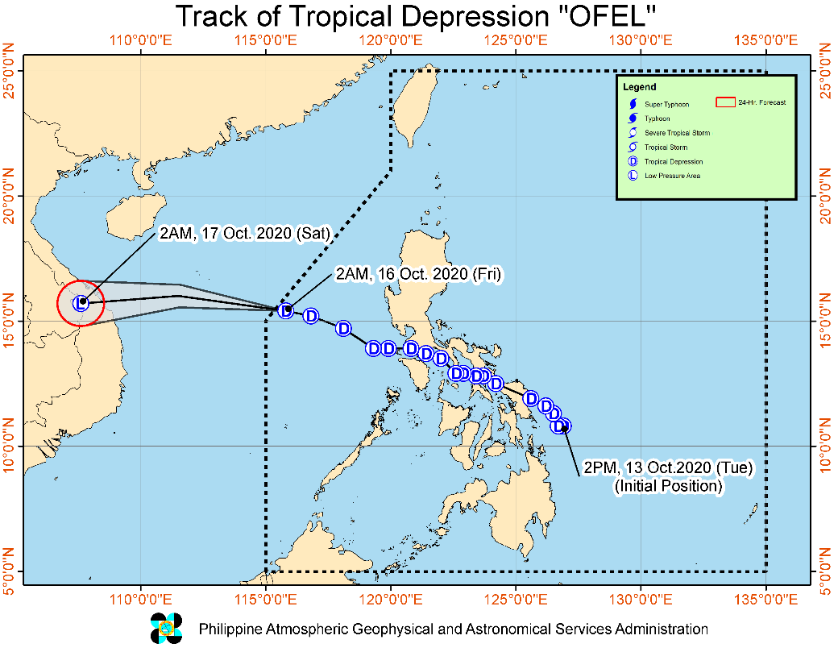
Situation Overview

Issued at 05:00 am today, TROPICAL DEPRESSION "OFEL" IS NOW OUTSIDE THE PHILIPPINE AREA OF RESPONSIBILITY (PAR).

- "OFEL" will continue moving generally westward over the West Philippine Sea in the next 24 hours. The tropical depression is likely to persist until its landfall over the central portion of Vietnam between tonight and tomorrow early morning, where it is expected to weaken into a remnant low.
- Rainfall: Today, the Southwest Monsoon will bring light to moderate with at times heavy rains due to Southwest Monsoon over MIMAROPA, Western Visayas, Central Visayas, Northern Mindanao, Bangsamoro, and Zamboanga Peninsula. Flooding (including flashfloods) and rain-induced landslides may occur during heavy or prolonged rainfall especially in areas that are highly or very highly susceptible to these hazards. PAGASA Regional Services Divisions may issue local thunderstorm/rainfall advisories and heavy rainfall warnings as appropriate.
- Winds: Strong- to gale-force winds with occasional gusts due to the northeasterly surface wind flow will be experienced over Batanes, Babuyan Islands, and the northern coastal and/or mountainous areas of mainland Cagayan, Apayao and Ilocos Norte. Strong-force winds with occasional gusts due to the Southwest Monsoon will be experienced over Kalayaan Islands and the coastal and mountainous areas of southern Palawan.

Hazards affecting coastal waters:
- Gale Warning is in effect over the seaboards of Batanes, Cagayan, and Ilocos Norte due to rough to very rough seas (2.8 to 4.5 m) associated with the northeasterly surface wind flow. Sea travel is risky over these areas, especially for those using small seacrafts.
- Moderate to rough seas (2.1 to 3.5 m) due to the Southwest Monsoon and the northeasterly surface windflow will also be experienced over the remaining seaboards of Northern Luzon and the eastern and western seaboards of Central and Southern Luzon. Those with small seacrafts are advised to take precautionary measures when venturing out to sea.

At 4:00 AM today, the center of Tropical Depression "OFEL" was estimated based on all available data at 500 km West of Iba, Zambales (OUTSIDE PAR) (15.4 °N, 115.3 °E )

Source: DOST-PAGASA Severe Weather Bulletin

- Status of Affected Families / Persons
A total of 926 families or 3,518 persons were affected in 74 barangays in Regions CALABARZON and V (see Table 1).

Table 1. Number of Affected Families / Persons
REGION / PROVINCE / MUNICIPALITY |  | NUMBER OF AFFECTED
 |  | Barangays | Families | Persons
GRAND TOTAL |  | 74 | 926 | 3,518
CALABARZON |  | 52 | 749 | 2,758
Laguna |  | 16 | 152 | 640
 | Cabuyao | 1 | 3 | 11
 | City of Calamba | 3 | 60 | 232
 | Calauan | 1 | 4 | 13
 | Liliw | 3 | 29 | 139
 | Los Baños | 4 | 28 | 104
 | Nagcarlan | 1 | 2 | 9
 | Paete | 1 | 22 | 99
 | Pangil | 1 | 1 | 4
 | Santa Cruz (capital) | 1 | 3 | 29
Quezon |  | 36 | 597 | 2,118
 | Calauag | 3 | 37 | 153
 | Candelaria | 1 | 6 | 22
 | Gumaca | 17 | 422 | 1,453
 | Lopez | 3 | 33 | 121
 | Lucena City (capital) | 2 | 23 | 99
 | Pitogo | 6 | 64 | 219
 | Plaridel | 4 | 12 | 51
REGION V |  | 22 | 177 | 760
Camarines Norte |  | 10 | 58 | 238
 | Labo | 1 | 25 | 106
 | Mercedes | 2 | 11 | 34
 | San Vicente | 2 | 6 | 30
 | Talisay | 4 | 12 | 50
 | Vinzons | 1 | 4 | 18
Camarines Sur |  | 12 | 119 | 522
 | Buhi | 2 | 56 | 243
 | Del Gallego | 4 | 14 | 63
 | Lupi | 2 | 32 | 133
 | Ragay | 2 | 15 | 76
 | Siruma | 2 | 2 | 7
Note: Ongoing assessment and validation being conducted.
Source: DSWD-FOs CALABARZON and V

- Status of Displaced Families / Persons
- Inside Evacuation Centers
There are 502 families or 1,780 persons taking temporary shelter in 41 evacuation centers in Regions CALABARZON and V (see Table 2).

Table 2. Number of Displaced Families / Persons Inside Evacuation Centers
REGION / PROVINCE / MUNICIPALITY |  | NUMBER OF EVACUATION CENTERS (ECs) |  | NUMBER OF DISPLACED
 |  |  |  | INSIDE ECs
 |  |  |  | Families |  | Persons
 |  | CUM | NOW | CUM | NOW | CUM | NOW
GRAND TOTAL |  | 73 | 41 | 767 | 502 | 2,929 | 1,780
CALABARZON |  | 48 | 41 | 592 | 502 | 2,176 | 1,780
Laguna |  | 15 | 8 | 142 | 86 | 602 | 347
 | Cabuyao | 1 | 1 | 3 | 3 | 11 | 11
 | City of Calamba | 2 | 2 | 52 | 52 | 203 | 203
 | Calauan | 1 | - | 4 | - | 13 | -
 | Liliw | 3 | - | 29 | - | 139 | -
 | Los Baños | 4 | 4 | 28 | 28 | 104 | 104
 | Paete | 2 | - | 22 | - | 99 | -
 | Pangil | 1 | - | 1 | - | 4 | -
 | Santa Cruz (capital) | 1 | 1 | 3 | 3 | 29 | 29
Quezon |  | 33 | 33 | 450 | 416 | 1,574 | 1,433
 | Calauag | 3 | 3 | 37 | 37 | 153 | 153
 | Candelaria | 1 | 1 | 6 | 6 | 22 | 22
 | Gumaca | 14 | 14 | 303 | 274 | 1,020 | 884
 | Lopez | 4 | 4 | 33 | 33 | 121 | 121
 | Lucena City (capital) | 2 | 2 | 23 | 18 | 99 | 94
 | Pitogo | 4 | 4 | 39 | 39 | 118 | 118
 | Plaridel | 5 | 5 | 9 | 9 | 41 | 41
REGION V |  | 25 | - | 175 | - | 753 | -
Camarines Norte |  | 10 | - | 58 | - | 238 | -
 | Labo | 1 | - | 25 | - | 106 | -
 | Mercedes | 2 | - | 11 | - | 34 | -
 | San Vicente | 2 | - | 6 | - | 30 | -
 | Talisay | 4 | - | 12 | - | 50 | -
 | Vinzons | 1 | - | 4 | - | 18 | -
Camarines Sur |  | 15 | - | 117 | - | 515 | -
 | Buhi | 5 | - | 56 | - | 243 | -
 | Del Gallego | 4 | - | 14 | - | 63 | -
 | Lupi | 2 | - | 32 | - | 133 | -
 | Ragay | 2 | - | 15 | - | 76 | -
Note: Ongoing assessment and validation being conducted.
Source: DSWD-FOs CALABARZON and V

- Outside Evacuation Centers
There are 155 families or 568 persons currently staying with their relatives and/or friends in Regions CALABARZON and V (see Table 3).

Table 3. Number of Displaced Families / Persons Outside Evacuation Centers
REGION / PROVINCE / MUNICIPALITY |  | NUMBER OF DISPLACED
 |  | OUTSIDE ECs
 |  | Families |  | Persons
 |  | CUM | NOW | CUM | NOW
GRAND TOTAL |  | 160 | 155 | 586 | 568
CALABARZON |  | 158 | 155 | 579 | 568
Laguna |  | 13 | 10 | 49 | 38
 | City of Calamba | 8 | 8 | 29 | 29
 | Nagcarlan | 2 | 2 | 9 | 9
 | Pangil | 3 | - | 11 | -
Quezon |  | 145 | 145 | 530 | 530
 | Gumaca | 118 | 118 | 419 | 419
 | Pitogo | 25 | 25 | 101 | 101
 | Plaridel | 2 | 2 | 10 | 10
REGION V |  | 2 | - | 7 | -
Camarines Sur |  | 2 | - | 7 | -
 | Siruma | 2 | - | 7 | -
Note: Ongoing assessment and validation being conducted.
Source: DSWD-FOs CALABARZON and V

Status of Prepositioned Resources: Stockpile and Standby Funds

The DSWD Central Office (CO), Field Offices (FOs), and National Resource Operations Center (NROC) have stockpiles and standby funds amounting to ₱946,831,031.45 with breakdown as follows (see Table 2):

- Standby Funds
A total of ₱306,391,109.08 standby funds in the CO and FOs. Of the said amount, ₱263,367,817.19 is the available Quick Response Fund (QRF) in the CO.

- Stockpiles
A total of 218,484 family food packs (FFPs) amounting to ₱99,794,791.12, other food items amounting to ₱218,157,919.64 and non-food items (FNIs) amounting to ₱322,487,211.61 are available.

Table 4. Available Standby Funds and Stockpiles
Region / Office | Standby Funds | FAMILY FOOD PACKS |  | Other Food Items | Non-Food Relief Items | Total Standby Funds & Stockpile
 |  | Quantity | Total Cost
 | 306,391,109.08 | 218,484 | 99,794,791.12 | 218,157,919.64 | 322,487,211.61 | 946,831,031.45
Central Office | 263,367,817.19 | - | - | - | - | 263,367,817.19
NRLMB - NROC | - | 13,250 | 6,319,050.00 | 29,467,131.58 | 111,736,916.04 | 147,523,097.62
NRLMB - VDRC | - | 5,647 | 2,511,323.63 | 14,145,073.59 | 103,159.75 | 16,759,556.97
I | 3,000,455.20 | 2,858 | 1,223,613.54 | 2,813,730.00 | 31,166,997.46 | 38,204,796.20
II | 3,000,938.79 | 20,779 | 10,457,313.93 | 3,141,266.01 | 5,510,398.95 | 22,109,917.68
III | 2,181,900.00 | 12,002 | 4,665,467.46 | 5,398,151.71 | 5,295,371.88 | 17,540,891.05
CALABARZON | 3,000,000.00 | 7,502 | 2,751,492.00 | 4,465,835.12 | 4,069,768.72 | 14,287,095.84
MIMAROPA | 3,100,744.58 | 30,165 | 13,574,250.00 | 1,765,909.00 | 6,022,877.80 | 24,463,781.38
V | 3,228,250.00 | 15,928 | 5,094,351.94 | 1,053,537.41 | 26,420,032.90 | 35,796,172.25
VI | 3,000,051.68 | 21,199 | 7,918,656.94 | 48,660,483.77 | 5,890,820.31 | 65,470,012.70
VII | 3,000,462.71 | 7,397 | 3,698,500.00 | 20,307,123.37 | 78,198.00 | 27,084,284.08
VIII | 3,003,550.00 | 18,031 | 9,679,527.08 | 6,648,181.70 | 19,619,830.38 | 38,951,089.16
IX | 56,000.00 | 12,908 | 7,054,092.92 | 15,683,126.16 | 9,622,742.28 | 32,415,961.36
X | 3,000,724.42 | 17,455 | 9,270,615.50 | 31,798,961.86 | 27,895,054.53 | 71,965,356.31
XI | 3,000,001.00 | 6,846 | 2,534,046.90 | 12,367,725.00 | 19,758,485.36 | 37,660,258.26
XII | 1,449,000.68 | 895 | 492,250.00 | 5,464,198.12 | 11,580,932.78 | 18,986,381.58
CARAGA | 3,000,740.55 | 7,872 | 4,124,531.58 | 5,250,696.03 | 16,702,600.67 | 29,078,568.83
NCR | 3,000,439.00 | 1,677 | 921,176.10 | 7,479,060.00 | 9,929,291.41 | 21,329,966.51
CAR | 3,000,033.28 | 16,073 | 7,504,531.60 | 2,247,729.21 | 11,083,732.39 | 23,836,026.48
Note: The Inventory Summary is as of 16 October 2020, 4PM.
Source: DRMB and NRLMB

Situational Reports

DSWD-DRMB
DATE | SITUATIONS / ACTIONS UNDERTAKEN
16 October 2020 | - The Disaster Response Management Bureau (DRMB) is on BLUE alert status and is closely coordinating with the concerned Field Offices for significant disaster response updates.  - All QRT members and emergency equipment are on standby and ready for deployment.

DSWD-FO CALABARZON
DATE | SITUATIONS / ACTIONS UNDERTAKEN
16 October 2020 | - DSWD-FO CALABARZON through the Disaster Response Management Division (DRMD) advised the LGUs conducting assessment to share their findings with the response cluster of the Regional Disaster Risk Reduction and Management Council (RDRRMC) IV-A. In addition, LSWDOs are advised to share their activities and types of relief items or assistance provided to the community.  - DSWD-FO CALABARZON DRMD maintains close coordination with the affected LGUs and other relevant government agencies for identification of potential support and augmentation from the Field Office.  - Provincial Action Teams (PAT) and Provincial Quick Response Teams (PQRTs) of Quezon and Laguna were advised to be on stand-by alert status for possible deployment and conduct assessment in the affected areas.  - Regional and Provincial Quick Response Teams (PRQRTs) were advised to monitor weather forecast and warnings regarding anticipated risk due to movement of TD “Ofel” over the Philippine Sea.  - DSWD-FO CALABARZON DRMD coordination with Batangas Provincial Social Welfare and Development Office (PSWDO) provided temporary shelter to 145 persons stranded at the Port of Batangas.  - DSWD-FO CALABARZON DRMD Emergency Operations Center maintains close coordination with the PSWDOs for the assistance on assistance to be provided by the LGUs and other stakeholders.  - DSWD-FO CALABARZON DRMD is in close coordination with the RDRRMC IV-A Emergency Operations Center for latest development. The DRMD is on standby, continuously monitoring the situation of the affected LGUs.

DSWD-FO MIMAROPA
DATE | SITUATIONS / ACTIONS UNDERTAKEN
15 October 2020 | - DSWD-FO MIMAROPA submitted their terminal report.  - A total of 158 families or 665 persons have pre-emptively evacuated in 9 Evacuation Centers in Oriental Mindoro.  REGION / PROVINCE / MUNICIPALITY NUMBER OF EVACUATION CENTERS (ECs) NUMBER OF DISPLACED  INSIDE ECs  Families Persons  MIMAROPA 9 158 665  Oriental Mindoro 9 158 665  Baco 2 2 6  Bulalacao (San Pedro) 4 140 577  City of Calapan (capital) 2 11 57  Puerto Galera 1 5 25

DSWD-FO V
DATE | SITUATIONS / ACTIONS UNDERTAKEN
16 October 2020 | - DSWD-FO V submitted their terminal report.

*****
The Disaster Response Operations Monitoring and Information Center (DROMIC) of the DSWD-DRMB is closely monitoring the effects of TD “Ofel” and is coordinating with the concerned DSWD Field Offices for any significant updates.

Prepared by:

MARIE JOYCE G. RAFANAN

LESLIE R. JAWILI
Releasing Officer

