DSWD DROMIC Report #2 on Typhoon “Quinta”
as of 25 October 2020, 6PM
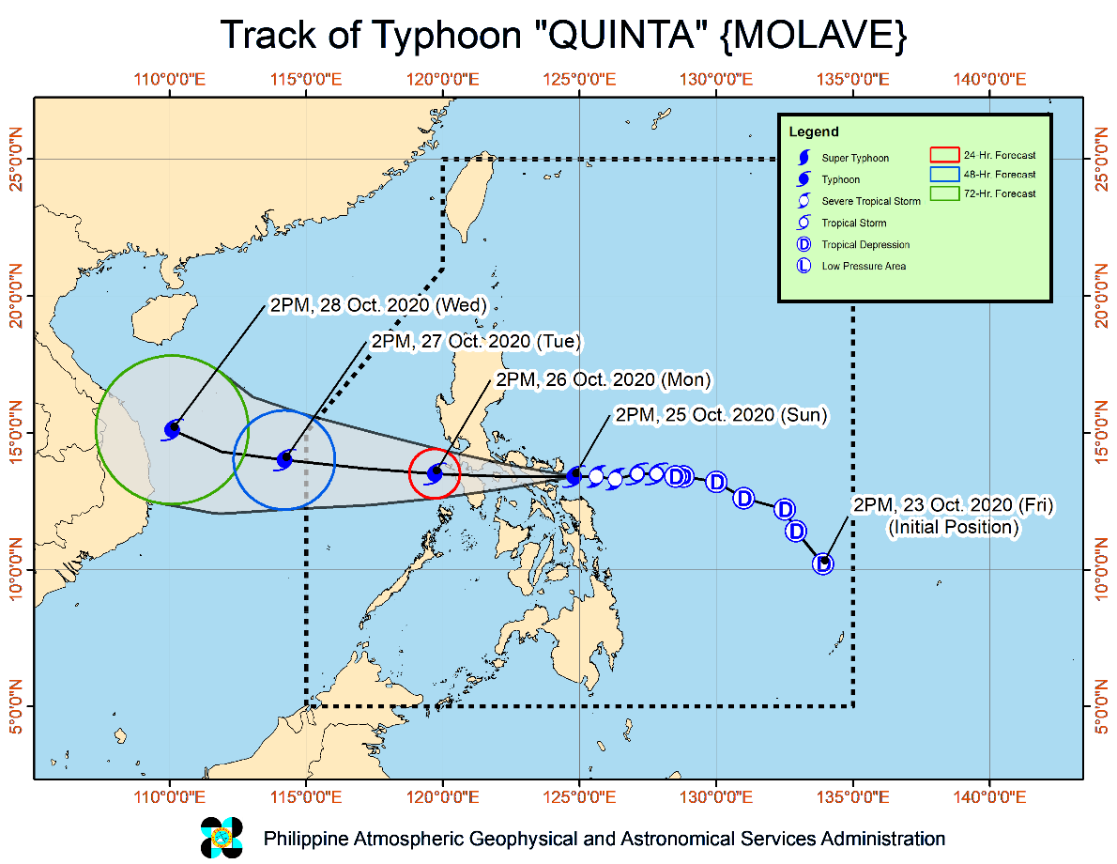
Situation Overview

At 05:00 PM, 25 October 2020, "QUINTA" RAPIDLY INTENSIFIES INTO A TYPHOON AS IT ENDANGERS ALBAY-CAMARINES SUR AREA.
- Track: "QUINTA" is forecast to continue moving generally westward until its landfall over eastern coast of Camarines Sur - northeastern coast of Albay between 6:00 and 8:00 PM today. Afterwards, it will traverse the Southern Luzon area until tomorrow afternoon, then turn west-northwestward over the West Philippine Sea. It is likely to exit the Philippine Area of Responsibility (PAR) on Tuesday afternoon.
- Intensity: "QUINTA" intensified into a typhoon at 2:00 PM today. After crossing the Philippine archipelago, this tropical cyclone will continue intensifying over the West Philippine Sea.
- Rainfall: Today through tomorrow morning, "QUINTA" will bring moderate to heavy with at times intense rains over Bicol Region, CALABARZON, Aurora, Occidental Mindoro, Oriental Mindoro, Romblon, Marinduque, Calamian Islands, Northern Samar, Eastern Samar, Samar, Biliran, Aklan, Capiz, and Antique. The tail-end of a frontal system will likewise bring moderate to heavy with at times intense rains over Cagayan, Isabela, Apayao, and Ilocos Norte. These two weather systems will also bring light to moderate with at times heavy rains over Metro Manila and the rest of Luzon, Zamboanga Peninsula, Bangsamoro, Northern Mindanao, Caraga, and the rest of Visayas. Flooding (including flash floods), rain-induced landslides, and sediment-laden streamflows (i.e. lahars) may occur during heavy or prolonged rainfall especially in areas that are highly or very highly susceptible to these hazards. PAGASA Regional Services Divisions may issue local thunderstorm/rainfall advisories and heavy rainfall warnings as appropriate.
- Strong winds: Typhoon-force winds will be experienced in areas under Tropical Cyclone Wind Signal (TCWS) #3, storm-force winds in areas under TCWS #2, and strong breeze to near gale conditions in areas under TCWS #1. Potential impacts of these wind conditions to structures and vegetation are detailed in the TCWS section of this bulletin. In other areas, strong breeze to gale conditions will also prevail over Batanes, Babuyan Islands, and the northern coastal areas of Ilocos Norte and mainland Cagayan due to the northeasterly surge.
At 4:00 PM today, the center of Tropical Depression "QUINTA" was estimated based on all available data at 610 km East of Juban, Sorsogon (13.2 °N, 129.6 °E )
Source: DOST-PAGASA Severe Weather Bulletin

- Status of Affected Families / Persons
A total of 21 families or 105 persons were affected in 1 Brgy. in Cabanatuan, Nueva Ecija (see Table 1).

Table 1. Number of Affected Families / Persons
REGION / PROVINCE / MUNICIPALITY |  | NUMBER OF AFFECTED
 |  | Barangays | Families | Persons
GRAND TOTAL |  | 1 | 21 | 105
REGION III |  | 1 | 21 | 105
Nueva Ecija |  | 1 | 21 | 105
 | Cabanatuan City | 1 | 21 | 105
Source: DSWD-FO III

- Status of Displaced Families / Inside Evacuation Centers
A total of 42 families or 210 persons are taking temporary shelter at the Lazaro Francisco Integrated School (see Table 2).

Table 2. Displaced Families / Persons Inside Evacuation Center
REGION / PROVINCE / MUNICIPALITY |  | NUMBER OF EVACUATION CENTERS (ECs) |  | NUMBER OF DISPLACED
 |  |  |  | INSIDE ECs
 |  |  |  | Families |  | Persons
 |  | CUM | NOW | CUM | NOW | CUM | NOW
GRAND TOTAL |  | 1 | 1 | 42 | 42 | 210 | 210
REGION III |  | 1 | 1 | 42 | 42 | 210 | 210
Nueva Ecija |  | 1 | 1 | 42 | 42 | 210 | 210
 | Cabanatuan City | 1 | 1 | 42 | 42 | 210 | 210
Source: DSWD-FO II

PREDICTIVE ANALYTICS FOR HUMANITARIAN RESPONSE
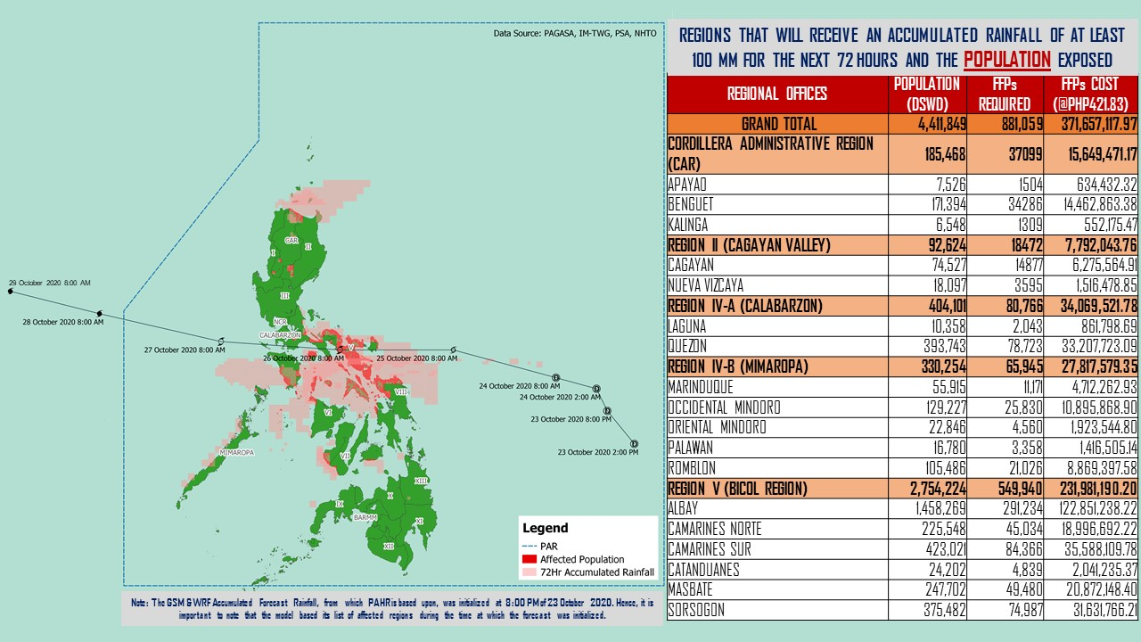
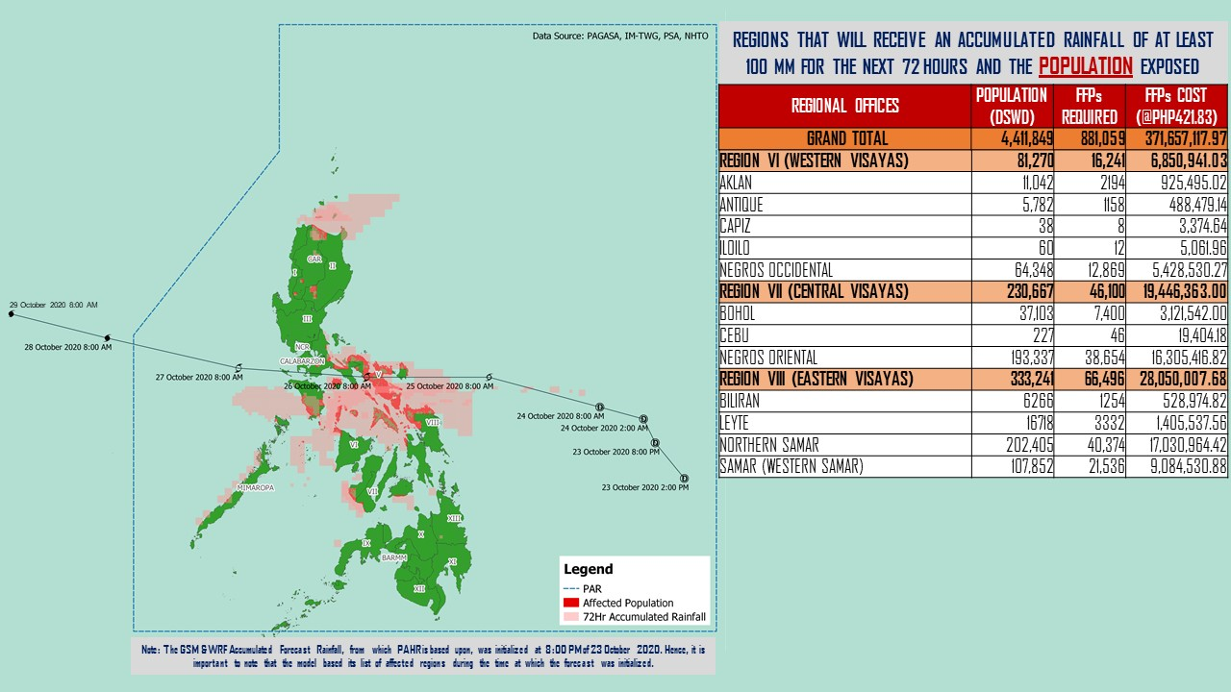

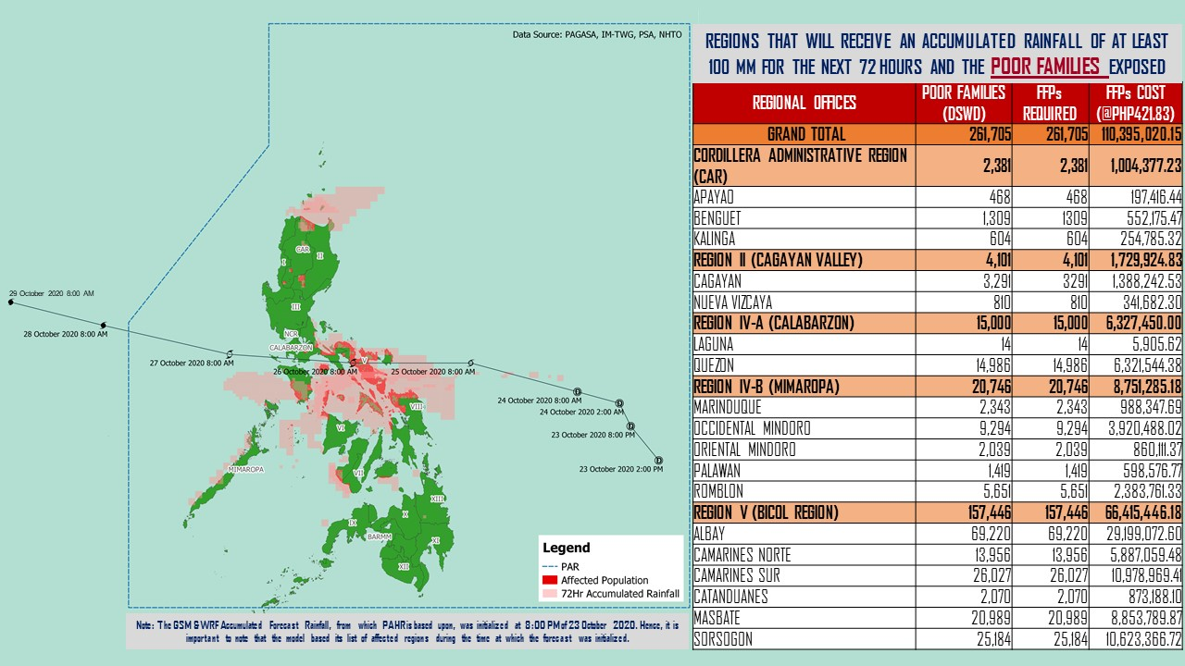

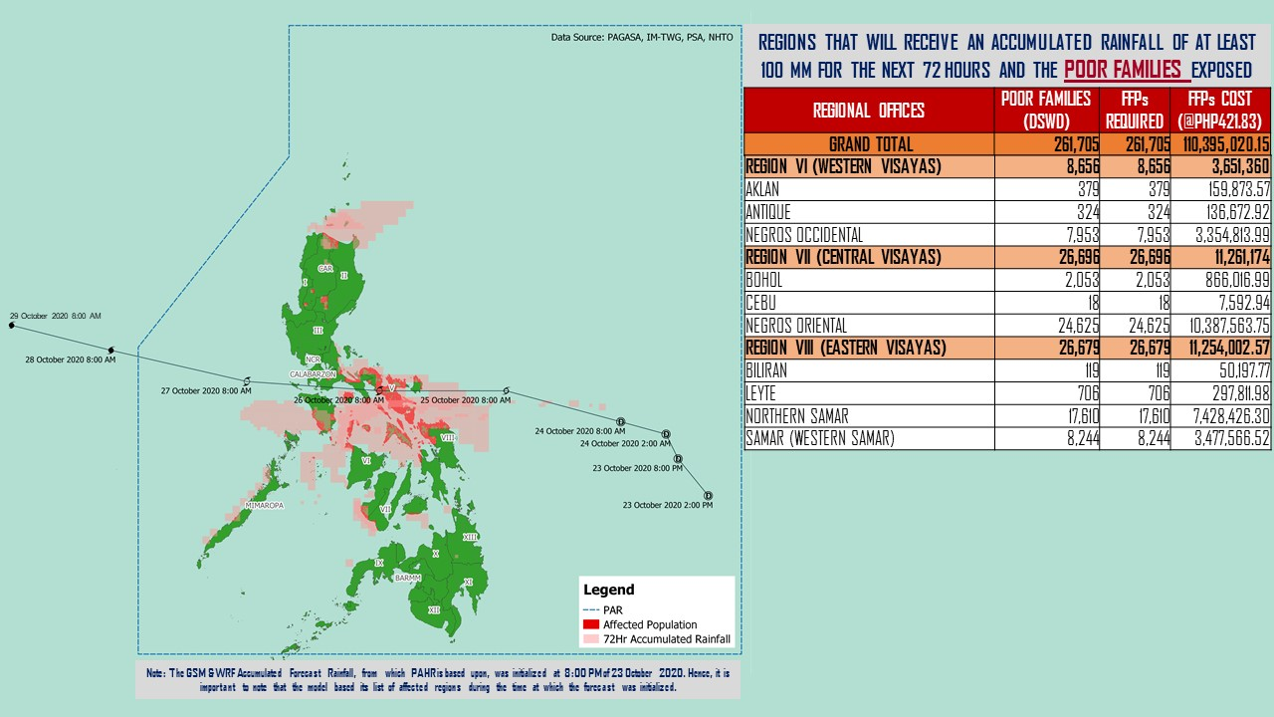

Source: DRMB-DROMIC GIS Specialists
Status of Prepositioned Resources: Stockpile and Standby Funds
The DSWD Central Office (CO), Field Offices (FOs), and National Resource Operations Center (NROC) have stockpiles and standby funds amounting to ₱890,596,116.79 with breakdown as follows (see Table 1):

- Standby Funds
A total of ₱302,882,354.54 standby funds in the CO and FOs. Of the said amount, ₱263,367,817.19 is the available Quick Response Fund (QRF) in the CO.

- Stockpiles
A total of 249,121 family food packs (FFPs) amounting to ₱112,049,761.57, other food items amounting to ₱194,056,123.53 and non-food items (FNIs) amounting to ₱281,607,877.15 are available.

Table 1. Available Standby Funds and Stockpiles
Region / Office | Standby Funds | FAMILY FOOD PACKS |  | Other Food Items | Non-Food Relief Items | Total Standby Funds & Stockpile
 |  | Quantity | Total Cost
 | 302,882,354.54 | 249,121 | 112,049,761.57 | 194,056,123.53 | 281,607,877.15 | 890,596,116.79
Central Office | 263,367,817.19 | - | - | - | - | 263,367,817.19
NRLMB - NROC | - | 8,050 | 4,271,550.00 | 22,011,145.48 | 72,856,098.39 | 99,138,793.87
NRLMB - VDRC | - | 8,847 | 3,935,631.63 | 7,007,812.43 | 103,159.75 | 11,046,603.81
I | 490,455.20 | 1,821 | 830,659.32 | 2,813,730.00 | 31,166,997.46 | 35,301,841.98
II | 3,000,938.79 | 17,317 | 8,855,191.11 | 3,141,266.01 | 5,510,398.95 | 20,507,794.86
III | 4,205,028.74 | 7,523 | 2,988,809.70 | 5,398,151.71 | 5,294,121.88 | 17,886,112.03
CALABARZON | 3,000,000.00 | 7,784 | 1,643,576.00 | 3,376,598.98 | 4,069,663.12 | 12,089,838.10
MIMAROPA | 3,100,744.58 | 30,451 | 13,702,950.00 | 1,765,909.00 | 5,879,198.80 | 24,448,802.38
V | 3,000,000.00 | 14,555 | 4,604,759.08 | 1,053,537.41 | 26,420,032.90 | 35,078,329.39
VI | 3,000,051.68 | 30,329 | 10,984,286.94 | 48,660,483.77 | 5,890,820.31 | 68,535,642.70
VII | 3,000,462.71 | 16,719 | 7,412,339.20 | 14,758,012.19 | 78,198.00 | 25,249,012.10
VIII | 3,003,550.00 | 17,831 | 9,724,976.08 | 6,648,181.70 | 19,619,830.38 | 38,996,538.16
IX | 56,000.00 | 10,030 | 5,481,294.70 | 15,614,222.16 | 8,518,245.45 | 29,669,762.31
X | 3,000,724.42 | 39,408 | 21,755,647.42 | 31,174,169.86 | 27,940,054.89 | 83,870,596.59
XI | 3,000,001.00 | 5,293 | 1,959,203.95 | 12,292,725.00 | 19,758,485.36 | 37,010,415.31
XII | 1,449,000.68 | 2,214 | 1,217,700.00 | 3,885,006.55 | 10,899,586.54 | 17,451,293.77
CARAGA | 3,000,740.55 | 13,892 | 4,519,439.08 | 5,239,330.83 | 16,589,961.17 | 29,349,471.63
NCR | 3,000,439.00 | 1,677 | 921,176.10 | 7,479,060.00 | 9,929,291.41 | 21,329,966.51
CAR | 206,400.00 | 15,380 | 7,240,571.26 | 1,736,780.45 | 11,083,732.39 | 20,267,484.10
Note: The Inventory Summary is as of 25 October 2020, 4PM.
Source: DRMB and NRLMB

Situational Reports

DSWD-DRMB
DATE | SITUATIONS / ACTIONS UNDERTAKEN
25 October 2020 | - The Disaster Response Management Bureau (DRMB) is on BLUE alert status and is closely coordinating with the concerned field offices for significant disaster response updates  - All QRT members and emergency equipment are on standby and ready for deployment.  - DRMB participated in the Online Pre-Disaster Risk Assessment Meeting on Tropical Depression “Quinta” on 24 October 2020 with other response cluster member agencies. Further meetings shall be conducted on the implementation of COVID-19 protocols during the response efforts on TD “Quinta”.

DSWD-FO CAR
DATE | SITUATIONS / ACTIONS UNDERTAKEN
- October 2020 | - DSWD-FO CAR DRMD are on standby to render duty at the Operations Center and monitor the status on the ground as well as the alert status and weather updates.  - The Provincial Social Welfare and Development Teams (PSWADT) DRMD PDO IIs were informed of the situation.  - Municipal Action Teams are on standby.  - Continuous coordination by the DRMD PDO IIs assigned in the PSWADTs with the LDRRMOs for updates.  - Rapid Emergency Telecommunications Team (RETT) including the International Maritime/Marine Satellite (INMARSAT) equipment are on standby.  - DSWD-FO CAR DRMD prepared reports for the weather disturbance and shared it to the end users.  - The Operations Center is on RED ALERT since 16 March 2020.  - Pre-disaster Risk Assessment Meeting via video teleconferencing attended by Ms. Mary Ann G. Buclao.  - Close coordination with Cordillera Regional Disaster Risk Reduction and Management Council Emergency Operations Center for updates.  - QRT and Delta Teams were on standby for possible deployment.  - Cascaded the susceptibility map to Provincial SWAD Teams for their guidance.  - Evacuations Center Updated for dissemination to SWADs.
DSWD-FO III
DATE | SITUATIONS / ACTIONS UNDERTAKEN
25 October 2020 | - Activation of Rapid Deployment Team-Disaster Response Management Division of DSWD Field Office and DSWD Provincial Extension Office Quick Response Team.  - Participated during the conduct of Pre-Disaster Risk Assessment with RDRRMC Members.  - Continuous monitoring of weather updates in coordination with the DPEO’s and concerned LGUs.

DSWD-FO MIMAROPA
DATE | SITUATIONS / ACTIONS UNDERTAKEN
- October 2020 | - DSWD-FO MIMAROPA Disaster Response Management Division and SWADT Offices are alerted to monitor daily local weather condition and ensure provision of information to all concerned offices, divisions, sections, offices.  - 24/7 On-call status of the R/P/C/M QRTs together with special projects staff for possible activation of Operation Center.  - Close coordination with the Office of Civil Defense (OCD) and RDRRMC MIMAROPA for any warning signal updates for monitoring purposes and response mechanism for areas that will be affected.  - Standby logistical equipment and workforce through coordination with SWADT Offices and concerned LGUs on the management of stranded passengers, if any, in ports and terminals.  - Information and Communication Technology Management Unit (ICTMU) is on standby status to ensure robust communication system.  - Ensure that there is an on-call truck available for delivery of goods and equipment to areas that will be affected.

DSWD-FO V
DATE | SITUATIONS / ACTIONS UNDERTAKEN
25 October 2020 | - A total of 551 families or 1,864 persons have pre-emptively evacuated in 5 Evacuation Centers in Region V.  REGION / PROVINCE / MUNICIPALITY NUMBER OF EVACUATION CENTERS (ECs) NUMBER OF DISPLACED  INSIDE ECs  Families Persons  GRAND TOTAL 5 551 1,864  REGION V 5 551 1,864  Albay 3 521 1,747  Guinobatan 3 521 1,747  Camarines Sur 1 11 42  Canaman 1 11 42  Sorsogon 1 19 75  Casiguran 1 19 75  - DSWD-FO V continuous to monitor weather updates and information.  - The Resource Operation Section ensures the availability of family food packs and non-food items as need arises.  - DSWD-FO V QRTs are activated.  - QRTs in POO and MOO Level are on Blue Alert Status. C/MATs are in close coordination with C/MDRRMOs for situational updates on pre-emptive evacuation, report on standees etc.  - PAT and MAT members in the 6 provinces are activated and instructed to coordinate with the P/MDRRMOs, C/MSWDOs for reports and updates.

DSWD-FO VIII
DATE | SITUATIONS / ACTIONS UNDERTAKEN
25 October 2020 | - DSWD-FO VIII prepositioned Family Food Packs (FFPs) in Samar Island which can be distributed immediately by the P/C/MATs to Local Government Units that need augmentation support.  - Communicated SWAD Teams and City/Municipal Actions Teams to be alerted on the Severe Tropical Storm “Quinta”.  - Conducted Pre-Disaster Risk Assessment Meeting on 23 October 2020 prior to RDRRMC PDRA Meeting and discussed internal preparations of the department considering that the implementation of Bayanihan to Heal as One Act is still ongoing and Bayanihan to Recover as One Act has started its planning phase.  - Contacted VDRC and NRLMB for the possible augmentation of FFPs to Eastern Visayas considering that some of our family food packs are for fumigation and stockpile is insufficient to respond to the possible requests of LGUs.

*****
The Disaster Response Operations Monitoring and Information Center (DROMIC) of the DSWD-DRMB is closely monitoring the effects of Severe Tropical Storm “Quinta” and is coordinating with the concerned DSWD Field Offices for any significant updates.

Prepared by:

MARIE JOYCE G. RAFANAN
JAN ERWIN ANDREW I. ONTANILLAS

LESLIE R. JAWILI
Releasing Officer

