DSWD DROMIC Report #2 on the Tropical Storm “PEPITO”
as of 22 October 2020, 6PM

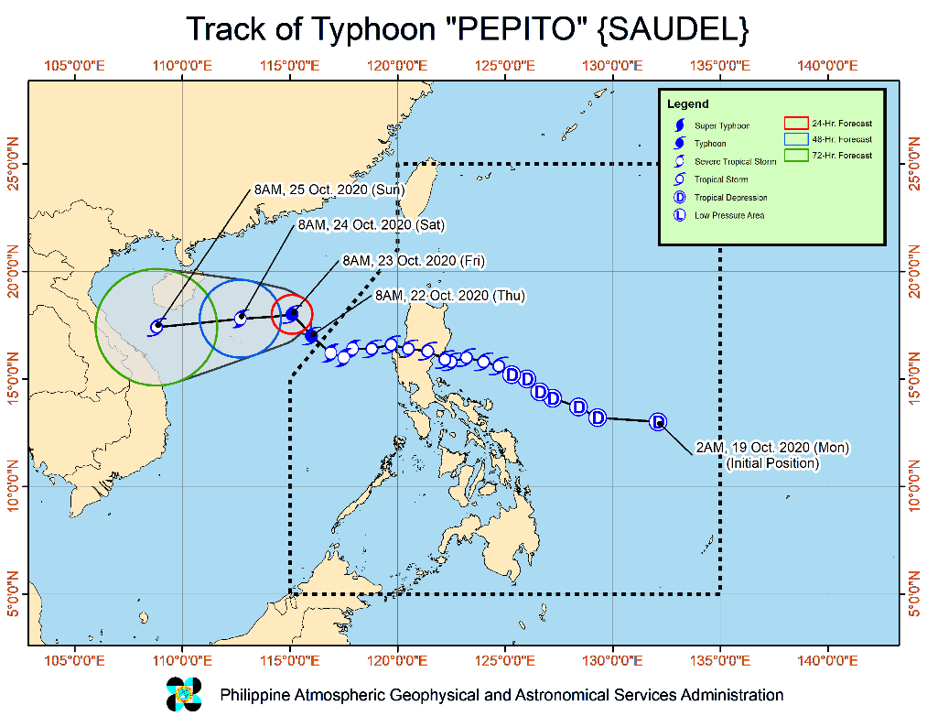
SITUATION OVERVIEW

Issued at 11:00 am today, TYPHOON "PEPITO" IS NOW OUTSIDE THE PHILIPPINE AREA OF RESPONSIBILITY (PAR).

Track and intensity outlook:
- Track: "PEPITO" left the PAR at 7:30 AM today. On the forecast track, this tropical cyclone will move northwestward today and turn westward beginning tomorrow. It is forecast to make landfall over central portion of Vietnam by Sunday.
- Intensity: "PEPITO" intensified into a typhoon at 8:00 AM today and may reach its peak intensity tomorrow.

Hazards affecting land areas:
- Rainfall: Today, light to moderate with at times heavy rains will be experienced over Batanes, Pangasinan, Zambales, Bataan, Occidental Mindoro, and Palawan. Flooding (including flash floods) and rain-induced landslides may occur during heavy or prolonged rainfall especially in areas that are highly or very highly susceptible to these hazards. PAGASA Regional Services Divisions may issue local thunderstorm/rainfall advisories and heavy rainfall warnings as appropriate.
- Winds: High winds to gale-force winds with occasional gusts due to "PEPITO" will continue to affect the Northern and Central Luzon, especially over the western portions of these areas. Such conditions are more likely to be experienced in coastal and mountainous areas.

Hazards affecting coastal waters:
- Gale Warning remains in effect over the northern and western seaboards of Northern Luzon and the western seaboards of Central Luzon, Batangas, Occidental Mindoro (including Lubang Island), and Palawan (including Calamian and Kalayaan Islands) due to rough to very rough seas (2.8 to 5.5 m). Sea travel is risky over these areas, especially for small seacrafts.
- Moderate to rough seas (1.5 to 2.5 m) will prevail over the eastern seaboards of Luzon. Those with small seacrafts are advised to take precautionary measures when venturing out to sea. Inexperienced mariners should avoid navigating in these conditions.
- Other disturbance being monitored (as of 10:00 AM):
- The Tropical Depression outside the PAR weakened into a Low-Pressure Area (LPA) at 8:00 AM today. It was estimated based on all available data at 1,870 km East Northeast of Extreme Northern Luzon (25.5 °N,139.4 °E). This disturbance remains less likely to enter the PAR.
- The Low-Pressure Area outside the PAR was estimated based on all available data at 1,200 km East of Mindanao (9.3 °N, 137.2 °E). It is likely to enter the PAR tomorrow and may develop into a tropical depression during the weekend. It is not affecting the weather over any portion of the country at this time.

Other disturbance being monitored:
At 10:00 AM today, the eye of Typhoon "PEPITO" was located based on all available data at 475 km West Northwest of Iba, Zambales (OUTSIDE PAR) (17.0 °N, 115.9 °E)
Source: PAGASA Severe Weather Bulletin

- Status of Affected Families / Persons
A total of 34,404 families or 162,958 persons were affected by the Tropical Storm “Pepito” in 230 barangays in Regions II, III and CALABARZON (see Table 1).

Table 1. Number of Affected Families / Persons
REGION / PROVINCE / MUNICIPALITY |  | NUMBER OF AFFECTED
 |  | Barangays | Families | Persons
GRAND TOTAL |  | 230 | 34,404 | 162,958
REGION II |  | 55 | 765 | 2,696
Cagayan |  | 2 | 119 | 423
 | Rizal | 1 | 115 | 410
 | Tuguegarao City (capital) | 1 | 4 | 13
Isabela |  | 37 | 566 | 2,001
 | Aurora | 1 | 7 | 26
 | Benito Soliven | 1 | 4 | 11
 | Cabatuan | 3 | 6 | 16
 | Cordon | 1 | 1 | 2
 | Dinapigue | 3 | 63 | 213
 | Ilagan (capital) | 4 | 41 | 137
 | Jones | 2 | 15 | 52
 | Maconacon | 8 | 218 | 684
 | San Guillermo | 10 | 76 | 262
 | San Mariano | 3 | 31 | 138
 | City of Santiago | 1 | 104 | 460
Nueva Vizcaya |  | 9 | 34 | 131
 | Aritao | 4 | 12 | 40
 | Bambang | 3 | 17 | 75
 | Dupax del Norte | 1 | 2 | 6
 | Quezon | 1 | 3 | 10
Quirino |  | 7 | 46 | 141
 | Aglipay | 2 | 3 | 9
 | Cabarroguis (capital) | 2 | 27 | 79
 | Maddela | 3 | 16 | 53
REGION III |  | 83 | 27,965 | 133,857
Aurora |  | 32 | 308 | 1,154
 | Baler (capital) | 6 | 18 | 86
 | Casiguran | 7 | 114 | 452
 | Dilasag | 2 | 4 | 12
 | Dinalungan | 6 | 91 | 253
 | Dingalan | 6 | 67 | 293
 | Maria Aurora | 2 | 4 | 19
 | San Luis | 3 | 10 | 39
Bulacan |  | 25 | 4,235 | 23,935
 | San Miguel | 25 | 4,235 | 23,935
Nueva Ecija |  | 26 | 9,265 | 40,301
 | Cabanatuan City | 20 | 6,487 | 30,887
 | Licab | 6 | 2,778 | 9,414
Pampanga |  | - | 14,157 | 68,467
 | Masantol | - | 14,157 | 68,467
CALABARZON |  | 92 | 5,674 | 26,405
Laguna |  | 1 | 2 | 9
 | Santa Cruz (capital) | 1 | 2 | 9
Quezon |  | 91 | 5,672 | 26,396
 | Buenavista | 2 | 42 | 189
 | Calauag | 13 | 522 | 2,305
 | Catanauan | 12 | 1,829 | 9,145
 | General Luna | 3 | 29 | 158
 | Gumaca | 13 | 258 | 965
 | Lopez | 39 | 1,637 | 6,861
 | Real | 1 | 5 | 23
 | Tagkawayan | 8 | 1,350 | 6,750
Note: Ongoing assessment and validation being conducted.
Source: DSWD-FOs II, III and CALABARZON

II. Status of Displaced Families / Persons
- Inside Evacuation Centers
There are 4,071 families or 18,436 persons taking temporary shelter in 67 evacuation centers in Regions II, III and CALABARZON (see Table 2).

Table 2. Status of Displaced Families / Persons Inside Evacuation Centers
REGION / PROVINCE / MUNICIPALITY |  | NUMBER OF EVACUATION CENTERS (ECs) |  | NUMBER OF DISPLACED
 |  |  |  | INSIDE ECs
 |  |  |  | Families |  | Persons
 |  | CUM | NOW | CUM | NOW | CUM | NOW
GRAND TOTAL |  | 147 | 67 | 4,885 | 4,071 | 21,305 | 18,436
REGION II |  | 43 | 2 | 597 | 12 | 2,065 | 50
Cagayan |  | 1 | 1 | 3 | 3 | 9 | 9
 | Tuguegarao City (capital) | 1 | 1 | 3 | 3 | 9 | 9
Isabela |  | 31 | 1 | 538 | 9 | 1,887 | 41
 | Aurora | 1 | - | 7 | - | 26 | -
 | Cabatuan | 3 | - | 6 | - | 16 | -
 | Cordon | 1 | - | 1 | - | 2 | -
 | Dinapigue | 4 | - | 63 | - | 185 | -
 | Ilagan (capital) | 2 | 1 | 17 | 9 | 66 | 41
 | Jones | 2 | - | 15 | - | 52 | -
 | Maconacon | 4 | - | 218 | - | 680 | -
 | San Guillermo | 10 | - | 76 | - | 262 | -
 | San Mariano | 3 | - | 31 | - | 138 | -
 | City of Santiago | 1 | - | 104 | - | 460 | -
Nueva Vizcaya |  | 4 | - | 10 | - | 28 | -
 | Bambang | 2 | - | 5 | - | 12 | -
 | Dupax del Norte | 1 | - | 2 | - | 6 | -
 | Quezon | 1 | - | 3 | - | 10 | -
Quirino |  | 7 | - | 46 | - | 141 | -
 | Aglipay | 2 | - | 3 | - | 9 | -
 | Cabarroguis (capital) | 2 | - | 27 | - | 79 | -
 | Maddela | 3 | - | 16 | - | 53 | -
REGION III |  | 46 | 7 | 613 | 384 | 2,387 | 1,533
Aurora |  | 39 | - | 229 | - | 854 | -
 | Baler (capital) | 7 | - | 17 | - | 82 | -
 | Casiguran | 8 | - | 71 | - | 269 | -
 | Dilasag | 1 | - | 4 | - | 12 | -
 | Dinalungan | 7 | - | 56 | - | 140 | -
 | Dingalan | 10 | - | 67 | - | 293 | -
 | Maria Aurora | 2 | - | 4 | - | 19 | -
 | San Luis | 4 | - | 10 | - | 39 | -
Nueva Ecija |  | 7 | 7 | 384 | 384 | 1,533 | 1,533
 | Cabanatuan City | 7 | 7 | 384 | 384 | 1,533 | 1,533
CALABARZON |  | 58 | 58 | 3,675 | 3,675 | 16,853 | 16,853
Laguna |  | 1 | 1 | 2 | 2 | 9 | 9
 | Santa Cruz (capital) | 1 | 1 | 2 | 2 | 9 | 9
Quezon |  | 57 | 57 | 3,673 | 3,673 | 16,844 | 16,844
 | Calauag | 14 | 14 | 522 | 522 | 2,305 | 2,305
 | Catanauan | 12 | 12 | 1,829 | 1,829 | 9,145 | 9,145
 | General Luna | 1 | 1 | 27 | 27 | 149 | 149
 | Gumaca | 9 | 9 | 139 | 139 | 555 | 555
 | Lopez | 20 | 20 | 1,151 | 1,151 | 4,667 | 4,667
 | Real | 1 | 1 | 5 | 5 | 23 | 23
Note: Ongoing assessment and validation being conducted.
Source: DSWD-FOs II, III and CALABARZON
- Outside Evacuation Centers
There are 2,023 families or 9,624 persons currently staying with their relatives and/or friends in Regions II, III and CALABARZON (see Table 3).

Table 3. Status of Displaced Families / Persons Outside Evacuation Centers
REGION / PROVINCE / MUNICIPALITY |  | NUMBER OF DISPLACED
 |  | OUTSIDE ECs
 |  | Families |  | Persons
 |  | CUM | NOW | CUM | NOW
GRAND TOTAL |  | 2,119 | 2,023 | 9,992 | 9,624
REGION II |  | 41 | 24 | 140 | 72
Cagayan |  | 13 | 1 | 58 | 4
 | Rizal | 12 | - | 54 | -
 | Tuguegarao City (capital) | 1 | 1 | 4 | 4
Isabela |  | 28 | 23 | 82 | 68
 | Benito Soliven | 4 | - | 11 | -
 | Ilagan (capital) | 24 | 23 | 71 | 68
REGION III |  | 79 | - | 300 | -
Aurora |  | 79 | - | 300 | -
 | Baler (capital) | 1 | - | 4 | -
 | Casiguran | 43 | - | 183 | -
 | Dinalungan | 35 | - | 113 | -
CALABARZON |  | 1,999 | 1,999 | 9,552 | 9,552
Quezon |  | 1,999 | 1,999 | 9,552 | 9,552
 | Buenavista | 42 | 42 | 189 | 189
 | General Luna | 2 | 2 | 9 | 9
 | Gumaca | 119 | 119 | 410 | 410
 | Lopez | 486 | 486 | 2,194 | 2,194
 | Tagkawayan | 1,350 | 1,350 | 6,750 | 6,750
Note: Ongoing assessment and validation being conducted.
Source: DSWD-FOs II, III and CALABARZON
III. Status of Displaced Families / Persons
A total of ₱233,738.00 worth of assistance was provided to the families; of which, ₱44,650.00 was provided by DSWD and ₱189,088.00 from LGUs (see Table 4).

Table 4. Cost of Assistance Provided to Affected Families / Persons
REGION / PROVINCE / MUNICIPALITY |  | COST OF ASSISTANCE
 |  | DSWD | LGU | NGOs | OTHERS | GRAND TOTAL
GRAND TOTAL |  | 44,650.00 | 189,088.00 | - | - | 233,738.00
REGION II |  | 44,650.00 | - | - | - | 44,650.00
Cagayan |  | 44,650.00 | - | - | - | 44,650.00
 | Calayan | 44,650.00 | - | - | - | 44,650.00
REGION III |  | - | 189,088.00 | - | - | 189,088.00
Aurora |  | - | 5,488.00 | - | - | 5,488.00
 | Baler (capital) | - | 500.00 | - | - | 500.00
 | Casiguran | - | 3,882.00 | - | - | 3,882.00
 | Dilasag | - | 160.00 | - | - | 160.00
 | San Luis | - | 946.00 | - | - | 946.00
Bulacan |  | - | 183,600.00 | - | - | 183,600.00
 | San Miguel | - | 183,600.00 | - | - | 183,600.00

SITUATIONAL REPORT

DSWD-DRMB
DATE | SITUATIONS / ACTIONS UNDERTAKEN
22 October 2020 | - The Disaster Response Operations Monitoring and Information Center (DROMIC) of the DSWD-DRMB continues to closely coordinate with the concerned field offices for significant reports on the status of affected families, assistance, and relief efforts.

DSWD-FO CAR
DATE | SITUATIONS / ACTIONS UNDERTAKEN
22 October 2020 | - DSWD-FO CAR is on standby-alert to render duty at the Operation Center and in closely monitoring the status on the ground as well as the alert status and weather updates  - The Provincial Social Welfare and Development Teams (PSWADT) DRMD PDO IIs were informed of the situation.  - DSWD-FO CAR is on RED ALERT status  - Pre-disaster Risk Assessment Meeting via video teleconferencing attended by Ms. Mary Ann G. Buclao.  - DSWD-FO CAR is in close coordination with Cordillera Regional Disaster Risk Reduction and Management Council Emergency Operations Center for updates.

DSWD-FO NCR
DATE | SITUATIONS / ACTIONS UNDERTAKEN
21 October 2020 | - DSWD-FO NCR submitted their terminal report
20 October 2020 | - DSWD-FO NCR Quick Response Teams of composed of organic staff from the Field Office and Centers and Residential Care Facilities (C/RCFs) are activated and on standby in response to any eventualities. The assignment of said staff is scheduled per day.  - DSWD-FO NCR is continuously monitoring weather conditions and other emergencies through telephone, internet, cell phone, etc. by the Disaster Response Management Division Staff and Quick Response Team Leaders.

DSWD-FO I
DATE | SITUATIONS / ACTIONS UNDERTAKEN
21 October 2020 | - DSWD-FO I is in closely monitoring the possible effects of Tropical Storm “PEPITO” through the Department of Science and Technology – Philippine Atmospheric, Geophysical and Astronomical Services Administration (DOST – PAGASA) and close coordination with the RDRRMC Field Office I. Likewise, Provincial Operations Offices (POOs) are in close coordination with the different Provincial/City/Municipal Disaster Risk Reduction and Management Councils (P/C/MDRRMCs) and Provincial/City/Municipal Social Welfare and Development Offices (P/C/MSWDOs) to monitor the adverse effects that might be brought by the weather disturbance and submission of reports for significant updates.  - DSWD-FO I Regional Director Marcelo Nicomedes J. Castillo conducted a Response Cluster Meeting re: TS “PEPITO” through video conference on October 20, 2020 Updates on the baseline information and commitment of each member agency were discussed during the meeting.

DSWD-FO II
DATE | SITUATIONS / ACTIONS UNDERTAKEN
22 October 2020 | - The National Irrigation Administration- Magat River Integrated Irrigation System ordered the Dam discharge to maintain the safe water level of the dam. Public living near the Magat River were advised to take precautionary measures.  - The City Government of Tuguegarao assisted 4 families with 13 individuals in doing pre-emptive evacuation due to flooding; 3 families composed of 9 individuals were sent to Centro 1 Barangay Hall and 1 family with 4 individuals chose to stay in their relative’s house.
20 October 2020 | - DSWD-FO II-DRMD through the Regional Resource Operation Section ensures availability of Food and Non-Food Items at any given time.  - DSWD-FO II Disaster Response Information Management Section (DRIMS) is continuously monitoring the status of the said weather disturbance thru the PAGASA weather bulletin/advisory.  - The Regional Disaster Management Response Team is already activated on a 24-hour duty. The team started to monitor the status of affected families though the SWADTs, P/C/MATs coordination with LGUs.

DSWD-FO III
DATE | SITUATIONS / ACTIONS UNDERTAKEN
22 October 2020 | - DSWD-FO III participated the conduct of Pre-Disaster Risk Assessment with RDRRMC Members.  - DSWD-FO III is continuously monitoring of weather updates in coordination with the DPEO’s and concerned LGUs.  - DSWD-FO III activated the Rapid Deployment Team of Disaster Response Management Division
21 October 2020 | - DSWD-FO III has 15 active QRTs with 27 members per team that are ready for deployment upon the activation of the Blue and Red alert status of the RDRRMC III.  - DSWD-FO III activated DRMD skeletal duty from the Regional Office  - DSWD-FO III is continuously coordinating and monitoring with the DSWD Provincial Extension Office of the seven (7) provinces relative to the status of their respective area.  - DSWD-FO III is ongoing repacking of 5,454 family food packs in Regional Warehouse.  - DSWD-FO III is ongoing procurement of 6,000 family food packs.

DSWD-FO CALABARZON
DATE | SITUATIONS / ACTIONS UNDERTAKEN
22 October 2020 | - The DRMD coordinated with the Regional Disaster Risk Reduction and Management Council (RDRRMC) IV-A for the mobilization of vehicle logistics to transport Family Food Packs in the heavily affected areas of Quezon.  - DSWD-FO CALABARZON through DRMD is in close coordination with the RDRRMC CALABARZON Emergency Operations Center for latest development. The DRDM is on stand-by, continuously monitoring the situation of the affected LGUs.  - The DRMD have mobilized the Regional Quick Response Team (QRT-Rapid Damage Assessment (RDANA)Team to conduct assessment in the Municipalities of Lopez, Catanauan and Tagkawayan, Quezon.
21 October 2020 | - DSWD-FO CALABARZON through DRMD advised the LGUs to conduct assessment to share their findings with the response cluster of the Regional Disaster Risk Reduction and Management Council (RDRRMC) CALABARZON.  - DSWD-FO CALABARZON is in close coordination with the affected LGUs and other relevant government agencies for identification of potential support and augmentation from the Field Office.  - Provincial Action Team (PAT) and Provincial Quick Response Teams (PQRT) of Quezon were advised to be on stand-by alert status for possible deployment and conduct assessment in the affected areas.  - Regional and Provincial Quick Response Teams (PRQRT) were advised to monitor weather forecast and warnings regarding anticipated risk due to movement of the weather disturbance.  - DSWD-FO CALABARZON Emergency Operations Center maintains close coordination with the PSWDOs for the assistance on assistance to be provided by the LGUs and other stakeholders.

DSWD-FO MIMAROPA
DATE | SITUATIONS / ACTIONS UNDERTAKEN
19 October 2020 | - DSWD-FO MIMAROPA Ensured that there is an on-call truck available for delivery of goods and equipment to areas that will be affected.  - P/C/M QRTs in Five Provinces are alerted to monitor the daily local weather condition and any disturbances that may occur in their areas.  - 24/7 On-call status of the R/P/C/M QRTs together with special projects staff for possible activation of Operation Center.  - Standby logistical equipment and workforce through coordination with SWADT Offices and concerned LGUs on the management of stranded passengers, if any, in ports and terminals.
*****
The Disaster Response Operations Monitoring and Information Center (DROMIC) of the DSWD-DRMB is closely coordinating with DSWD-FO V and FO CALABARZON for any significant disaster response updates.

Prepared by:

MARIEL B. FERRARIZ

LESLIE R. JAWILI
Releasing Officer

