DSWD DROMIC Report #4 on Typhoon “QUINTA”
as of 27 October 2020, 6AM

Situation Overview
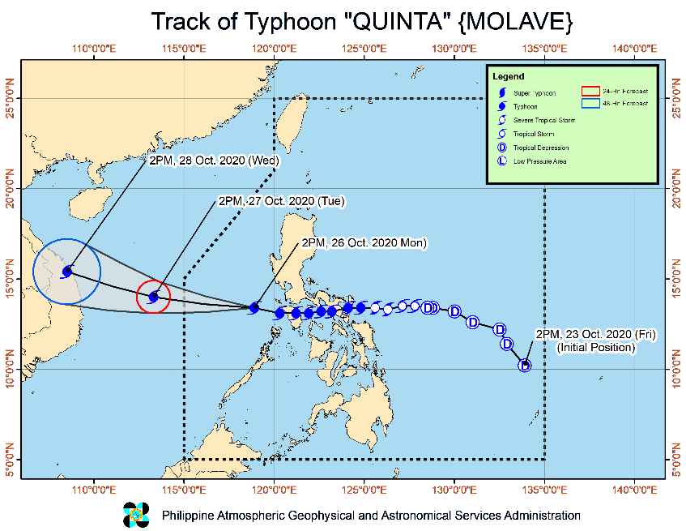
Issued at 11:00 pm, 26 October 2020, TYPHOON "QUINTA" FURTHER INTENSIFIES AS IT CONTINUES TO MOVE AWAY FROM THE COUNTRY.
- Track: "QUINTA" is forecast to exit the Philippine Area of Responsibility tomorrow morning. The typhoon is expected to further intensify over the West Philippine Sea and reach its peak intensity within 24 hours.
- Rainfall: Tonight tomorrow morning, "QUINTA" will bring moderate to heavy with at times intense rains over Western Visayas, Occidental Mindoro, Oriental Mindoro, Palawan including Calamian, Cuyo, and Kalayaan Islands, Quezon, Aurora, Isabela, Cagayan and light to moderate with at times heavy rains over Zamboanga Peninsula, Bangsamoro, Northern Mindanao, Caraga, and the rest of Luzon and Visayas. Flooding (including flash floods) and rain-induced landslides may occur during heavy or prolonged rainfall especially in areas that are highly or very highly susceptible to these hazards. PAGASA Regional Services Divisions may issue local thunderstorm/rainfall advisories and heavy rainfall warnings as appropriate.
- Strong winds: Strong breeze to near gale conditions will be experienced in areas under Tropical Cyclone Wind Signal (TCWS) #1. Potential impacts of these wind conditions to structures and vegetation are detailed in the TCWS section of this bulletin. In other areas, strong breeze to gale conditions associated with the northeasterlies will prevail in Batanes, northern Cagayan including Babuyan Islands, Apayao, and Ilocos Norte, while occasional gusts associated with the outer circulation of "QUINTA" will still be experienced over MIMAROPA, Western Visayas, and the western section of Luzon.
- Coastal surf: Heavy swells of 2.0 to 4.0 m due to "QUINTA" can cause significant breaking waves that may bring potentially hazardous surf conditions over the western coastal areas of Pangasinan, Central Luzon, Occidental Mindoro, and Palawan including Calamian Islands.
At 10:00 PM today, the eye of Typhoon "QUINTA" was located based on all available data at 420 km West of Calapan City, Oriental Mindoro (13.3 °N, 117.3 °E)
Source: DOST-PAGASA Severe Weather Bulletin

- Status of Affected Families / Persons
A total of 42,381 families or 182,547 persons were affected in 443 barangays in Regions III, CALABARZON MIMAROPA and VI (see Table 1).

Table 1. Number of Affected Families / Persons
REGION / PROVINCE / MUNICIPALITY |  | NUMBER OF AFFECTED
 |  | Barangays | Families | Persons
GRAND TOTAL |  | 443 | 42,381 | 182,547
REGION III |  | 62 | 33,837 | 150,110
Aurora |  | 1 | 7 | 30
 | San Luis | 1 | 7 | 30
Bulacan |  | 28 | 19,005 | 76,019
 | Calumpit | 28 | 19,005 | 76,019
Nueva Ecija |  | 3 | 698 | 2,942
 | Cabanatuan City | 1 | 80 | 420
 | Jaen | 1 | 422 | 1,488
 | San Antonio | 1 | 196 | 1,034
Pampanga |  | 28 | 13,589 | 68,553
 | Arayat | 2 | 252 | 1,175
 | Masantol | 26 | 13,337 | 67,378
Tarlac |  | 2 | 538 | 2,566
 | La Paz | 2 | 538 | 2,566
CALABARZON |  | 313 | 6,778 | 25,616
Batangas |  | 35 | 382 | 2,001
 | Agoncillo | 1 | 9 | 39
 | Bauan | 3 | 19 | 75
 | Calaca | 2 | 81 | 338
 | Ibaan | 1 | 14 | 76
 | Lipa City | 3 | 36 | 161
 | Mabini | 1 | 70 | 599
 | Malvar | 1 | 4 | 21
 | Mataas Na Kahoy | 1 | 6 | 36
 | Padre Garcia | 4 | 17 | 110
 | San Jose | 4 | 27 | 135
 | San Juan | 2 | 16 | 56
 | San Nicolas | 2 | 23 | 114
 | San Pascual | 1 | 5 | 22
 | Santo Tomas | 1 | 3 | 14
 | City of Tanauan | 3 | 18 | 92
 | Taysan | 1 | 7 | 20
 | Tingloy | 4 | 27 | 93
Cavite |  | 1 | 3 | 15
 | Cavite City | 1 | 3 | 15
Laguna |  | 41 | 573 | 2,180
 | Biñan | 1 | 1 | 8
 | City of Calamba | 9 | 238 | 932
 | Liliw | 3 | 37 | 137
 | Los Baños | 10 | 98 | 407
 | Magdalena | 2 | 19 | 36
 | Nagcarlan | 5 | 93 | 295
 | Paete | 1 | 3 | 7
 | Pangil | 1 | 6 | 29
 | San Pablo City | 5 | 35 | 128
 | Santa Cruz (capital) | 1 | 7 | 35
 | City of Santa Rosa | 3 | 36 | 166
Quezon |  | 235 | 5,819 | 21,415
 | Agdangan | 3 | 21 | 85
 | Alabat | 17 | 353 | 1,463
 | Atimonan | 15 | 142 | 532
 | Buenavista | 8 | 306 | 1,065
 | Calauag | 11 | 332 | 1,483
 | Candelaria | 1 | 3 | 10
 | Catanauan | 5 | 181 | 863
 | General Luna | 6 | 90 | 367
 | Guinayangan | 3 | 124 | 351
 | Gumaca | 37 | 1,089 | 3,711
 | Jomalig | 2 | 10 | 41
 | Lopez | 17 | 759 | 2,427
 | Lucena City (capital) | 10 | 410 | 1,678
 | Macalelon | 5 | 55 | 210
 | Mauban | 1 | 11 | 27
 | Mulanay | 9 | 361 | 898
 | Padre Burgos | 8 | 102 | 359
 | Pagbilao | 3 | 15 | 63
 | Pitogo | 25 | 643 | 2,391
 | Quezon | 6 | 51 | 169
 | Real | 1 | 5 | 13
 | Sampaloc | 2 | 7 | 34
 | San Andres | 4 | 70 | 180
 | San Francisco (Aurora) | 3 | 58 | 265
 | San Narciso | 7 | 206 | 1,030
 | Tagkawayan | 17 | 291 | 1,117
 | City of Tayabas | 2 | 7 | 31
 | Unisan | 7 | 117 | 552
Rizal |  | 1 | 1 | 5
 | Cardona | 1 | 1 | 5
MIMAROPA |  | 50 | 1,299 | 4,631
Marinduque |  | 28 | 198 | 775
 | Boac (capital) | 5 | 35 | 145
 | Buenavista | 8 | 59 | 221
 | Santa Cruz | 7 | 25 | 86
 | Torrijos | 8 | 79 | 323
Occidental Mindoro |  | 4 | 83 | 356
 | Looc | 4 | 32 | 125
 | Mamburao (capital) | - | 51 | 231
Oriental Mindoro |  | 18 | 1,018 | 3,500
 | Baco | 1 | 6 | 30
 | Bongabong | 1 | 40 | 166
 | Bulalacao (San Pedro) | 2 | 81 | 348
 | City of Calapan (capital) | 3 | 117 | 463
 | Gloria | 1 | 42 | 157
 | Naujan | 3 | 225 | 1,046
 | Pinamalayan | 1 | 50 | 200
 | Pola | 1 | 9 | 32
 | Puerto Galera | 2 | 85 | 362
 | Roxas | 3 | 363 | 696
REGION VI |  | 18 | 467 | 2,190
Antique |  | 15 | 349 | 1,733
 | Hamtic | 1 | 119 | 474
 | San Jose (capital) | 4 | 34 | 119
 | Sibalom | 4 | 131 | 820
 | Barbaza | 1 | 20 | 100
 | Culasi | 1 | 6 | 30
 | Laua-an | 1 | 12 | 53
 | Libertad | 1 | 25 | 125
 | Patnongon | 2 | 2 | 12
Negros Occidental |  | 3 | 118 | 457
 | Isabela | 3 | 118 | 457
Note: Ongoing assessment and validation being conducted.
Source: DSWD-FOs III, CALABARZON, MIMAROPA and VI

- Status of Displaced Families / Persons
- Inside Evacuation Centers
There are 6,849 families or 26,599 persons taking temporary shelter in 417 evacuation centers in Regions III, CALABARZON, MIMAROPA and VI (see Table 2).

Table 2. Number of Displaced Families / Persons Inside Evacuation Centers
REGION / PROVINCE / MUNICIPALITY |  | NUMBER OF EVACUATION CENTERS (ECs) |  | NUMBER OF DISPLACED
 |  |  |  | INSIDE ECs
 |  |  |  | Families |  | Persons
 |  | CUM | NOW | CUM | NOW | CUM | NOW
GRAND TOTAL |  | 417 | 417 | 6,851 | 6,849 | 26,619 | 26,599
REGION III |  | 6 | 6 | 63 | 63 | 275 | 275
Aurora |  | 1 | 1 | 7 | 7 | 30 | 30
 | San Luis | 1 | 1 | 7 | 7 | 30 | 30
Bulacan |  | 3 | 3 | 10 | 10 | 44 | 44
 | Calumpit | 3 | 3 | 10 | 10 | 44 | 44
Nueva Ecija |  | 1 | 1 | 34 | 34 | 145 | 145
 | Cabanatuan City | 1 | 1 | 34 | 34 | 145 | 145
Tarlac |  | 1 | 1 | 12 | 12 | 56 | 56
 | La Paz | 1 | 1 | 12 | 12 | 56 | 56
CALABARZON |  | 369 | 369 | 5,453 | 5,451 | 21,538 | 21,518
Batangas |  | 25 | 25 | 329 | 328 | 1,734 | 1,732
 | Agoncillo | 1 | 1 | 9 | 9 | 39 | 39
 | Bauan | 3 | 3 | 19 | 19 | 75 | 75
 | Calaca | 2 | 2 | 81 | 81 | 338 | 338
 | Lipa City | 2 | 2 | 35 | 35 | 153 | 153
 | Mabini | 1 | 1 | 70 | 70 | 599 | 599
 | Malvar | 1 | 1 | 4 | 4 | 21 | 21
 | Mataas Na Kahoy | 1 | 1 | 6 | 6 | 36 | 36
 | San Jose | 3 | 3 | 20 | 20 | 105 | 105
 | San Juan | 1 | 1 | 13 | 13 | 47 | 47
 | San Nicolas | 2 | 2 | 23 | 23 | 114 | 114
 | San Pascual | 1 | 1 | 5 | 5 | 22 | 22
 | Santo Tomas | 1 | 1 | 3 | 2 | 14 | 12
 | City of Tanauan | 3 | 3 | 18 | 18 | 92 | 92
 | Tingloy | 3 | 3 | 23 | 23 | 79 | 79
Cavite |  | 1 | 1 | 3 | 3 | 15 | 15
 | Carmona | 1 | 1 | 3 | 3 | 15 | 15
Laguna |  | 41 | 41 | 566 | 565 | 2,163 | 2,145
 | Biñan | 1 | 1 | 1 | 1 | 8 | 8
 | City of Calamba | 9 | 9 | 231 | 231 | 894 | 894
 | Liliw | 3 | 3 | 37 | 37 | 137 | 137
 | Los Baños | 10 | 10 | 98 | 98 | 407 | 407
 | Magdalena | 2 | 2 | 19 | 19 | 57 | 57
 | Nagcarlan | 5 | 5 | 93 | 93 | 295 | 295
 | Paete | 1 | 1 | 3 | 3 | 7 | 7
 | Pangil | 1 | 1 | 6 | 6 | 29 | 29
 | San Pablo City | 5 | 5 | 35 | 35 | 128 | 128
 | Santa Cruz (capital) | 1 | 1 | 7 | 6 | 35 | 17
 | City of Santa Rosa | 3 | 3 | 36 | 36 | 166 | 166
Quezon |  | 301 | 301 | 4,554 | 4,554 | 17,621 | 17,621
 | Agdangan | 5 | 5 | 21 | 21 | 85 | 85
 | Alabat | 43 | 43 | 353 | 353 | 1,463 | 1,463
 | Atimonan | 17 | 17 | 142 | 142 | 532 | 532
 | Buenavista | 14 | 14 | 306 | 306 | 1,065 | 1,065
 | Calauag | 11 | 11 | 294 | 294 | 1,311 | 1,311
 | Candelaria | 1 | 1 | 3 | 3 | 10 | 10
 | Catanauan | 6 | 6 | 181 | 181 | 863 | 863
 | General Luna | 6 | 6 | 41 | 41 | 179 | 179
 | Guinayangan | 4 | 4 | 124 | 124 | 351 | 351
 | Gumaca | 47 | 47 | 809 | 809 | 2,803 | 2,803
 | Jomalig | 2 | 2 | 10 | 10 | 41 | 41
 | Lopez | 24 | 24 | 385 | 385 | 1,279 | 1,279
 | Lucena City (capital) | 14 | 14 | 407 | 407 | 1,667 | 1,667
 | Macalelon | 6 | 6 | 55 | 55 | 210 | 210
 | Mauban | 1 | 1 | 11 | 11 | 27 | 27
 | Mulanay | 9 | 9 | 156 | 156 | 632 | 632
 | Padre Burgos | 9 | 9 | 90 | 90 | 314 | 314
 | Pagbilao | 3 | 3 | 15 | 15 | 63 | 63
 | Pitogo | 28 | 28 | 391 | 391 | 1,551 | 1,551
 | Quezon | 6 | 6 | 51 | 51 | 169 | 169
 | Real | 1 | 1 | 5 | 5 | 13 | 13
 | Sampaloc | 2 | 2 | 7 | 7 | 34 | 34
 | San Andres | 4 | 4 | 70 | 70 | 180 | 180
 | San Francisco (Aurora) | 3 | 3 | 58 | 58 | 265 | 265
 | San Narciso | 10 | 10 | 206 | 206 | 1,030 | 1,030
 | Tagkawayan | 16 | 16 | 241 | 241 | 910 | 910
 | City of Tayabas | 2 | 2 | 7 | 7 | 31 | 31
 | Unisan | 7 | 7 | 115 | 115 | 543 | 543
Rizal |  | 1 | 1 | 1 | 1 | 5 | 5
 | Cardona | 1 | 1 | 1 | 1 | 5 | 5
MIMAROPA |  | 32 | 32 | 1,020 | 1,020 | 3,515 | 3,515
Occidental Mindoro |  | 1 | 1 | 51 | 51 | 231 | 231
 | Mamburao (capital) | 1 | 1 | 51 | 51 | 231 | 231
Oriental Mindoro |  | 31 | 31 | 969 | 969 | 3,284 | 3,284
 | Baco | 1 | 1 | 6 | 6 | 30 | 30
 | Bongabong | 1 | 1 | 40 | 40 | 166 | 166
 | Bulalacao (San Pedro) | 1 | 1 | 45 | 45 | 193 | 193
 | City of Calapan (capital) | 5 | 5 | 117 | 117 | 463 | 463
 | Gloria | 3 | 3 | 42 | 42 | 157 | 157
 | Naujan | 4 | 4 | 220 | 220 | 1,026 | 1,026
 | Pinamalayan | 1 | 1 | 50 | 50 | 200 | 200
 | Pola | 2 | 2 | 9 | 9 | 32 | 32
 | Puerto Galera | 4 | 4 | 83 | 83 | 352 | 352
 | Roxas | 9 | 9 | 357 | 357 | 665 | 665
REGION VI |  | 10 | 10 | 315 | 315 | 1,291 | 1,291
Antique |  | 8 | 8 | 197 | 197 | 834 | 834
 | Hamtic | 2 | 2 | 119 | 119 | 474 | 474
 | San Jose (capital) | 3 | 3 | 21 | 21 | 82 | 82
 | Barbaza | 1 | 1 | 20 | 20 | 100 | 100
 | Laua-an | 1 | 1 | 12 | 12 | 53 | 53
 | Libertad | 1 | 1 | 25 | 25 | 125 | 125
Negros Occidental |  | 2 | 2 | 118 | 118 | 457 | 457
 | Isabela | 2 | 2 | 118 | 118 | 457 | 457
Note: Ongoing assessment and validation being conducted.
Source: DSWD-FOs III, CALABARZON, MIMAROPA and VI

- Outside Evacuation Centers
There are 1,673 families or 5,646 persons currently staying with their relatives and/or friends in Regions CALABARZON, MIMAROPA and VI (see Table 3).

Table 3. Number of Displaced Families / Persons Outside Evacuation Centers
REGION / PROVINCE / MUNICIPALITY |  | NUMBER OF DISPLACED
 |  | OUTSIDE ECs
 |  | Families |  | Persons
 |  | CUM | NOW | CUM | NOW
GRAND TOTAL |  | 1,673 | 1,673 | 5,646 | 5,646
CALABARZON |  | 1,393 | 1,393 | 4,379 | 4,379
Batangas |  | 53 | 53 | 267 | 267
 | Ibaan | 14 | 14 | 76 | 76
 | Lipa City | 1 | 1 | 8 | 8
 | Padre Garcia | 17 | 17 | 110 | 110
 | San Jose | 7 | 7 | 30 | 30
 | San Juan | 3 | 3 | 9 | 9
 | Taysan | 7 | 7 | 20 | 20
 | Tingloy | 4 | 4 | 14 | 14
Laguna |  | 7 | 7 | 38 | 38
 | City of Calamba | 7 | 7 | 38 | 38
Quezon |  | 1,333 | 1,333 | 4,074 | 4,074
 | Buenavista | 16 | 16 | 82 | 82
 | Calauag | 38 | 38 | 172 | 172
 | General Luna | 49 | 49 | 188 | 188
 | Gumaca | 279 | 279 | 908 | 908
 | Lopez | 374 | 374 | 1,148 | 1,148
 | Lucena City (capital) | 56 | 56 | 209 | 209
 | Mulanay | 205 | 205 | 266 | 266
 | Padre Burgos | 12 | 12 | 45 | 45
 | Pitogo | 252 | 252 | 840 | 840
 | Tagkawayan | 50 | 50 | 207 | 207
 | Unisan | 2 | 2 | 9 | 9
MIMAROPA |  | 128 | 128 | 533 | 533
Marinduque |  | 77 | 77 | 293 | 293
 | Boac (capital) | 17 | 17 | 72 | 72
 | Buenavista | 12 | 12 | 39 | 39
 | Santa Cruz | 16 | 16 | 52 | 52
 | Torrijos | 32 | 32 | 130 | 130
Occidental Mindoro |  | 4 | 4 | 32 | 32
 | Looc | 4 | 4 | 32 | 32
Oriental Mindoro |  | 47 | 47 | 208 | 208
 | Bulalacao (San Pedro) | 36 | 36 | 155 | 155
 | Naujan | 5 | 5 | 20 | 20
 | Puerto Galera | 2 | 2 | 10 | 10
 | Roxas | 4 | 4 | 23 | 23
REGION VI |  | 152 | 152 | 734 | 734
Antique |  | 152 | 152 | 734 | 734
 | San Jose (capital) | 13 | 13 | 37 | 37
 | Sibalom | 131 | 131 | 655 | 655
 | Culasi | 6 | 6 | 30 | 30
 | Patnongon | 2 | 2 | 12 | 12
Note: Ongoing assessment and validation being conducted.
Source: DSWD-FOs III, CALABARZON, MIMAROPA and VI

- Assistance provided
A total of ₱31,045.00 worth of assistance was provided by LGUs to the affected families (see Table 4).

Table 4. Cost of Assistance Provided to Affected Families / Persons
REGION / PROVINCE / MUNICIPALITY |  | COST OF ASSISTANCE
 |  | DSWD | LGU | NGOs | OTHERS | GRAND TOTAL
GRAND TOTAL |  | - | 31,045.00 | - | - | 31,045.00
REGION III |  | - | 31,045.00 | - | - | 31,045.00
Bulacan |  | - | 4,000.00 | - | - | 4,000.00
 | Calumpit | - | 4,000.00 | - | - | 4,000.00
Nueva Ecija |  | - | 6,795.00 | - | - | 6,795.00
 | Cabanatuan City | - | 6,795.00 | - | - | 6,795.00
Tarlac |  | - | 20,250.00 | - | - | 20,250.00
 | La Paz | - | 20,250.00 | - | - | 20,250.00
Source: DSWD-FO III

DSWD DISASTER RESPONSE INFORMATION

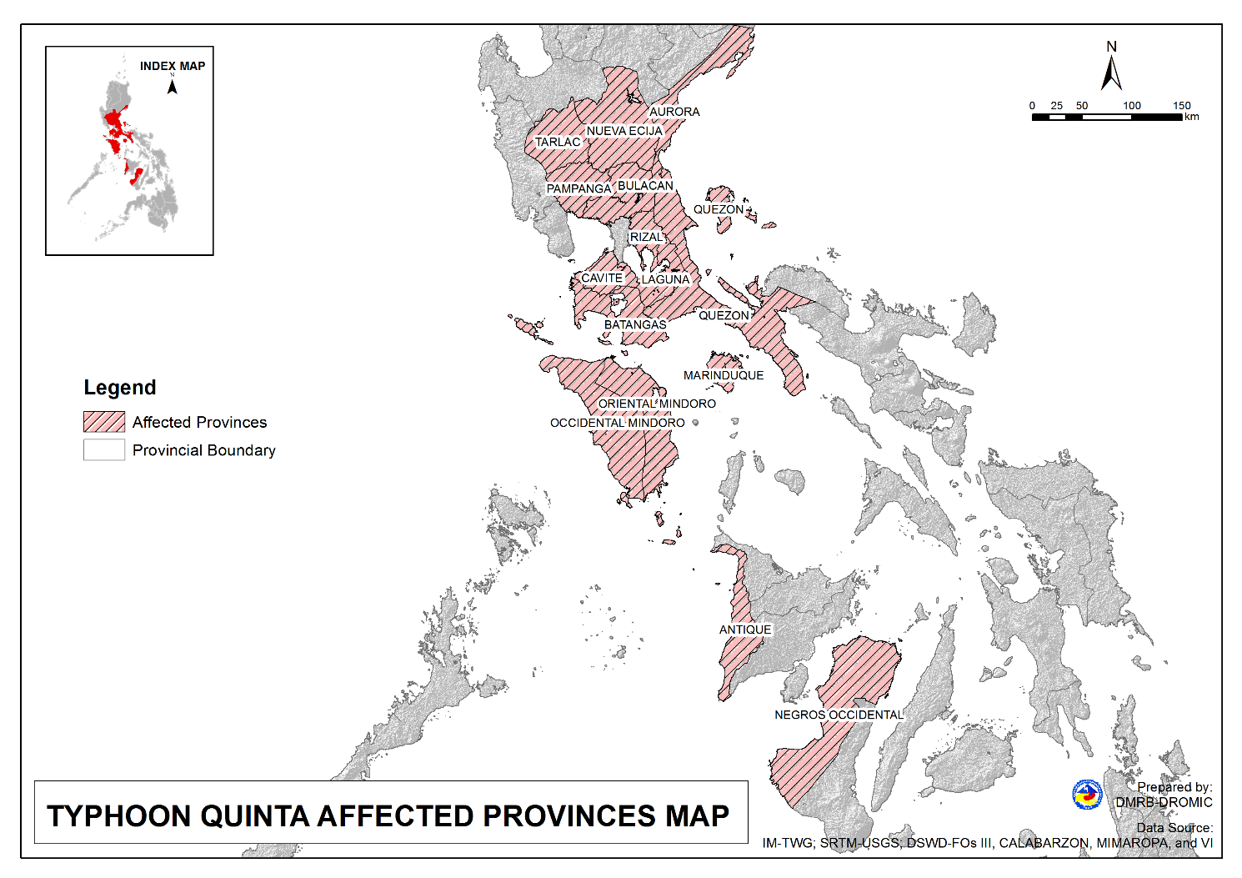

Status of Prepositioned Resources: Stockpile and Standby Funds
The DSWD Central Office (CO), Field Offices (FOs), and National Resource Operations Center (NROC) have stockpiles and standby funds amounting to ₱898,260,565.50 with breakdown as follows (see Table 1):

- Standby Funds
A total of ₱302,882,354.54 standby funds in the CO and FOs. Of the said amount, ₱263,367,817.19 is the available Quick Response Fund (QRF) in the CO.

- Stockpiles
A total of 261,477 family food packs (FFPs) amounting to ₱119,387,923.80, other food items amounting to ₱191,884,270.20 and non-food items (FNIs) amounting to ₱284,106,017.00 are available.

Table 1. Available Standby Funds and Stockpiles
Region / Office | Standby Funds | FAMILY FOOD PACKS |  | Other Food Items | Non-Food Relief Items | Total Standby Funds & Stockpile
 |  | Quantity | Total Cost
 | 302,882,354.50 | 261,477 | 119,387,923.80 | 191,884,270.20 | 284,106,017.00 | 898,260,565.50
Central Office | 263,367,817.19 | - | - | - | - | 263,367,817.20
NRLMB - NROC | - | 8,550 | 4,932,850.00 | 22,414,570.48 | 72,845,661.75 | 100,193,082.20
NRLMB - VDRC | - | 12,647 | 5,601,133.63 | 4,888,897.13 | 2,326,991.20 | 12,817,021.96
I | 490,455.20 | 1,821 | 830,659.32 | 2,813,730.00 | 31,166,997.46 | 35,301,841.98
II | 3,000,938.79 | 17,317 | 8,855,191.11 | 3,141,266.01 | 5,510,398.95 | 20,507,794.86
III | 4,205,028.74 | 7,523 | 2,988,809.70 | 5,398,151.71 | 5,294,121.88 | 17,886,112.03
CALABARZON | 3,000,000.00 | 7,784 | 1,643,576.00 | 3,376,598.98 | 4,069,663.12 | 12,089,838.10
MIMAROPA | 3,100,744.58 | 30,051 | 13,522,950.00 | 1,765,909.00 | 6,289,098.80 | 24,678,702.38
V | 3,000,000.00 | 14,555 | 4,604,759.08 | 1,053,537.41 | 26,420,032.90 | 35,078,329.39
VI | 3,000,051.68 | 37,141 | 13,436,326.94 | 48,660,483.77 | 5,890,820.31 | 70,987,682.70
VII | 3,000,462.71 | 16,719 | 7,412,339.20 | 14,758,012.19 | 78,198.00 | 25,249,012.10
VIII | 3,003,550.00 | 17,131 | 9,380,800.08 | 6,648,181.70 | 19,619,830.38 | 38,652,362.16
IX | 56,000.00 | 10,030 | 5,481,294.70 | 15,614,222.16 | 8,518,245.45 | 29,669,762.31
X | 3,000,724.42 | 39,408 | 21,755,647.42 | 31,174,169.86 | 27,940,054.89 | 83,870,596.59
XI | 3,000,001.00 | 5,293 | 1,959,203.95 | 12,292,725.00 | 19,758,485.36 | 37,010,415.31
XII | 1,449,000.68 | 3,114 | 1,712,700.00 | 3,428,643.55 | 10,899,586.54 | 17,489,930.77
CARAGA | 3,000,740.55 | 13,892 | 7,131,089.08 | 5,239,330.83 | 16,464,806.17 | 31,835,966.63
NCR | 3,000,439.00 | 1,677 | 921,176.10 | 7,479,060.00 | 9,929,291.41 | 21,329,966.51
CAR | 206,400.00 | 16,824 | 7,217,417.50 | 1,736,780.45 | 11,083,732.39 | 20,244,330.34
Note: The Inventory Summary is as of 26 October 2020, 8PM.
Source: DRMB and NRLMB

Situational Reports

DSWD-DRMB
DATE | SITUATIONS / ACTIONS UNDERTAKEN
27 October 2020 | - The Disaster Response Management Bureau (DRMB) is on BLUE alert status and is closely coordinating with the concerned field offices for significant disaster response updates.  - All QRT members and emergency equipment are on standby and ready for deployment.  - DRMB participated in the Online Pre-Disaster Risk Assessment Meeting on Tropical Depression “Quinta” on 24 October 2020 with other response cluster member agencies. Further meetings shall be conducted on the implementation of COVID-19 protocols during the response efforts on Typhoon “Quinta”.

DSWD-NCR
DATE | SITUATIONS / ACTIONS UNDERTAKEN
26 October 2020 | - A total of 184 families or 718 persons who have pre-emptively evacuated in 7 Evacuation Centers in Region NCR.  REGION / PROVINCE / MUNICIPALITY DISPLACEMENT DATA  NUMBER OF EVACUATION CENTERS (ECs) NUMBER OF DISPLACED  INSIDE ECs  Families Persons  NOW NOW NOW  GRAND TOTAL 7 184 718  NCR 7 184 718  Muntinlupa City 6 173 678  Parañaque City 1 11 40  - DSWD FO-NCR Disaster Response Management Division (DRMD) and the FO Quick Response Teams are on standby-alert and/or already activated for any eventualities that might happen due to the said weather condition.  - DSWD FO-NCR DRMD is ready to provide food and non-food items, as well as other possible assistance to any requesting agencies and other partner stakeholders upon request, in coordination with the LSWDOs. Moreover, logistics including vehicles are ready to be mobilized to respond to any eventualities.  - DSWD FO-NCR DRMD continuously coordinate with the 17 LGUs thru its respective Local Social Welfare and Development Office (LSWDOs) regarding any possible necessary augmentation assistance.

DSWD-FO CAR
DATE | SITUATIONS / ACTIONS UNDERTAKEN
24 October 2020 | - DSWD-FO CAR DRMD are on standby to render duty at the Operations Center and monitor the status on the ground as well as the alert status and weather updates.  - The Provincial Social Welfare and Development Teams (PSWADT) DRMD PDO IIs were informed of the situation.  - Municipal Action Teams are on standby.  - Continuous coordination by the DRMD PDO IIs assigned in the PSWADTs with the LDRRMOs for updates.  - Rapid Emergency Telecommunications Team (RETT) including the International Maritime/Marine Satellite (INMARSAT) equipment are on standby.  - DSWD-FO CAR DRMD prepared reports for the weather disturbance and shared it to the end users.  - The Operations Center is on RED ALERT since 16 March 2020.  - Pre-disaster Risk Assessment Meeting via video teleconferencing attended by Ms. Mary Ann G. Buclao.  - Close coordination with Cordillera Regional Disaster Risk Reduction and Management Council Emergency Operations Center for updates.  - QRT and Delta Teams were on standby for possible deployment.  - Cascaded the susceptibility map to Provincial SWAD Teams for their guidance.  - Evacuations Center Updated for dissemination to SWADs.

DSWD-FO III
DATE | SITUATIONS / ACTIONS UNDERTAKEN
26 October 2020 | - Activation of Rapid Deployment Team-Disaster Response Management Division of DSWD Field Office and DSWD Provincial Extension Office Quick Response Team.  - Participated during the conduct of Pre-Disaster Risk Assessment with RDRRMC Members.  - Continuous monitoring of weather updates in coordination with the DPEO’s and concerned LGUs.

DSWD-FO CALABARZON
DATE | SITUATIONS / ACTIONS UNDERTAKEN
26 October 2020 | - DSWD-FO CALABARZON convened the members of the Response Cluster through virtual teleconference, the meeting served as venue to conduct a strategic planning to discuss strategies to reach the affected areas.  - DSWD-FO CALABARZON DRMD advised Local Government Units (LGUs) to allot wider spaces in evacuation centers to ensure adequate physical distancing. Families who will be evacuated must also be reminded to observe minimum health standards, which includes wearing of face masks, proper hygiene and cough etiquette.  - DSWD-FO CALABARZON DRMD urged Local Social Welfare and Development Offices to explore alternative evacuation centers, since schools could not be used as many have been designated as quarantine facilities for COVID-19 patients.  - DSWD-FO CALABARZON activated the Provincial Quick Response Teams (PQRTs) of the five (5) Provinces of CALABARZON to rapidly and effectively gather data and information from the affected LGUs.  - DSWD-FO CALABARZON conducted operational period briefing to identify the priorities of for Humanitarian Response Operation for Typhoon Quinta.  - The Rapid Damage Assessment and Needs Analysis (RDANA) Teams of the Regional Quick Response Teams were placed on standby alert status and advised to be ready for deployment should need arises.  - The Emergency Operation Center (EOC) of the Field Office has been activated and currently being managed and operated by the personnel of the DRMD.  - DSWD-FO CALABARZON DRMD is closely coordinating with the five (5) Provincial Social Welfare and Development Offices (PSWDOs) of CALABARZON for updates.  - DSWD-FO CALABARZON DRMD conducted assessment in Port of Batangas to identify the needs of the stranded passengers.

DSWD-FO MIMAROPA
DATE | SITUATIONS / ACTIONS UNDERTAKEN
26 October 2020 | - A total of 484 families or 1,589 persons have pre-emptively evacuated in 65 Evacuation Centers in Region MIMAROPA.  REGION / PROVINCE / MUNICIPALITY NUMBER OF EVACUATION CENTERS (ECs) NUMBER OF DISPLACED  INSIDE ECs  Families Persons  MIMAROPA 65 484 1,589  Marinduque 20 121 482  Occidental Mindoro 9 109 443  Romblon 36 254 664  REGION V 241 5,351 22,375  Albay 29 1,407 5,030  Camarines Norte 21 83 298  Camarines Sur 49 1,027 4,091  Catanduanes 13 110 510  Masbate 40 397 1,241  Sorsogon 89 2,327 11,205  - Powerline interruptions are currently experienced in some City/Municipalities of Oriental Mindoro and Marinduque.  - DSWD-FO MIMAROPA Disaster Response Management Division and SWADT Offices are alerted to monitor daily local weather condition and ensure provision of information to all concerned offices, divisions, sections, offices.  - 24/7 On-call status of the R/P/C/M QRTs together with special projects staff for possible activation of Operation Center.  - Close coordination with the Office of Civil Defense (OCD) and RDRRMC MIMAROPA for any warning signal updates for monitoring purposes and response mechanism for areas that will be affected.  - Standby logistical equipment and workforce through coordination with SWADT Offices and concerned LGUs on the management of stranded passengers, if any, in ports and terminals.  - Information and Communication Technology Management Unit (ICTMU) is on standby status to ensure robust communication system.  - Ensure that there is an on-call truck available for delivery of goods and equipment to areas that will be affected.

DSWD-FO V
DATE | SITUATIONS / ACTIONS UNDERTAKEN
26 October 2020 | - A total of 5,351 families or 22,375 persons have pre-emptively evacuated in 241 Evacuation Centers and 292 families or 1,590 persons currently staying with their relatives and/or friends in Region V.  REGION / PROVINCE / MUNICIPALITY NUMBER OF EVACUATION CENTERS (ECs) NUMBER OF DISPLACED  INSIDE ECs OUTSIDE ECs  Families Persons Families Persons  REGION V 241 5,351 22,375 292 1,590  Albay 29 1,407 5,030 - -  Camarines Norte 21 83 298 22 110  Camarines Sur 49 1,027 4,091 6 19  Catanduanes 13 110 510 39 133  Masbate 40 397 1,241 53 230  Sorsogon 89 2,327 11,205 172 1,098  - DSWD-FO V QRTs are activated.  - QRTs in POO and MOO Level are on Blue Alert Status. C/MATs are in close coordination with C/MDRRMOs for situational updates on pre-emptive evacuation, report on standees etc.  - PAT and MAT members in the 6 provinces are activated and instructed to coordinate with the P/MDRRMOs, C/MSWDOs for reports and updates.  - Validation on the affected population is now being conducted by the MATs in coordination with the Local Government Units.  - DSWD-FO V is ready to provide augmentation support to the affected municipalities/cities.

DSWD-FO VI
DATE | SITUATIONS / ACTIONS UNDERTAKEN
26 October 2020 | - DSWD-FO VI consolidated DROMIC Report from PSWDO Antique. On-going validation of DROMIC Reports submitted by the LGUs is being conducted.  - DSWD-FO VI staff are in close coordination with the LGUs for any possible augmentation.  - Philippine Coast Guard released an advisory that trips of vessels and motorbanca from Caticlan Jetty port to Batangas, Mindoro and Romblon are all cancelled.  - On-going repacking of relief goods is being conducted at the regional warehouse.

DSWD-FO VIII
DATE | SITUATIONS / ACTIONS UNDERTAKEN
25 October 2020 | - DSWD-FO VIII prepositioned Family Food Packs (FFPs) in Samar Island which can be distributed immediately by the P/C/MATs to Local Government Units that need augmentation support.  - Communicated SWAD Teams and City/Municipal Actions Teams to be alerted on the Severe Tropical Storm “Quinta”.  - Conducted Pre-Disaster Risk Assessment Meeting on 23 October 2020 prior to RDRRMC PDRA Meeting and discussed internal preparations of the department considering that the implementation of Bayanihan to Heal as One Act is still ongoing and Bayanihan to Recover as One Act has started its planning phase.  - Contacted VDRC and NRLMB for the possible augmentation of FFPs to Eastern Visayas considering that some of our family food packs are for fumigation and stockpile is insufficient to respond to the possible requests of LGUs.

DSWD-X
DATE | SITUATIONS / ACTIONS UNDERTAKEN
26 October 2020 | - DSWD FO-X DRMD continuously monitor the weather condition and in constant coordination with the LGUs for possible augmentation and for further updates on Typhoon “Quinta”.
*****
The Disaster Response Operations Monitoring and Information Center (DROMIC) of the DSWD-DRMB is closely monitoring the effects of Typhoon “Quinta” and is coordinating with the concerned DSWD Field Offices for any significant updates.

Prepared by:

MARIEL B. FERRARIZ
JOANNA CAMILLE R. JACINTO
CLARRIE MAE A. CASTILLO

RODEL V. CABADDU
Releasing Officer

