DSWD DROMIC Report #5 on Typhoon “Rolly”
as of 02 November 2020, 6AM

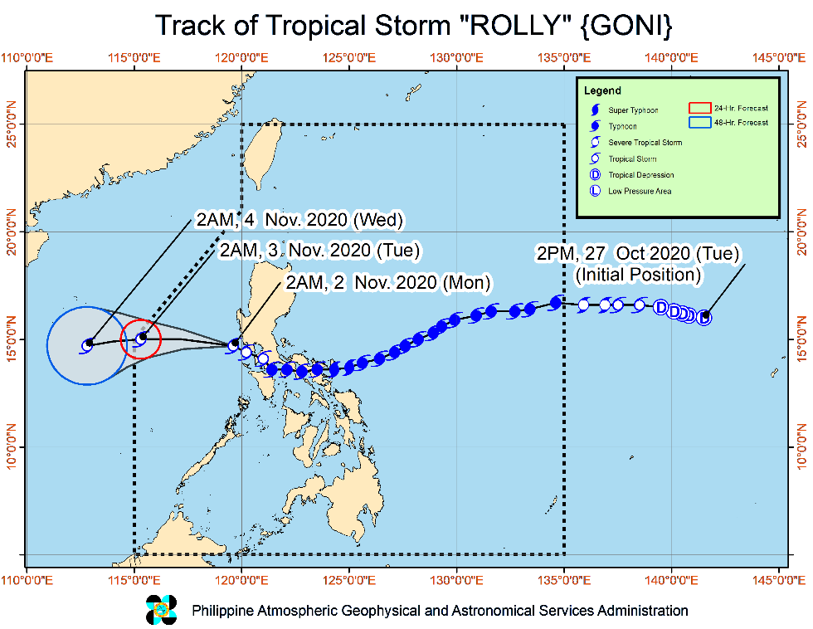
Situation Overview

Issued at 05:00 am, 02 November 2020, "ROLLY" CONTINUES TO WEAKENS OVER THE WEST PHILIPPINE SEA.

Track and intensity outlook:
- On the forecast track, “ROLLY” is expected to exit the Philippine Area of Responsibility (PAR) tomorrow morning. It is forecast to remain as a tropical storm throughout the forecast period. However, there is an increasing likelihood that “ROLLY” will weaken into a tropical depression due to increasingly unfavorable conditions.

At 4:00 AM today, the center of Tropical Storm "ROLLY" was estimated based on all available data at 100 km West Southwest of Subic Bay (14.6 °N, 119.4 °E )

Source: DOST-PAGASA Severe Weather Bulletin

- Status of Affected Families / Persons
A total of 14,807 families or 54,947 persons were affected in 547 barangays in Regions CALABARZON, MIMAROPA and CAR (see Table 1).

Table 1. Number of Affected Families / Persons
REGION / PROVINCE / MUNICIPALITY |  | NUMBER OF AFFECTED
 |  | Barangays | Families | Persons
GRAND TOTAL |  | 547 | 14,807 | 54,947
CALABARZON |  | 305 | 8,004 | 30,146
Batangas |  | 14 | 239 | 985
 | Alitagtag | 7 | 91 | 409
 | Bauan | 4 | 57 | 211
 | San Jose | 1 | 32 | 122
 | City of Tanauan | 2 | 59 | 243
Cavite |  | 36 | 558 | 2,360
 | Amadeo | 4 | 11 | 40
 | Carmona | 2 | 43 | 163
 | Cavite City | 1 | 55 | 278
 | Gen. Mariano Alvarez | 6 | 3 | 11
 | Magallanes | 1 | 1 | 6
 | Naic | 2 | 27 | 138
 | Noveleta | 2 | 138 | 690
 | Tagaytay City | 7 | 108 | 426
 | Tanza | 5 | 50 | 152
 | Ternate | 6 | 122 | 456
Laguna |  | 104 | 2,112 | 8,159
 | Alaminos | 8 | 70 | 262
 | Bay | 13 | 304 | 1,089
 | City of Calamba | 8 | 564 | 2,021
 | Kalayaan | 3 | 4 | 12
 | Los Baños | 10 | 131 | 503
 | Luisiana | 2 | 7 | 14
 | Lumban | 3 | 80 | 404
 | Mabitac | 6 | 93 | 358
 | Magdalena | 4 | 44 | 170
 | Pagsanjan | 6 | 38 | 151
 | Pakil | 5 | 82 | 317
 | Pila | 1 | 15 | 52
 | San Pablo City | 19 | 230 | 956
 | San Pedro | 3 | 13 | 70
 | Santa Cruz (capital) | 10 | 367 | 1,514
 | Siniloan | 3 | 70 | 266
Quezon |  | 137 | 4,698 | 17,493
 | Atimonan | 32 | 1,063 | 3,671
 | Burdeos | 4 | 89 | 370
 | Calauag | 1 | 115 | 575
 | General Luna | 4 | 28 | 115
 | General Nakar | 4 | 28 | 115
 | Guinayangan | 12 | 441 | 1,843
 | Jomalig | 1 | 90 | 375
 | Lucena City (capital) | 18 | 904 | 3,769
 | Macalelon | 3 | 11 | 38
 | Padre Burgos | 21 | 1,098 | 3,321
 | Pitogo | 1 | 5 | 18
 | Polillo | 7 | 34 | 150
 | Quezon | 5 | 108 | 383
 | Real | 3 | 278 | 1,132
 | Sampaloc | 6 | 79 | 266
 | San Andres | 1 | 25 | 172
 | San Antonio | 2 | 6 | 29
 | San Francisco (Aurora) | 2 | 110 | 420
 | Tiaong | 10 | 186 | 731
Rizal |  | 14 | 397 | 1,149
 | City of Antipolo | 3 | 271 | 589
 | Cardona | 2 | 5 | 15
 | Morong | 2 | 20 | 104
 | Pililla | 7 | 101 | 441
REGION MIMAROPA |  | 238 | 6,697 | 24,396
Marinduque |  | 53 | 1,815 | 6,420
 | Boac (capital) | 21 | 963 | 3,214
 | Gasan | 11 | 550 | 2,058
 | Mogpog | 11 | 118 | 397
 | Santa Cruz | 10 | 184 | 751
Occidental Mindoro |  | 10 | 334 | 1,309
 | Calintaan | 3 | 121 | 479
 | Magsaysay | 6 | 191 | 725
 | Mamburao (capital) | 1 | 22 | 105
Oriental Mindoro |  | 56 | 1,399 | 5,471
 | Baco | 3 | 20 | 95
 | Bulalacao (San Pedro) | 1 | 31 | 116
 | City of Calapan (capital) | 14 | 555 | 2,193
 | Mansalay | 3 | 57 | 249
 | Naujan | 5 | 83 | 288
 | Pola | 5 | 141 | 541
 | Puerto Galera | 6 | 237 | 896
 | Roxas | 6 | 67 | 295
 | Socorro | 6 | 76 | 288
 | Victoria | 7 | 132 | 510
Romblon |  | 119 | 3,149 | 11,196
 | Alcantara | 5 | 36 | 157
 | Banton | 16 | 767 | 2,232
 | Cajidiocan | 7 | 213 | 836
 | Calatrava | 1 | 155 | 614
 | Concepcion | 4 | 183 | 674
 | Corcuera | 5 | 146 | 657
 | Ferrol | 6 | 170 | 603
 | Looc | 11 | 189 | 719
 | Magdiwang | 5 | 146 | 556
 | Odiongan | 12 | 139 | 429
 | Romblon (capital) | 25 | 361 | 1,297
 | San Agustin | 15 | 407 | 1,473
 | San Andres | 7 | 237 | 949
CAR |  | 4 | 106 | 405
Apayao |  | 3 | 105 | 399
 | Flora | 2 | 103 | 391
 | Kabugao (capital) | 1 | 2 | 8
Benguet |  | 1 | 1 | 6
 | Sablan | 1 | 1 | 6
Note: Ongoing assessment and validation being conducted.
Source: DSWD-FOs CALABARZON, MIMAROPA and CAR

- Status of Displaced Families / Persons
- Inside Evacuation Centers
There are 10,613 families or 39,754 persons taking temporary shelter in 601 evacuation centers in Regions CALABARZON, MIMAROPA and CAR (see Table 2).

Table 2. Number of Displaced Families / Persons Inside Evacuation Centers
REGION / PROVINCE / MUNICIPALITY |  | NUMBER OF EVACUATION CENTERS (ECs) |  | NUMBER OF DISPLACED
 |  |  |  | INSIDE ECs
 |  |  |  | Families |  | Persons
 |  | CUM | NOW | CUM | NOW | CUM | NOW
GRAND TOTAL |  | 601 | 601 | 10,642 | 10,613 | 39,846 | 39,754
CALABARZON |  | 376 | 376 | 7,728 | 7,699 | 29,093 | 29,001
Batangas |  | 15 | 15 | 211 | 211 | 884 | 884
 | Alitagtag | 7 | 7 | 91 | 91 | 409 | 409
 | Bauan | 3 | 3 | 29 | 29 | 110 | 110
 | San Jose | 1 | 1 | 32 | 32 | 122 | 122
 | City of Tanauan | 4 | 4 | 59 | 59 | 243 | 243
Cavite |  | 32 | 32 | 552 | 552 | 2,335 | 2,335
 | Amadeo | 4 | 4 | 11 | 11 | 40 | 40
 | Carmona | 2 | 2 | 43 | 43 | 163 | 163
 | Cavite City | 3 | 3 | 55 | 55 | 278 | 278
 | Naic | 3 | 3 | 27 | 27 | 138 | 138
 | Noveleta | 3 | 3 | 138 | 138 | 690 | 690
 | Tagaytay City | 6 | 6 | 106 | 106 | 418 | 418
 | Tanza | 5 | 5 | 50 | 50 | 152 | 152
 | Ternate | 6 | 6 | 122 | 122 | 456 | 456
Laguna |  | 119 | 119 | 2,087 | 2,058 | 8,062 | 7,985
 | Alaminos | 10 | 10 | 70 | 70 | 262 | 262
 | Bay | 21 | 21 | 304 | 304 | 1,089 | 1,089
 | City of Calamba | 8 | 8 | 564 | 564 | 2,021 | 2,021
 | Kalayaan | 3 | 3 | 4 | 4 | 12 | 12
 | Los Baños | 1 | 1 | 131 | 131 | 503 | 503
 | Luisiana | 1 | 1 | 3 | 3 | 5 | 5
 | Lumban | 6 | 6 | 72 | 72 | 370 | 370
 | Mabitac | 7 | 7 | 93 | 93 | 358 | 358
 | Magdalena | 4 | 4 | 38 | 38 | 140 | 140
 | Pagsanjan | 6 | 6 | 38 | 38 | 151 | 151
 | Pakil | 6 | 6 | 82 | 82 | 317 | 317
 | Pila | 1 | 1 | 15 | 15 | 52 | 52
 | San Pablo City | 28 | 28 | 230 | 201 | 956 | 879
 | San Pedro | 3 | 3 | 13 | 13 | 70 | 70
 | Santa Cruz (capital) | 11 | 11 | 367 | 367 | 1,514 | 1,514
 | Siniloan | 3 | 3 | 63 | 63 | 242 | 242
Quezon |  | 190 | 190 | 4,481 | 4,481 | 16,663 | 16,648
 | Atimonan | 44 | 44 | 996 | 996 | 3,478 | 3,478
 | Burdeos | 2 | 2 | 36 | 36 | 150 | 150
 | Calauag | 2 | 2 | 115 | 115 | 575 | 575
 | General Luna | 2 | 2 | 28 | 28 | 115 | 115
 | Guinayangan | 14 | 14 | 436 | 436 | 1,818 | 1,803
 | Jomalig | 5 | 5 | 87 | 87 | 364 | 364
 | Lucena City (capital) | 28 | 28 | 904 | 904 | 3,769 | 3,769
 | Macalelon | 1 | 1 | 11 | 11 | 38 | 38
 | Padre Burgos | 41 | 41 | 1,098 | 1,098 | 3,321 | 3,321
 | Pitogo | 1 | 1 | 5 | 5 | 18 | 18
 | Polillo | 9 | 9 | 33 | 33 | 147 | 147
 | Quezon | 6 | 6 | 107 | 107 | 379 | 379
 | Real | 9 | 9 | 219 | 219 | 873 | 873
 | Sampaloc | 6 | 6 | 79 | 79 | 266 | 266
 | San Andres | 2 | 2 | 25 | 25 | 172 | 172
 | San Antonio | 2 | 2 | 6 | 6 | 29 | 29
 | San Francisco (Aurora) | 3 | 3 | 110 | 110 | 420 | 420
 | Tiaong | 13 | 13 | 186 | 186 | 731 | 731
Rizal |  | 20 | 20 | 397 | 397 | 1,149 | 1,149
 | City of Antipolo | 5 | 5 | 271 | 271 | 589 | 589
 | Cardona | 2 | 2 | 5 | 5 | 15 | 15
 | Morong | 2 | 2 | 20 | 20 | 104 | 104
 | Pililla | 11 | 11 | 101 | 101 | 441 | 441
REGION MIMAROPA |  | 224 | 224 | 2,913 | 2,913 | 10,747 | 10,747
Oriental Mindoro |  | 72 | 72 | 1,210 | 1,210 | 4,669 | 4,669
 | Baco | 3 | 3 | 20 | 20 | 95 | 95
 | Bulalacao (San Pedro) | 2 | 2 | 24 | 24 | 88 | 88
 | City of Calapan (capital) | 17 | 17 | 491 | 491 | 1,888 | 1,888
 | Mansalay | 7 | 7 | 57 | 57 | 249 | 249
 | Naujan | 7 | 7 | 83 | 83 | 288 | 288
 | Pola | 7 | 7 | 109 | 109 | 396 | 396
 | Puerto Galera | 15 | 15 | 229 | 229 | 868 | 868
 | Roxas | 6 | 6 | 67 | 67 | 295 | 295
 | Victoria | 8 | 8 | 130 | 130 | 502 | 502
Romblon |  | 152 | 152 | 1,703 | 1,703 | 6,078 | 6,078
 | Alcantara | 6 | 6 | 28 | 28 | 122 | 122
 | Banton | 11 | 11 | 252 | 252 | 798 | 798
 | Cajidiocan | 1 | 1 | 68 | 68 | 172 | 172
 | Calatrava | 5 | 5 | 155 | 155 | 614 | 614
 | Concepcion | 4 | 4 | 49 | 49 | 190 | 190
 | Corcuera | 2 | 2 | 29 | 29 | 99 | 99
 | Ferrol | 8 | 8 | 170 | 170 | 603 | 603
 | Looc | 1 | 1 | 18 | 18 | 70 | 70
 | Magdiwang | 7 | 7 | 146 | 146 | 556 | 556
 | Odiongan | 16 | 16 | 111 | 111 | 342 | 342
 | Romblon (capital) | 50 | 50 | 265 | 265 | 964 | 964
 | San Agustin | 30 | 30 | 257 | 257 | 944 | 944
 | San Andres | 11 | 11 | 155 | 155 | 604 | 604
CAR |  | 1 | 1 | 1 | 1 | 6 | 6
Benguet |  | 1 | 1 | 1 | 1 | 6 | 6
 | Sablan | 1 | 1 | 1 | 1 | 6 | 6
Note: Ongoing assessment and validation being conducted.
Source: DSWD-FOs CALABARZON, MIMAROPA and CAR

- Outside Evacuation Centers
There are 236 families or 889 persons currently staying with their relatives and/or friends in Regions CALABARZON and CAR (see Table 3).

Table 3. Number of Displaced Families / Persons Outside Evacuation Centers
REGION / PROVINCE / MUNICIPALITY |  | NUMBER OF DISPLACED
 |  | OUTSIDE ECs
 |  | Families |  | Persons
 |  | CUM | NOW | CUM | NOW
GRAND TOTAL |  | 236 | 236 | 889 | 889
CALABARZON |  | 234 | 234 | 881 | 881
Batangas |  | 28 | 28 | 101 | 101
 | Bauan | 28 | 28 | 101 | 101
Cavite |  | 6 | 6 | 25 | 25
 | Gen. Mariano Alvarez | 3 | 3 | 11 | 11
 | Magallanes | 1 | 1 | 6 | 6
 | Tagaytay City | 2 | 2 | 8 | 8
Laguna |  | 11 | 11 | 40 | 40
 | Luisiana | 4 | 4 | 8 | 8
 | Magdalena | 6 | 6 | 30 | 30
 | Siniloan | 1 | 1 | 2 | 2
Quezon |  | 189 | 189 | 715 | 715
 | Atimonan | 67 | 67 | 193 | 193
 | Burdeos | 53 | 53 | 220 | 220
 | Guinayangan | 5 | 5 | 25 | 25
 | Jomalig | 3 | 3 | 11 | 11
 | Polillo | 1 | 1 | 3 | 3
 | Quezon | 1 | 1 | 4 | 4
 | Real | 59 | 59 | 259 | 259
CAR |  | 2 | 2 | 8 | 8
Apayao |  | 2 | 2 | 8 | 8
 | Kabugao (capital) | 2 | 2 | 8 | 8
Note: Ongoing assessment and validation being conducted.
Source: DSWD-FOs CALABARZON and CAR

- Damaged Houses
There are two (2) houses partially damaged by Typhoon “ROLLY” (see Table 4).

Table 4. Number of Damaged Houses
REGION / PROVINCE / MUNICIPALITY |  | NO. OF DAMAGED HOUSES
 |  | Total | Totally | Partially
GRAND TOTAL |  | 2 | - | 2
CAR |  | 2 | - | 2
Benguet |  | 2 | - | 2
 | Sablan | 2 | - | 2
Note: Ongoing assessment and validation being conducted.
Source: DSWD-FO CAR

- Assistance provided
A total of ₱387,386.00 worth of assistance was provided to the affected families; of which, ₱164,490.00 from DSWD and ₱222,896.00 from LGUs (see Table 5).

Table 5. Cost of Assistance Provided to Affected Families / Persons
REGION / PROVINCE / MUNICIPALITY |  | COST OF ASSISTANCE
 |  | DSWD | LGUs | NGOs | OTHERS | GRAND TOTAL
GRAND TOTAL |  | 164,490.00 | 222,896.00 | - | - | 387,386.00
REGION V |  | 164,490.00 | 166,030.00 | - | - | 330,520.00
Albay |  | 164,490.00 | - | - | - | 164,490.00
 | Camalig | 164,490.00 | - | - | - | 164,490.00
Masbate |  | - | 166,030.00 | - | - | 166,030.00
 | Baleno | - | 36,000.00 | - | - | 36,000.00
 | Mobo | - | 53,100.00 | - | - | 53,100.00
 | San Fernando | - | 14,430.00 | - | - | 14,430.00
 | Uson | - | 62,500.00 | - | - | 62,500.00
CAR |  | - | 56,866.00 | - | - | 56,866.00
Apayao |  | - | 56,238.00 | - | - | 56,238.00
 | Flora | - | 56,238.00 | - | - | 56,238.00
Benguet |  | - | 628.00 | - | - | 628.00
 | Sablan | - | 628.00 | - | - | 628.00
Source: DSWD-FO V

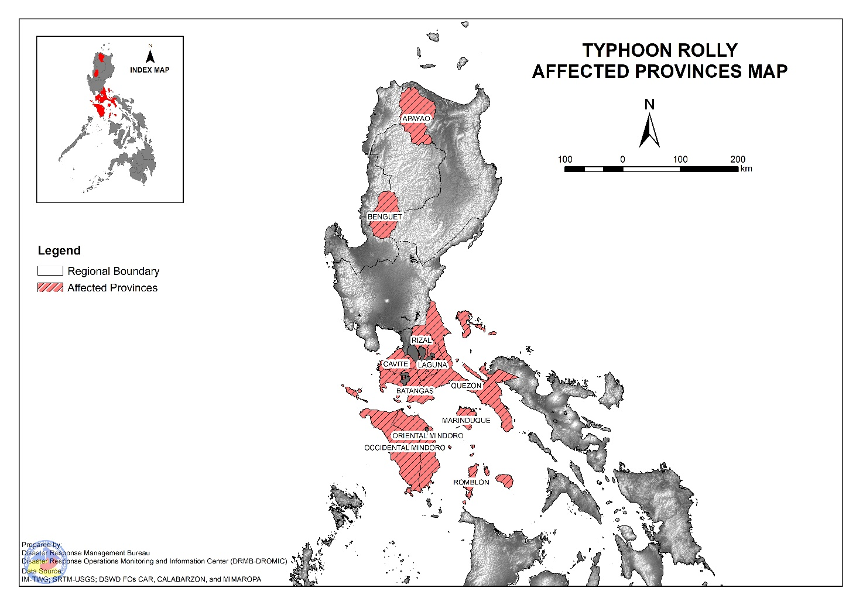
DSWD DISASTER RESPONSE INFORMATION

Status of Prepositioned Resources: Stockpile and Standby Funds

The DSWD Central Office (CO), Field Offices (FOs), and National Resource Operations Center (NROC) have stockpiles and standby funds amounting to ₱842,963,257.72 with breakdown as follows (see Table 1):

- Standby Funds
A total of ₱254,350,456.71 standby funds in the CO and FOs. Of the said amount, ₱212,815,913.19 is the available Quick Response Fund (QRF) in the CO.

- Stockpiles
A total of 280,785 family food packs (FFPs) amounting to ₱126,151,040.94, other food items amounting to ₱181,879,742.70 and non-food items (FNIs) amounting to ₱280,582,017.38 are available.

Table 1. Available Standby Funds and Stockpiles
Region / Office | Standby Funds | FAMILY FOOD PACKS |  | Other Food Items | Non-Food Relief Items | Total Standby Funds & Stockpile
 |  | Quantity | Total Cost
 | 254,350,456.71 | 280,785 | 126,151,040.94 | 181,879,742.70 | 280,582,017.38 | 842,963,257.72
Central Office | 212,815,913.19 | - | - | - | - | 212,815,913.19
NRLMB - NROC | - | 10,687 | 6,438,665.00 | 16,925,826.82 | 72,736,157.75 | 96,100,649.57
NRLMB - VDRC | - | 10,247 | 4,549,237.63 | 3,755,227.33 | 2,469,751.20 | 10,774,216.16
I | 3,000,455.20 | 1,621 | 728,659.32 | 2,813,730.00 | 30,898,834.96 | 37,441,679.48
II | 3,000,938.79 | 20,158 | 10,187,730.36 | 2,762,516.01 | 5,510,398.95 | 21,461,584.11
III | 4,205,028.74 | 12,441 | 5,681,030.73 | 2,012,085.86 | 5,022,278.98 | 16,920,424.31
CALABARZON | 3,000,000.00 | 7,634 | 2,643,864.00 | 5,735,748.48 | 4,069,663.12 | 15,449,275.60
MIMAROPA | 2,882,244.58 | 29,724 | 13,375,800.00 | 2,061,634.00 | 6,003,498.80 | 24,323,177.38
V | - | 23,052 | 7,117,590.14 | 1,053,537.41 | 26,499,532.90 | 34,670,660.45
VI | 3,000,051.68 | 44,551 | 16,103,926.94 | 67,792,935.77 | 5,890,820.31 | 92,787,734.70
VII | 3,000,462.71 | 33,686 | 14,678,129.00 | 9,817,642.56 | 78,797.00 | 27,575,031.27
VIII | 3,194,543.00 | 20,228 | 11,167,188.04 | 7,878,269.90 | 19,619,837.45 | 41,859,838.39
IX | 56,000.00 | 7,047 | 3,851,115.03 | 15,614,222.16 | 8,518,245.45 | 28,039,582.64
X | 3,000,724.42 | 25,458 | 13,758,723.50 | 13,863,632.31 | 27,960,690.00 | 58,583,770.23
XI | 3,000,001.00 | 4,593 | 1,700,098.95 | 11,530,225.00 | 16,356,885.36 | 32,587,210.31
XII | 1,757,513.85 | 1,514 | 832,700.00 | 3,289,022.55 | 10,899,586.54 | 16,778,822.94
CARAGA | 3,000,740.55 | 11,378 | 6,005,819.98 | 6,663,746.83 | 16,464,806.17 | 32,135,113.53
NCR | 2,229,439.00 | 2,440 | 1,340,292.00 | 6,222,081.20 | 10,498,500.05 | 20,290,312.25
CAR | 3,206,400.00 | 14,326 | 5,990,470.32 | 2,087,658.51 | 11,083,732.39 | 22,368,261.22
Note: The Inventory Summary is as of 02 November 2020, 12MN.
Source: DRMB and NRLMB

Situational Reports

DSWD-DRMB
DATE | SITUATIONS / ACTIONS UNDERTAKEN
01 November 2020 | - The Disaster Response Management Bureau (DRMB) is on BLUE alert status and is closely coordinating with the concerned field offices for significant disaster response updates  - All QRT members and emergency equipment are on standby and ready for deployment.  - DSWD DRMB received 500 modular tents from International Organization for Migration (IOM) amounting to ₱3,000,000.00

DSWD-FO NCR
DATE | SITUATIONS / ACTIONS UNDERTAKEN
01 November 2020 | - A total of 3,160 families or 13,682 persons have pre-emptively evacuated in 89 evacuation centers in NCR.  REGION / PROVINCE / MUNICIPALITY NUMBER OF EVACUATION CENTERS (ECs) NUMBER OF DISPLACED  INSIDE ECs  Families Persons  NCR 89 3,160 13,682  Caloocan 1 1 5  Las Pinas 4 30 91  Malabon 5 35 197  Mandaluyong 3 184 815  Manila City 7 505 1,981  Marikina city 8 101 517  Muntinlupa City 26 1,640 7,390  Navotas 12 330 1,376  Paranaque City 9 138 525  Pateros 1 1 3  Taguig City 7 127 510  Quezon City 6 68 272  - DSWD FO-NCR Disaster Response Management Division with Secretary Bautista had a meeting with regard to the preparedness measures of FO-NCR as well as update on the status of evacuation centers, and the families and individuals affected by Typhoon Rolly in Metro Manila.  - DSWD-FO NCR attended the Metro Manila Disaster Risk Reduction Management Council (MDRRMC) emergency meeting for Typhoon Rolly thru zoom meeting held on November 1, 2020.  - DSWD FO-NCR Quick Response Team (QRT) has a total of 10 Personnel on duty.  - DSWD FO-NCR is continuously coordinating with the 17 LGUs thru its respective Local Social Welfare and Development Office (LSWDOs) regarding necessary augmentation assistance needed by affected families. As of reporting time, please be informed that only Pateros has requested for augmentation and is currently being facilitated by FO-NCR.

DSWD-FO CAR
DATE | SITUATIONS / ACTIONS UNDERTAKEN
01 November 2020 | - DSWD-FO CAR issued Weather Disturbance Advisory No. 2 re: Activation of Delta 1 and the Provincial Quick Response Team.  - The Delta 1 had a meeting at the Operations Center.  - The DRMD rendered duty at the Operations Center and monitored the status on the ground as well as the alert status and weather updates.  - The Provincial Social Welfare and Development Teams (PSWADT) DRMD PDO IIs monitored the situation on the ground.  - Municipal Action Teams monitored the situation on the ground.  - Continuous coordination by the DRMD PDO IIs assigned in the PSWADTs with the LDRRMOs for updates.  - Rapid Emergency Telecommunications Team (RETT) including the International Maritime/Marine Satellite (INMARSAT) equipment are on standby.  - The Operations Center is on RED ALERT since 16 March 2020.  - Close coordination with Cordillera Regional Disaster Risk Reduction and Management Council Emergency Operations Center for updates.  - Continuous roll out of advisories and maps for the consumption of the provincial QRTs.

DSWD-FO I
DATE | SITUATIONS / ACTIONS UNDERTAKEN
01 November 2020 | - A total of 15 families or 139 persons have pre-emptively evacuated in 2 evacuation centers in Region I. Out of the 139 individuals, 96 individuals are residents and staff from DSWD FO 1 Centers and Institutions.  REGION / PROVINCE / MUNICIPALITY NUMBER OF EVACUATION CENTERS (ECs) NUMBER OF AFFECTED  Families Persons  REGION I 2 15 139  Pangasinan 2 15 139  Calasiao 1 15 43  Dagupan City 1 - 96  - DSWD-FO I is continuously monitoring the possible effects of Typhoon “ROLLY” through the Department of Science and Technology – Philippine Atmospheric, Geophysical and Astronomical Services Administration (DOST – PAGASA) and close coordination with the Regional Disaster Risk Reduction and Management Council 1 (RDRRMC1). Likewise, Incident Management Team (IMT) Branches are in close coordination with the different Provincial/City/Municipal Disaster Risk Reduction and Management Councils (P/C/MDRRMCs) and Provincial/City/Municipal Social Welfare and Development Offices (P/C/MSWDOs) to monitor the adverse effects that might be brought by the weather disturbance and submission of reports for significant updates.  - DSWD-FO I IMT is on duty while other DSWD staff are on standby for possible augmentation.  - DSWD-FO I with RDRRMC1’s logistical support, hauled 600 bags of NFA rice at NFA Agoo, La Union. Likewise, repacking of FFPs with the help of regional volunteers was conducted at Regional Warehouse in Biday, City of San Fernando, La Union.  - Continuous updating of the official Facebook Page and other social media account of DSWD-FO I to inform the public for necessary preparedness activities.  - As part of the ways forward of the Department, DSWD staff continuously provide orientation to disaster volunteers and LSWDOs in the conduct of preemptive evacuation and preparing every families with their Go Bags. Likewise, prepositioning of FNFIs are being conducted for timely provision of assistance to the Community.
DSWD-FO II
DATE | SITUATIONS / ACTIONS UNDERTAKEN
01 November 2020 | - A total of 21 families or 66 persons have pre-emptively evacuated in 3 evacuation centers in Region II.  REGION / PROVINCE / MUNICIPALITY NUMBER OF EVACUATION CENTERS (ECs) NUMBER OF AFFECTED  Families Persons  REGION II 3 21 66  Isabela 1 3 10  Quezon 1 3 10  Quirino 18 56  Cabarroguis (capital) 1 15 38  Diffun 1 3 18  - Preparedness measures are being undertaken in all MATs, and LGUs including PDRRMC.  - Activation on 24/7 monitoring of the weather systems and all hazard web-based system of all MATs, LGUs including PDRRMC.  - Rescued Teams in all LGUs including the PDDRMC of Cagayan Province are on standby  - Reported landslide/soil erosion in Barangay Masi along Gaggabutan road after talat bridge (National Road along junction logic lasam) which made the provincial highway still impassable as of reporting time and no affected families.  - Reported Pinacanauan crossing block area road in Bonificaio Street, Barangay Centro 1, Tuguegarao City, Cagayan is still impassable.  - SWADTs and MATs of province Cagayan is on a 24-hour duty to monitoring the effects of TY Rolly thru PDRRMC and MATs.  - The LGU Quezon, Nueva Viscaya provided 3 FFPs amounting to ₱750.00 to the families staying in Evacuation Center.

DSWD-FO III
DATE | SITUATIONS / ACTIONS UNDERTAKEN
01 November 2020 | - Activation of Rapid Deployment Team-Disaster Response Management Division of DSWD Field Office and DSWD Provincial Extension Office Quick Response Team.The Disaster Response Management Division thru the Disaster Response Information and Management Section (DRIMS) continuously monitor the weather advisory;  - Continuous monitoring of weather updates in coordination with the DPEO’s and concerned LGUs.  - Continuous repacking of 2,750 FFPs in the Regional Warehouse.  - Coordinated with NROC for the delivery of additional 2,300 FFPs in the Regional Warehouse and 1,700 FFPs in the Satellite Warehouse in Fort Magsaysay.  - Coordinated with OCD 3 for the delivery of 1,000 FFPs to DPEO Aurora Warehouse.  - Prepared recommendation for provision of additional relief augmentation to LGU Cabanatuan City, Nueva Ecija:  - Hygiene Kit – 200  - Sleeping Kit – 200  - Family Kit – 200

DSWD-FO CALABARZON
DATE | SITUATIONS / ACTIONS UNDERTAKEN
02 November 2020 | - DSWD-FO CALABARZON participated the virtual Emergency Operation Center (EOC) briefing facilitated by the Office of Civil Defense IV-A (OCD). The meeting served as venue to conduct a strategic planning to discuss strategies to reach the affected areas.  - DSWD-FO CALABARZON continuously provide technical assistance on the DROMIC Reporting Tools to ensure consistency among the data received.  - DSWD-FO CALABARZON urged Local Social Welfare and Development Offices to explore alternative evacuation centers, since schools could not be used as many have been designated as quarantine facilities for COVID-19 patients.  - DSWD-FO CALABARZON activated the virtual EOC for the updating and exchange of monitoring reports from the RPQRTs from the five (5) Provinces.  - DSWD-FO CALABARZON conducted evacuation center monitoring in the Municipalities of Kawit and Noveleta to check the status of the IDPs who were evacuated prior the impending passage of Typhoon Rolly.  - DSWD-FO CALABARZON conducted an operational briefing with Sec. Bautista regarding the preparation for the imminent effects of TY Rolly and discussed the issues on the hauling of NFA rice.  - DSWD-FO CALABARZON currently assess the request of LGUs for relief augmentation particularly in the 3rd and 4th district of Quezon.  - DSWD-FO CALABARZON

DSWD-FO MIMAROPA
DATE | SITUATIONS / ACTIONS UNDERTAKEN
01 November 2020 | - A total of 2,586 families or 9,643 persons have pre-emptively evacuated in 139 evacuation centers in MIMAROPA.  REGION / PROVINCE / MUNICIPALITY NUMBER OF EVACUATION CENTERS (ECs) NUMBER OF DISPLACED  INSIDE ECs  Families Persons  MIMAROPA 139 2,586 9,643  Marinduque 66 1,519 5,612  Boac (capital) 24 963 3,489  Gasan 20 318 1,195  Mogpog 11 118 397  Santa Cruz 11 120 531  Occidental Mindoro 25 332 1,296  Calintaan 10 121 479  Magsaysay 14 189 712  Mamburao (capital) 1 22 105  Oriental Mindoro 13 76 288  Socorro 13 76 288  Romblon 35 659 2,447  Banton 5 215 601  Cajidiocan 8 129 605  Calatrava 3 30 117  Corcuera 5 56 268  Looc 10 171 649  San Agustin 4 58 207  - The Local Government Units initially provided hot meals to support the immediate need of the displaced families/ individuals inside evacuation centers.  - All concerned SWADT Offices are now coordinating with affected LGUs as to other needs of the affected families/individuals inside evacuation centers.  - With on-going assessment and validation on the reported affected families/individuals.

DSWD-FO V
DATE | SITUATIONS / ACTIONS UNDERTAKEN
01 November 2020 | - A total of 28,213 families or 105,910 persons have pre-emptively evacuated in 893 evacuation centers in Region V.  REGION / PROVINCE / MUNICIPALITY NUMBER OF EVACUATION CENTERS (ECs) NUMBER OF DISPLACED  INSIDE ECs  Families Persons  REGION V 893 28,213 105,910  Albay 316 11,345 38,860  Bacacay 8 308 1,024  Guinobatan 34 3,465 9,784  Jovellar 7 87 432  Legazpi City (capital) 11 531 1,796  Libon 20 379 1,419  City of Ligao 66 2,637 9,736  Malilipot 19 386 1,439  Malinao 21 414 1,561  Oas 3 107 426  Pio Duran 8 358 1,301  Polangui 8 149 512  Santo Domingo (Libog) 53 740 2,659  City of Tabaco 22 672 2,519  Tiwi 36 1,112 4,252  Camarines Norte 262 4,272 17,776  Basud 27 409 1,721  Capalonga 33 642 2,863  Daet (capital) 33 297 1,400  Jose Panganiban 17 274 1,065  Labo 83 1,016 3,916  Mercedes 4 330 1,393  Paracale 28 593 2,737  Santa Elena 35 445 1,768  Vinzons 2 266 913  Camarines Sur 189 4,165 17,476  Baao 18 192 800  Buhi 6 492 1,759  Calabanga 1 45 159  Del Gallego 16 320 1,413  Garchitorena 2 54 256  Lupi 17 96 339  Magarao 1 54 188  Nabua 9 53 233  Naga City 11 304 1,171  Pasacao 1 42 185  Pili (capital) 5 100 308  Ragay 52 953 3,990  Sagñay 5 393 1,757  Siruma 2 27 104  Tinambac 43 1,040 4,814  Masbate 38 970 4,015  Aroroy 4 77 357  Baleno - 39 123  Cataingan 1 14 53  Cawayan 5 107 416  Claveria 4 107 443  Mandaon 1 58 165  Milagros 12 405 1,863  Mobo 6 78 304  Monreal 1 16 56  San Fernando 1 19 69  Uson 3 50 166  Sorsogon 88 7,461 27,783  Barcelona - - 910  Bulusan 30 286 1,081  Donsol 6 261 1,256  Irosin - - 86  Magallanes 7 174 762  Matnog 2 40 187  Prieto Diaz 1 57 225  Santa Magdalena 1 20 119  City of Sorsogon (capital) 41 6,623 23,157  REGION VI 94 1,827 7,212  Aklan 40 560 2,375  Buruanga 12 56 206  Malay 19 275 1,198  Nabas 9 229 971  Antique 44 1,116 4,239  Barbaza 1 16 77  Caluya 40 1,083 4,109  Libertad 3 17 53  Capiz 10 151 598  Pilar 9 139 538  President Roxas 1 12 60  - DSWD to provide 3,000 FFPs and 100 rolls laminated sacks as augmentation support to the affected families in the Province of Catanduanes.  - DSWD to provide 1,500 FFPs as augmentation support to the families in Brgy. Calaguas, Vinzon, Camarines Norte.  - DSWD-FO V continuous to monitor weather updates and information.  - DSWD-FO V has ongoing procurement of 30,000 family food packs  - The Resource Operation Section ensures the availability of family food packs and non-food items as need arises.  - Requested 20,000 FFPs, 100 rolls laminated sacks and 50 tents from Central Office.  - Resource Operation Section ensures the availability of family food packs and non-food items as need arises.  - DSWD-FO V QRTs are activated.  - PAT and MAT members in the 6 provinces are activated and instructed to coordinate with the P/MDRRMOs, C/MSWDOs for reports and updates.

DSWD-FO VI
DATE | SITUATIONS / ACTIONS UNDERTAKEN
01 November 2020 | - A total of 1,827 families or 7,212 persons have pre-emptively evacuated in 94 evacuation centers in Region VI.  REGION / PROVINCE / MUNICIPALITY NUMBER OF EVACUATION CENTERS (ECs) NUMBER OF DISPLACED  INSIDE ECs  Families Persons  REGION VI 94 1,827 7,212  Aklan 40 560 2,375  Buruanga 12 56 206  Malay 19 275 1,198  Nabas 9 229 971  Antique 44 1,116 4,239  Barbaza 1 16 77  Caluya 40 1,083 4,109  Libertad 3 17 53  Capiz 10 151 598  Pilar 9 139 538  President Roxas 1 12 60  - Activation of the Quick Response Team un the entire Western Visayas.  - All staff are in coordination with the LGUs for any possible relief augmentation.

DSWD-FO VII
DATE | SITUATIONS / ACTIONS UNDERTAKEN
01 November 2020 | - Activation of the DSWD Field Office VII Quick Response Team from the Regional level up to the Provincial and Local City/Municipal Action Teams. All are directed to closely coordinate with their respective LDRRMCs and provide assistance and support when needed. Including the submission of incident reports to the Regional Office.  - DSWD-FO VII Regional Quick Response Team 1 are directed to be on standby and alert once there is a need for physical presence in the Operation Center. The Disaster Response Management Division is directed to be on top of the monitoring.  - Continuous monitoring by the DSWD Regional DROMIC Focal for the latest weather updates from PAGASA and cascading the info for widest dissemination to the P/C/MATs.  - Warehouses in the three island provinces are on standby alert.  - Though Cebu City will not have any direct impacts from Rolly, City Mayor has directed its CDRRMO to be on full alert especially in monitoring possible flashfloods and landslides. The city’s heavy equipment is now stationed in landslide-prone areas while the Department of Public Service (DPS) has been instructed to work on the clearing of waterways. The city’s emergency services are also on standby in case of an emergency.  - Talisay City Mayor has also placed his city on alert. Disaster Risk Reduction Office (CDRRMO) has been placed on standby for any possible emergencies that may result from the severe weather systems.  - Cebu P/LDRRMOs now on Blue Alert Disaster Response Level. In reports, Cebu PDRRMO Spokesperson said that several areas in the North are experiencing moderate rains but no evacuation has been conducted yet. Cebu LDRRMOs are on 24/7 alert and rescue equipment, personnel and resources in coordination with the PNP, AFP and BFP are all on standby to respond to any emergencies.  - All sea trips to and from the Region, including trips bound to several island barangays and municipalities within the Provinces and all island-hopping activities were previously cancelled.

DSWD-FO VIII
DATE | SITUATIONS / ACTIONS UNDERTAKEN
01 November 2020 | - Prepositioned Family Food Packs (FFPs) in Samar Island which can be distributed immediately by the P/C/MATs to Local Government Units that need augmentation support.  - Provincial Action Team (PAT) and DRMD PDO assigned are in close coordination with C/MDRRMO and C/MSWDO to have a situational overview on the ground and to ensure response activities of LGUs to this ST Rolly had considered the health protocols, especially during the management of their respective evacuation centers.  - Monitored the arrival of 5,000 FFPs from VDRC Cebu which was requested by the office due to limited stockpile in the region.  - The Regional Resource Operations Center (RROC) is conducting repacking of FFPs from the available raw materials and the Disaster Response Information Management Section is in coordination with SWAD Teams and DRMD PDOs on the ground to collect data and information as to the situation and effect of STY Rolly in Eastern Visayas.

DSWD-FO X
DATE | SITUATIONS / ACTIONS UNDERTAKEN
30 October 2020 | - DSWD FO-X DRMD continuously monitor the weather condition and in constant coordination with the LGUs for possible augmentation and for further updates on Typhoon “Rolly”.

*****
The Disaster Response Operations Monitoring and Information Center (DROMIC) of the DSWD-DRMB is closely monitoring the effects of Typhoon “Rolly” and is coordinating with the concerned DSWD Field Offices for any significant updates.

Prepared by:

MARC LEO L. BUTAC
MARIE JOYCE G. RAFANAN
JAN ERWIN ANDREW I. ONTANILLAS

LESLIE R. JAWILI
Releasing Officer
PHOTO DOCUMENTATION
