DSWD DROMIC Preparedness for Response Report #1 on Tropical Storm “Siony”
as of 02 November 2020, 6AM

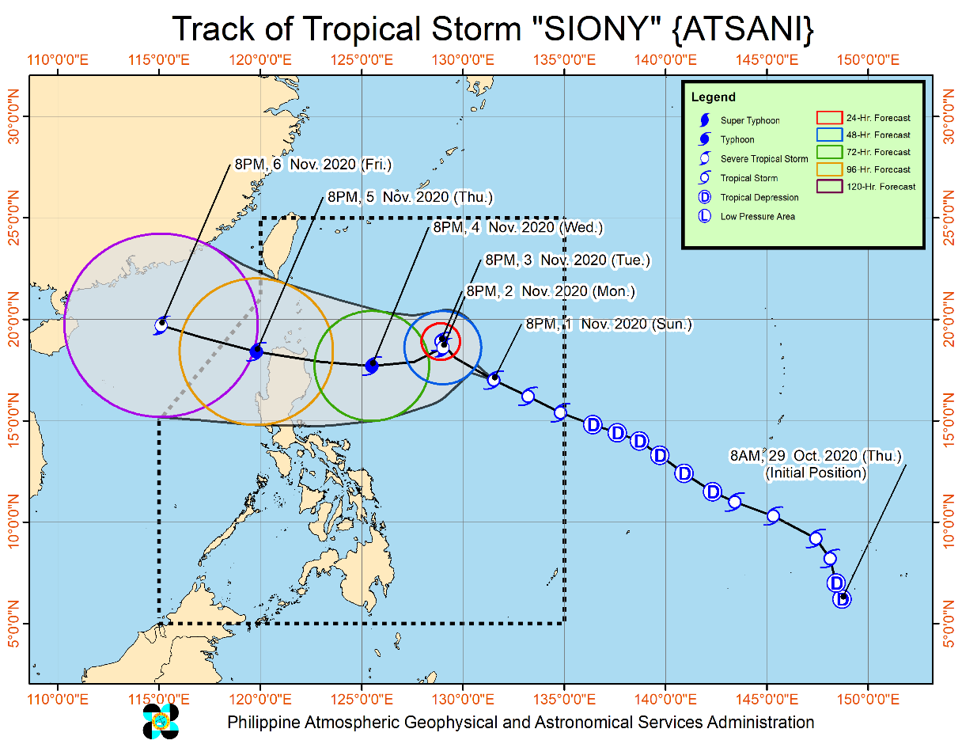
Situation Overview

Issued at 11:00 pm, 1 November 2020, "SIONY" SLIGHTLY WEAKENS BUT REMAINS WITHIN TROPICAL STORM CATEGORY OVER THE PHILIPPINE SEA.

- Track: The center of Tropical Storm “SIONY” is forecast to continue moving west-northwestward tonight through tomorrow evening before slows down significantly and becomes almost stationary tomorrow evening through Tuesday evening. Afterwards, “SIONY” will begin tracking west-southwestward or westward towards Extreme Northern Luzon. Due to the projected erratic movement of this system in the next 48 hours, there is high degree of uncertainty in the forecast track.
- Intensity: “SIONY” is likely remain within tropical storm category within the next 36 to 48 hours. It may intensify to severe tropical storm category during the period when it becomes almost stationary on Tuesday.

At 10:00 PM 1 November 2020, the center of Tropical Storm "SIONY" was estimated based on all available data at 990 km East of Northern Luzon (17.0 °N, 131.0 °E )

Source: DOST-PAGASA Severe Weather Bulletin

PREDICTIVE ANALYTICS FOR HUMANITARIAN RESPONSE

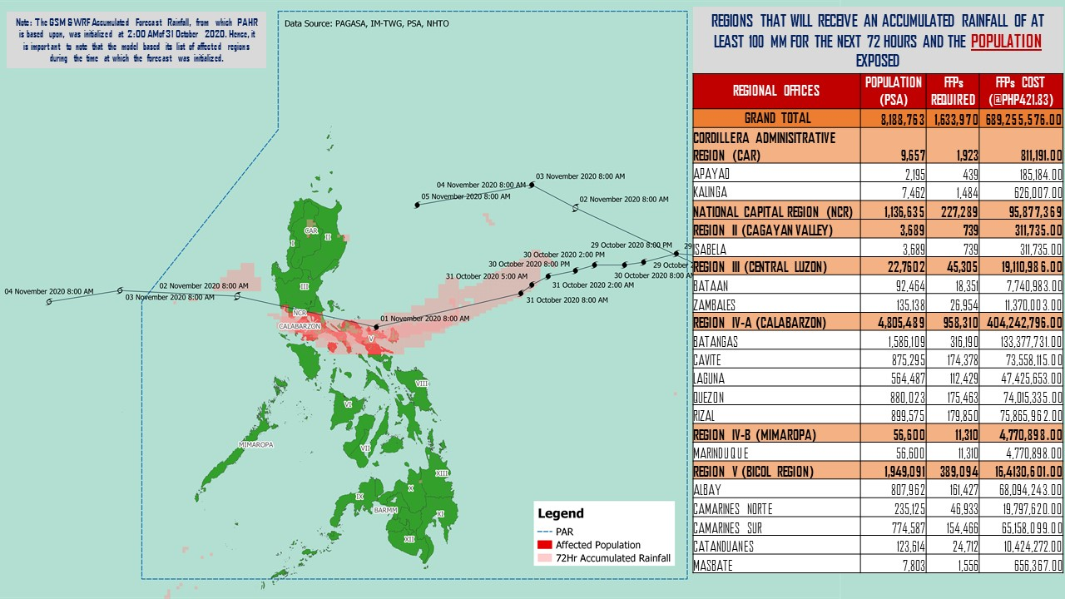

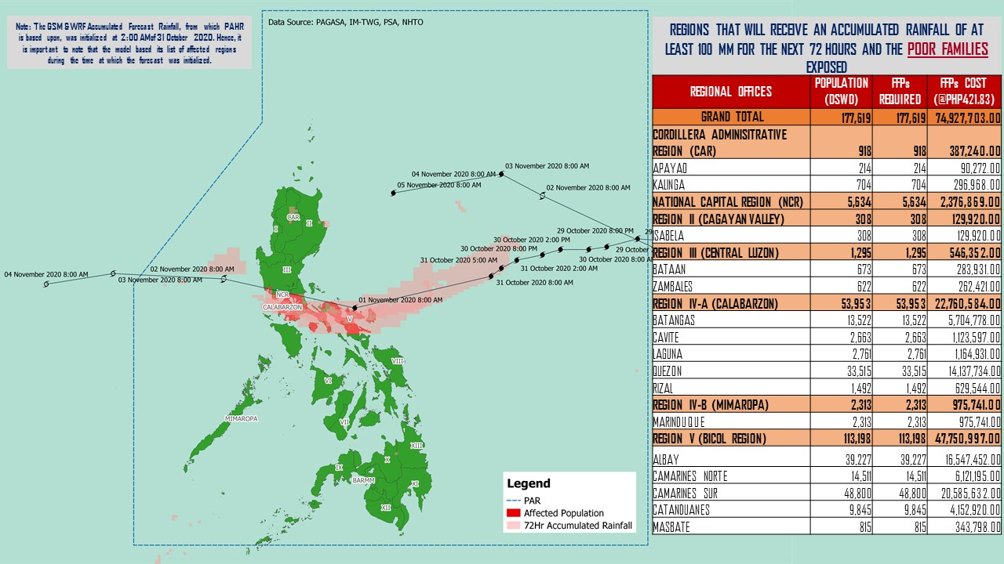

Source: DRMB-DROMIC GIS Specialists
Status of Prepositioned Resources: Stockpile and Standby Funds

The DSWD Central Office (CO), Field Offices (FOs), and National Resource Operations Center (NROC) have stockpiles and standby funds amounting to ₱842,963,257.72 with breakdown as follows (see Table 1):

- Standby Funds
A total of ₱254,350,456.71 standby funds in the CO and FOs. Of the said amount, ₱212,815,913.19 is the available Quick Response Fund (QRF) in the CO.

- Stockpiles
A total of 280,785 family food packs (FFPs) amounting to ₱126,151,040.94, other food items amounting to ₱181,879,742.70 and non-food items (FNIs) amounting to ₱280,582,017.38 are available.

Table 1. Available Standby Funds and Stockpiles
Region / Office | Standby Funds | FAMILY FOOD PACKS |  | Other Food Items | Non-Food Relief Items | Total Standby Funds & Stockpile
 |  | Quantity | Total Cost
 | 254,350,456.71 | 280,785 | 126,151,040.94 | 181,879,742.70 | 280,582,017.38 | 842,963,257.72
Central Office | 212,815,913.19 | - | - | - | - | 212,815,913.19
NRLMB - NROC | - | 10,687 | 6,438,665.00 | 16,925,826.82 | 72,736,157.75 | 96,100,649.57
NRLMB - VDRC | - | 10,247 | 4,549,237.63 | 3,755,227.33 | 2,469,751.20 | 10,774,216.16
I | 3,000,455.20 | 1,621 | 728,659.32 | 2,813,730.00 | 30,898,834.96 | 37,441,679.48
II | 3,000,938.79 | 20,158 | 10,187,730.36 | 2,762,516.01 | 5,510,398.95 | 21,461,584.11
III | 4,205,028.74 | 12,441 | 5,681,030.73 | 2,012,085.86 | 5,022,278.98 | 16,920,424.31
CALABARZON | 3,000,000.00 | 7,634 | 2,643,864.00 | 5,735,748.48 | 4,069,663.12 | 15,449,275.60
MIMAROPA | 2,882,244.58 | 29,724 | 13,375,800.00 | 2,061,634.00 | 6,003,498.80 | 24,323,177.38
V | - | 23,052 | 7,117,590.14 | 1,053,537.41 | 26,499,532.90 | 34,670,660.45
VI | 3,000,051.68 | 44,551 | 16,103,926.94 | 67,792,935.77 | 5,890,820.31 | 92,787,734.70
VII | 3,000,462.71 | 33,686 | 14,678,129.00 | 9,817,642.56 | 78,797.00 | 27,575,031.27
VIII | 3,194,543.00 | 20,228 | 11,167,188.04 | 7,878,269.90 | 19,619,837.45 | 41,859,838.39
IX | 56,000.00 | 7,047 | 3,851,115.03 | 15,614,222.16 | 8,518,245.45 | 28,039,582.64
X | 3,000,724.42 | 25,458 | 13,758,723.50 | 13,863,632.31 | 27,960,690.00 | 58,583,770.23
XI | 3,000,001.00 | 4,593 | 1,700,098.95 | 11,530,225.00 | 16,356,885.36 | 32,587,210.31
XII | 1,757,513.85 | 1,514 | 832,700.00 | 3,289,022.55 | 10,899,586.54 | 16,778,822.94
CARAGA | 3,000,740.55 | 11,378 | 6,005,819.98 | 6,663,746.83 | 16,464,806.17 | 32,135,113.53
NCR | 2,229,439.00 | 2,440 | 1,340,292.00 | 6,222,081.20 | 10,498,500.05 | 20,290,312.25
CAR | 3,206,400.00 | 14,326 | 5,990,470.32 | 2,087,658.51 | 11,083,732.39 | 22,368,261.22
Note: The Inventory Summary is as of 02 November 2020, 12MN.
Source: DRMB and NRLMB

Situational Reports

DSWD-DRMB
DATE | SITUATIONS / ACTIONS UNDERTAKEN
01 November 2020 | - The Disaster Response Management Bureau (DRMB) is on BLUE alert status and is closely coordinating with the concerned field offices for significant disaster response updates  - All QRT members and emergency equipment are on standby and ready for deployment.

DSWD-FO CAR
DATE | SITUATIONS / ACTIONS UNDERTAKEN
01 November 2020 | - DSWD-FO CAR issued Weather Disturbance Advisory No. 2 re: Activation of Delta 1 and the Provincial Quick Response Team.  - The Delta 1 had a meeting at the Operations Center.  - The DRMD rendered duty at the Operations Center and monitored the status on the ground as well as the alert status and weather updates.  - The Provincial Social Welfare and Development Teams (PSWADT) DRMD PDO IIs monitored the situation on the ground.  - The DROMIC Reports were prepared by the Field Office.  - Municipal Action Teams monitored the situation on the ground.  - Continuous coordination by the DRMD PDO IIs assigned in the PSWADTs with the LDRRMOs for updates.  - Rapid Emergency Telecommunications Team (RETT) including the International Maritime/Marine Satellite (INMARSAT) equipment are on standby.  - The Operations Center is on RED ALERT since 16 March 2020.  - Prepared the Preparedness for Response Report for submission to CO and other line agencies.  - Close coordination with Cordillera Regional Disaster Risk Reduction and Management Council Emergency Operations Center for updates.  - QRT and Delta Teams were on standby for possible deployment.  - Continuous roll out of advisories and maps for the consumption of the provincial QRTs.
DSWD-FO CARAGA
DATE | SITUATIONS / ACTIONS UNDERTAKEN
30 October 2020 | - DSWD-FO Caraga is continuously monitoring the weather updates.  - DSWD-FO Quick Response Teams and transport vehicles are on standby for possible deployment.

*****
The Disaster Response Operations Monitoring and Information Center (DROMIC) of the DSWD-DRMB is closely monitoring the effects of Tropical Storm “Siony” and is coordinating with the concerned DSWD Field Offices for any significant updates.

Prepared by:

MARIE JOYCE G. RAFANAN

LESLIE R. JAWILI
Releasing Officer

