DSWD DROMIC Preparedness for Response Report #1
on Tropical Storm “ULYSSES”
as of 10 November 2020, 6PM

Situation Overview

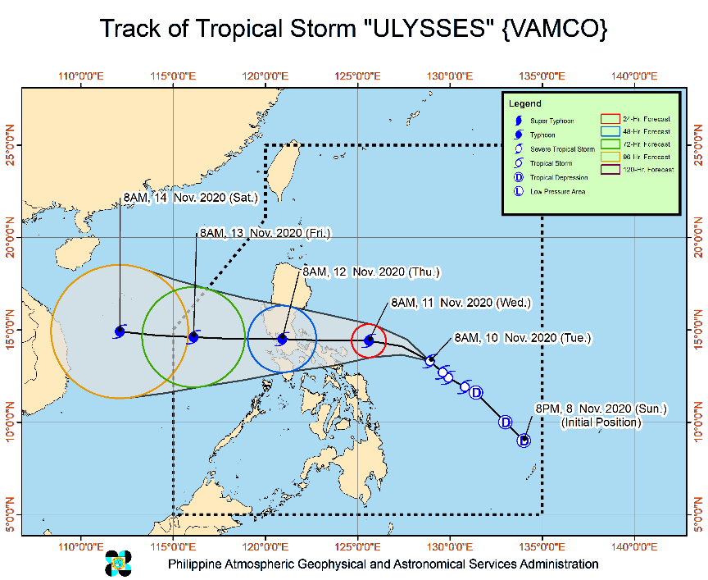
Issued at 5:00 pm, 10 November 2020 TROPICAL STORM "ULYSSES" INTENSIFIES FURTHER AS IT CONTINUES TO MOVE NORTHWESTWARD.
- Track: On the forecast track, Tropical Storm “ULYSSES” will move generally west-northwestward today, then turn westward tomorrow morning. On the forecast track, the center of “ULYSSES” is more likely to make landfall over Quezon on Thursday early morning, with a close approach of Catanduanes and Camarines Norte tomorrow afternoon and evening, respectively. However, slight southward shift in the orientation of the track forecast shows an increasing likelihood of landfall over Bicol Region tomorrow afternoon or evening.
- Intensity: “ULYSSES” is forecast to intensify into a severe tropical storm tonight. Owing to favorable conditions, this storm may rapidly intensify into typhoon category by tomorrow morning and reach its peak intensity (130-155 km/h) tomorrow afternoon or evening. Landfall at or near peak intensity is highly likely.
- Strong winds: Areas under Tropical Cyclone Wind Signals (TCWS) #2 will be experiencing damaging gale- to storm-force winds while those under TCWS #1 will have strong breeze to near gale conditions during the passage of the storm. Based on the intensity forecast, the highest wind signal to be hoisted during the passage of “ULYSSES” will be TCWS #3.
- Heavy rainfall: Today, the tail-end of a cold front (shear line) will bring light to moderate with at times heavy rains over Cagayan including Babuyan Islands, Isabela, Apayao, and Ilocos Norte. Light to moderate with at times heavy rains due to “ULYSSES” will also be experienced over Aurora, Quezon, Bicol Region, Eastern and Central Visayas, Caraga, Northern Mindanao, Zamboanga Peninsula, and Bangsamoro. Moderate to heavy rains associated with the rainbands of “ULYSSES” will begin affecting Bicol Region and portions of Eastern Visayas tomorrow. Flooding (including flashfloods), rain-induced landslides, and sediment-laden streamflows (i.e. lahar) may occur during heavy or prolonged rainfall especially in areas that are highly or very highly susceptible to these hazards and/or those that received significant antecedent rainfall. PAGASA Regional Services Divisions may issue local thunderstorm/rainfall advisories and heavy rainfall warnings while the Hydrometeorology Division and River Basin Flood Forecasting and Warning Centers may issue General Flood Advisories and Basin Flood Bulletins as appropriate.
- Storm Surge: In the next 48 hours, moderate to high risk of storm surge of 1.0 to 2.0 m over the coastal areas of CALABARZON, Aurora, Camarines Provinces, Catanduanes, Albay, Metro Manila, Bulacan, Pampanga, Bataan, Romblon, and Marinduque, the western coastal area of Masbate including Burias Island, and the northern coastal areas of Occidental Mindoro and Oriental Mindoro including Lubang Island. These storm surges, which may be accompanied by swells and breaking waves reaching the coast can cause life-threatening and damaging coastal inundation.

At 4:00 PM today, the center of Tropical Storm "ULYSSES" was estimated based on all available data at 375 km East Northeast of Virac, Catanduanes or 500 km East of Daet, Camarines Norte (14.4 °N, 127.6 °E )
Source: DOST-PAGASA Severe Weather Bulletin

PREDICTIVE ANALYTICS FOR HUMANITARIAN RESPONSE

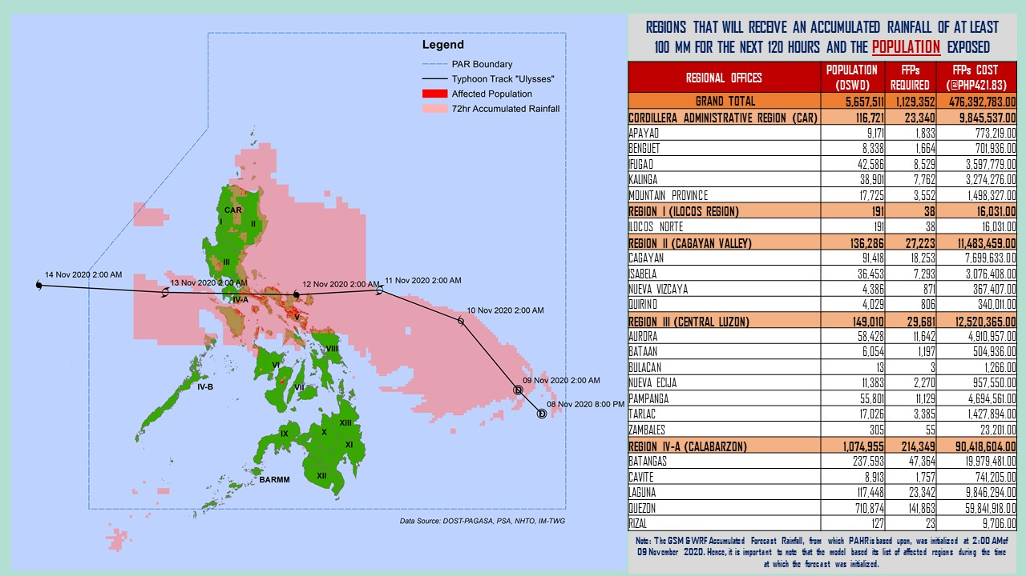
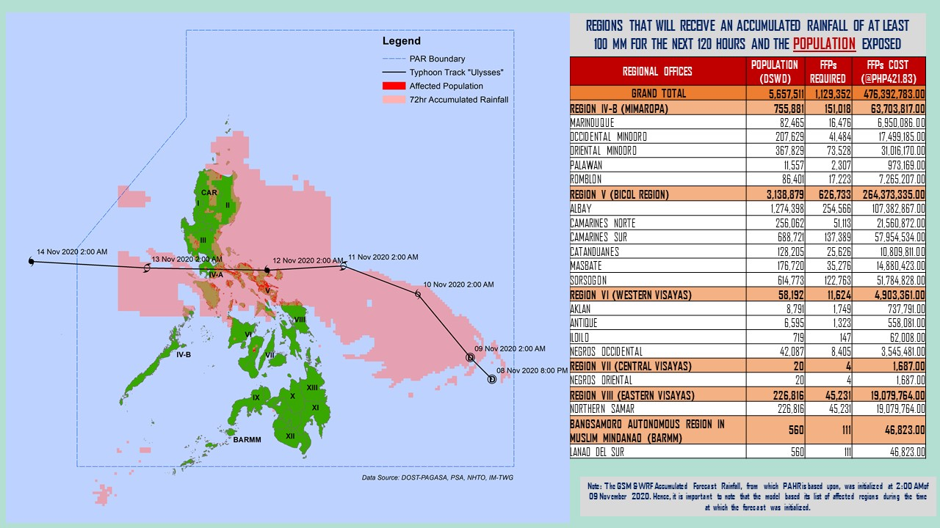
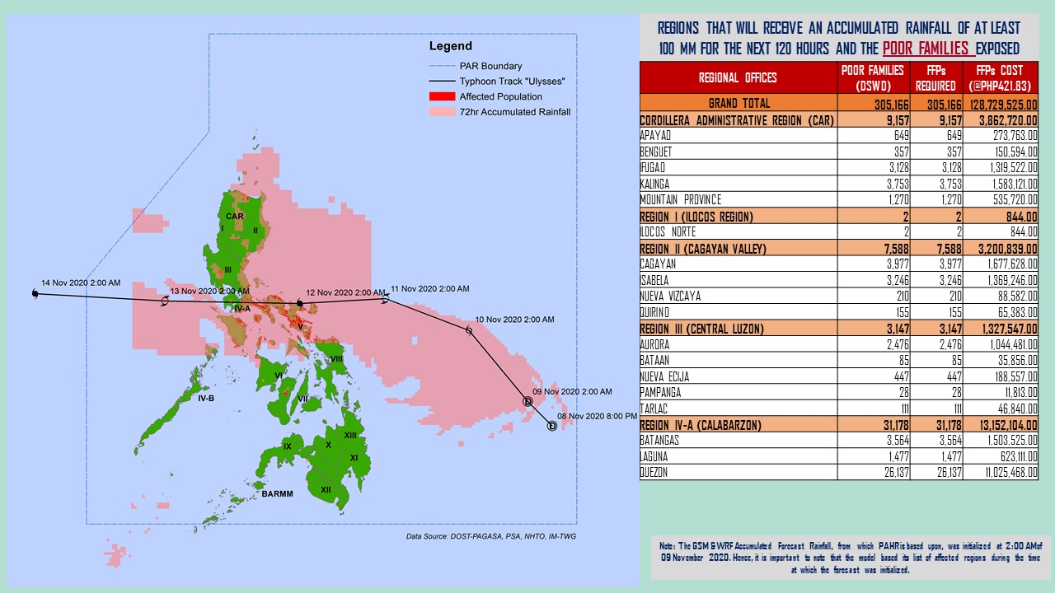

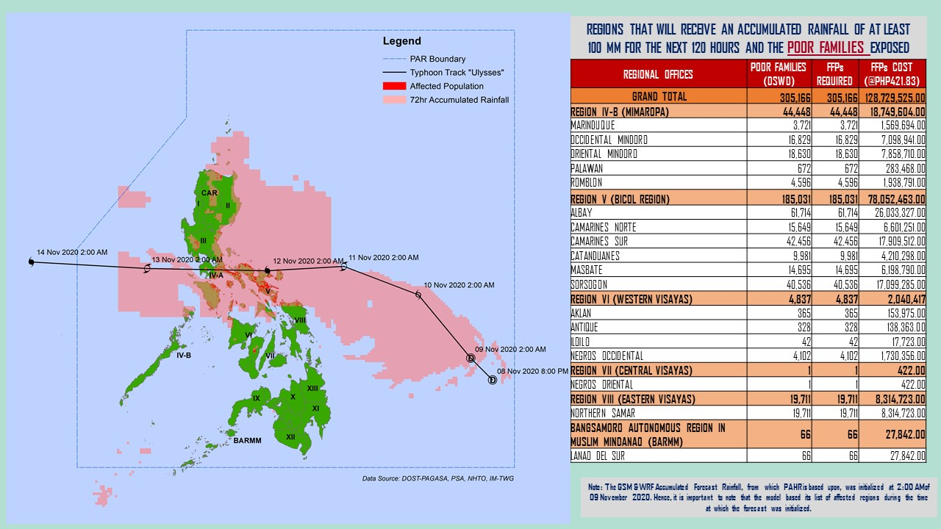
Note: Predictive Analytics for the next 5 days (up to 14 November 2020, 2AM)
Source: DRMB-DROMIC
Status of Prepositioned Resources: Stockpile and Standby Funds
The DSWD Central Office (CO), Field Offices (FOs), and National Resource Operations Center (NROC) have stockpiles and standby funds amounting to ₱802,369,889.69 with breakdown as follows (see Table 2):

- Standby Funds
A total of ₱226,127,488.27 standby funds in the CO and FOs. Of the said amount ₱184,762,513.19 is the available Quick Response Fund (QRF) in the CO.

- Stockpiles
A total of 263,235 family food packs (FFPs) amounting to ₱120,943,090.89, other food items amounting to ₱180,989,584.76 and non-food items (FNIs) amounting to ₱274,309,725.77 are available.

Table 2. Available Stockpiles and Standby Funds
REGIONAL / FIELD OFFICE | STANDBY FUNDS | FAMILY FOOD PACKS |  | OTHER FOOD ITEMS | NON-FOOD RELIEF ITEMS | TOTAL STANDBY FUNDS & STOCKPILE
 |  | QUANTITY | TOTAL COST | TOTAL COST | TOTAL COST
TOTAL | 226,127,488.27 | 263,235 | 120,943,090.89 | 180,989,584.76 | 274,309,725.77 | 802,369,889.69
Central Office | 184,762,513.19 | - | - | - | - | 184,762,513.19
NRLMB - NROC | - | 11,131 | 5,204,120.00 | 19,346,270.84 | 73,015,335.75 | 97,565,726.59
NRLMB - VDRC | - | 10,647 | 4,724,553.63 | 4,718,647.33 | 3,145,887.20 | 12,589,088.16
I | 3,000,455.20 | 7,782 | 3,893,089.80 | 594,039.93 | 30,219,036.72 | 37,706,621.65
II | 1,165,138.79 | 26,084 | 13,276,656.06 | 968,022.68 | 5,510,398.95 | 20,920,216.48
III | 3,305,028.74 | 2,754 | 1,114,554.47 | 5,118,381.86 | 5,022,278.98 | 14,560,244.05
CALABARZON | 3,000,000.00 | 4,384 | 1,760,696.00 | 5,116,247.92 | 4,069,663.12 | 13,946,607.04
MIMAROPA | 2,455,394.58 | 26,128 | 11,757,600.00 | 2,061,634.00 | 5,463,498.80 | 21,738,127.38
V | 3,000,000.00 | 18,115 | 9,189,857.24 | 1,053,537.41 | 21,981,566.90 | 35,224,961.55
VI | 3,000,051.68 | 50,699 | 18,316,792.08 | 71,489,146.98 | 5,890,820.31 | 98,696,811.05
VII | 1,750,544.27 | 31,317 | 13,622,895.00 | 8,224,958.47 | 9,357,840.65 | 32,956,238.39
VIII | 3,194,543.00 | 20,194 | 11,148,940.92 | 7,878,269.90 | 19,360,193.45 | 41,581,947.27
IX | 56,000.00 | 5,530 | 3,022,089.70 | 15,614,222.16 | 6,413,392.88 | 25,105,704.74
X | 3,000,724.42 | 20,960 | 11,235,345.50 | 13,863,590.41 | 27,912,918.94 | 56,012,579.27
XI | 3,000,001.00 | 4,593 | 1,700,098.95 | 11,530,225.00 | 14,916,885.36 | 31,147,210.31
XII | 3,000,513.85 | 2,078 | 1,142,900.00 | 2,228,234.59 | 10,899,586.54 | 17,271,234.98
CARAGA | 3,000,740.55 | 8,816 | 4,735,711.28 | 6,679,909.63 | 16,059,303.97 | 30,475,665.43
NCR | 2,229,439.00 | 0 | - | 3,597,574.50 | 5,741,232.78 | 11,568,246.28
CAR | 3,206,400.00 | 12,023 | 5,097,190.26 | 906,671.15 | 9,329,884.47 | 18,540,145.88
Note: The Inventory Summary is as of 10 November 2020, 3PM.
Source: DRMB and NRLMB

Situational Reports

DSWD-DRMB
DATE | SITUATIONS / ACTIONS UNDERTAKEN
10 November 2020 | - The Disaster Response Management Bureau (DRMB) is on BLUE alert status and is closely coordinating with the concerned field offices for significant disaster response updates  - All QRT members and emergency equipment are on standby and ready for deployment.

DSWD-FO I
DATE | SITUATIONS / ACTIONS UNDERTAKEN
10 November 2020 | - DSWD Field Office 1 is closely monitoring the movement of Tropical Storm “ULYSSES” through the Department of Science and Technology – Philippine Atmospheric, Geophysical and Astronomical Services Administration (DOST – PAGASA) and close coordination with the Regional Disaster Risk Reduction and Management Council 1 (RDRRMC1). Likewise, Provincial Operations Offices (POOs) are in close coordination with the different Provincial/City/Municipal Disaster Risk Reduction and Management Councils (P/C/MDRRMCs) and Provincial/City/Municipal Social Welfare and Development Offices (P/C/MSWDOs) to monitor the adverse effects that might be brought by the weather disturbance.  - The DSWD FO 1 Incident Management Team (IMT) is still on duty while other DSWD staff are on standby for possible augmentation. Likewise, the Field Office ensures availability and readiness of resources.

DSWD-FO MIMAROPA
DATE | SITUATIONS / ACTIONS UNDERTAKEN
10 November 2020 | - Disaster Response Management Division and SWADT Offices are alerted to monitor daily local weather condition and ensure provision of information to all concerned offices, divisions, sections, and units.  - 24/7 On-call status of the R/P/C/M QRTs together with special projects staff for possible activation of Operation Center.  - Close coordination with the Office of Civil Defense (OCD) and RDRRMC MIMAROPA for any warning signal updates for monitoring purposes and response mechanism for areas that will be affected.  - Standby logistical equipment and workforce through coordination with SWADT Offices and concerned LGUs on the management of stranded passengers, if any, in ports and terminals.  - Information and Communication Technology Management Unit (ICTMU) is on standby status to ensure robust communication system.  - Ensure that there is an on-call truck available for delivery of goods and equipment to areas that will be affected.

DSWD-FO VI
DATE | SITUATIONS / ACTIONS UNDERTAKEN
10 November 2020 | - All QRT members are on stand by and ready for augmentation if needed, following the new normal protocols of the agency.  - RDANA team is composed of 40 trained QRTs and is ready to be deployed if needed.  - DSWD issued a total of 150 vests, 50 GO bags, 50 survival bags, and 50 sleeping kits to QRT members in the region and field staff.

DSWD-FO VIII
DATE | SITUATIONS / ACTIONS UNDERTAKEN
10 November 2020 | - Prepositioned Family Food Packs (FFPs) in Samar Island which can be distributed immediately by the P/C/MATs to Local Government Units that need augmentation support.  - Quick Response Teams (QRT) and Disaster Response Management Division (DRMD) are alerted in case augmentation of workforce is needed.  - Disaster Response Information Management Section (DRIMS) is closely coordinating with SWADTs, QRTs and PDOs for any eventualities on the ground.  - Regional Resource Operations Section (RROS) are also alerted to ensure the readiness of dispatching the Food and Non-Food commodities whenever needed.
*****
The Disaster Response Operations Monitoring and Information Center (DROMIC) of the DSWD-DRMB is closely monitoring the effects of Severe Tropical Storm “Ulysses” and is coordinating with the concerned DSWD Field Offices for any significant updates.

Prepared by:

MARIEL B. FERRARIZ
CLARRIE MAE A. CASTILLO

RODEL V. CABADDU
Releasing Officer

