DSWD DROMIC Preparedness for Response Report #2 on
Tropical Storm “Siony”
as of 02 November 2020, 6PM

Situation Overview

Issued at 11:00 am, 2 November 2020, "SIONY" MAINTAINS ITS STRENGTH AS IT ACCELERATES WEST-NORTHWESTWARD OVER THE PHILIPPINE SEA.

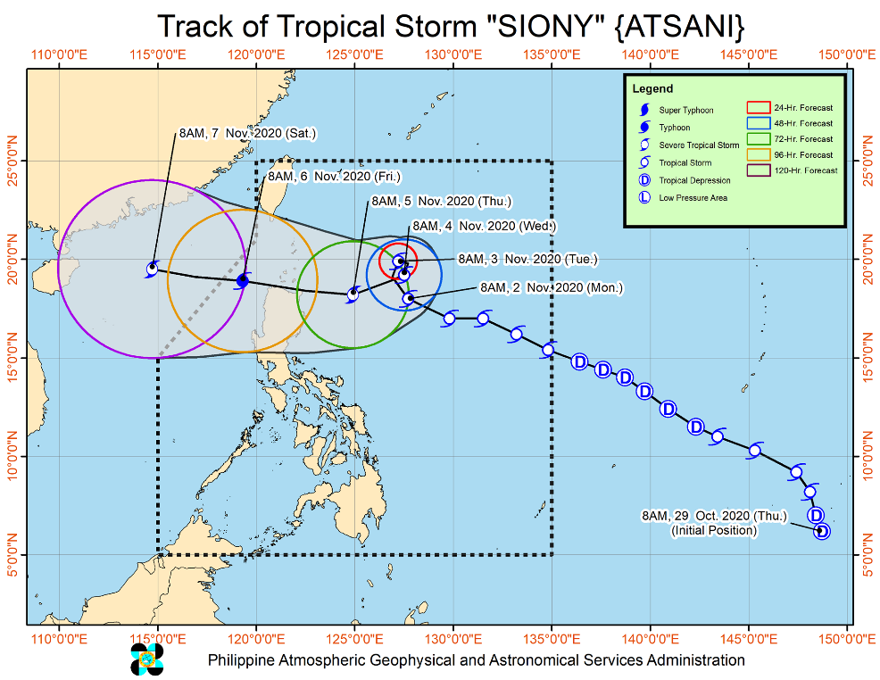
- Track: The center of Tropical Storm “SIONY” is forecast to continue moving west-northwestward or northwestward today before it slows down significantly and becomes almost stationary tomorrow morning through Wednesday morning. Afterwards, “SIONY” will begin tracking west-southwestward or westward towards Extreme Northern Luzon. Due to the projected erratic movement of this system in the next 48 hours, there is high degree of uncertainty in the forecast track.
- Intensity: “SIONY” is likely remain within tropical storm category within the next 36 to 48 hours.

At 10:00 AM 2 November 2020, the center of Tropical Storm "SIONY" was estimated based on all available data at 620 km East of Aparri, Cagayan(18.1°N, 127.5°E).

Source: DOST-PAGASA Severe Weather Bulletin

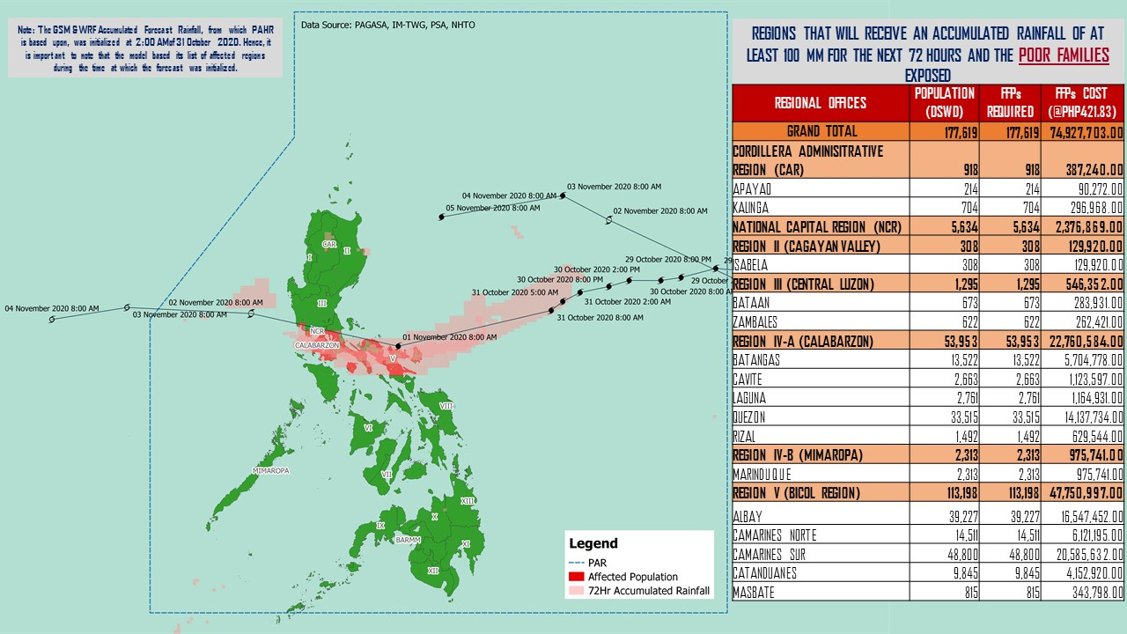
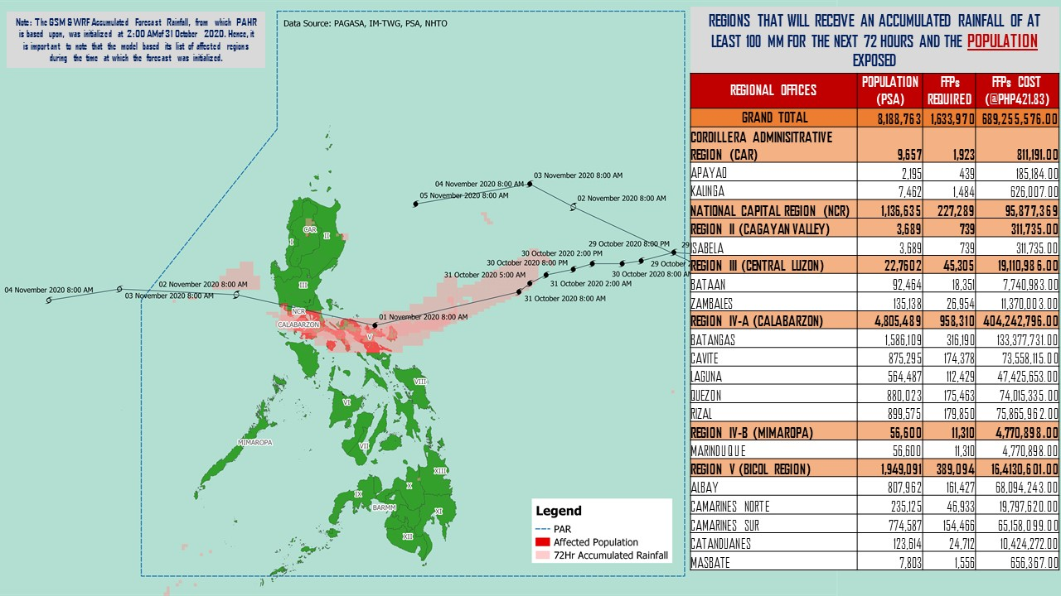
PREDICTIVE ANALYTICS FOR HUMANITARIAN RESPONSE
Source: DRMB-DROMIC GIS Specialists

Status of Prepositioned Resources: Stockpile and Standby Funds

The DSWD Central Office (CO), Field Offices (FOs), and National Resource Operations Center (NROC) have stockpiles and standby funds amounting to ₱874,250,081.46 with breakdown as follows (see Table 1):

- Standby Funds
A total of ₱281,242,956.71 standby funds in the CO and FOs. Of the said amount, ₱239,708,413.19 is the available Quick Response Fund (QRF) in the CO.

- Stockpiles
A total of 279,216 family food packs (FFPs) amounting to ₱128,173,046.68, other food items amounting to ₱186,649,400.70 and non-food items (FNIs) amounting to ₱278,184,677.38 are available.

Table 1. Available Standby Funds and Stockpiles
Regional / Field Office | STANDBY FUNDS | FAMILY FOOD PACKS |  | Food items | Non Food Items | SUB-TOTAL (Food and NFIs) | Total STANDBY FUNDS & STOCKPILE
 |  | Quantity | Total Cost | Total Cost | Total Cost
TOTAL | 281,242,956.71 | 279,216 | 128,173,046.68 | 186,649,400.70 | 278,184,677.38 | 464,834,078.07 | 874,250,081.46
Central Office | 239,708,413.19 | - | - | - | - | - | 239,708,413.19
NRLMB - NROC | - | 9,687 | 5,821,665.00 | 24,135,202.82 | 70,339,517.75 | 94,474,720.57 | 100,296,385.57
NRLMB - VDRC | - | 10,247 | 4,549,237.63 | 3,755,227.33 | 2,469,751.20 | 6,224,978.53 | 10,774,216.16
I | 3,000,455.20 | 1,621 | 728,659.32 | 2,813,730.00 | 30,898,834.96 | 33,712,564.96 | 37,441,679.48
II | 3,000,938.79 | 20,158 | 10,187,730.36 | 2,762,516.01 | 5,510,398.95 | 8,272,914.96 | 21,461,584.11
III | 4,205,028.74 | 12,441 | 5,681,030.73 | 2,012,085.86 | 5,022,278.98 | 7,034,364.84 | 16,920,424.31
CALABARZON | 3,000,000.00 | 8,034 | 2,833,264.00 | 3,296,030.48 | 4,069,663.12 | 7,365,693.60 | 13,198,957.60
MIMAROPA | 2,882,244.58 | 29,724 | 13,375,800.00 | 2,061,634.00 | 6,003,498.80 | 8,065,132.80 | 24,323,177.38
V | - | 22,083 | 9,567,195.88 | 1,053,537.41 | 26,499,532.90 | 27,553,070.31 | 37,120,266.19
VI | 3,000,051.68 | 44,551 | 16,103,926.94 | 67,792,935.77 | 5,890,820.31 | 73,683,756.08 | 92,787,734.70
VII | 3,000,462.71 | 33,686 | 14,678,129.00 | 9,817,642.56 | 78,097.00 | 9,895,739.56 | 27,574,331.27
VIII | 3,194,543.00 | 20,228 | 11,167,188.04 | 7,878,269.90 | 19,619,837.45 | 27,498,107.35 | 41,859,838.39
IX | 56,000.00 | 7,047 | 3,851,115.03 | 15,614,222.16 | 8,518,245.45 | 24,132,467.61 | 28,039,582.64
X | 3,000,724.42 | 25,458 | 13,758,723.50 | 13,863,632.31 | 27,960,690.00 | 41,824,322.31 | 58,583,770.23
XI | 3,000,001.00 | 4,593 | 1,700,098.95 | 11,530,225.00 | 16,356,885.36 | 27,887,110.36 | 32,587,210.31
XII | 1,757,513.85 | 1,514 | 832,700.00 | 3,289,022.55 | 10,899,586.54 | 14,188,609.09 | 16,778,822.94
CARAGA | 3,000,740.55 | 11,378 | 6,005,819.98 | 6,663,746.83 | 16,464,806.17 | 23,128,553.00 | 32,135,113.53
NCR | 2,229,439.00 | 2,440 | 1,340,292.00 | 6,222,081.20 | 10,498,500.05 | 16,720,581.25 | 20,290,312.25
CAR | 3,206,400.00 | 14,326 | 5,990,470.32 | 2,087,658.51 | 11,083,732.39 | 13,171,390.90 | 22,368,261.22
Note: The Inventory Summary is as of 02 November 2020, 4PM.
Source: DRMB and NRLMB

Situational Reports

DSWD-DRMB
DATE | SITUATIONS / ACTIONS UNDERTAKEN
02 November 2020 | - The Disaster Response Management Bureau (DRMB) is on BLUE alert status and is closely coordinating with the concerned field offices for significant disaster response updates  - All QRT members and emergency equipment are on standby and ready for deployment.

DSWD-FO CAR
DATE | SITUATIONS / ACTIONS UNDERTAKEN
01 November 2020 | - DSWD-FO CAR issued Weather Disturbance Advisory No. 2 re: Activation of Delta 1 and the Provincial Quick Response Team.  - The Delta 1 had a meeting at the Operations Center.  - The DRMD rendered duty at the Operations Center and monitored the status on the ground as well as the alert status and weather updates.  - The Provincial Social Welfare and Development Teams (PSWADT) DRMD PDO IIs monitored the situation on the ground.  - The DROMIC Reports were prepared by the Field Office.  - Municipal Action Teams monitored the situation on the ground.  - Continuous coordination by the DRMD PDO IIs assigned in the PSWADTs with the LDRRMOs for updates.  - Rapid Emergency Telecommunications Team (RETT) including the International Maritime/Marine Satellite (INMARSAT) equipment are on standby.  - The Operations Center is on RED ALERT since 16 March 2020.  - Prepared the Preparedness for Response Report for submission to CO and other line agencies.  - Close coordination with Cordillera Regional Disaster Risk Reduction and Management Council Emergency Operations Center for updates.  - QRT and Delta Teams were on standby for possible deployment.  - Continuous roll out of advisories and maps for the consumption of the provincial QRTs.

DSWD-FO I
DATE | SITUATIONS / ACTIONS UNDERTAKEN
02 November 2020 | - DSWD-FO I is closely monitoring the movement of Tropical Storm “SIONY” through the Department of Science and Technology – Philippine Atmospheric, Geophysical and Astronomical Services Administration (DOST – PAGASA) and close coordination with the Regional Disaster Risk Reduction and Management Council 1 (RDRRMC1). Likewise, Provincial Operations Offices (POOs) are in close coordination with the different Provincial/City/Municipal Disaster Risk Reduction and Management Councils (P/C/MDRRMCs) and Provincial/City/Municipal Social Welfare and Development Offices (P/C/MSWDOs) to monitor the adverse effects that might be brought by the weather disturbance.  - DSWD-FO I Incident Management Team (IMT) is still on duty while other DSWD staff are on standby for possible augmentation. Likewise, the Field Office ensures availability and readiness of resources.  - Ongoing repacking of FFPs with the help of regional volunteers is being conducted at Regional Warehouse in Biday, City of San Fernando, La Union. Likewise, processing of procurement related documents is ongoing for additional raw materials.

DSWD-FO II
DATE | SITUATIONS / ACTIONS UNDERTAKEN
02 November 2020 | - DSWD-FO II has twenty-six (26) Regional Disaster Management and Resources Team (RDMRTs) composed of six (6) members per team on rotation basis. There are also five (5) Social Welfare Development Teams (SWADTs) and eighty-seven (87) City/Municipal Action Team (C/MATs) in the five (5) provinces readily available when the Tropical Storms (TS) “Siony” accelerate the Region.  - DSWD-FO II alerted all SWAD Teams/MATs on the occurrence of Tropical Storm (TS) Siony. They were advised to coordinate with their Local Social Welfare and Development Officers (LSWDOs) if there are concerns need to be addressed by the Field Office (FO).  - DSWD-FO II Disaster Response Management Division (DRMD) thru Disaster Response and Rehabilitation Section continuously monitor the weather advisory and provided advisory to all RDRMTs, SWADTs and Municipal Actions Team (MATs).  - DSWD-FO II DRMD through the Regional Resource Operations Section ensures availability of Food and Non-Food Items (FNIs) at any given time.  - DSWD-FO II DRMD thru the Disaster Response and Rehabilitation Section ensures to be on-call with the Regional DMRT, SWADTs, P/C/MATs in the event that TS Siony will accelerate or affect the Region.  - DSWD-FO II shall ensure reactivation of volunteers if needed.

DSWD-FO IX
DATE | SITUATIONS / ACTIONS UNDERTAKEN
02 November 2020 | - DSWD-FO IX is continuously monitoring the weather updates.  - DSWD-FO IX ensured on stock availability of Food and Non-Food Items.  - DSWD-FO IX is continuously repacking goods to maintain the required 30 family food packs.  - DSWD-FO IX through its Disaster Response Division inform the SWAD team leaders to monitor the situation in their respective area of responsibility.

DSWD-FO X
DATE | SITUATIONS / ACTIONS UNDERTAKEN
02 November 2020 | - DSWD-FO X is continuously monitoring the weather updates.  - DSWD-FO X has a total of 914 Regional Quick Response Team members including P/MAT on standby for possible deployment.  - DSWD-FO X has two available warehouses for the hauling and preparation of FNFIs.  - DSWD-FO X has two (2) operational vehicles/trucks on standby to be utilized for logistical support.  - DSWD-FO X has 4 Samsung Grand cellphones currently used by the Regional Response Teams.  - DSWD-FO X DROMIC will be available and on standby 24/7 for monitoring and coordination with CDRRMO and OCD for any developments on the situation.

DSWD-FO CARAGA
DATE | SITUATIONS / ACTIONS UNDERTAKEN
30 October 2020 | - DSWD-FO Caraga is continuously monitoring the weather updates.  - DSWD-FO Quick Response Teams and transport vehicles are on standby for possible deployment.

*****
The Disaster Response Operations Monitoring and Information Center (DROMIC) of the DSWD-DRMB is closely monitoring the effects of Tropical Storm “Siony” and is coordinating with the concerned DSWD Field Offices for any significant updates.

Prepared by: Releasing Officer:

JOANNA CAMILLE R. JACINTO RODEL V. CABADDU

