DSWD DROMIC Preparedness for Response Report #2
on Typhoon “ULYSSES”
as of 11 November 2020, 6PM

Situation Overview

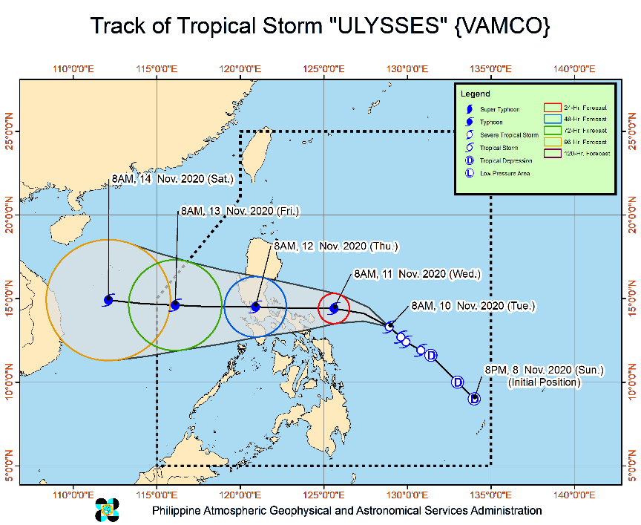
Issued at 2:00 pm, 11 November 2020 TYPHOON "ULYSSES" INTENSIFIES FURTHER AS IT CONTINUES TO MOVE CLOSER TOWARDS QUEZON-AURORA AREA.
- Track: On the forecast track, “ULYSSES” will move generally westward throughout the forecast period and pass over the seas north of Camarines Provinces between this afternoon and evening. The center of “ULYSSES” is forecast to make landfall over Polillo Islands and mainland Quezon between tonight and tomorrow early morning. Afterwards, “ULYSSES” will cross Central Luzon and emerge over the western seaboard of Zambales tomorrow morning.
- Intensity: “ULYSSES” may reach its peak intensity of 130-155 km/h prior to landfall. “ULYSSES” may slightly weaken as it crosses mainland Luzon due to frictional effects in the presence of the Sierra Madre and Zambales Mountain Ranges. However, it is likely to remain a typhoon throughout its traverse.
- Strong winds: Throughout the passage of the typhoon, destructive typhoon-force winds will be experiencing in areas under Tropical Cyclone Wind Signal (TCWS) #3, damaging gale- to storm-force winds in areas under TCWS #2, and strong breeze to near gale conditions in areas under TCWS #1. In other areas, the rest of Northern Luzon will be experiencing strong breeze to gale-force winds due to the surge of the Northeast Monsoon.
- Heavy rainfall: Until tonight, heavy to intense with at times torrential rains over Camarines Norte, Camarines Sur, and Catanduanes. Moderate to heavy with at times intense rains over Albay, Sorsogon, Quezon including Polillo Islands, and Burias and Ticao Islands. Light to moderate with at times heavy rains over Metro Manila and the rest of Luzon and Visayas. Between tonight and tomorrow early morning, heavy to intense with at times torrential rains over Camarines Norte, Camarines Sur, Metro Manila, CALABARZON, Aurora, Bulacan, Pampanga, and Bataan. Moderate to heavy with at times intense rains over Cordillera Administrative Region, mainland Cagayan Valley, Catanduanes, Marinduque, the northern portion of Mindoro Provinces, and the rest of Central Luzon. Light to moderate with at times heavy rains over the rest of Luzon and Visayas. Flooding (including flashfloods), rain-induced landslides, and sediment-laden streamflows (i.e. lahar) may occur during heavy or prolonged rainfall especially in areas that are highly or very highly susceptible to these hazards and/or those that received significant antecedent rainfall. PAGASA Regional Services Divisions may issue local thunderstorm/rainfall advisories and heavy rainfall warnings while the Hydrometeorology Division and River Basin Flood Forecasting and Warning Centers may issue General Flood Advisories and Basin Flood Bulletins as appropriate.
- Storm SurgeThere is a high risk of storm surge with heights of up to 3.0 m over the coastal areas of Quezon including Polillo Islands, Camarines Norte, Catanduanes, and the northern and eastern coastal areas of Camarines Sur, and up to 2.0 m over the coastal areas of La Union, Pangasinan, Isabela, Zambales, Aurora, Bataan, Pampanga, Bulacan, Metro Manila, Cavite, Batangas, northern portions of Mindoro Provinces including Lubang Island, Marinduque, Romblon, Masbate including Ticao and Burias Islands, Albay, and Sorsogon, and the remaining coastal areas of Camarines Sur. These storm surges, which may be accompanied by swells and/or breaking waves near the coast, can cause life-threatening and damaging coastal inundation. Moreover, there is also a moderate risk of seiche or storm surge over the coastal areas surrounding Laguna de Bay.

At 1:00 PM today, the center of the eye of Typhoon "ULYSSES" was located based on all available data at 125 km North Northwest of Virac, Catanduanes or 95 km Northeast of Daet, Camarines Norte (14.6 °N, 123.7 °E )
Source: DOST-PAGASA Severe Weather Bulletin

PREDICTIVE ANALYTICS FOR HUMANITARIAN RESPONSE

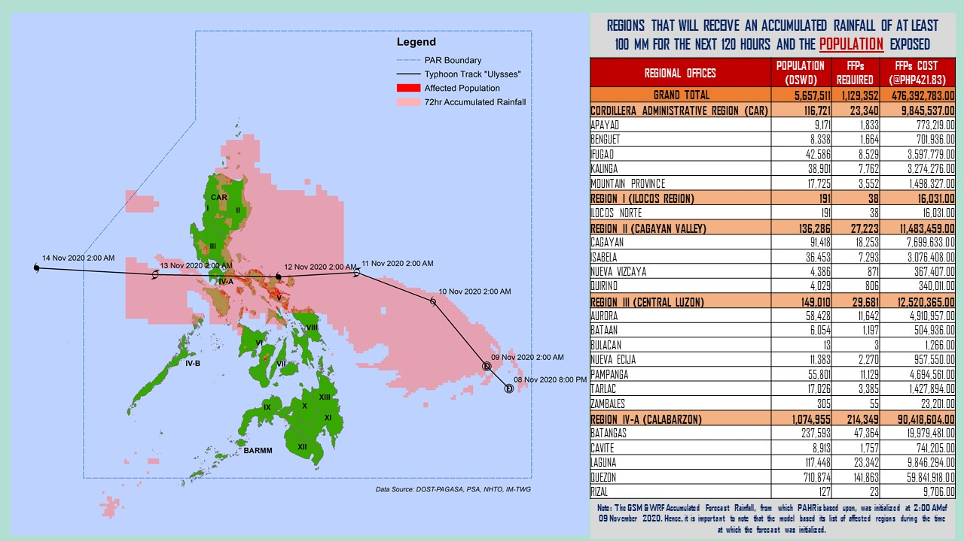
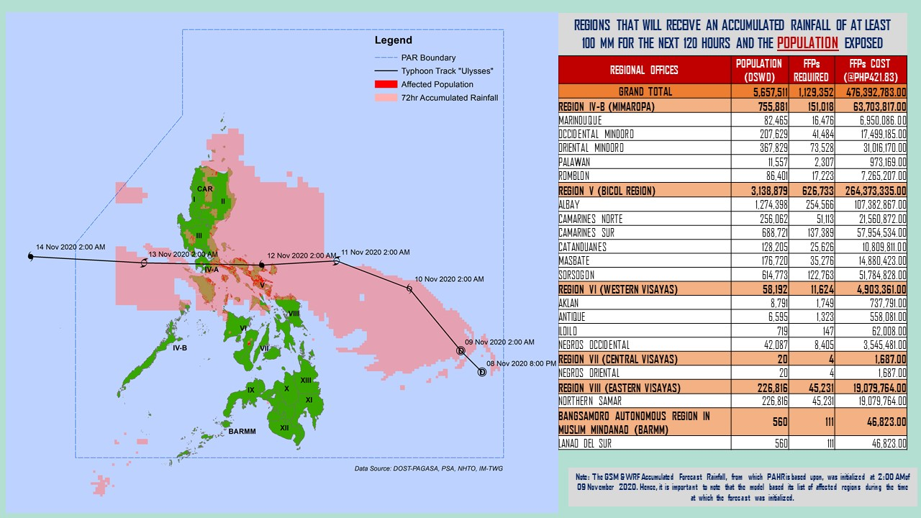
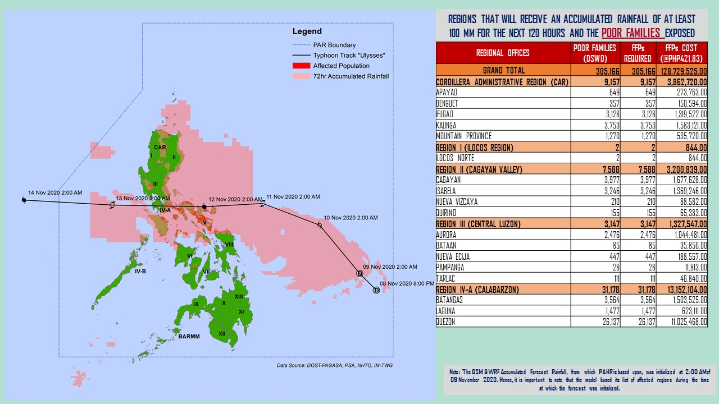

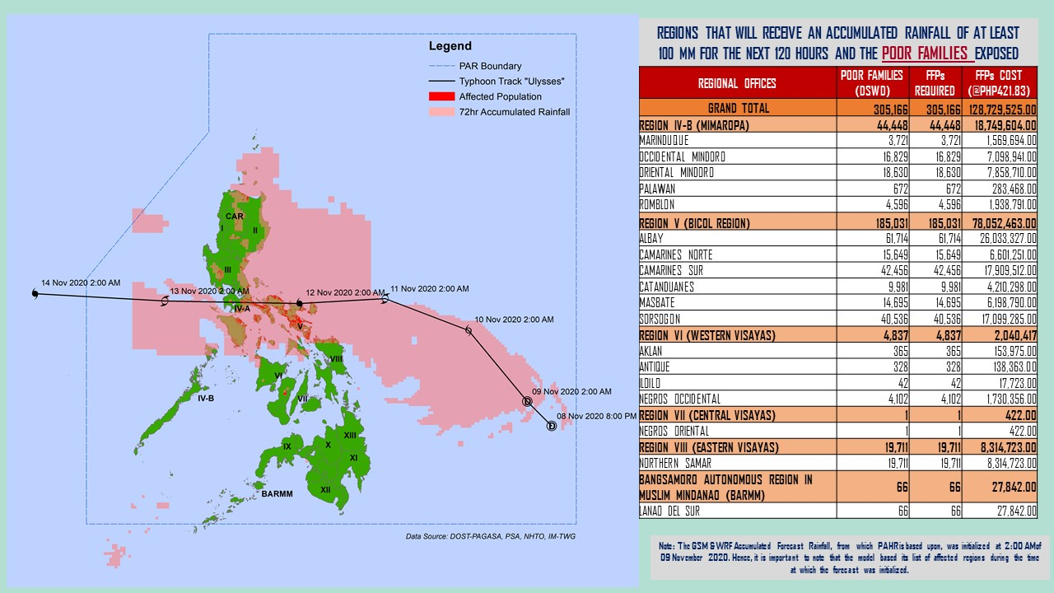
Note: Predictive Analytics for the next 5 days (up to 14 November 2020, 2AM)
Source: DRMB-DROMIC
Status of Prepositioned Resources: Stockpile and Standby Funds
The DSWD Central Office (CO), Field Offices (FOs), and National Resource Operations Center (NROC) have stockpiles and standby funds amounting to ₱810,228,258.58 with breakdown as follows (see Table 2):

- Standby Funds
A total of ₱226,127,488.27 standby funds in the CO and FOs. Of the said amount ₱184,762,513.19 is the available Quick Response Fund (QRF) in the CO.

- Stockpiles
A total of 279,186 family food packs (FFPs) amounting to ₱128,833,603.61, other food items amounting to ₱183,854,295.38 and non-food items (FNIs) amounting to ₱271,412,871.32 are available.

Table 2. Available Stockpiles and Standby Funds
REGIONAL / FIELD OFFICE | STANDBY FUNDS | FAMILY FOOD PACKS |  | OTHER FOOD ITEMS | NON-FOOD RELIEF ITEMS | TOTAL STANDBY FUNDS & STOCKPILE
 |  | QUANTITY | TOTAL COST | TOTAL COST | TOTAL COST
TOTAL | 226,127,488.27 | 279,186 | 128,833,603.61 | 183,854,295.38 | 271,412,871.32 | 810,228,258.58
Central Office | 184,762,513.19 | - | - | - | - | 184,762,513.19
NRLMB - NROC | - | 17,956 | 8,683,376.00 | 19,223,201.44 | 72,760,658.25 | 100,667,235.69
NRLMB - VDRC | - | 11,447 | 5,075,185.63 | 6,858,559.33 | 3,145,887.20 | 15,079,632.16
I | 3,000,455.20 | 9,147 | 4,589,239.80 | 155,738.30 | 30,061,846.77 | 37,807,280.07
II | 1,165,138.79 | 26,084 | 13,276,656.06 | 968,022.68 | 5,510,398.95 | 20,920,216.48
III | 3,305,028.74 | 2,754 | 1,114,554.47 | 5,161,085.86 | 5,022,278.98 | 14,602,948.05
CALABARZON | 3,000,000.00 | 4,384 | 1,760,696.00 | 5,116,247.92 | 4,069,663.12 | 13,946,607.04
MIMAROPA | 2,455,394.58 | 26,108 | 11,748,600.00 | 2,061,634.00 | 5,004,948.80 | 21,270,577.38
V | 3,000,000.00 | 25,297 | 13,012,842.24 | 1,053,537.41 | 19,955,129.90 | 37,021,509.55
VI | 3,000,051.68 | 53,865 | 19,456,552.08 | 71,489,146.98 | 5,890,820.31 | 99,836,571.05
VII | 1,750,544.27 | 28,984 | 12,608,040.00 | 8,087,639.80 | 9,357,840.65 | 31,804,064.72
VIII | 3,194,543.00 | 19,494 | 10,584,340.92 | 7,878,269.90 | 19,360,193.45 | 41,017,347.27
IX | 56,000.00 | 5,530 | 3,022,089.70 | 15,614,222.16 | 6,413,392.88 | 25,105,704.74
X | 3,000,724.42 | 20,960 | 11,235,345.50 | 13,863,590.41 | 27,912,918.94 | 56,012,579.27
XI | 3,000,001.00 | 4,593 | 1,700,098.95 | 11,530,225.00 | 14,916,885.36 | 31,147,210.31
XII | 3,000,513.85 | 2,078 | 1,142,900.00 | 2,228,234.59 | 10,899,586.54 | 17,271,234.98
CARAGA | 3,000,740.55 | 8,816 | 4,730,896.00 | 6,679,909.63 | 16,059,303.97 | 30,470,850.15
NCR | 2,229,439.00 | - | - | 3,597,574.50 | 5,741,232.78 | 11,568,246.28
CAR | 3,206,400.00 | 11,689 | 5,092,190.26 | 2,287,455.47 | 9,329,884.47 | 19,915,930.20
Note: The Inventory Summary is as of 11 November 2020, 3PM.
Source: DRMB and NRLMB

Situational Reports

DSWD-DRMB
DATE | SITUATIONS / ACTIONS UNDERTAKEN
11 November 2020 | - The Disaster Response Management Bureau (DRMB) is on RED alert status and is closely coordinating with the concerned field offices for significant disaster response updates  - All QRT members and emergency equipment are on standby and ready for deployment.  - DRMB participated in the Online Pre-Disaster Risk Assessment Meeting on Typhoon “ULYSSES” on 9 November 2020 with other response cluster member agencies.

DSWD-FO I
DATE | SITUATIONS / ACTIONS UNDERTAKEN
11 November 2020 | - DSWD Field Office 1 is closely monitoring the movement of Tropical Storm “ULYSSES” through the Department of Science and Technology – Philippine Atmospheric, Geophysical and Astronomical Services Administration (DOST – PAGASA) and close coordination with the Regional Disaster Risk Reduction and Management Council 1 (RDRRMC1). Likewise, Provincial Operations Offices (POOs) are in close coordination with the different Provincial/City/Municipal Disaster Risk Reduction and Management Councils (P/C/MDRRMCs) and Provincial/City/Municipal Social Welfare and Development Offices (P/C/MSWDOs) to monitor the adverse effects that might be brought by the weather disturbance.  - The DSWD FO 1 Incident Management Team (IMT) is still on duty while other DSWD staff are on standby for possible augmentation. Likewise, the Field Office ensures availability and readiness of resources.

DSWD-FO CALABARZON
DATE | SITUATIONS / ACTIONS UNDERTAKEN
11 November 2020 | - Coordinated with the PQRTs of CALABARZON were advised to monitor and coordinate with the LGUs to gather reports on the possible effects of the typhoon.  - Coordinated with P/C/MSWDOs and P/C/MDRRMOs of the five (5) Province and instructed them to be on standby alert and prepare their respective evacuation centers, and family food pack should need arises.  - The DRMD requested the LSWDOs to ensure that situation reports are provided to the DSWD FO IV-A Emergency Operations Center (EOC) the through the fastest means of communication.  - The Field Office through the DRMD provided technical assistance to the LSWDOs to ensure that guidelines for typhoon preparedness in COVID-context 19, to reduce risk of transmission in evacuation centers  - Advised the LGUs in the flood, landslide and storm surge prone areas to conduct pre-emptive evacuation and ensure that COVID-19 minimum health standard is incorporated in their response plans.  - DSWD FO IV-A through the DRMD has informed member agencies of the response cluster to be on-stand-by alert status and ready for mobilization in case situation arises.  - The DSWD FO IV-A Emergency Operations Center has been activated and placed on heightened alert status.  - The DRMD participated in the Emergency Preparedness for Response (EPR) for STS Ulysses through virtual teleconference.  - The DRDM joined in the activated Virtual Emergency Operations Center (EOC) of the Regional Disaster Risk Reduction and Management Council (RDRRMC) IV-A and Response Cluster.  - The DRMD communicated to the Army Reserve Command (ARESCOM) in Tanza, Cavite for the possible deployment of personnel and logistics should need arises.

DSWD-FO MIMAROPA
DATE | SITUATIONS / ACTIONS UNDERTAKEN
10 November 2020 | - Disaster Response Management Division and SWADT Offices are alerted to monitor daily local weather condition and ensure provision of information to all concerned offices, divisions, sections, and units.  - 24/7 On-call status of the R/P/C/M QRTs together with special projects staff for possible activation of Operation Center.  - Close coordination with the Office of Civil Defense (OCD) and RDRRMC MIMAROPA for any warning signal updates for monitoring purposes and response mechanism for areas that will be affected.  - Standby logistical equipment and workforce through coordination with SWADT Offices and concerned LGUs on the management of stranded passengers, if any, in ports and terminals.  - Information and Communication Technology Management Unit (ICTMU) is on standby status to ensure robust communication system.  - Ensure that there is an on-call truck available for delivery of goods and equipment to areas that will be affected.

DSWD-FO V
DATE | SITUATIONS / ACTIONS UNDERTAKEN
11 November 2020 | - A total of 1,694 families or 6,113 persons have pre-emptively evacuated in 42 evacuation centers in Region V.  REGION / PROVINCE / MUNICIPALITY NUMBER OF EVACUATION CENTERS (ECs) NUMBER OF DISPLACED  INSIDE ECs  Families Persons  NOW NOW NOW  GRAND TOTAL 42 1,694 6,113  REGION V 42 1,694 6,113  Albay 14 1,151 4,000  Guinobatan 5 986 3,250  Malilipot 5 37 158  Oas 4 128 592  Camarines Norte 15 225 786  Daet (capital) 1 1 5  Jose Panganiban 5 18 94  Santa Elena 2 9 32  Talisay 4 16 78  Vinzons 3 181 577  Camarines Sur 6 274 1,144  Buhi 6 274 1,144  Catanduanes 5 33 133  Bato 5 33 133  Sorsogon 2 11 50  Barcelona 1 1 7  Irosin 1 10 43  - DRMD V continuous to monitor weather updates and information.  - Resource Operation Section ensures the availability of family food packs and non-food items as need arises.  - DSWD FO V QRTs are activated.  - QRT on duty will captured report on LGU preparedness and activities/involvement of C/MATs in their respective areas.  - PAT and MAT members in the 6 provinces are activated and instructed to coordinate with the P/MDRRMOs, C/MSWDOs for TY Rolly reports and updates.

DSWD-FO VI
DATE | SITUATIONS / ACTIONS UNDERTAKEN
10 November 2020 | - All QRT members are on stand by and ready for augmentation if needed, following the new normal protocols of the agency.  - RDANA team is composed of 40 trained QRTs and is ready to be deployed if needed.  - DSWD issued a total of 150 vests, 50 GO bags, 50 survival bags, and 50 sleeping kits to QRT members in the region and field staff.

DSWD-FO VIII
DATE | SITUATIONS / ACTIONS UNDERTAKEN
10 November 2020 | - Prepositioned Family Food Packs (FFPs) in Samar Island which can be distributed immediately by the P/C/MATs to Local Government Units that need augmentation support.  - Quick Response Teams (QRT) and Disaster Response Management Division (DRMD) are alerted in case augmentation of workforce is needed.  - Disaster Response Information Management Section (DRIMS) is closely coordinating with SWADTs, QRTs and PDOs for any eventualities on the ground.  - Regional Resource Operations Section (RROS) are also alerted to ensure the readiness of dispatching the Food and Non-Food commodities whenever needed.
*****
The Disaster Response Operations Monitoring and Information Center (DROMIC) of the DSWD-DRMB is closely monitoring the effects of Severe Tropical Storm “Ulysses” and is coordinating with the concerned DSWD Field Offices for any significant updates.

Prepared by:

MARIEL B. FERRARIZ
CLARRIE MAE A. CASTILLO

JEM ERIC F. FAMORCAN
Releasing Officer

