DSWD DROMIC Preparedness for Response Report #3
on Tropical Storm “Siony”
as of 03 November 2020, 6AM

Situation Overview
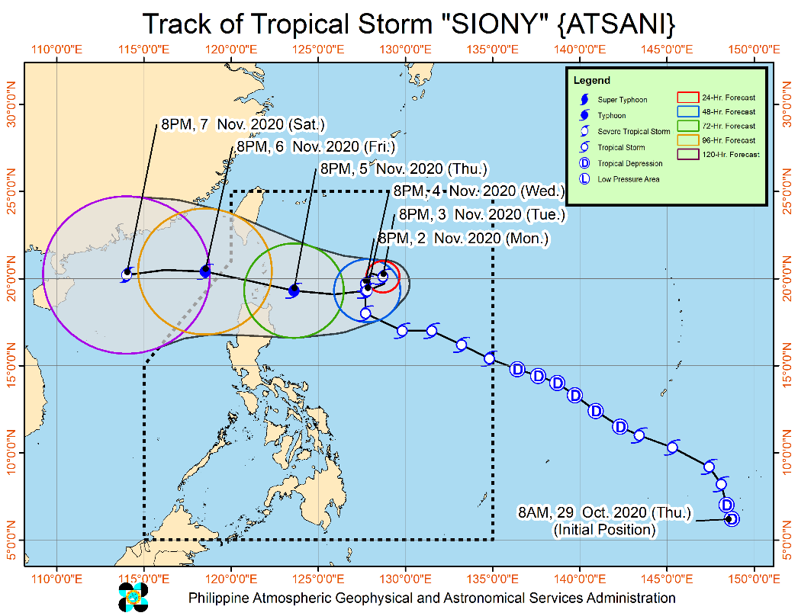
Issued at 11:00 pm, 02 November 2020, "SIONY" CONTINUES TO DECELERATE NORTHWARD OVER THE PHILIPPINE SEA EAST OF EXTREME NORTHERN LUZON.

- Track: "SIONY" is forecast to gradually enter into a quasi-stationary state in the next 36 hours. Afterwards, the tropical storm will move generally westward towards Extreme Northern Luzon. A landfall scenario over Batanes-Babuyan Islands area around Friday remains likely. However, due to the projected quasi-stationary state of this tropical storm in the next 36 hours, there remains a high degree of uncertainty in the forecast track.
- Intensity: "SIONY" is likely remain within tropical storm category within the next 36 hours. Intensification into a severe tropical storm is likely on Wednesday and into a Typhoon on Thursday prior to close approach or landfall over Extreme Northern Luzon.

At 10:00 PM today, the center of Tropical Storm "SIONY" was estimated based on all available data at 605 km East of Basco, Batanes (19.8 °N, 127.7 °E )

Source: DOST-PAGASA Severe Weather Bulletin

PREDICTIVE ANALYTICS FOR HUMANITARIAN RESPONSE

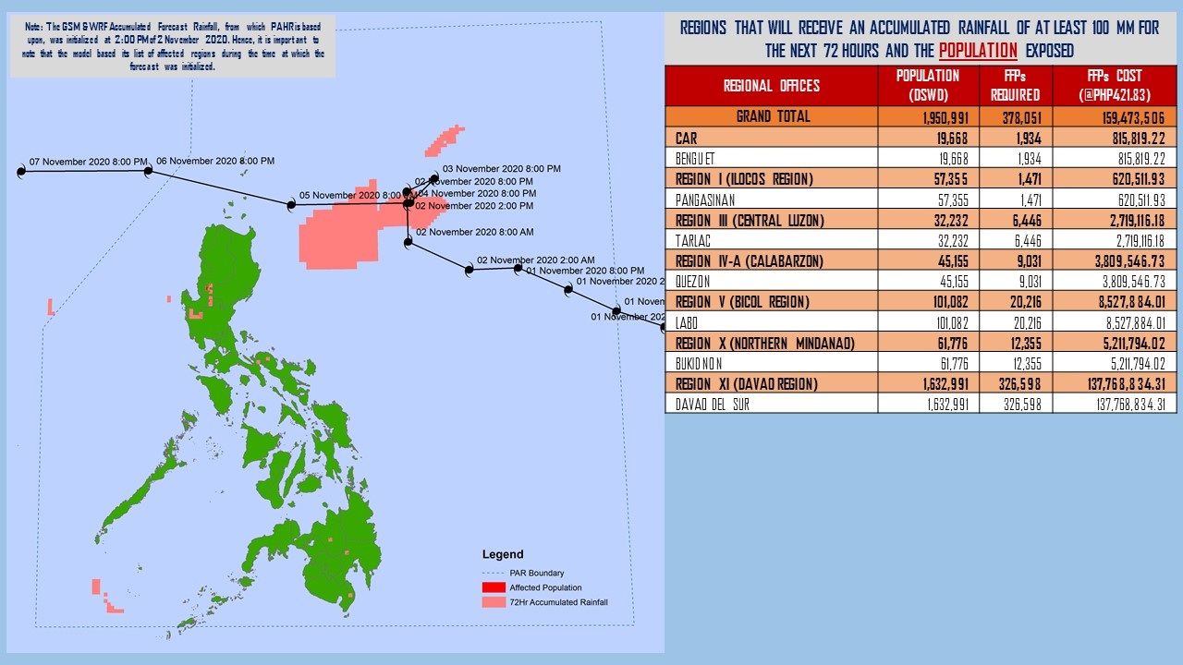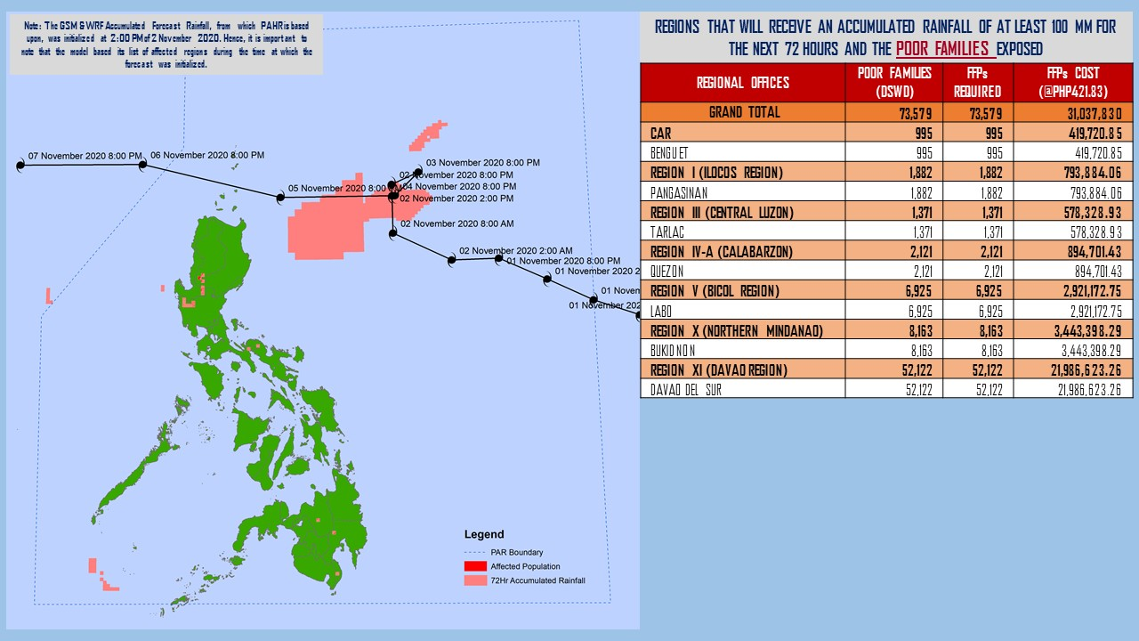
Note: Predictive Analytics for the next 3 days (up to 5 November 2020)
Source: DRMB-DROMIC

Status of Prepositioned Resources: Stockpile and Standby Funds
The DSWD Central Office (CO), Field Offices (FOs), and National Resource Operations Center (NROC) have stockpiles and standby funds amounting to ₱877,412,894.82 with breakdown as follows (see Table 1):

- Standby Funds
A total of ₱281,242,956.71 standby funds in the CO and FOs. Of the said amount, ₱239,708,413.19 is the available Quick Response Fund (QRF) in the CO.

- Stockpiles
A total of 277,448 family food packs (FFPs) amounting to ₱127,591,410.04, other food items amounting to ₱190,393,150.70 and non-food items (FNIs) amounting to ₱278,185,377.38 are available.

Table 1. Available Standby Funds and Stockpiles
Region / Office | Standby Funds | FAMILY FOOD PACKS |  | Other Food Items | Non-Food Relief Items | Total Standby Funds & Stockpile
 |  | Quantity | Total Cost
 | 281,242,956.71 | 277,448 | 127,591,410.04 | 190,393,150.70 | 278,185,377.38 | 877,412,894.82
Central Office | 239,708,413.19 | - | - | - | - | 239,708,413.19
NRLMB - NROC | - | 9,687 | 5,821,665.00 | 27,878,952.82 | 70,339,517.75 | 104,040,135.57
NRLMB - VDRC | - | 10,247 | 4,549,237.63 | 3,755,227.33 | 2,469,751.20 | 10,774,216.16
I | 3,000,455.20 | 1,621 | 728,659.32 | 2,813,730.00 | 30,898,834.96 | 37,441,679.48
II | 3,000,938.79 | 20,158 | 10,187,730.36 | 2,762,516.01 | 5,510,398.95 | 21,461,584.11
III | 4,205,028.74 | 12,441 | 5,681,030.73 | 2,012,085.86 | 5,022,278.98 | 16,920,424.31
CALABARZON | 3,000,000.00 | 8,034 | 2,833,264.00 | 3,296,030.48 | 4,069,663.12 | 13,198,957.60
MIMAROPA | 2,882,244.58 | 29,724 | 13,375,800.00 | 2,061,634.00 | 6,003,498.80 | 24,323,177.38
V | - | 20,315 | 8,985,559.24 | 1,053,537.41 | 26,499,532.90 | 36,538,629.55
VI | 3,000,051.68 | 44,551 | 16,103,926.94 | 67,792,935.77 | 5,890,820.31 | 92,787,734.70
VII | 3,000,462.71 | 33,686 | 14,678,129.00 | 9,817,642.56 | 78,797.00 | 27,575,031.27
VIII | 3,194,543.00 | 20,228 | 11,167,188.04 | 7,878,269.90 | 19,619,837.45 | 41,859,838.39
IX | 56,000.00 | 7,047 | 3,851,115.03 | 15,614,222.16 | 8,518,245.45 | 28,039,582.64
X | 3,000,724.42 | 25,458 | 13,758,723.50 | 13,863,632.31 | 27,960,690.00 | 58,583,770.23
XI | 3,000,001.00 | 4,593 | 1,700,098.95 | 11,530,225.00 | 16,356,885.36 | 32,587,210.31
XII | 1,757,513.85 | 1,514 | 832,700.00 | 3,289,022.55 | 10,899,586.54 | 16,778,822.94
CARAGA | 3,000,740.55 | 11,378 | 6,005,819.98 | 6,663,746.83 | 16,464,806.17 | 32,135,113.53
NCR | 2,229,439.00 | 2,440 | 1,340,292.00 | 6,222,081.20 | 10,498,500.05 | 20,290,312.25
CAR | 3,206,400.00 | 14,326 | 5,990,470.32 | 2,087,658.51 | 11,083,732.39 | 22,368,261.22
Note: The Inventory Summary is as of 03 November 2020, 12MN.
Source: DRMB and NRLMB

Situational Reports

DSWD-DRMB
DATE | SITUATIONS / ACTIONS UNDERTAKEN
02 November 2020 | - The Disaster Response Management Bureau (DRMB) is on RED alert status and is closely coordinating with the concerned field offices for significant disaster response updates  - All QRT members and emergency equipment are on standby and ready for deployment.

DSWD-FO CAR
DATE | SITUATIONS / ACTIONS UNDERTAKEN
02 November 2020 | - DSWD-FO CAR DRMD together with Delta 1 Members and RD Quintilla attended the RDANA for TY Rolly and the PDRA for TS Siony.  - Delta 1 and DRMD rendered duty to monitor the situation on the ground and ensure the production and hauling of food and non-food items for augmentation to LGUs.  - The Provincial Social Welfare and Development Teams (PSWADT) DRMD PDO IIs monitored the situation on the ground.  - The procurement of the raw materials for the Food and Non-Food Items were monitored  - The hauling of rice was coordinated with volunteers and scheduled on 03 November 2020.  - The production of Family Food Packs was conducted at the Regional Warehouse.  - The family tents from Region 1 were unloaded in Wangal Sports Complex.  - Mr. Clarito Albing Jr. and Ms. Marifil Jugal rendered duty at the Emergency Operations Center of Cordillera RDRRM Council as Detailed Duty Officers.  - Municipal Action Teams monitored the situation on the ground.  - Continuous coordination by the DRMD PDO IIs assigned in the PSWADTs with the LDRRMOs for updates.  - Rapid Emergency Telecommunications Team (RETT) including the International Maritime/Marine Satellite (INMARSAT) equipment are on standby.  - The Operations Center is on RED ALERT status to monitor the possible effects of TS “Siony”.  - Prepared the Preparedness for Response Report for submission to CO and other line agencies.  - Close coordination with Cordillera Regional Disaster Risk Reduction and Management Council Emergency Operations Center for updates.  - QRT and Delta Teams were on standby for possible deployment.  - Continuous roll out of advisories and maps for the consumption of the provincial QRTs.

DSWD-FO I
DATE | SITUATIONS / ACTIONS UNDERTAKEN
02 November 2020 | - DSWD-FO I is closely monitoring the movement of Tropical Storm “SIONY” through the Department of Science and Technology – Philippine Atmospheric, Geophysical and Astronomical Services Administration (DOST – PAGASA) and close coordination with the Regional Disaster Risk Reduction and Management Council 1 (RDRRMC1). Likewise, Provincial Operations Offices (POOs) are in close coordination with the different Provincial/City/Municipal Disaster Risk Reduction and Management Councils (P/C/MDRRMCs) and Provincial/City/Municipal Social Welfare and Development Offices (P/C/MSWDOs) to monitor the adverse effects that might be brought by the weather disturbance.  - DSWD-FO I Incident Management Team (IMT) is still on duty while other DSWD staff are on standby for possible augmentation. Likewise, the Field Office ensures availability and readiness of resources.  - Ongoing repacking of FFPs with the help of regional volunteers is being conducted at Regional Warehouse in Biday, City of San Fernando, La Union. Likewise, processing of procurement related documents is ongoing for additional raw materials.

DSWD-FO II
DATE | SITUATIONS / ACTIONS UNDERTAKEN
02 November 2020 | - DSWD-FO II has twenty-six (26) Regional Disaster Management and Resources Team (RDMRTs) composed of six (6) members per team on rotation basis. There are also five (5) Social Welfare Development Teams (SWADTs) and eighty-seven (87) City/Municipal Action Team (C/MATs) in the five (5) provinces readily available when the Tropical Storms (TS) “Siony” accelerate the Region.  - DSWD-FO II alerted all SWAD Teams/MATs on the occurrence of Tropical Storm (TS) Siony. They were advised to coordinate with their Local Social Welfare and Development Officers (LSWDOs) if there are concerns need to be addressed by the Field Office (FO).  - DSWD-FO II Disaster Response Management Division (DRMD) thru Disaster Response and Rehabilitation Section continuously monitor the weather advisory and provided advisory to all RDRMTs, SWADTs and Municipal Actions Team (MATs).  - DSWD-FO II DRMD through the Regional Resource Operations Section ensures availability of Food and Non-Food Items (FNIs) at any given time.  - DSWD-FO II DRMD thru the Disaster Response and Rehabilitation Section ensures to be on-call with the Regional DMRT, SWADTs, P/C/MATs in the event that TS Siony will accelerate or affect the Region.  - DSWD-FO II shall ensure reactivation of volunteers if needed.

DSWD-FO IX
DATE | SITUATIONS / ACTIONS UNDERTAKEN
02 November 2020 | - DSWD-FO IX is continuously monitoring the weather updates.  - DSWD-FO IX ensured on stock availability of Food and Non-Food Items.  - DSWD-FO IX is continuously repacking goods to maintain the required 30 family food packs.  - DSWD-FO IX through its Disaster Response Division inform the SWAD team leaders to monitor the situation in their respective area of responsibility.

DSWD-FO X
DATE | SITUATIONS / ACTIONS UNDERTAKEN
02 November 2020 | - DSWD-FO X is continuously monitoring the weather updates.  - DSWD-FO X has a total of 914 Regional Quick Response Team members including P/MAT on standby for possible deployment.  - DSWD-FO X has two available warehouses for the hauling and preparation of FNFIs.  - DSWD-FO X has two (2) operational vehicles/trucks on standby to be utilized for logistical support.  - DSWD-FO X has 4 Samsung Grand cellphones currently used by the Regional Response Teams.  - DSWD-FO X DROMIC will be available and on standby 24/7 for monitoring and coordination with CDRRMO and OCD for any developments on the situation.

DSWD-FO CARAGA
DATE | SITUATIONS / ACTIONS UNDERTAKEN
30 October 2020 | - DSWD-FO Caraga is continuously monitoring the weather updates.  - DSWD-FO Quick Response Teams and transport vehicles are on standby for possible deployment.

*****
The Disaster Response Operations Monitoring and Information Center (DROMIC) of the DSWD-DRMB is closely monitoring the effects of Tropical Storm “Siony” and is coordinating with the concerned DSWD Field Offices for any significant updates.

Prepared by:

MARIE JOYCE G. RAFANAN

LESLIE R. JAWILI
Releasing Officer

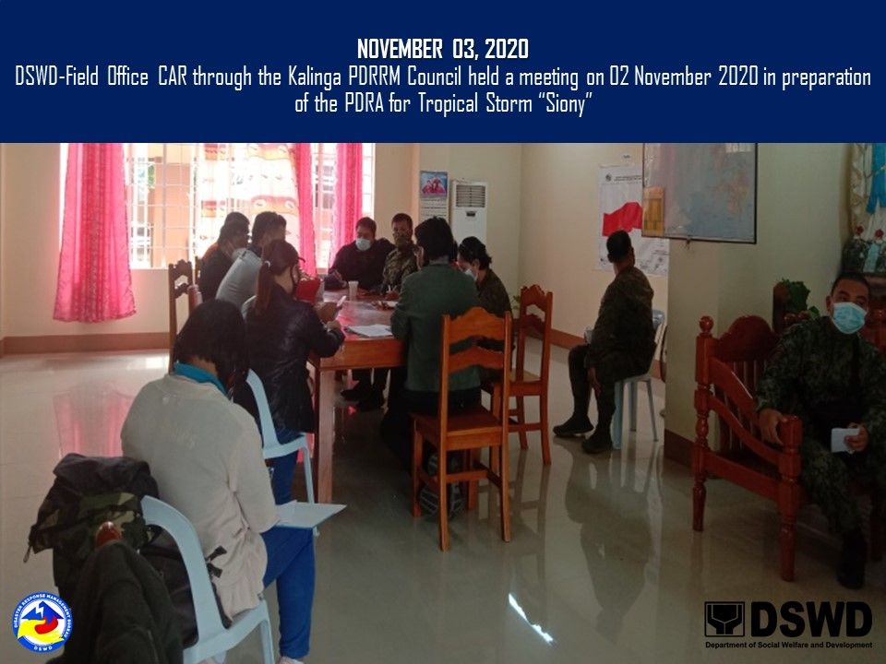
PHOTO DOCUMENTATION

