DSWD DROMIC Preparedness for Response Report #4
on Tropical Storm “Siony”
as of 04 November 2020, 6AM

Situation Overview
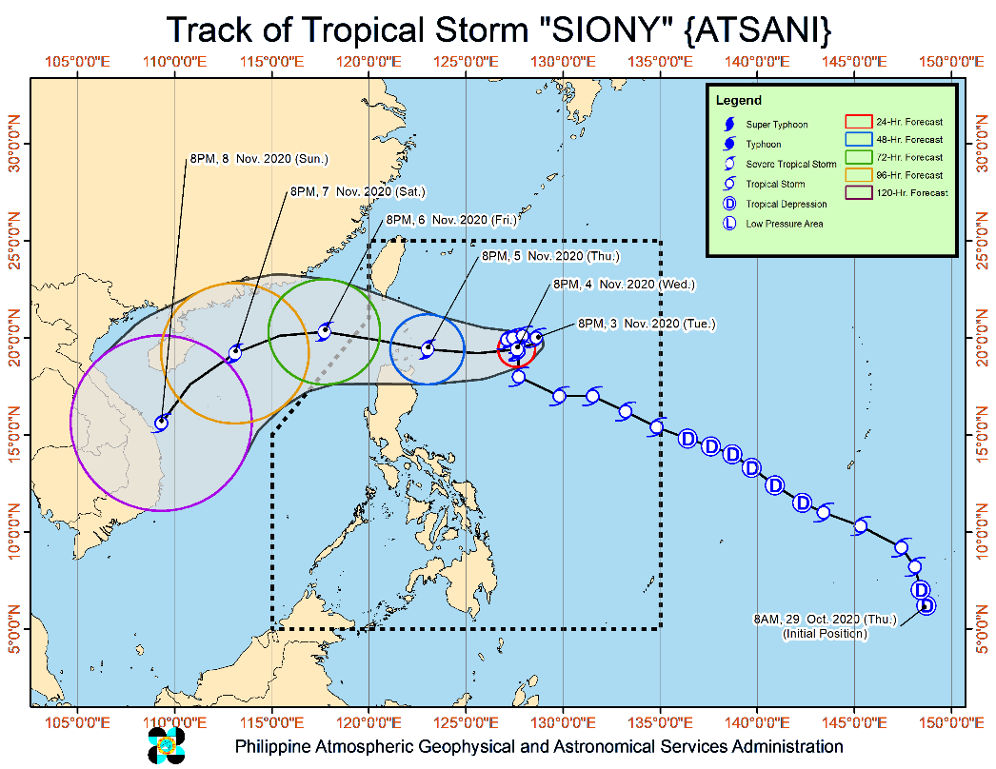
Issued at 11:00 pm, 03 November 2020, "SIONY" MAINTAINS ITS STRENGTH WHILE OVER THE PHILIPPINE SEA EAST OF EXTREME NORTHERN LUZON.

- Track: "SIONY" is forecast to move slowly in an apparent looping manner or remain almost stationary in the next 24 hours. Afterwards, the tropical storm will move generally westward or west-northwestward towards the Luzon Strait and Extreme Northern Luzon. This will bring the center of "SIONY" over or very close to the Batanes and Babuyan Island between Thursday evening and Friday morning. As such, a landfall scenario over these localities remains likely. On the forecast track, "SIONY" will leave the Philippine Area of Responsibility on Friday afternoon or evening.
- Intensity: "SIONY" is forecast to intensify into severe tropical storm in the next 24 to 36 hours and reach its peak intensity of 100-110 km/h on Thursday prior to its landfall or close approach over Extreme Northern Luzon. However, intensification into typhoon category is not ruled out at this time.

At 10:00 PM today, the center of Tropical Storm "SIONY" was estimated based on all available data at 665 km East of Basco, Batanes (19.9 °N, 128.3 °E)
Source: DOST-PAGASA Severe Weather Bulletin

PREDICTIVE ANALYTICS FOR HUMANITARIAN RESPONSE

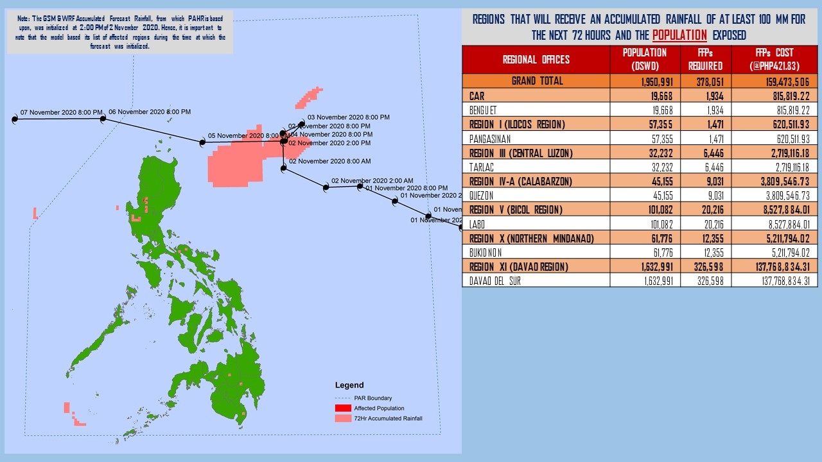
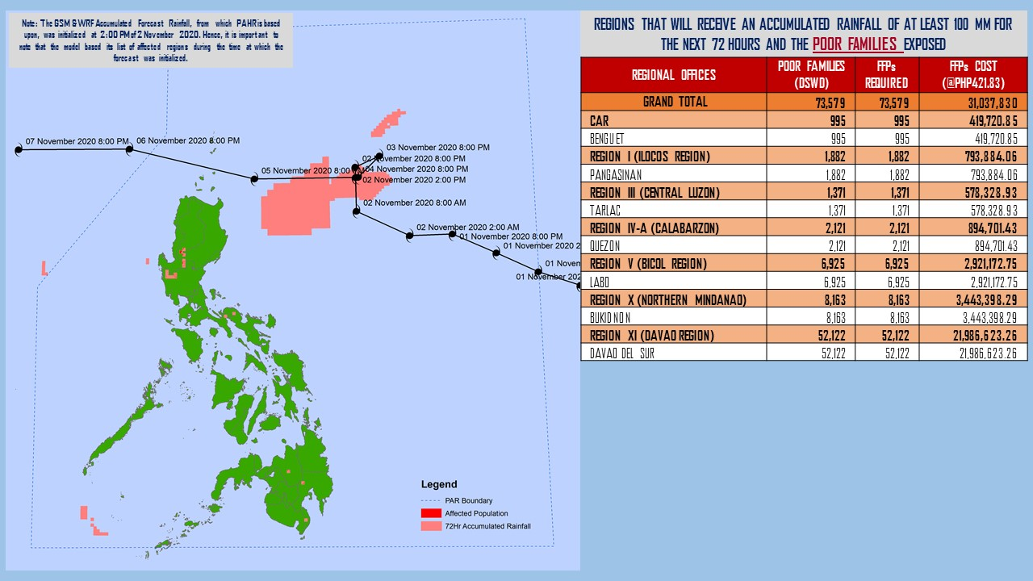
Note: Predictive Analytics for the next 3 days (up to 05 November 2020, 2AM)
Source: DRMB-DROMIC

Status of Prepositioned Resources: Stockpile and Standby Funds
The DSWD Central Office (CO), Field Offices (FOs), and National Resource Operations Center (NROC) have stockpiles and standby funds amounting to ₱865,614,432.20 with breakdown as follows (see Table 1):

- Standby Funds
A total of ₱281,242,956.70 standby funds in the CO and FOs. Of the said amount, ₱239,708,413.19 is the available Quick Response Fund (QRF) in the CO.

- Stockpiles
A total of 271,682 family food packs (FFPs) amounting to ₱124,145,675.80, other food items amounting to ₱185,787,090.70 and non-food items (FNIs) amounting to ₱274,438,709.00 are available.

Table 1. Available Standby Funds and Stockpiles
Regional / Field Office | STANDBY FUNDS | FAMILY FOOD PACKS |  | Other Food Items | Non-Food Relief Items | Total Standby Funds & Stockpile
 |  | Quantity | Total Cost
 | 281,242,956.70 | 271,682 | 124,145,675.80 | 185,787,090.70 | 274,438,709.00 | 865,614,432.20
Central Office | 239,708,413.19 | - | - | - | - | 239,708,413.20
NRLMB - NROC | - | 9,230 | 4,836,110.00 | 24,532,950.24 | 70,339,517.75 | 99,708,577.99
NRLMB - VDRC | - | 10,247 | 4,549,237.63 | 3,755,227.33 | 2,469,751.20 | 10,774,216.16
I | 3,000,455.20 | 1,621 | 728,659.32 | 2,813,730.00 | 30,898,834.96 | 37,441,679.48
II | 3,000,938.79 | 26,084 | 12,531,656.06 | 968,022.68 | 5,510,398.95 | 22,011,016.48
III | 4,205,028.74 | 7,298 | 3,522,636.19 | 2,012,085.86 | 5,022,278.98 | 14,762,029.77
CALABARZON | 3,000,000.00 | 8,034 | 2,833,264.00 | 3,296,030.48 | 4,069,663.12 | 13,198,957.60
MIMAROPA | 2,882,244.58 | 27,782 | 12,501,900.00 | 2,061,634.00 | 5,553,498.80 | 22,999,277.38
V | - | 17,804 | 8,157,963.22 | 1,053,537.41 | 26,499,532.90 | 35,711,033.53
VI | 3,000,051.68 | 44,845 | 16,209,352.08 | 67,792,935.77 | 5,890,820.31 | 92,893,159.84
VII | 3,000,462.71 | 32,804 | 14,294,459.00 | 9,150,264.31 | 78,797.00 | 26,523,983.02
VIII | 3,194,543.00 | 20,228 | 11,167,188.04 | 7,878,269.90 | 19,619,837.45 | 41,859,838.39
IX | 56,000.00 | 5,550 | 3,033,019.50 | 15,614,222.16 | 6,811,763.08 | 25,515,004.74
X | 3,000,724.42 | 25,058 | 13,534,323.50 | 13,863,632.31 | 27,960,690.00 | 58,359,370.23
XI | 3,000,001.00 | 4,593 | 1,700,098.95 | 11,530,225.00 | 14,916,885.36 | 31,147,210.31
XII | 1,757,513.85 | 1,614 | 887,700.00 | 3,677,891.79 | 10,899,586.54 | 17,222,692.18
CARAGA | 3,000,740.55 | 11,378 | 6,005,819.98 | 6,685,453.63 | 16,314,620.17 | 32,006,634.33
NCR | 2,229,439.00 | 2,440 | 1,340,292.00 | 6,222,081.20 | 10,498,500.05 | 20,290,312.25
CAR | 3,206,400.00 | 15,072 | 6,311,996.32 | 2,878,896.62 | 11,083,732.39 | 23,481,025.33
Note: The Inventory Summary is as of 04 November 2020, 12MN.
Source: DRMB and NRLMB

Situational Reports

DSWD-DRMB
DATE | SITUATIONS / ACTIONS UNDERTAKEN
04 November 2020 | - The Disaster Response Management Bureau (DRMB) is on RED alert status and is closely coordinating with the concerned field offices for significant disaster response updates  - All QRT members and emergency equipment are on standby and ready for deployment.

DSWD-FO CAR
DATE | SITUATIONS / ACTIONS UNDERTAKEN
04 November 2020 | - The Delta 1 is activated.  - The Provincial Social Welfare and Development Teams (PSWADT) DRMD PDO IIs monitored the situation on the ground.  - The DROMIC Reports were prepared by the Field Office and submitted to end users.  - The procurement of the raw materials for the Food and Non-Food Items were monitored.  - The hauling of rice was done by DPWH CAR.  - The production of Family Food Packs was conducted at the Regional Warehouse.  - The DRMD rendered duty at the Emergency Operations Center of Cordillera RDRRM Council as Detailed Duty Officers.  - Municipal Action Teams monitored the situation on the ground.  - Continuous coordination by the DRMD PDO IIs assigned in the PSWADTs with the LDRRMOs for updates.  - Rapid Emergency Telecommunications Team (RETT) including the International Maritime/Marine Satellite (INMARSAT) equipment are on standby.  - The Operations Center is on RED ALERT since 16 March 2020.  - Prepared the Preparedness for Response Report for submission to CO and other line agencies.  - Close coordination with Cordillera Regional Disaster Risk Reduction and Management Council Emergency Operations Center for updates.  - Continuous roll out of advisories and maps for the consumption of the provincial QRTs and other stakeholders.  - Posting of the Field Office efforts and capacities on DSWD-FO CAR page.
01 November 2020 | - DSWD-FO CAR issued Weather Disturbance Advisory No. 2 re: Activation of Delta 1 and the Provincial Quick Response Team.  - The Delta 1 had a meeting at the Operations Center.  - The DRMD rendered duty at the Operations Center and monitored the status on the ground as well as the alert status and weather updates.  - QRT and Delta Teams were on standby for possible deployment.

DSWD-FO I
DATE | SITUATIONS / ACTIONS UNDERTAKEN
04 November 2020 | - DSWD-FO I reactivated the Response Cluster and its sub-clusters effective on 02 November 2020.  - DSWD-FO I is closely monitoring the movement of Tropical Storm “SIONY” through the Department of Science and Technology – Philippine Atmospheric, Geophysical and Astronomical Services Administration (DOST – PAGASA) and close coordination with the Regional Disaster Risk Reduction and Management Council 1 (RDRRMC1). Likewise, Provincial Operations Offices (POOs) are in close coordination with the different Provincial/City/Municipal Disaster Risk Reduction and Management Councils (P/C/MDRRMCs) and Provincial/City/Municipal Social Welfare and Development Offices (P/C/MSWDOs) to monitor the adverse effects that might be brought by the weather disturbance.  - DSWD-FO I Incident Management Team (IMT) is still on duty while other DSWD staff are on standby for possible augmentation. Likewise, the Field Office ensures availability and readiness of resources.  - DSWD-FO I repacked a total of 3,298 Family Food Packs (FFPs) at the DSWD FO 1 Regional Warehouse. Out of 3,298 FFPs, 64 FFPs were released as Food for Work (FFW) to the volunteers for the repacking activity.
02 November 2020 | - DSWD-FO I is closely monitoring the movement of Tropical Storm “SIONY” through the Department of Science and Technology – Philippine Atmospheric, Geophysical and Astronomical Services Administration (DOST – PAGASA) and close coordination with the Regional Disaster Risk Reduction and Management Council 1 (RDRRMC1). Likewise, Provincial Operations Offices (POOs) are in close coordination with the different Provincial/City/Municipal Disaster Risk Reduction and Management Councils (P/C/MDRRMCs) and Provincial/City/Municipal Social Welfare and Development Offices (P/C/MSWDOs) to monitor the adverse effects that might be brought by the weather disturbance.  - DSWD-FO I Incident Management Team (IMT) is still on duty while other DSWD staff are on standby for possible augmentation. Likewise, the Field Office ensures availability and readiness of resources.  - Ongoing repacking of FFPs with the help of regional volunteers is being conducted at Regional Warehouse in Biday, City of San Fernando, La Union. Likewise, processing of procurement related documents is ongoing for additional raw materials.

DSWD-FO II
DATE | SITUATIONS / ACTIONS UNDERTAKEN
02 November 2020 | - DSWD-FO II has 26 Regional Disaster Management and Resources Team (RDMRTs) composed of six (6) members per team on rotation basis. There are also five (5) Social Welfare Development Teams (SWADTs) and 87 City/Municipal Action Team (C/MATs) in five (5) provinces readily available when the Tropical Storms (TS) “Siony” accelerate the Region.  - DSWD-FO II alerted all SWAD Teams/MATs on the occurrence of Tropical Storm (TS) Siony. They were advised to coordinate with their Local Social Welfare and Development Officers (LSWDOs) if they have concerns which needs to be addressed by Field Office (FO).  - DSWD-FO II Disaster Response Management Division (DRMD) thru Disaster Response and Rehabilitation Section continuously monitor the weather advisory and provided advisory to all RDRMTs, SWADTs and Municipal Actions Team (MATs).  - DSWD-FO II DRMD through the Regional Resource Operations Section ensures availability of Food and Non-Food Items (FNIs) at any given time.  - DSWD-FO II DRMD thru the Disaster Response and Rehabilitation Section ensures to be on-call with the Regional DMRT, SWADTs, P/C/MATs in the event that TS Siony will accelerate or affect the Region.  - DSWD-FO II shall ensure reactivation of volunteers if needed.

DSWD-FO V
DATE | SITUATIONS / ACTIONS UNDERTAKEN
04 November 2020 | - DSWD-FO V has 16,998 family food packs amounting to P7,892,805.34 which is available in DSWD Warehouse.  - DSWD-FO V is continuously monitoring the weather updates and information.  - The Resource Operation Section ensures the availability of family food packs and non-food items as need arises.  - DSWD-FO V QRTs are alerted.  - PAT and MAT members in the six (6) provinces are activated and instructed to coordinate with the P/MDRRMOs, C/MSWDOs for weather reports and updates.

DSWD-FO IX
DATE | SITUATIONS / ACTIONS UNDERTAKEN
02 November 2020 | - DSWD-FO IX is continuously monitoring the weather updates.  - DSWD-FO IX ensured on stock availability of Food and Non-Food Items.  - DSWD-FO IX is continuously repacking goods to maintain the required 30 family food packs.  - DSWD-FO IX through its Disaster Response Division inform the SWAD team leaders to monitor the situation in their respective area of responsibility.

DSWD-FO X
DATE | SITUATIONS / ACTIONS UNDERTAKEN
02 November 2020 | - DSWD-FO X is continuously monitoring the weather updates.  - DSWD-FO X has a total of 914 Regional Quick Response Team members including P/MAT on standby for possible deployment.  - DSWD-FO X has two (2) available warehouses for hauling and preparation of FNFIs.  - DSWD-FO X has two (2) operational vehicles/trucks on standby to be utilized for logistical support.  - DSWD-FO X has four (4) Samsung Grand cellphones currently used by the Regional Response Teams.  - DSWD-FO X DROMIC will be available and on standby 24/7 for monitoring and coordination with CDRRMO and OCD for any developments on the situation.

DSWD-FO CARAGA
DATE | SITUATIONS / ACTIONS UNDERTAKEN
30 October 2020 | - DSWD-FO Caraga is continuously monitoring the weather updates.  - DSWD-FO Quick Response Teams and transport vehicles are on standby for possible deployment.

*****
The Disaster Response Operations Monitoring and Information Center (DROMIC) of the DSWD-DRMB is closely monitoring the effects of Tropical Storm “Siony” and is coordinating with the concerned DSWD Field Offices for any significant updates.

Prepared by:

DIANE C. PELEGRINO

LESLIE R. JAWILI
Releasing Officer

PHOTO DOCUMENTATION

