DSWD DROMIC Preparedness for Response Report #7
on Severe Tropical Storm “Siony”
as of 05 November 2020, 6PM

Situation Overview
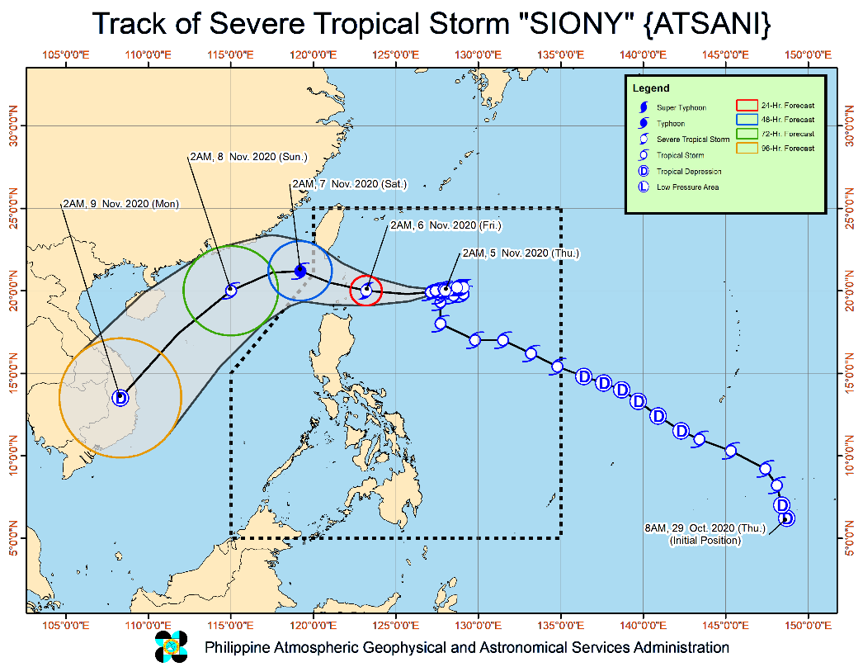
Issued at 05:00 pm, 05 November 2020, SEVERE TROPICAL STORM "SIONY" SLIGHTLY INTENSIFIES AS IT MOVES CLOSER TOWARDS LUZON STRAIT.

- Track: "SIONY" will continue to move westward or west-northwestward in the next 24 hours. On the forecast track, the center of "SIONY" will likely pass over (landfall) or near (close approach) the vicinity of Batanes or Babuyan Islands tomorrow morning. After leaving the Philippine Area of Responsibility (PAR) tomorrow afternoon or evening, this tropical cyclone is forecast to turn towards the southwest on Saturday morning and accelerate over the West Philippine Sea.
- Intensity: "SIONY" is forecast to reach typhoon category with a peak intensity of 120 km/h by tomorrow morning as it passes near or over the Batanes-Babuyan Islands area. After exiting the PAR, "SIONY" will gradually weaken due to increasingly unfavorable conditions over the West Philippine Sea associated with a northeasterly surge.

At 4:00 PM today, the center of Severe Tropical Storm "SIONY" was estimated based on all available data at 340 km East of Basco, Batanes (20.2 °N, 125.2 °E )
Source: DOST-PAGASA Severe Weather Bulletin

PREDICTIVE ANALYTICS FOR HUMANITARIAN RESPONSE

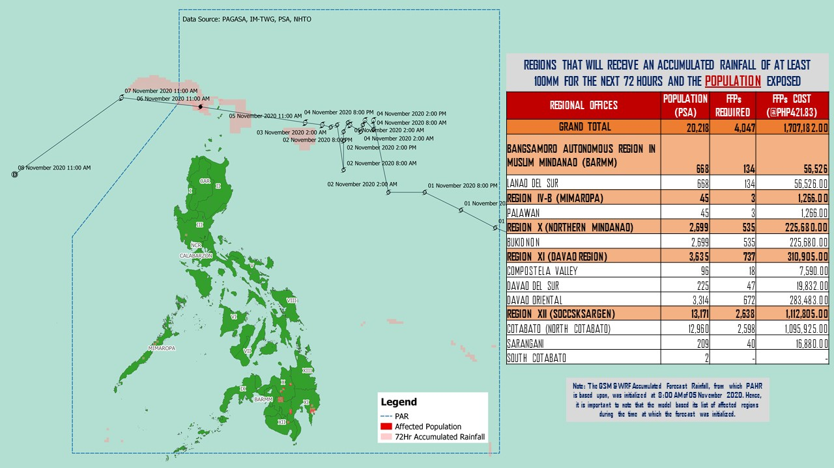
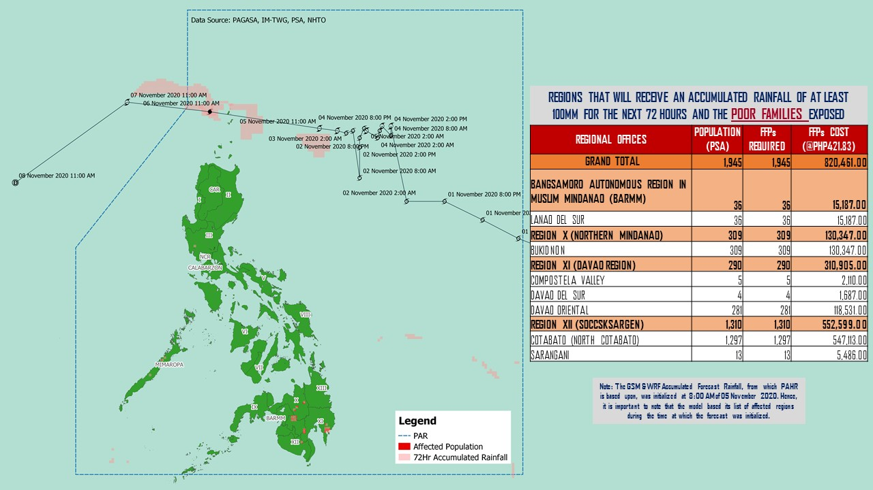
Note: Predictive Analytics for the next 3 days (up to 8 November 2020, 2PM)
Source: DRMB-DROMIC

Status of Prepositioned Resources: Stockpile and Standby Funds
The DSWD Central Office (CO), Field Offices (FOs), and National Resource Operations Center (NROC) have stockpiles and standby funds amounting to ₱809,701,942.40 with breakdown as follows (see Table 2):

- Standby Funds
A total of ₱228,365,287.00 standby funds in the CO and FOs. Of the said amount ₱184,762,513.19 is the available Quick Response Fund (QRF) in the CO.

- Stockpiles
A total of 279,129 family food packs (FFPs) amounting to ₱129,153,360.40, other food items amounting to ₱189,984,458.50 and non-food items (FNIs) amounting to ₱262,198,836.50 are available.

Table 2. Available Standby Funds and Stockpiles
Region / Office | Standby Funds | FAMILY FOOD PACKS |  | Other Food Items | Non-Food Relief Items | Total Standby Funds & Stockpile
 |  | Quantity | Total Cost
 | 228,365,287.00 | 279,129 | 129,153,360.40 | 189,984,458.50 | 262,198,836.50 | 809,701,942.40
Central Office | 184,762,513.19 | 0 | - | - | - | 184,762,513.20
NRLMB - NROC | - | 11,957 | 6,554,850.00 | 23,447,822.14 | 66,725,335.75 | 96,728,007.89
NRLMB - VDRC | - | 10,647 | 4,724,553.63 | 3,755,227.33 | 2,469,751.20 | 10,949,532.16
I | 3,000,455.20 | 9,837 | 4,941,139.80 | 1,269,977.00 | 30,076,359.92 | 39,287,931.92
II | 3,000,938.79 | 26,084 | 12,531,656.06 | 968,022.68 | 5,510,398.95 | 22,011,016.48
III | 3,305,028.74 | 8,031 | 3,642,328.77 | 6,520,881.86 | 5,022,278.98 | 18,490,518.35
CALABARZON | 3,000,000.00 | 4,384 | 1,760,696.00 | 5,116,247.92 | 4,069,663.12 | 13,946,607.04
MIMAROPA | 2,882,244.58 | 27,282 | 12,276,900.00 | 2,061,634.00 | 5,463,498.80 | 22,684,277.38
V | 3,000,000.00 | 16,494 | 8,272,643.94 | 1,053,537.41 | 24,237,532.90 | 36,563,714.25
VI | 3,000,051.68 | 47,920 | 17,316,352.08 | 72,683,378.30 | 5,890,820.31 | 98,890,602.37
VII | 1,725,692.96 | 33,504 | 14,598,959.00 | 9,006,255.31 | 78,797.00 | 25,409,704.27
VIII | 3,194,543.00 | 20,198 | 11,151,087.64 | 7,878,269.90 | 19,619,837.45 | 41,843,737.99
IX | 56,000.00 | 5,530 | 3,022,089.70 | 15,614,222.16 | 6,413,392.88 | 25,105,704.74
X | 3,000,724.42 | 24,475 | 13,207,260.50 | 13,863,590.41 | 27,912,918.94 | 57,984,494.27
XI | 3,000,001.00 | 4,593 | 1,700,098.95 | 11,530,225.00 | 14,916,885.36 | 31,147,210.31
XII | 3,000,513.85 | 2,092 | 1,150,600.00 | 2,983,436.09 | 10,899,586.54 | 18,034,136.48
CARAGA | 3,000,740.55 | 9,316 | 4,996,876.28 | 6,685,453.63 | 16,066,813.27 | 30,749,883.73
NCR | 2,229,439.00 | 530 | 291,129.00 | 3,597,574.50 | 5,741,232.78 | 11,859,375.28
CAR | 3,206,400.00 | 16,255 | 7,014,139.00 | 1,948,702.90 | 11,083,732.39 | 23,252,974.29
Note: The Inventory Summary is as of 05 November 2020, 12MN.
Source: DRMB and NRLMB

Situational Reports

DSWD-DRMB
DATE | SITUATIONS / ACTIONS UNDERTAKEN
05 November 2020 | - The Disaster Response Management Bureau (DRMB) is on RED alert status and is closely coordinating with the concerned field offices for significant disaster response updates  - All QRT members and emergency equipment are on standby and ready for deployment.

DSWD-FO CAR
DATE | SITUATIONS / ACTIONS UNDERTAKEN
05 November 2020 | - DSWD-FO CAR DRMD rendered duty at the Emergency Operations Center of Cordillera RDRRM Council as Detailed Duty Officers.  - The Provincial Social Welfare and Development Teams (PSWADT) DRMD PDO II and Municipal Action Teams monitored the situation on the ground.  - The production of Family Food Packs was conducted at the Regional Warehouse.  - Rapid Emergency Telecommunications Team (RETT) including the International Maritime/Marine Satellite (INMARSAT) equipment are on standby.  - DSWD-FO CAR is in close coordination with Cordillera Regional Disaster Risk Reduction and Management Council Emergency Operations Center for updates.  - Continuous roll out of advisories and maps for the consumption of the provincial QRTs and other stakeholders.

DSWD-FO I
DATE | SITUATIONS / ACTIONS UNDERTAKEN
04 November 2020 | - DSWD-FO I reactivated the Response Cluster and its sub-clusters effective on 02 November 2020.  - DSWD-FO I is closely monitoring the movement of Tropical Storm “SIONY” through the Department of Science and Technology – Philippine Atmospheric, Geophysical and Astronomical Services Administration (DOST – PAGASA) and close coordination with the Regional Disaster Risk Reduction and Management Council 1 (RDRRMC1). Likewise, Provincial Operations Offices (POOs) are in close coordination with the different Provincial/City/Municipal Disaster Risk Reduction and Management Councils (P/C/MDRRMCs) and Provincial/City/Municipal Social Welfare and Development Offices (P/C/MSWDOs) to monitor the adverse effects that might be brought by the weather disturbance.  - DSWD-FO I Incident Management Team (IMT) is still on duty while other DSWD staff are on standby for possible augmentation. Likewise, the Field Office ensures availability and readiness of resources.  - DSWD-FO I repacked a total of 3,298 Family Food Packs (FFPs) in DSWD FO 1 Regional Warehouse. Out of 3,298 FFPs, 64 FFPs were released as Food for Work (FFW) to the volunteers for the repacking activity.

DSWD-FO II
DATE | SITUATIONS / ACTIONS UNDERTAKEN
04 November 2020 | - DSWD-FO II processed the request of 2nd District of Cagayan Board Member, Hon. Alfonso Liopis for 69 FFPs intended for the stranded residents of Calayan, Cagayan.  - DSWD-FO II Disaster Response Management Division (DRMD) through the Disaster Response and Rehabilitation Section continuously monitor the weather advisory and provided advisory to all RDRMTs, SWADTs and Municipal Actions Team (MATs).  - DSWD-FO II DRMD through the Regional Resource Operations Section ensures availability of Food and Non-Food Items (FNIs) at any given time.

DSWD-FO V
DATE | SITUATIONS / ACTIONS UNDERTAKEN
04 November 2020 | - DSWD-FO V has 16,998 family food packs amounting to P7,892,805.34 which is available in DSWD Warehouse.  - DSWD-FO V is continuously monitoring the weather updates and information.  - The Resource Operation Section ensures the availability of family food packs and non-food items as need arises.  - DSWD-FO V QRTs are alerted.  - PAT and MAT members in the six (6) provinces are activated and instructed to coordinate with the P/MDRRMOs, C/MSWDOs for weather reports and updates.

DSWD-FO VI
DATE | SITUATIONS / ACTIONS UNDERTAKEN
04 November 2020 | - DSWD-FO VI QRT Members are on standby and ready for augmentation if needed.  - RDANA Team is composed of 40 trained QRTs and is ready to be deployed.  - Thirty QRT Members are in-charge for reports.
DSWD-FO IX
DATE | SITUATIONS / ACTIONS UNDERTAKEN
02 November 2020 | - DSWD-FO IX is continuously monitoring the weather updates.  - DSWD-FO IX ensured the stock availability of Food and Non-Food Items.  - DSWD-FO IX is continuously repacking goods to maintain the required 30 family food packs.  - DSWD-FO IX through its Disaster Response Division inform the SWAD team leaders to monitor the situation in their respective area of responsibility.

DSWD-FO X
DATE | SITUATIONS / ACTIONS UNDERTAKEN
02 November 2020 | - DSWD-FO X is continuously monitoring the weather updates.  - DSWD-FO X has a total of 914 Regional Quick Response Team members including P/MAT on standby for possible deployment.  - DSWD-FO X has two (2) available warehouses for hauling and preparation of FNFIs.  - DSWD-FO X has two (2) operational vehicles/trucks on standby to be utilized for logistical support.  - DSWD-FO X has four (4) Samsung Grand cellphones currently used by the Regional Response Teams.  - DSWD-FO X DROMIC will be available and on standby 24/7 for monitoring and coordination with CDRRMO and OCD for any developments on the situation.

DSWD-FO CARAGA
DATE | SITUATIONS / ACTIONS UNDERTAKEN
30 October 2020 | - DSWD-FO Caraga is continuously monitoring the weather updates.  - DSWD-FO Quick Response Teams and transport vehicles are on standby for possible deployment.

*****
The Disaster Response Operations Monitoring and Information Center (DROMIC) of the DSWD-DRMB is closely monitoring the effects of Severe Tropical Storm “Siony” and is coordinating with the concerned DSWD Field Offices for any significant updates.

Prepared by:

MARIEL B. FERRARIZ
CLARRIE MAE A. CASTILLO

RODEL V. CABADDU
Releasing Officer

PHOTO DOCUMENTATION

