DSWD DROMIC Report #2 on the
Tail-End of a Frontal System (Shear Line)
as of 30 November 2020, 6PM

SITUATION OVERVIEW

Issued on 28 November 2020 at 11:00 AM, PAGASA forecasted that the tail-end of a frontal system (shear line) will bring moderate with at times heavy rains are being experienced over mainland Cagayan, Isabela, Apayao, Apayao, Kalinga, Mountain Province, Ifugao, Quirino, Nueva Vizcaya and Aurora. Flooding (including flashfloods) and rain-induced landslides may occur during heavy or prolonged rainfall, especially in areas that are identified to be highly or very highly susceptible to these hazards and in localities that received significant antecedent rainfall over the past couple of days or weeks.
Source: PAGASA Weather Advisory

- Status of Affected Families / Persons
A total of 488 families or 1,668 persons were affected by the Tail-End of a Frontal System (Shear Line) in 18 barangays in Region II (see Table 1).

Table 1. Number of Affected Families / Persons
REGION / PROVINCE / MUNICIPALITY |  | NUMBER OF AFFECTED
 |  | Barangays | Families | Persons
GRAND TOTAL |  | 18 | 488 | 1,668
REGION II |  | 18 | 488 | 1,668
Cagayan |  | 5 | 114 | 421
 | Tuguegarao City (capital) | 5 | 114 | 421
Isabela |  | 12 | 369 | 1,227
 | Alicia | 1 | 65 | 238
 | Benito Soliven | 1 | 10 | 25
 | Cabatuan | 3 | 117 | 355
 | Luna | 1 | 30 | 115
 | San Guillermo | 1 | 11 | 33
 | San Isidro | 3 | 39 | 143
 | San Mateo | 2 | 97 | 318
Quirino |  | 1 | 5 | 20
 | Saguday | 1 | 5 | 20
Note: Ongoing assessment and validation being conducted.
Source: DSWD-FO II

- Status of Displaced Families / Persons
- Inside Evacuation Centers
There are 200 families or 738 persons taking temporary shelter in eight (8) evacuation centers in Regions II (see Table 2).

Table 2. Number of Displaced Families / Persons Inside Evacuation Centers
REGION / PROVINCE / MUNICIPALITY |  | NUMBER OF EVACUATION CENTERS (ECs) |  | NUMBER OF DISPLACED
 |  |  |  | INSIDE ECs
 |  |  |  | Families |  | Persons (Actual)
 |  | CUM | NOW | CUM | NOW | CUM | NOW
GRAND TOTAL |  | 18 | 8 | 388 | 200 | 1,339 | 738
REGION II |  | 18 | 8 | 388 | 200 | 1,339 | 738
Cagayan |  | 6 | 6 | 114 | 114 | 421 | 421
 | Tuguegarao City (capital) | 6 | 6 | 114 | 114 | 421 | 421
Isabela |  | 11 | 2 | 269 | 86 | 898 | 317
 | Alicia | 1 | 1 | 65 | 65 | 238 | 238
 | Cabatuan | 3 | - | 117 | - | 355 | -
 | Luna | 1 | - | 30 | - | 115 | -
 | San Guillermo | 2 | - | 11 | - | 33 | -
 | San Isidro | 2 | 1 | 33 | 21 | 121 | 79
 | San Mateo | 2 | - | 13 | - | 36 | -
Quirino |  | 1 | - | 5 | - | 20 | -
 | Saguday | 1 | - | 5 | - | 20 | -
Note: Ongoing assessment and validation being conducted.
Source: DSWD-FO II

- Outside Evacuation Centers
There are 10 families or 25 persons temporarily staying with their relatives and/or friends in Region II (see Table 3).

Table 3. Number of Displaced Families / Persons Outside Evacuation Centers
REGION / PROVINCE / MUNICIPALITY |  | NUMBER OF DISPLACED
 |  | OUTSIDE ECs
 |  | Families |  | Persons
 |  | CUM | NOW | CUM | NOW
GRAND TOTAL |  | 52 | 10 | 179 | 25
REGION II |  | 52 | 10 | 179 | 25
Isabela |  | 52 | 10 | 179 | 25
 | Benito Soliven | 10 | 10 | 25 | 25
 | San Isidro | 6 | - | 22 | -
 | San Mateo | 36 | - | 132 | -
Note: Ongoing assessment and validation being conducted.
Source: DSWD-FO II

- Assistance provided
A total of ₱137,700.00 worth of assistance was provided by DSWD to the affected families (see Table 4).

Table 4. Cost of Assistance Provided to Affected Families / Persons
REGION / PROVINCE / MUNICIPALITY |  | COST OF ASSISTANCE
 |  | DSWD | LGU | NGOs | OTHERS | GRAND TOTAL
GRAND TOTAL |  | 137,700.00 | - | - | - | 137,700.00
REGION II |  | 137,700.00 | - | - | - | 137,700.00
Cagayan |  | 137,700.00 | - | - | - | 137,700.00
 | Tuguegarao City (capital) | 137,700.00 | - | - | - | 137,700.00
Source: DSWD-FO II

SITUATIONAL REPORT

DSWD-DRMB
DATE | SITUATIONS / ACTIONS UNDERTAKEN
30 November 2020 | - The Disaster Response Operations Monitoring and Information Center (DROMIC) of the DSWD-DRMB continues to closely coordinate with the concerned field offices for significant reports on the status of affected families, assistance, and relief efforts.

DSWD-FO II
DATE | SITUATIONS / ACTIONS UNDERTAKEN
30 November 2020 | - DSWD-FO II provided 81 Hygiene Kits amounting to ₱137,700.00 to the affected families in Tuguegarao City.  - There were 117 families or 355 persons have pre-emptively evacuated in three (3) evacuation centers in Cabatuan, Isabela.  - DSWD-FO II attended the CVDRRMC virtual meeting relative to updates on the effects of the Tail-End of Frontal System.  - The Disaster Response Management Division (DRMD) - DMRT continuously monitors the status of every city/municipality in the region through the SWADTs, P/C/MATs in coordination with LGUs specifically, Cagayan, Isabela and Quirino Provinces.  - DSWD-FO II ensures availability of Food and Non-Food Items (FNIs) at any given time.  - SWADTs/Provincial Operations Offices (POOs)/C/MATs closely coordinated with their respective Provincial/City/Municipal Disaster Risk Reduction and Management Councils (P/C/MDRRMCs) that are currently monitoring the effects of this weather disturbance.

*****
The Disaster Response Operations Monitoring and Information Center (DROMIC) of the DSWD-DRMB is closely coordinating with concerned DSWD Field Offices for any significant disaster response updates.

Prepared by:  MARIE JOYCE G. RAFANAN  MARIEL B. FERRARIZ | Releasing Officer:  RODEL V. CABADDU

PHOTO DOCUMENTATION
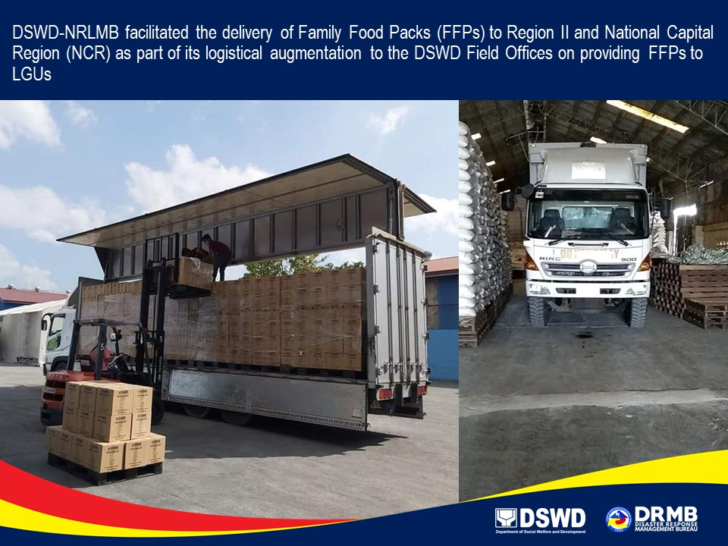

Photo taken last 28 November 2020

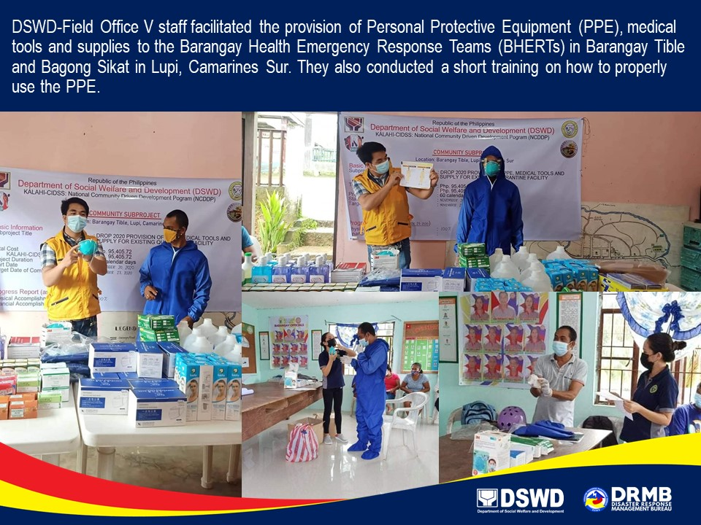

Photo taken last 28 November 2020

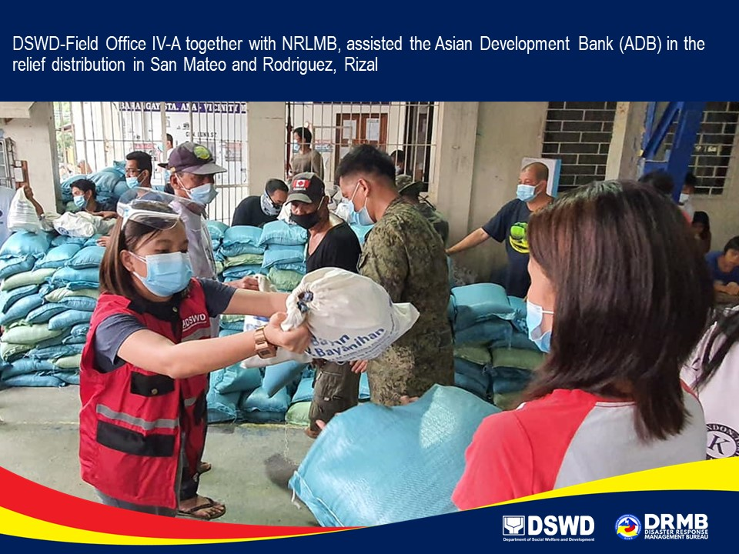
Photo taken last 28 November 2020

