DSWD DROMIC Report #4 on the
Tail-End of a Frontal System (Shear Line)
as of 02 December 2020, 6PM

SITUATION OVERVIEW

Issued on 28 November 2020 at 11:00 AM, PAGASA forecasted that the tail-end of a frontal system (shear line) will bring moderate with at times heavy rains are being experienced over mainland Cagayan, Isabela, Apayao, Apayao, Kalinga, Mountain Province, Ifugao, Quirino, Nueva Vizcaya and Aurora. Flooding (including flashfloods) and rain-induced landslides may occur during heavy or prolonged rainfall, especially in areas that are identified to be highly or very highly susceptible to these hazards and in localities that received significant antecedent rainfall over the past couple of days or weeks.
Source: PAGASA Weather Advisory

- Status of Affected Families / Persons
A total of 392 families or 1,364 persons were affected by the Tail-End of a Frontal System (Shear Line) in 16 barangays in Region II (see Table 1).

Table 1. Number of Affected Families / Persons
REGION / PROVINCE / MUNICIPALITY |  | NUMBER OF AFFECTED
 |  | Barangays | Families | Persons
GRAND TOTAL |  | 16 | 392 | 1,364
REGION II |  | 16 | 392 | 1,364
Cagayan |  | 6 | 135 | 472
 | Allacapan | 1 | 30 | 90
 | Tuguegarao City (capital) | 5 | 105 | 382
Isabela |  | 9 | 252 | 872
 | Alicia | 1 | 65 | 238
 | Benito Soliven | 1 | 10 | 25
 | Luna | 1 | 30 | 115
 | San Guillermo | 1 | 11 | 33
 | San Isidro | 3 | 39 | 143
 | San Mateo | 2 | 97 | 318
Quirino |  | 1 | 5 | 20
 | Saguday | 1 | 5 | 20
Note: Ongoing assessment and validation being conducted.
*The changes in the figures is based on the validated report submitted by DSWD-FO II regarding the preemptive evacuees
Source: DSWD-FO II

- Status of Displaced Families / Persons
- Inside Evacuation Centers
There are 97 families or 349 persons taking temporary shelter in four (4) evacuation centers in Regions II (see Table 2).

Table 2. Number of Displaced Families / Persons Inside Evacuation Centers
REGION / PROVINCE / MUNICIPALITY |  | NUMBER OF EVACUATION CENTERS (ECs) |  | NUMBER OF DISPLACED
 |  |  |  | INSIDE ECs
 |  |  |  | Families |  | Persons
 |  | CUM | NOW | CUM | NOW | CUM | NOW
GRAND TOTAL |  | 13 | 4 | 264 | 97 | 957 | 349
REGION II |  | 13 | 4 | 264 | 97 | 957 | 349
Cagayan |  | 4 | 4 | 107 | 97 | 394 | 349
 | Tuguegarao City (capital) | 4 | 4 | 107 | 97 | 394 | 349
Isabela |  | 8 | - | 152 | - | 543 | -
 | Alicia | 1 | - | 65 | - | 238 | -
 | Luna | 1 | - | 30 | - | 115 | -
 | San Guillermo | 2 | - | 11 | - | 33 | -
 | San Isidro | 2 | - | 33 | - | 121 | -
 | San Mateo | 2 | - | 13 | - | 36 | -
Quirino |  | 1 | - | 5 | - | 20 | -
 | Saguday | 1 | - | 5 | - | 20 | -
Note: Ongoing assessment and validation being conducted.
Source: DSWD-FO II

- Outside Evacuation Centers
There were 52 families or 179 persons took temporary shelter with their relatives and/or friends in Region II (see Table 3).

Table 3. Number of Displaced Families / Persons Outside Evacuation Centers
REGION / PROVINCE / MUNICIPALITY |  | NUMBER OF DISPLACED
 |  | OUTSIDE ECs
 |  | Families |  | Persons
 |  | CUM | NOW | CUM | NOW
GRAND TOTAL |  | 52 | - | 179 | -
REGION II |  | 52 | - | 179 | -
Isabela |  | 52 | - | 179 | -
 | Benito Soliven | 10 | - | 25 | -
 | San Isidro | 6 | - | 22 | -
 | San Mateo | 36 | - | 132 | -
Note: Ongoing assessment and validation being conducted.
Source: DSWD-FO II

- Assistance provided
A total of ₱137,700.00 worth of assistance was provided by DSWD to the affected families (see Table 4).

Table 4. Cost of Assistance Provided to Affected Families / Persons
REGION / PROVINCE / MUNICIPALITY |  | COST OF ASSISTANCE
 |  | DSWD | LGU | NGOs | OTHERS | GRAND TOTAL
GRAND TOTAL |  | 137,700.00 | - | - | - | 137,700.00
REGION II |  | 137,700.00 | - | - | - | 137,700.00
Cagayan |  | 137,700.00 | - | - | - | 137,700.00
 | Tuguegarao City (capital) | 137,700.00 | - | - | - | 137,700.00
Source: DSWD-FO II

SITUATIONAL REPORT

DSWD-DRMB
DATE | SITUATIONS / ACTIONS UNDERTAKEN
02 December 2020 | - The Disaster Response Operations Monitoring and Information Center (DROMIC) of the DSWD-DRMB continues to closely coordinate with the concerned field offices for significant reports on the status of affected families, assistance, and relief efforts.

DSWD-FO II
DATE | SITUATIONS / ACTIONS UNDERTAKEN
02 December 2020 | - DSWD-FO II provided 81 Hygiene Kits amounting to ₱137,700.00 to the affected families in Tuguegarao City.  - DSWD-FO II attended the response cluster meeting to discuss updates and other concerns of member agencies relative to updates on the effects of the Tail-End of Frontal System.  - The Disaster Response Management Division (DRMD) - DMRT continuously monitors the status of every city/municipality in the region through the SWADTs, P/C/MATs in coordination with LGUs specifically, Cagayan, Isabela and Quirino Provinces.  - DSWD-FO II ensures availability of Food and Non-Food Items (FNIs) at any given time.  - SWADTs/Provincial Operations Offices (POOs)/C/MATs closely coordinated with their respective Provincial/City/Municipal Disaster Risk Reduction and Management Councils (P/C/MDRRMCs) that are currently monitoring the effects of this weather disturbance.

*****
The Disaster Response Operations Monitoring and Information Center (DROMIC) of the DSWD-DRMB is closely coordinating with concerned DSWD Field Offices for any significant disaster response updates.

Prepared by:  MARIEL B. FERRARIZ | Releasing Officer:  RODEL V. CABADDU

PHOTO DOCUMENTATION
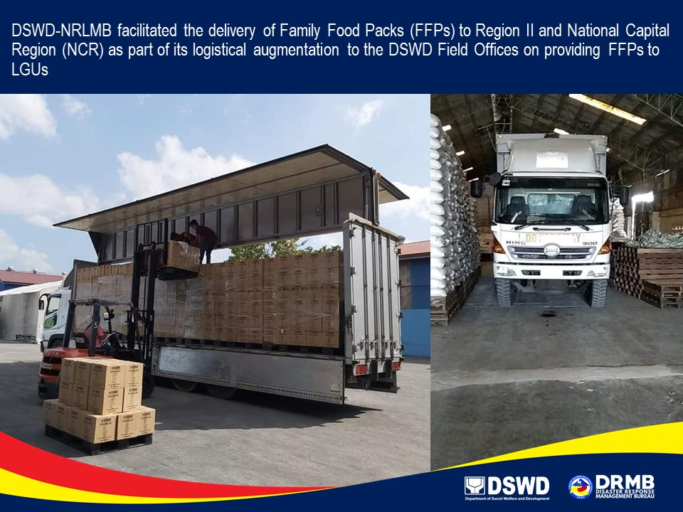

Photo taken last 28 November 2020

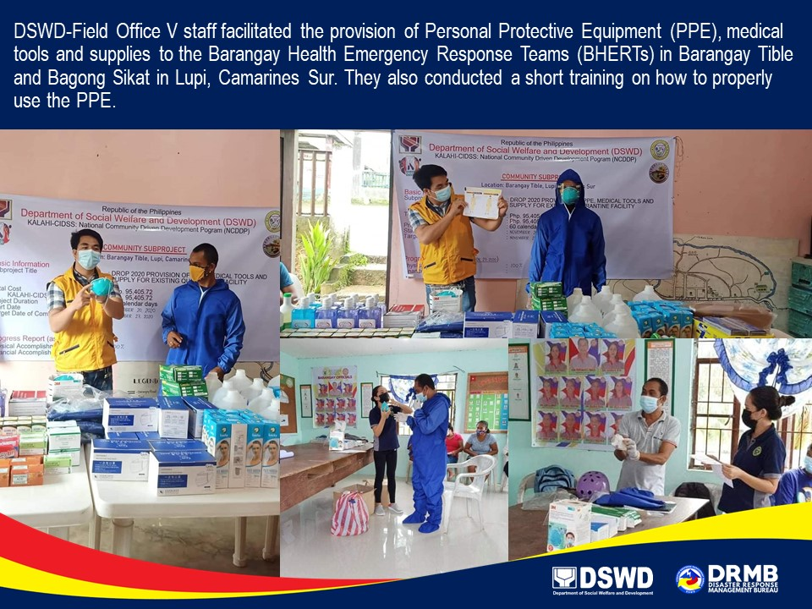

Photo taken last 28 November 2020

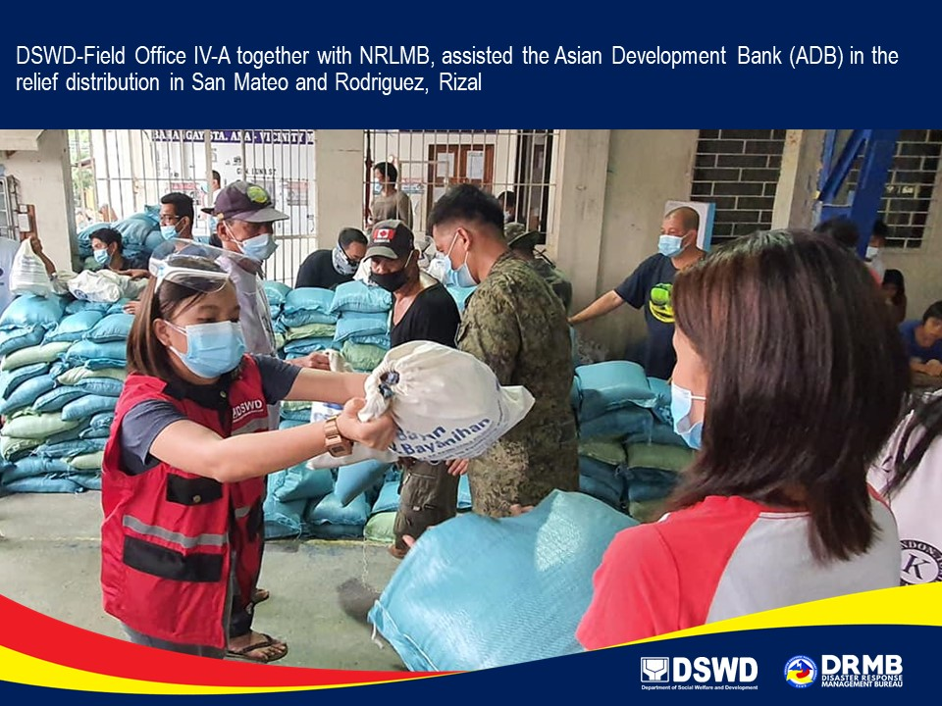
Photo taken last 28 November 2020

