DSWD DROMIC Preparedness for Response Report #1
on Tropical Depression “Vicky”
as of 18 December 2020, 6PM
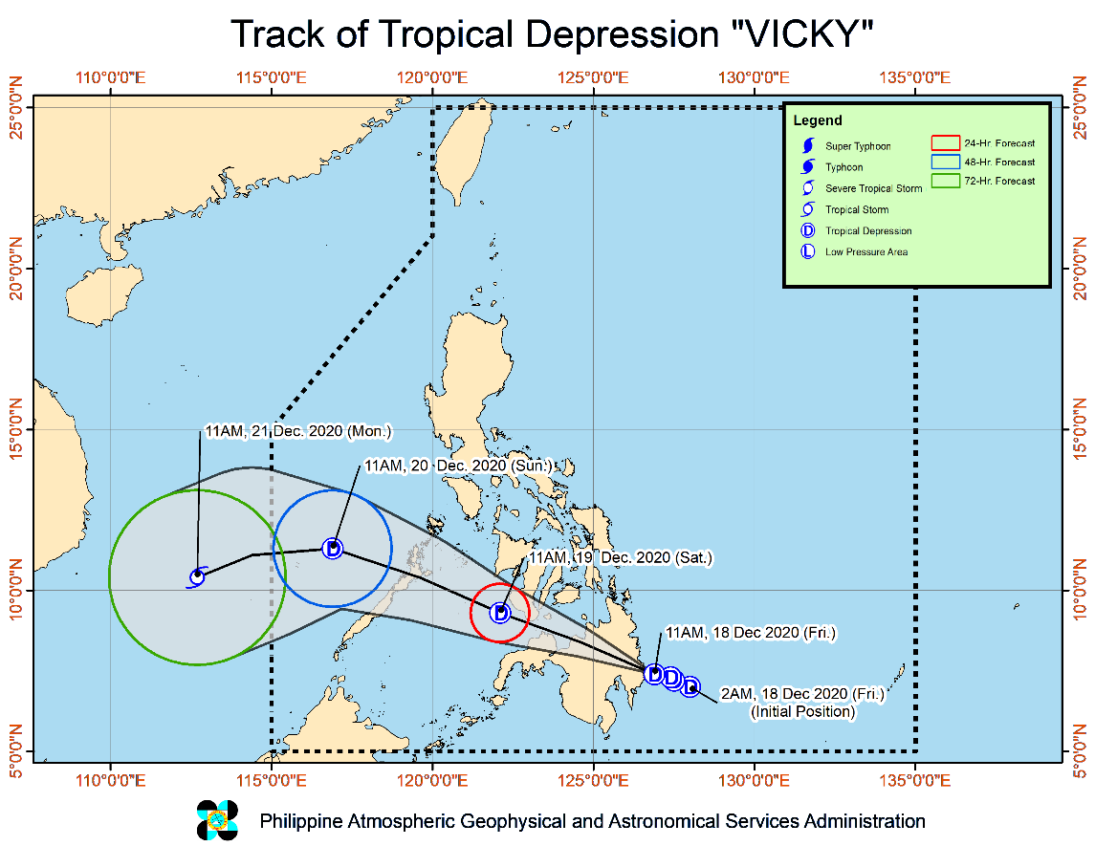
Situation Overview

Issued at 2:00 PM, 18 December 2020, TROPICAL DEPRESSION "VICKY" MAINTAINS ITS STRENGTH AND IS ABOUT TO MAKE LANDFALL OVER DAVAO ORIENTAL.

- Strong winds: Areas under Tropical Cyclone Wind Signal (TCWS #1) will have strong breeze to near gale conditions during the passage of the tropical cyclone.
- Heavy rainfall: The combined effects of Tropical Depression VICKY and Tail-End of a Frontal System (Shear Line) will bring:
- Today: Moderate to heavy with at times intense rains over Caraga, Davao Oriental, Davao de Oro, Davao del Norte, Bukidnon, Misamis Oriental, Camiguin, Southern Leyte, Leyte, and Bohol. Light to moderate with at times heavy rains over Bicol Region, the southern portion of Quezon, Lanao del Sur, Zamboanga del Norte, and the rest of Visayas, Davao Region, and Northern Mindanao.
- Tomorrow: Moderate to heavy with at times intense rains over Bicol Region, Eastern Visayas, Central Visayas, Quezon, and the northern portion of Palawan including Calamian and Cuyo Islands. Light to moderate with at times heavy rains over mainland Cagayan Valley, Apayao, Kalinga, Mountain Province, Ifugao, Bulacan, Metro Manila, Camiguin, Dinagat Islands, and the rest of CALABARZON, MIMAROPA, and Visayas.
- Flooding (including flash floods) and rain-induced landslides may occur during heavy or prolonged periods of rainfall, especially in areas identified to be highly or very highly susceptible to these hazards and in localities that received significant antecedent rainfall over the past couple of days or weeks. Adjacent or nearby areas may also experience flooding in the absence of such rainfall occurrence due to surface runoff or swelling of river channels. PAGASA Regional Services Divisions may issue local thunderstorm/rainfall advisories and heavy rainfall warnings in their respective areas of responsibility while the Hydrometeorology Division and River Basin Flood Forecasting and Warning Centers may issue general flood advisories and river basin flood advisories/bulletins as appropriate.
- In the next 24 hours, the combined effects of the surge of the Northeast Monsoon and the approaching tropical depression will bring rough to very rough seas (2.5 to 4.5 m) over the entire seaboards of Northern Luzon, the seaboard of Aurora, the eastern seaboard of Quezon including Polillo Islands, the seaboard of Camarines Norte, the northern seaboard of Camarines Sur, the northern and eastern seaboards of Catanduanes, the eastern seaboard of Albay including Rapu-Rapu Islands, the eastern seaboard of Sorsogon, the northern and eastern seaboards of Northern Samar, and the eastern seaboard of Eastern Samar including Homonhon Island. Moderate to rough seas (2.0 to 4.0 m) will be experienced over the coastal waters of areas under TCWS #1. Sea travel is risky over these waters especially for small sea vessels.
- Track: “VICKY” is forecast to make landfall in the vicinity of Baganga-Caraga area in Davao Oriental between 2:00 to 5:00 PM today. After crossing Mindanao, the tropical depression is likely to emerge over the Bohol Sea tomorrow early morning, pass close Siquijor, and pass close or make another landfall over the southern portion of Negros Island. By tomorrow morning or afternoon, “VICKY” is likely to emerge over the Sulu Sea.
- Intensity: VICKY is forecast to remain a tropical depression while crossing the Philippine archipelago.

At 1:00 PM today, the center of Tropical Depression "VICKY" was estimated based on all available data at 95 km East of Davao City (07.4 °N, 126.7 °E )
Source: DOST-PAGASA Severe Weather Bulletin

Status of Prepositioned Resources: Stockpile and Standby Funds
The DSWD Central Office (CO), Field Offices (FOs), and National Resource Operations Center (NROC) have stockpiles and standby funds amounting to ₱779,958,349.25 with breakdown as follows (see Table 2):

- Standby Funds
A total of ₱182,704,546.23 standby funds in the CO and FOs. Of the said amount, ₱140,084,929.19 is the available Quick Response Fund (QRF) in the CO.

- Stockpiles
A total of 230,191 family food packs (FFPs) amounting to ₱107,686,479.11, other food items amounting to ₱167,935,065.82 and non-food items (FNIs) amounting to ₱321,632,258.10 are available.

Table 2. Available Stockpiles and Standby Funds
REGIONAL / FIELD OFFICE | STANDBY FUNDS | FAMILY FOOD PACKS |  | OTHER FOOD ITEMS | NON-FOOD RELIEF ITEMS | TOTAL STANDBY FUNDS & STOCKPILE
 |  | QUANTITY | TOTAL COST | TOTAL COST | TOTAL COST
TOTAL | 182,704,546.23 | 230,191 | 107,686,479.11 | 167,935,065.82 | 321,632,258.10 | 779,958,349.25
Central Office | 140,084,929.19 | - | - | - | - | 140,084,929.19
NRLMB - NROC | - | 2,501 | 1,543,117.00 | 35,958,661.92 | 123,042,647.79 | 160,544,426.71
NRLMB - VDRC | - | 13,647 | 6,096,051.63 | 10,912,302.30 | 3,115,495.45 | 20,123,849.38
I | 3,000,000.00 | 12,357 | 6,267,393.54 | 2,867,146.30 | 28,365,766.18 | 40,500,306.02
II | 3,000,000.00 | 36,933 | 19,103,314.11 | 2,732,130.65 | 13,467,878.32 | 38,303,323.08
III | 3,305,028.74 | 6,180 | 3,738,971.72 | 3,557,385.86 | 5,020,960.98 | 15,622,347.30
CALABARZON | 3,000,000.00 | 2,100 | 968,100.00 | 1,018,934.00 | 3,980,373.37 | 8,967,407.37
MIMAROPA | 1,903,226.58 | 23,025 | 10,361,250.00 | 2,061,634.00 | 4,289,670.80 | 18,615,781.38
V | 3,000,000.00 | 12,033 | 5,422,878.26 | 3,197,289.36 | 17,125,279.90 | 28,745,447.52
VI | 0.07 | 36,937 | 12,293,534.42 | 58,683,753.54 | 9,470,572.13 | 80,447,860.16
VII | 3,029,852.77 | 5,301 | 2,305,935.00 | 6,806,403.28 | 9,294,575.05 | 21,436,766.10
VIII | 3,194,543.00 | 15,007 | 7,817,253.76 | 5,132,799.90 | 19,284,402.95 | 35,428,999.61
IX | 570,000.00 | 15,823 | 8,647,111.27 | 14,994,195.68 | 10,866,180.12 | 35,077,487.07
X | 3,000,724.42 | 10,551 | 5,360,278.60 | 11,330,547.64 | 27,509,355.74 | 47,200,906.40
XI | 3,000,001.00 | 9,972 | 3,691,135.80 | 2,473,750.00 | 13,078,235.36 | 22,243,122.16
XII | 3,000,513.85 | 1,118 | 617,100.00 | 1,787,590.76 | 4,462,999.25 | 9,868,203.86
CARAGA | 3,000,740.55 | 13,707 | 6,619,754.81 | 1,629,458.12 | 15,319,782.02 | 26,569,735.50
NCR | 3,000,559.00 | 1,260 | 692,118.00 | 634,667.00 | 5,741,232.78 | 10,068,576.78
CAR | 3,614,427.06 | 11,739 | 6,141,181.19 | 2,156,415.50 | 8,196,849.91 | 20,108,873.66
Note: The Inventory Summary is as of 18 December 2020, 4PM.
Source: DRMB and NRLMB

Situational Reports

DSWD-DRMB
DATE | SITUATIONS / ACTIONS UNDERTAKEN
18 December 2020 | - The Disaster Response Management Bureau (DRMB) is closely coordinating with the concerned field offices for significant disaster response updates  - All QRT members and emergency equipment are on standby and ready for deployment.  - DRMB participated in the Online Pre-Disaster Risk Assessment Meeting on Tropical Depression (TD) “Vicky” on 18 December 2020 with other response cluster member agencies. Further meetings shall be conducted on the implementation of COVID-19 protocols during the response efforts on TD “Vicky”.

DSWD-FO MIMAROPA
DATE | SITUATIONS / ACTIONS UNDERTAKEN
18 December 2020 | - Awaiting for the delivery of the additional stockpile amounting to 2 million.  - Disaster Response Management Division and SWADT Offices are alerted to monitor daily local weather condition and ensure provision of information to all concerned offices, divisions, sections, and units.  - 24/7 On-call status of the R/P/C/M QRTs together with special projects staff for possible activation of Operation Center.  - Close coordination with the Office of Civil Defense (OCD) and RDRRMC MIMAROPA for any warning signal updates for monitoring purposes and response mechanism for areas that will be affected.  - Standby logistical equipment and workforce through coordination with SWADT Offices and concerned LGUs on the management of stranded passengers, if any, in ports and terminals.  - Information and Communication Technology Management Unit (ICTMU) is on standby status to ensure robust communication system.  - Ensure that there is an on-call truck available for delivery of goods and equipment to areas that will be affected.

DSWD-FO VI
DATE | SITUATIONS / ACTIONS UNDERTAKEN
18 December 2020 | - All QRT members are on stand by and ready for augmentation if needed, following the new normal protocols of the agency.  - RDANA team is composed of 40 trained QRTs and is ready to be deployed if needed.  - DSWD recently conducted TA provision to Provincial LGUs and SWAD Offices in DROMIC Reporting.  - DSWD-FO VI issued a total of 150 vests, 50 GO bags, 50 survival bags, and 50 sleeping kits to QRT members in the region and field staff.

DSWD-FO VII
DATE | SITUATIONS / ACTIONS UNDERTAKEN
18 December 2020 | - Quick Response Team of the Region is now activated.  - Regional/Provincial/City/Municipal Quick Response Team is on standby alert and ready for mobilization for any assistance and augmentation support needed from the LGUs.  - Continuous monitoring by the DSWD Regional DROMIC Focal for the latest weather updates from PAGASA and cascading the same for widest dissemination to Provincial/City/Municipal Action Teams.  - City and Municipal Action Team and SWAD Offices were alerted and already requested to closely coordinate with their local counterparts and their respective LDRRMCs. Field staff requested to monitor AOR and provide reports and updates to the Regional DROMIC Focal for any impacts/effects.  - Regional Disaster Division is in closed coordination with OCD-7 and other members of the RDRRMC for any response mobilization activities/strategies.  - Warehouses in the three island provinces are on ready alert for any response activities.

DSWD-FO VIII
DATE | SITUATIONS / ACTIONS UNDERTAKEN
18 December 2020 | - Prepositioned Family Food Packs (FFPs) in Samar Island which can be distributed immediately by the P/C/MATs to Local Government Units that need augmentation support.  - Communicated SWAD Teams and City/Municipal Actions Teams to be alerted on the weather disturbance.

DSWD-FO X
DATE | SITUATIONS / ACTIONS UNDERTAKEN
18 December 2020 | - 4 Samsung Grand Cellphones currently in use for the Regional Quick Response Team for Covid-19 Response  - For disaster response, DROMIC focal person may be contacted directly.

DSWD-FO XI
DATE | SITUATIONS / ACTIONS UNDERTAKEN
18 December 2020 | - Activated DSWD FO – XI Quick Response Team composed of 8 teams with 12 members. Each team is ready and available for deployment should the need arise.  - DSWD-FO XI has 20 vehicles on standby, 5 of which are ambulances stationed at the residential care facilities. These vehicles are ready to be used in cases of necessity.  - Close coordination with the Office of Civil Defense (OCD) XI for monitoring purposes and response mechanism.
DSWD-FO CARAGA
DATE | SITUATIONS / ACTIONS UNDERTAKEN
18 December 2020 | - DSWD-FO Caraga is continuously monitoring the weather updates.  - DSWD-FO Caraga Quick Response Team (QRT) members on standby for possible deployment.  - DSWD-FO Caraga has one (1) operational disaster vehicle and one (1) wingvan on standby to be utilized for logistics support.  - DSWD-FO Caraga has 5 smartphones available to be utilized for Emergency Operations Center.  - DSWD-FO Caraga is continuously coordinating with SWADTLs and LSWDOs to monitor the situation in their respective area of responsibility.

*****
The Disaster Response Operations Monitoring and Information Center (DROMIC) of the DSWD-DRMB is closely monitoring the effects of STS “Goni” and is coordinating with the concerned DSWD Field Offices for any significant updates.

Prepared by:

MARIE JOYCE G. RAFANAN

LESLIE R. JAWILI
Releasing Officer

