DSWD DROMIC Report #1 on Northeast Monsoon
Enhanced by Tropical Depression “VICKY”
as of 20 December 2020, 6PM

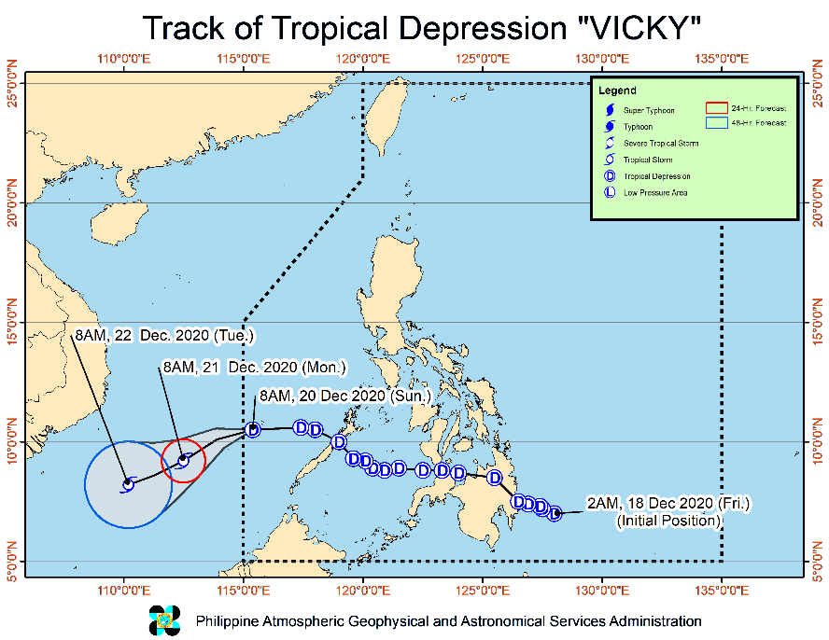
Situation Overview

Issued on 20 December 2020 at 5PM, TROPICAL DEPRESSION "VICKY" IS NOW OUTSIDE THE PHILIPPINE AREA OF RESPONSIBILITY AND IS HEADING TOWARDS KALAYAAN ISLANDS.

- Strong winds: Strong breeze to near gale conditions will be experienced over the Kalayaan Islands due to the passage of the tropical depression. Moreover, gusty conditions are also likely over most of Luzon, especially in coastal and mountainous areas, due to the surge of the Northeast Monsoon.
- Heavy rainfall: The combined effects of the Tail-End of a Frontal System (Shear Line) and Tropical Depression VICKY will bring:
- Until tonight: Moderate to heavy with at times intense rains over mainland Cagayan Valley, Apayao, Kalinga, Mountain Province, Ifugao, Aurora, Quezon, Bicol Region, northern portion of Palawan including Calamian Islands, and Kalayaan Islands. Light to moderate with at times heavy rains over Babuyan Islands and the rest of Cordillera Administrative Region.
- Tomorrow: Moderate to heavy rains over Babuyan Islands, mainland Cagayan Valley, Aurora, Apayao, Kalinga, Mountain Province, Ifugao, and the northern portion of Quezon. Light to moderate with at times heavy rains over Batanes, Kalayaan Islands, and the rest of Cordillera Administrative Region
- Flooding (including flash floods) and rain-induced landslides may occur during heavy or prolonged periods of rainfall, especially in areas identified to be highly or very highly susceptible to these hazards and in localities that received significant antecedent rainfall over the past couple of days or weeks. Adjacent or nearby areas may also experience flooding in the absence of such rainfall occurrence due to surface runoff or swelling of river channels. PAGASA Regional Services Divisions may issue local thunderstorm/rainfall advisories and heavy rainfall warnings in their respective areas of responsibility while the Hydrometeorology Division and River Basin Flood Forecasting and Warning Centers may issue general flood advisories and river basin flood advisories/bulletins as appropriate.

At 4:00 PM today, the center of Tropical Depression "VICKY" was estimated based on all available data at 70 km Southeast of Kalayaan, Palawan (OUTSIDE PAR) (10.6 °N, 114.6 °E )
Source: DOST-PAGASA Severe Weather Bulletin

- Status of Affected Families / Persons
A total of 2,379 families or 9,419 persons were affected in 41 barangays in Region II (see Table 1).

Table 1. Number of Affected Families / Persons
REGION / PROVINCE / MUNICIPALITY |  | NUMBER OF AFFECTED
 |  | Barangays | Families | Persons
GRAND TOTAL |  | 41 | 2,379 | 9,419
REGION II |  | 41 | 2,379 | 9,419
Cagayan |  | 17 | 374 | 1,419
 | Alcala | 1 | 24 | 58
 | Amulung | 3 | 15 | 47
 | Ballesteros | 1 | 13 | 60
 | Enrile | 1 | 6 | 20
 | Tuguegarao City (capital) | 11 | 316 | 1,234
Isabela |  | 22 | 2,001 | 7,979
 | Benito Soliven | 1 | 14 | 34
 | Cabagan | 1 | 7 | 18
 | Ilagan (capital) | 10 | 1,011 | 4,003
 | Mallig | 1 | 71 | 224
 | Quezon | 1 | 4 | 11
 | Roxas | 5 | 837 | 3,537
 | San Mariano | 2 | 38 | 88
 | San Pablo | 1 | 19 | 64
Quirino |  | 2 | 4 | 21
 | Saguday | 2 | 4 | 21
Note: Ongoing assessment and validation being conducted.
Source: DSWD-FO II

- Status of Displaced Families / Persons
- Inside Evacuation Centers
There are 639 families or 2,303 persons currently taking temporary shelter in 33 evacuation centers in Region II (see Table 2).

Table 2. Number of Displaced Families / Persons Inside Evacuation Centers
REGION / PROVINCE / MUNICIPALITY |  | NUMBER OF EVACUATION CENTERS (ECs) |  | NUMBER OF DISPLACED
 |  |  |  | INSIDE ECs
 |  |  |  | Families |  | Persons
 |  | CUM | NOW | CUM | NOW | CUM | NOW
GRAND TOTAL |  | 34 | 33 | 640 | 639 | 2,307 | 2,303
REGION II |  | 34 | 33 | 640 | 639 | 2,307 | 2,303
Cagayan |  | 18 | 18 | 358 | 358 | 1,344 | 1,344
 | Alcala | 1 | 1 | 24 | 24 | 58 | 58
 | Amulung | 2 | 2 | 13 | 13 | 41 | 41
 | Enrile | 1 | 1 | 6 | 6 | 20 | 20
 | Tuguegarao City (capital) | 14 | 14 | 315 | 315 | 1,225 | 1,225
Isabela |  | 14 | 13 | 278 | 277 | 942 | 938
 | Cabagan | 1 | 1 | 7 | 7 | 18 | 18
 | Ilagan (capital) | 7 | 7 | 173 | 173 | 632 | 632
 | Mallig | 1 | 1 | 36 | 36 | 125 | 125
 | Quezon | 1 | 1 | 4 | 4 | 11 | 11
 | Roxas | 1 | - | 1 | - | 4 | -
 | San Mariano | 2 | 2 | 38 | 38 | 88 | 88
 | San Pablo | 1 | 1 | 19 | 19 | 64 | 64
Quirino |  | 2 | 2 | 4 | 4 | 21 | 21
 | Saguday | 2 | 2 | 4 | 4 | 21 | 21
Note: Ongoing assessment and validation being conducted.
Source: DSWD-FO II

- Outside Evacuation Centers
There are 79 families or 237 persons currently staying with their relatives and/or friends in Region II (see Table 3).

Table 3. Number of Displaced Families / Persons Outside Evacuation Centers
REGION / PROVINCE / MUNICIPALITY |  | NUMBER OF DISPLACED
 |  | OUTSIDE ECs
 |  | Families |  | Persons
 |  | CUM | NOW | CUM | NOW
GRAND TOTAL |  | 79 | 79 | 237 | 237
REGION II |  | 79 | 79 | 237 | 237
Cagayan |  | 2 | 2 | 6 | 6
 | Amulung | 2 | 2 | 6 | 6
Isabela |  | 77 | 77 | 231 | 231
 | Benito Soliven | 14 | 14 | 34 | 34
 | Ilagan (capital) | 28 | 28 | 98 | 98
 | Mallig | 35 | 35 | 99 | 99
Note: Ongoing assessment and validation being conducted.
Source: DSWD-FO II

Situational Reports

DSWD-DRMB
DATE | SITUATIONS / ACTIONS UNDERTAKEN
20 December 2020 | - The Disaster Response Management Bureau (DRMB) is closely coordinating with the concerned field offices for significant disaster response updates.  - All QRT members and emergency equipment are on standby and ready for deployment.

DSWD-FO II
DATE | SITUATIONS / ACTIONS UNDERTAKEN
- December 2020 | - DSWD-FO II activated the 24/7 duty to continuously coordinate with the SWAD Teams and P/C/MATs in the region thru their P/C/MDRRMCs per Area of Responsibility (AOR) if there are concerns need to be addressed by the FO.  - DSWD-FO II is continuously monitoring thru the SWADTs and P/C/MATS of FO2 with regard to the present weather condition in the region.  - DSWD-FO II-Disaster Response Information and Management Section (DRIMS) is continuously monitor the weather advisory.  - DSWD-FO II ensures availability of Food and Non-Food Items (FNIs) at any given time  - The SWADTs/Provincial Operations Offices (POOs) and C/MATs are closely coordinating with their respective Local Disaster Risk Reduction and Management Councils the adverse effects brought by this weather disturbance.

*****
The Disaster Response Operations Monitoring and Information Center (DROMIC) of the DSWD-DRMB is closely monitoring the effects of Northeast Monsoon Enhanced by Tropical Depression “Vicky” and is coordinating with the concerned DSWD Field Office II for any significant updates.

Prepared by:

MARIEL B. FERRARIZ

JEM ERIC F. FAMORCAN
Releasing Officer

