DSWD DROMIC Report #1 on the Mw 6.2 Earthquake
Incident in Sarangani, Davao Occidental
as of 30 December 2020, 6PM

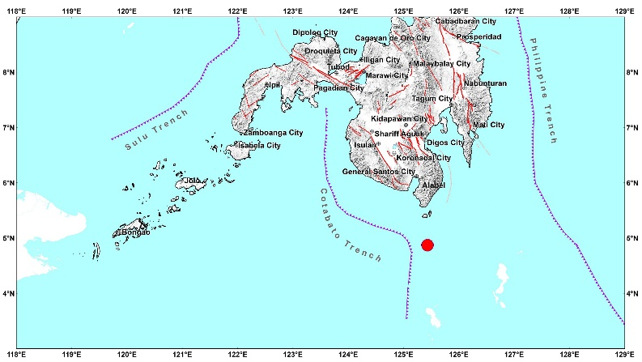
Situation Overview

On 16 December 2020 at 07:21 AM, a 6.2 magnitude earthquake jolted the municipality of of Sarangani, Davao Occidental (04.87°N, 125.43°E - 060 km S 01° E) with a tectonic origin and a depth of focus of 20 km.

Date/Time: | 16 Dec 2020 - 07:21 AM
Reported Intensities: | Intensity VI- Sarangani, Davao Occidental  Intensity V - General Santos City, South Cotabato  Intensity IV - Kiamba, Alabel, Maasim, Glan, Malungon and Malapatan Sarangani; Lebak, Sultan Kudarat; Datu Blah Sinsuat, Maguindanao; Koronadal City, Polomolok, Tampakan and Tupi and Banga, South Cotabato  Intensity III - Maitum, Sarangani; Cotabato City, Maguindanao; Davao City; Kidapawan City, North Cotabato; Tantangan and Santo Nino, Norala, Surallah, T’Boli, Lake Sebu, South Cotabato; Bagumbayan, Sultan Kudarat; Digos City and Santa Cruz, Davao del Sur  Intensity II - Columbio, Sultan Kudarat; Tacurong City, Kalamansig, Sultan Kudarat; Magpet, North Cotabato; Tulanan and Kabacan, Cotabato  Intensity I - Zamboanga City  Instrumental Intensities:  Intensity V - Gen. Santos City, South Cotabato  Intensity IV - Kiamba, Malungon, Sarangani; Tupi, South Cotabato; Koronadal City, South Cotabato  Intensity III - Kidapawan City, North Cotabato; Alabel, Saranggani  Intensity II- Zamboanga City
Expecting Damage: | YES
Expecting Aftershocks: | YES
Source: DOST-PHIVOLCS Earthquake Bulletin

- Status of Affected Families / Persons
A total of 26 families or 130 persons were affected by the earthquake incident in 3 barangays in Sarangani, Davao Occidental (see Table 1).

Table 1. Number of Affected Families / Persons
REGION / PROVINCE / MUNICIPALITY |  | NUMBER OF AFFECTED
 |  | Barangays | Families | Persons
GRAND TOTAL |  | 3 | 26 | 130
REGION XI |  | 3 | 26 | 130
Davao Occidental |  | 3 | 26 | 130
 | Sarangani | 3 | 26 | 130
Note: Ongoing assessment and validation being conducted.
Source: DSWD-FOs XI

- Damaged Houses
There are 26 partially damaged houses by the earthquake incident (see Table 2).

Table 2. Number of Damaged Houses
REGION / PROVINCE / MUNICIPALITY |  | NO. OF DAMAGED HOUSES
 |  | Total | Totally | Partially
GRAND TOTAL |  | 26 | - | 26
REGION XI |  | 26 | - | 26
Davao Occidental |  | 26 | - | 26
 | Sarangani | 26 | - | 26
Note: Ongoing assessment and validation being conducted
Source: DSWD-FO XI

Situational Reports

DSWD-DRMB
DATE | SITUATIONS / ACTIONS UNDERTAKEN
30 December 2020 | - The Disaster Response Management Bureau (DRMB) is continuously coordinating with concerned field offices for significant disaster response updates.  - All QRT members and emergency equipment are on standby and ready for deployment.

DSWD-FO XI
DATE | ACTION(S) TAKEN
30 December 2020 | - DSWD-FO XI is in close coordination with the concerned LGU/MSWDO of Sarangani for any significant update.

***
The Disaster Response Operations Monitoring and Information Center (DROMIC) of the DSWD-DRMB is closely coordinating with DSWD-FO XI for any significant disaster response updates.

Prepared by: Releasing Officer:

MARIEL B. FERRARIZ JEM ERIC F. FAMORCAN

