DSWD DROMIC Report #2 on Northeast Monsoon
Enhanced by Tropical Depression “VICKY”
as of 21 December 2020, 6PM

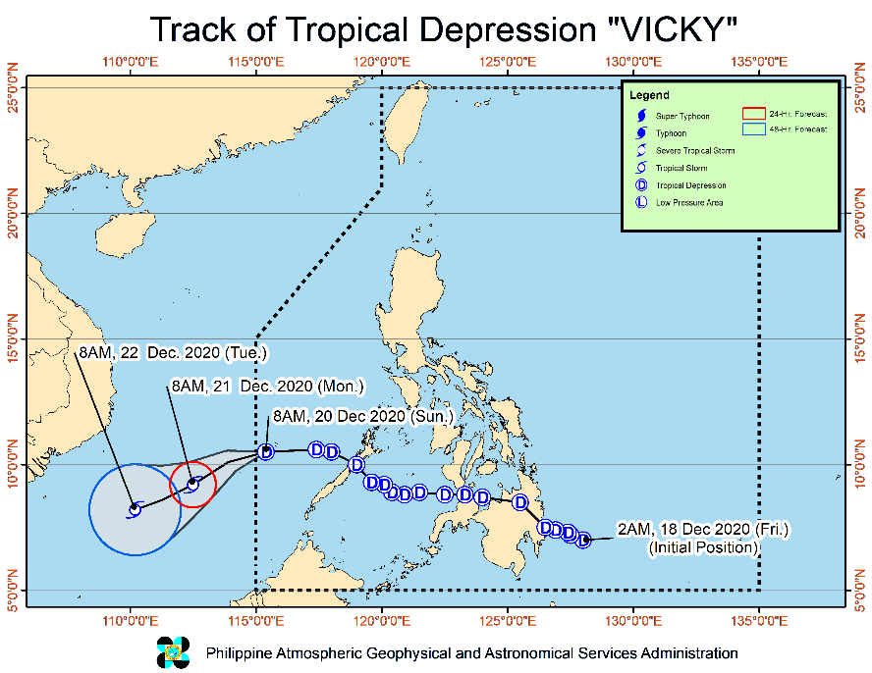
Situation Overview

Issued on 21 December 2020 at 11AM, "VICKY" WEAKENS INTO A TROPICAL DEPRESSION AS IT CONTINUES TO MOVE AWAY FROM THE KALAYAAN ISLANDS.

- Strong winds: The tropical cyclone wind signal over the Kalayaan Islands is now lifted. However, due to the surge of the Northeast Monsoon enhanced by the tropical depression, Batanes, Babuyan Islands, and the northern portions of Cagayan, Apayao, and Ilocos Norte will be experiencing strong to gale-force winds, while occasional gusty conditions are also likely over the eastern portions of mainland Cagayan, Isabela, Aurora, Quezon, and Palawan including Calamian Islands.
- Heavy rainfall: The combined effects of the Tail-End of a Frontal System (Shear Line) and Tropical Depression VICKY will bring:
- Today: Moderate to heavy rains over Kalayaan Islands, Babuyan and Calayan Islands, the eastern portion of mainland Cagayan Valley, Aurora, and the northern portion of Quezon. Light to moderate with at times heavy rains over the rest of mainland Cagayan Valley, Apayao, Kalinga, Mountain Province, Ifugao.
- Tomorrow: Moderate to heavy rains over Cagayan and Apayao. Light to moderate with at times heavy rains over Kalinga, Mountain Province, Ifugao, Aurora, Quezon, and the rest of Cagayan Valley.
- Flooding (including flash floods) and rain-induced landslides may occur during heavy or prolonged periods of rainfall, especially in areas identified to be highly or very highly susceptible to these hazards and in localities that received significant antecedent rainfall over the past couple of days or weeks. Adjacent or nearby areas may also experience flooding in the absence of such rainfall occurrence due to surface runoff or swelling of river channels. PAGASA Regional Services Divisions may issue local thunderstorm/rainfall advisories and heavy rainfall warnings in their respective areas of responsibility while the Hydrometeorology Division and River Basin Flood Forecasting and Warning Centers may issue general flood advisories and river basin flood advisories/bulletins as appropriate.

At 10:00 AM today, the center of Tropical Depression "VICKY" was estimated based on all available data at 210 km South Southwest of Pagasa Island, Palawan (OUTSIDE PAR) (09.3 °N, 113.3 °E )
Source: DOST-PAGASA Severe Weather Bulletin

- Status of Affected Families / Persons
A total of 13,306 families or 51,749 persons were affected in 139 barangays in Region II (see Table 1).

Table 1. Number of Affected Families / Persons
REGION / PROVINCE / MUNICIPALITY |  | NUMBER OF AFFECTED
 |  | Barangays | Families | Persons
GRAND TOTAL |  | 139 | 13,306 | 51,749
REGION II |  | 139 | 13,306 | 51,749
Cagayan |  | 85 | 10,886 | 42,212
 | Alcala | 4 | 96 | 242
 | Amulung | 15 | 462 | 1,551
 | Aparri | 2 | 132 | 572
 | Ballesteros | 1 | 13 | 60
 | Camalaniugan | 4 | 91 | 434
 | Enrile | 10 | 3,137 | 14,864
 | Gattaran | 1 | 1 | 3
 | Iguig | 2 | 4 | 18
 | Lal-lo | 4 | 71 | 208
 | Lasam | 1 | 3 | 10
 | Solana | 3 | 31 | 109
 | Tuguegarao City (capital) | 38 | 6,845 | 24,141
Isabela |  | 51 | 2,413 | 9,501
 | Benito Soliven | 1 | 14 | 36
 | Cabagan | 6 | 111 | 408
 | City of Cauayan | 5 | 50 | 191
 | Delfin Albano (Magsaysay) | 3 | 11 | 29
 | Ilagan (capital) | 11 | 1,011 | 4,005
 | Mallig | 5 | 188 | 657
 | Quezon | 1 | 4 | 11
 | Roxas | 5 | 837 | 3,537
 | San Isidro | 4 | 50 | 155
 | San Mariano | 2 | 38 | 100
 | San Pablo | 1 | 19 | 64
 | Santa Maria | 5 | 41 | 184
 | City of Santiago | 2 | 39 | 124
Quirino |  | 3 | 7 | 36
 | Cabarroguis (capital) | 1 | 3 | 15
 | Saguday | 2 | 4 | 21
Note: Ongoing assessment and validation being conducted.
Source: DSWD-FO II

- Status of Displaced Families / Persons
- Inside Evacuation Centers
There are 1,378 families or 4,675 persons currently taking temporary shelter in 90 evacuation centers in Region II (see Table 2).

Table 2. Number of Displaced Families / Persons Inside Evacuation Centers
REGION / PROVINCE / MUNICIPALITY |  | NUMBER OF EVACUATION CENTERS (ECs) |  | NUMBER OF DISPLACED
 |  |  |  | INSIDE ECs
 |  |  |  | Families |  | Persons
 |  | CUM | NOW | CUM | NOW | CUM | NOW
GRAND TOTAL |  | 98 | 90 | 1,473 | 1,378 | 5,056 | 4,675
REGION II |  | 98 | 90 | 1,473 | 1,378 | 5,056 | 4,675
Cagayan |  | 57 | 57 | 916 | 916 | 3,062 | 3,062
 | Alcala | 2 | 2 | 96 | 96 | 242 | 242
 | Amulung | 10 | 10 | 170 | 170 | 477 | 477
 | Camalaniugan | 3 | 3 | 15 | 15 | 54 | 54
 | Enrile | 3 | 3 | 21 | 21 | 71 | 71
 | Gattaran | 1 | 1 | 1 | 1 | 3 | 3
 | Iguig | 2 | 2 | 4 | 4 | 18 | 18
 | Lal-lo | 2 | 2 | 31 | 31 | 82 | 82
 | Lasam | 1 | 1 | 3 | 3 | 10 | 10
 | Solana | 2 | 2 | 6 | 6 | 24 | 24
 | Tuguegarao City (capital) | 31 | 31 | 569 | 569 | 2,081 | 2,081
Isabela |  | 37 | 29 | 550 | 455 | 1,958 | 1,577
 | Cabagan | 7 | 7 | 111 | 106 | 408 | 380
 | City of Cauayan | 5 | 5 | 50 | 50 | 191 | 191
 | Delfin Albano (Magsaysay) | 3 | 3 | 11 | 11 | 29 | 29
 | Ilagan (capital) | 7 | 7 | 173 | 162 | 632 | 600
 | Mallig | 1 | - | 36 | - | 125 | -
 | Quezon | 1 | 1 | 4 | 4 | 11 | 11
 | Roxas | 1 | - | 1 | - | 4 | -
 | San Isidro | 5 | - | 27 | - | 86 | -
 | San Mariano | 2 | 2 | 38 | 38 | 100 | 100
 | San Pablo | 1 | 1 | 19 | 19 | 64 | 64
 | Santa Maria | 2 | 2 | 41 | 37 | 184 | 149
 | City of Santiago | 2 | 1 | 39 | 28 | 124 | 53
Quirino |  | 4 | 4 | 7 | 7 | 36 | 36
 | Cabarroguis (capital) | 2 | 2 | 3 | 3 | 15 | 15
 | Saguday | 2 | 2 | 4 | 4 | 21 | 21
Note: Ongoing assessment and validation being conducted.
Source: DSWD-FO II

- Outside Evacuation Centers
There are 191 families or 780 persons currently staying with their relatives and/or friends in Region II (see Table 3).

Table 3. Number of Displaced Families / Persons Outside Evacuation Centers
REGION / PROVINCE / MUNICIPALITY |  | NUMBER OF DISPLACED
 |  | OUTSIDE ECs
 |  | Families |  | Persons
 |  | CUM | NOW | CUM | NOW
GRAND TOTAL |  | 374 | 191 | 1,396 | 780
REGION II |  | 374 | 191 | 1,396 | 780
Cagayan |  | 152 | 149 | 661 | 646
 | Amulung | 32 | 32 | 126 | 126
 | Aparri | 19 | 19 | 70 | 70
 | Camalaniugan | 76 | 73 | 380 | 365
 | Solana | 25 | 25 | 85 | 85
Isabela |  | 222 | 42 | 735 | 134
 | Benito Soliven | 14 | 14 | 36 | 36
 | Ilagan (capital) | 28 | 28 | 98 | 98
 | Mallig | 157 | - | 532 | -
 | San Isidro | 23 | - | 69 | -
Note: Ongoing assessment and validation being conducted.
Source: DSWD-FO II

- Assistance Provided
A total of ₱1,527,667.06 worth of assistance was provided to the affected families by the DSWD (see Table 4).

Table 4. Cost of Assistance Provided to Affected Families / Persons
REGION / PROVINCE / MUNICIPALITY |  | COST OF ASSISTANCE
 |  | DSWD | LGU | NGOs | OTHERS | GRAND TOTAL
GRAND TOTAL |  | 1,527,667.06 | - | - | - | 1,527,667.06
REGION II |  | 1,527,667.06 | - | - | - | 1,527,667.06
Cagayan |  | 1,125,995.00 | - | - | - | 1,125,995.00
 | Alcala | 1,125,995.00 | - | - | - | 1,125,995.00
Isabela |  | 401,672.06 | - | - | - | 401,672.06
 | Roxas | 401,672.06 | - | - | - | 401,672.06
Source: DSWD-FO II

Situational Reports

DSWD-DRMB
DATE | SITUATIONS / ACTIONS UNDERTAKEN
21 December 2020 | - The Disaster Response Management Bureau (DRMB) is closely coordinating with the concerned field offices for significant disaster response updates.  - All QRT members and emergency equipment are on standby and ready for deployment.

DSWD-FO II
DATE | SITUATIONS / ACTIONS UNDERTAKEN
21 December 2020 | - DSWD-FO II is continuously monitoring through the SWADTs and P/C/MATS with regard to the present weather condition in the Region.  - DSWD-FO II ensures availability of food and non-food items (FNIs) at any given time.  - The SWADTs/Provincial Operations Offices (POOs) and C/MATs are closely coordinating with the respective Local Disaster Risk Reduction and Management Councils in their area of responsibility on the adverse effects brought by the weather disturbance.

*****
The Disaster Response Operations Monitoring and Information Center (DROMIC) of the DSWD-DRMB is closely monitoring the effects of Northeast Monsoon enhanced by Tropical Depression “Vicky” and is coordinating with DSWD-Field Office II for any significant updates.

Prepared by:

MARIEL B. FERRARIZ

MARC LEO L. BUTAC
Releasing Officer

PHOTO DOCUMENTATION

