DSWD DROMIC Report #4 on Tropical Depression “VICKY”
as of 21 December 2020, 6PM

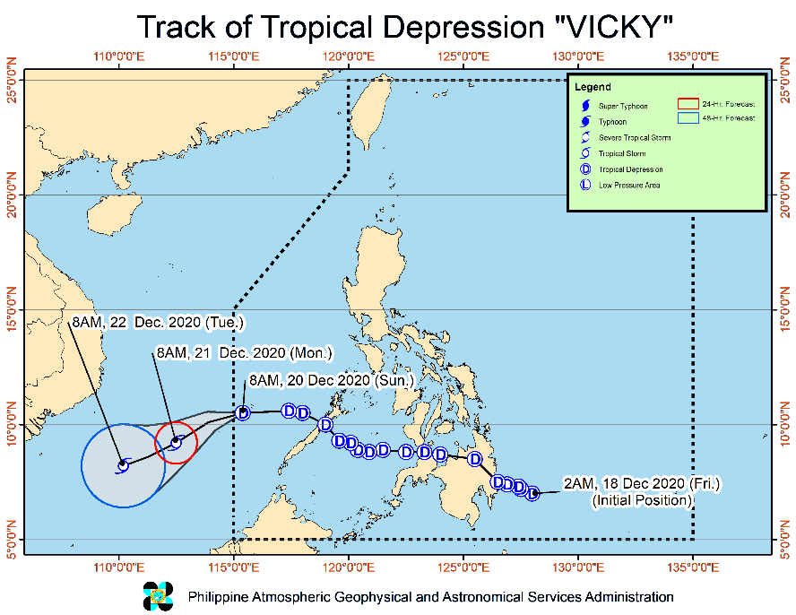
Situation Overview

Issued on 21 December 2020 at 11AM, "VICKY" WEAKENS INTO A TROPICAL DEPRESSION AS IT CONTINUES TO MOVE AWAY FROM THE KALAYAAN ISLANDS.

- Strong winds: The tropical cyclone wind signal over the Kalayaan Islands is now lifted. However, due to the surge of the Northeast Monsoon enhanced by the tropical depression, Batanes, Babuyan Islands, and the northern portions of Cagayan, Apayao, and Ilocos Norte will be experiencing strong to gale-force winds, while occasional gusty conditions are also likely over the eastern portions of mainland Cagayan, Isabela, Aurora, Quezon, and Palawan including Calamian Islands.
- Heavy rainfall: The combined effects of the Tail-End of a Frontal System (Shear Line) and Tropical Depression VICKY will bring:
- Today: Moderate to heavy rains over Kalayaan Islands, Babuyan and Calayan Islands, the eastern portion of mainland Cagayan Valley, Aurora, and the northern portion of Quezon. Light to moderate with at times heavy rains over the rest of mainland Cagayan Valley, Apayao, Kalinga, Mountain Province, Ifugao.
- Tomorrow: Moderate to heavy rains over Cagayan and Apayao. Light to moderate with at times heavy rains over Kalinga, Mountain Province, Ifugao, Aurora, Quezon, and the rest of Cagayan Valley.
- Flooding (including flash floods) and rain-induced landslides may occur during heavy or prolonged periods of rainfall, especially in areas identified to be highly or very highly susceptible to these hazards and in localities that received significant antecedent rainfall over the past couple of days or weeks. Adjacent or nearby areas may also experience flooding in the absence of such rainfall occurrence due to surface runoff or swelling of river channels. PAGASA Regional Services Divisions may issue local thunderstorm/rainfall advisories and heavy rainfall warnings in their respective areas of responsibility while the Hydrometeorology Division and River Basin Flood Forecasting and Warning Centers may issue general flood advisories and river basin flood advisories/bulletins as appropriate.

At 10:00 AM today, the center of Tropical Depression "VICKY" was estimated based on all available data at 210 km South Southwest of Pagasa Island, Palawan (OUTSIDE PAR) (09.3 °N, 113.3 °E )
Source: DOST-PAGASA Severe Weather Bulletin

- Status of Affected Families / Persons
A total of 16,762 families or 68,088 persons were affected in 239 barangays in Regions VII, VIII, XI and Caraga (see Table 1).

Table 1. Number of Affected Families / Persons
REGION / PROVINCE / MUNICIPALITY |  | NUMBER OF AFFECTED
 |  | Barangays | Families | Persons
GRAND TOTAL |  | 239 | 16,762 | 68,088
REGION VII |  | 32 | 618 | 2,510
Bohol |  | 3 | 15 | 60
 | Candijay | 3 | 15 | 60
Cebu |  | 15 | 441 | 1,812
 | Argao | 1 | 15 | 45
 | Boljoon | 2 | 13 | 44
 | Compostela | 2 | 54 | 221
 | Dalaguete | 1 | 2 | 8
 | Danao City | 1 | 150 | 600
 | Dumanjug | 1 | 20 | 140
 | Lapu-Lapu City (Opon) | 4 | 163 | 662
 | Sibonga | 3 | 24 | 92
Negros Oriental |  | 14 | 162 | 638
 | Bais City | 3 | 33 | 125
 | Dumaguete City (capital) | 6 | 92 | 365
 | City of Tanjay | 5 | 37 | 148
REGION VIII |  | 1 | 2 | 4
Leyte |  | 1 | 2 | 4
 | Mahaplag | 1 | 2 | 4
REGION XI |  | 22 | 608 | 2,818
Davao de Oro |  | 13 | 294 | 1,268
 | Compostela | 2 | 10 | 37
 | Mawab | 1 | 7 | 20
 | Monkayo | 3 | 72 | 360
 | Montevista | 1 | 13 | 65
 | Nabunturan (capital) | 4 | 152 | 546
 | Pantukan | 2 | 40 | 240
Davao del Norte |  | 8 | 310 | 1,530
 | Asuncion (Saug) | 6 | 238 | 1,180
 | Kapalong | 1 | 12 | 50
 | New Corella | 1 | 60 | 300
Davao Oriental |  | 1 | 4 | 20
 | Cateel | 1 | 4 | 20
CARAGA |  | 184 | 15,534 | 62,756
Agusan del Norte |  | 30 | 1,293 | 5,786
 | Butuan City (capital) | 16 | 702 | 3,327
 | City of Cabadbaran | 9 | 462 | 2,007
 | Jabonga | 2 | 38 | 119
 | Las Nieves | 1 | 10 | 50
 | Remedios T. Romualdez | 2 | 81 | 283
Agusan del Sur |  | 61 | 4,313 | 17,487
 | City of Bayugan | 3 | 172 | 825
 | Bunawan | 4 | 303 | 962
 | Esperanza | 13 | 1,121 | 4,593
 | Loreto | 3 | 160 | 668
 | Prosperidad (capital) | 18 | 1,549 | 7,123
 | Rosario | 1 | 11 | 44
 | San Francisco | 3 | 91 | 320
 | Santa Josefa | 4 | 33 | 137
 | Sibagat | 6 | 121 | 629
 | Talacogon | 3 | 86 | 355
 | Trento | 2 | 554 | 1,350
 | Veruela | 1 | 112 | 481
Dinagat Island |  | 2 | 2 | 10
 | Cagdianao | 2 | 2 | 10
Surigao del Norte |  | 19 | 543 | 2,156
 | Bacuag | 4 | 47 | 179
 | Mainit | 5 | 70 | 324
 | Malimono | 2 | 162 | 618
 | Sison | 1 | 48 | 192
 | Surigao City (capital) | 3 | 70 | 285
 | Tagana-an | 4 | 146 | 558
Surigao del Sur |  | 72 | 9,383 | 37,317
 | Barobo | 11 | 3,821 | 14,565
 | City of Bislig | 2 | 124 | 443
 | Cantilan | 14 | 1,159 | 5,795
 | Carmen | 6 | 423 | 1,746
 | Carrascal | 3 | 47 | 186
 | Lanuza | 1 | 18 | 70
 | Lianga | 3 | 255 | 1,439
 | Madrid | 5 | 440 | 2,200
 | Marihatag | 4 | 44 | 205
 | San Agustin | 6 | 554 | 2,064
 | Tagbina | 10 | 521 | 2,016
 | Tago | 7 | 1,977 | 6,588
N ote: Ongoing assessment and validation being conducted.
Source: DSWD-FOs VII, VIII, XI and CARAGA
- Status of Displaced Families / Persons
- Inside Evacuation Centers
There are 1,053 families or 4,791 persons currently taking temporary shelter in 48 evacuation centers in Regions VII, XI and Caraga (see Table 2).

Table 2. Number of Displaced Families / Persons Inside Evacuation Centers
REGION / PROVINCE / MUNICIPALITY |  | NUMBER OF EVACUATION CENTERS (ECs) |  | NUMBER OF DISPLACED
 |  |  |  | INSIDE ECs
 |  |  |  | Families |  | Persons
 |  | CUM | NOW | CUM | NOW | CUM | NOW
GRAND TOTAL |  | 226 | 48 | 7,737 | 1,053 | 32,150 | 4,791
REGION VII |  | 13 | 4 | 367 | 182 | 1,514 | 735
Cebu |  | 7 | 1 | 205 | 90 | 876 | 370
 | Argao | 1 | - | 15 | - | 45 | -
 | Compostela | 2 | - | 54 | - | 221 | -
 | Dalaguete | 1 | - | 2 | - | 8 | -
 | Dumanjug | 1 | - | 20 | - | 140 | -
 | Lapu-Lapu City (Opon) | 1 | 1 | 90 | 90 | 370 | 370
 | Sibonga | 1 | - | 24 | - | 92 | -
Negros Oriental |  | 6 | 3 | 162 | 92 | 638 | 365
 | Bais City | 2 | - | 33 | - | 125 | -
 | Dumaguete City (capital) | 3 | 3 | 92 | 92 | 365 | 365
 | City of Tanjay | 1 | - | 37 | - | 148 | -
REGION XI |  | 15 | - | 459 | - | 2,071 | -
Davao de Oro |  | 9 | - | 221 | - | 891 | -
 | Monkayo | 3 | - | 69 | - | 345 | -
 | Nabunturan (capital) | 6 | - | 152 | - | 546 | -
Davao del Norte |  | 6 | - | 238 | - | 1,180 | -
 | Asuncion (Saug) | 6 | - | 238 | - | 1,180 | -
CARAGA |  | 198 | 44 | 6,911 | 871 | 28,565 | 4,056
Agusan del Norte |  | 30 | 8 | 1,207 | 178 | 5,356 | 852
 | Butuan City (capital) | 18 | 8 | 702 | 178 | 3,327 | 852
 | City of Cabadbaran | 7 | - | 376 | - | 1,577 | -
 | Jabonga | 2 | - | 38 | - | 119 | -
 | Las Nieves | 1 | - | 10 | - | 50 | -
 | Remedios T. Romualdez | 2 | - | 81 | - | 283 | -
Agusan del Sur |  | 73 | 13 | 3,050 | 149 | 12,454 | 722
 | City of Bayugan | 3 | - | 172 | - | 825 | -
 | Bunawan | 8 | 3 | 279 | 15 | 908 | 63
 | Esperanza | 12 | 8 | 258 | 120 | 1,244 | 600
 | Loreto | 4 | - | 160 | - | 668 | -
 | Prosperidad (capital) | 18 | 1 | 1,226 | 13 | 5,823 | 54
 | Rosario | 1 | - | 11 | - | 44 | -
 | San Francisco | 4 | - | 91 | - | 320 | -
 | Santa Josefa | 3 | 1 | 18 | 1 | 66 | 5
 | Sibagat | 5 | - | 83 | - | 370 | -
 | Talacogon | 8 | - | 86 | - | 355 | -
 | Trento | 3 | - | 554 | - | 1,350 | -
 | Veruela | 4 | - | 112 | - | 481 | -
Surigao del Norte |  | 24 | - | 543 | - | 2,156 | -
 | Bacuag | 4 | - | 47 | - | 179 | -
 | Mainit | 5 | - | 70 | - | 324 | -
 | Malimono | 8 | - | 162 | - | 618 | -
 | Sison | 1 | - | 48 | - | 192 | -
 | Surigao City (capital) | 3 | - | 70 | - | 285 | -
 | Tagana-an | 3 | - | 146 | - | 558 | -
Surigao del Sur |  | 71 | 23 | 2,111 | 544 | 8,599 | 2,482
 | Barobo | 10 | 10 | 306 | 306 | 1,580 | 1,580
 | City of Bislig | 4 | 4 | 124 | 124 | 443 | 443
 | Cantilan | 6 | - | 109 | - | 449 | -
 | Carmen | 5 | - | 160 | - | 558 | -
 | Carrascal | 3 | 3 | 47 | 47 | 186 | 186
 | Lanuza | 2 | 1 | 18 | 7 | 70 | 25
 | Lianga | 7 | - | 255 | - | 1,439 | -
 | Madrid | 4 | - | 159 | - | 472 | -
 | Marihatag | 4 | - | 19 | - | 89 | -
 | San Agustin | 8 | - | 270 | - | 1,161 | -
 | Tagbina | 17 | 5 | 363 | 60 | 1,358 | 248
 | Tago | 1 | - | 281 | - | 794 | -
Note: Ongoing assessment and validation being conducted.
Source: DSWD-FOs VII, XI and CARAGA

- Outside Evacuation Centers
There are 1,180 families or 4,627 persons currently staying with their relatives and/or friends in Region Caraga (see Table 3).

Table 3. Number of Displaced Families / Persons Outside Evacuation Centers
REGION / PROVINCE / MUNICIPALITY |  | NUMBER OF DISPLACED
 |  | OUTSIDE ECs
 |  | Families |  | Persons
 |  | CUM | NOW | CUM | NOW
GRAND TOTAL |  | 3,822 | 1,180 | 14,357 | 4,627
CARAGA |  | 3,822 | 1,180 | 14,357 | 4,627
Agusan del Norte |  | 86 | - | 430 | -
 | City of Cabadbaran | 86 | - | 430 | -
Agusan del Sur |  | 1,263 | 1,180 | 5,033 | 4,627
 | Bunawan | 24 | - | 54 | -
 | Esperanza | 863 | 860 | 3,349 | 3,337
 | Prosperidad (capital) | 323 | 320 | 1,300 | 1,290
 | Santa Josefa | 15 | - | 71 | -
 | Sibagat | 38 | - | 259 | -
Dinagat Island |  | 2 | - | 10 | -
 | Cagdianao | 2 | - | 10 | -
Surigao del Sur |  | 2,471 | - | 8,884 | -
 | Barobo | 45 | - | 225 | -
 | Carmen | 263 | - | 1,188 | -
 | Marihatag | 25 | - | 116 | -
 | San Agustin | 284 | - | 903 | -
 | Tagbina | 158 | - | 658 | -
 | Tago | 1,696 | - | 5,794 | -
N ote: Ongoing assessment and validation being conducted.
Source: DSWD FO-CARAGA

- Damaged Houses
There are 235 damaged houses; of which, 120 are totally damaged and 115 are partially damaged (see Table 4).

Table 4. Number of Damaged Houses
REGION / PROVINCE / MUNICIPALITY |  | NO. OF DAMAGED HOUSES
 |  | Total | Totally | Partially
GRAND TOTAL |  | 235 | 120 | 115
REGION VII |  | 104 | 68 | 36
Cebu |  | 97 | 62 | 35
 | Lapu-Lapu City (Opon) | 97 | 62 | 35
Negros Oriental |  | 7 | 6 | 1
 | Dumaguete City (capital) | 7 | 6 | 1
REGION XI |  | 1 | - | 1
Davao de Oro |  | 1 | - | 1
 | Nabunturan (capital) | 1 | - | 1
CARAGA |  | 130 | 52 | 78
Dinagat Island |  | 2 | 2 | -
 | Cagdianao | 2 | 2 | -
Surigao del Sur |  | 128 | 50 | 78
 | Barobo | 100 | 46 | 54
 | Cantilan | 22 | 1 | 21
 | Lanuza | 1 | - | 1
 | Madrid | 1 | - | 1
 | Tago | 4 | 3 | 1
Note: Ongoing assessment and validation being conducted.
Source: DSWD FOs VII, XI and CARAGA

- Assistance provided
A total of ₱2,219,201.00 worth of assistance was provided to the affected families; of which, ₱1,470,450.00 from DSWD and ₱748,751.00 from LGUs (see Table 5).

Table 5. Cost of Assistance Provided to Affected Families / Persons
REGION / PROVINCE / MUNICIPALITY |  | COST OF ASSISTANCE
 |  | DSWD | LGU | NGOs | OTHERS | GRAND TOTAL
GRAND TOTAL |  | 1,470,450.00 | 748,751.00 | - | - | 2,219,201.00
REGION XI |  | 1,470,450.00 | - | - | - | 1,470,450.00
Davao Oriental |  | 1,470,450.00 | - | - | - | 1,470,450.00
 | Province | 1,470,450.00 | - | - | - | 1,470,450.00
CARAGA |  | - | 748,751.00 | - | - | 748,751.00
Agusan del Norte |  | - | 306,765.00 | - | - | 306,765.00
 | Butuan City (capital) | - | 306,765.00 | - | - | 306,765.00
Agusan del Sur |  | - | 135,216.00 | - | - | 135,216.00
 | Bunawan | - | 135,216.00 | - | - | 135,216.00
Surigao del Sur |  | - | 306,770.00 | - | - | 306,770.00
 | Barobo | - | 235,820.00 | - | - | 235,820.00
 | Carmen | - | 70,950.00 | - | - | 70,950.00
Source: DSWD-FOs XI and CARAGA

DSWD DISASTER RESPONSE INFORMATION

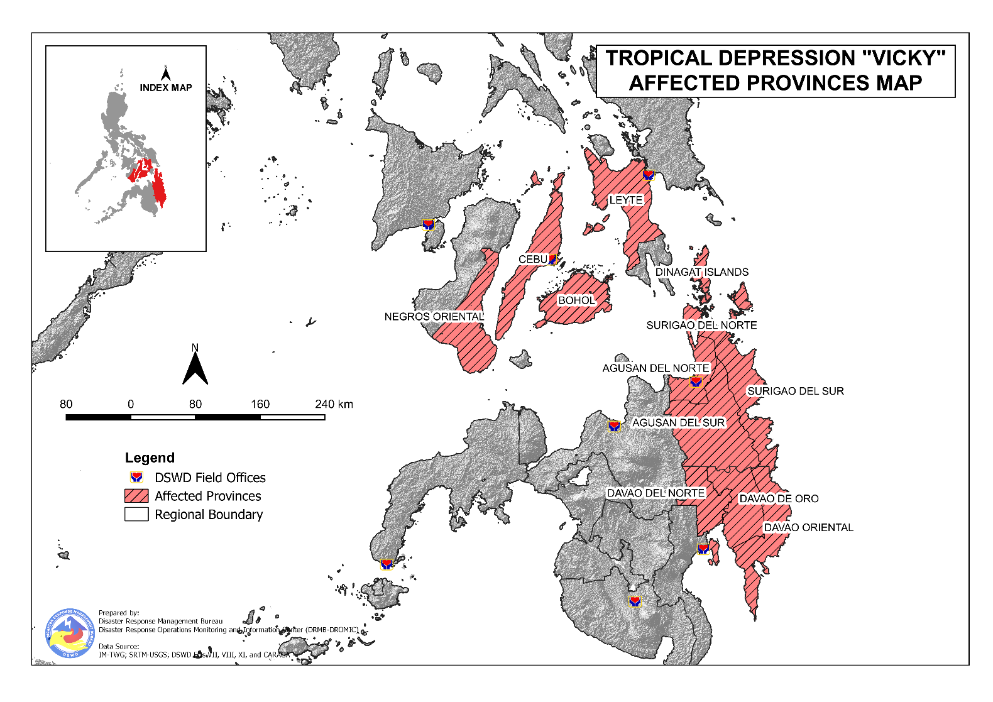
Status of Prepositioned Resources: Stockpile and Standby Funds
The DSWD Central Office (CO), Field Offices (FOs), and National Resource Operations Center (NROC) have stockpiles and standby funds amounting to ₱714,138,908.63 with breakdown as follows (see Table 2):

- Standby Funds
A total of ₱114,026,940.98 standby funds in the CO and FOs. Of the said amount ₱74,407,324.94 is the available Quick Response Fund (QRF) in the CO.
- Stockpiles
A total of 228,695 family food packs (FFPs) amounting to ₱106,334,029.69, other food items amounting to ₱167,408,115.36 and non-food items (FNIs) amounting to ₱326,369,822.60 are available.

Table 2. Available Stockpiles and Standby Funds
REGIONAL / FIELD OFFICE | STANDBY FUNDS | FAMILY FOOD PACKS |  | OTHER FOOD ITEMS | NON-FOOD RELIEF ITEMS | TOTAL STANDBY FUNDS & STOCKPILE
 |  | QUANTITY | TOTAL COST | TOTAL COST | TOTAL COST
TOTAL | 114,026,940.98 | 228,695 | 106,334,029.69 | 167,408,115.36 | 326,369,822.60 | 714,138,908.63
Central Office | 74,407,324.94 | - | - | - | - | 74,407,324.94
NRLMB - NROC | - | 2,501 | 1,543,117.00 | 35,958,661.92 | 127,785,247.79 | 165,287,026.71
NRLMB - VDRC | - | 13,647 | 6,096,051.63 | 10,912,302.30 | 3,115,495.45 | 20,123,849.38
I | 3,000,000.00 | 12,294 | 6,235,263.54 | 2,867,146.30 | 28,365,766.18 | 40,468,176.02
II | 3,000,000.00 | 36,933 | 19,103,314.11 | 2,732,130.65 | 13,467,878.32 | 38,303,323.08
III | 3,305,028.74 | 5,480 | 3,307,071.72 | 3,557,385.86 | 5,020,960.98 | 15,190,447.30
CALABARZON | 3,000,000.00 | 2,100 | 968,100.00 | 1,018,934.00 | 3,980,373.37 | 8,967,407.37
MIMAROPA | 1,903,226.58 | 23,025 | 10,361,250.00 | 2,061,634.00 | 4,289,670.80 | 18,615,781.38
V | 3,000,000.00 | 12,020 | 5,147,455.76 | 3,197,289.36 | 17,125,279.90 | 28,470,025.02
VI | 0.07 | 36,937 | 12,293,534.42 | 58,683,753.54 | 9,470,572.13 | 80,447,860.16
VII | 3,029,852.77 | 7,696 | 3,347,760.00 | 6,279,452.83 | 9,294,575.05 | 21,951,640.65
VIII | 3,194,543.00 | 12,100 | 6,256,400.00 | 5,132,799.90 | 19,284,402.95 | 33,868,145.85
IX | 570,000.00 | 15,823 | 8,647,111.27 | 14,994,195.68 | 10,866,180.12 | 35,077,487.07
X | 3,000,724.42 | 10,551 | 5,360,278.60 | 11,330,547.64 | 27,509,355.74 | 47,200,906.40
XI | 0 | 9,972 | 3,691,135.80 | 2,473,750.00 | 13,078,235.36 | 19,243,121.16
XII | 3,000,513.85 | 1,118 | 617,100.00 | 1,787,590.76 | 4,462,999.25 | 9,868,203.86
CARAGA | 3,000,740.55 | 13,499 | 6,525,786.65 | 1,629,458.12 | 15,314,746.52 | 26,470,731.84
NCR | 3,000,559.00 | 1,260 | 692,118.00 | 634,667.00 | 5,741,232.78 | 10,068,576.78
CAR | 3,614,427.06 | 11,739 | 6,141,181.19 | 2,156,415.50 | 8,196,849.91 | 20,108,873.66
Note: The Inventory Summary is as of 21 December 2020, 4PM.
Source: DRMB and NRLMB

Situational Reports

DSWD-DRMB
DATE | SITUATIONS / ACTIONS UNDERTAKEN
21 December 2020 | - The Disaster Response Management Bureau (DRMB) is closely coordinating with the concerned field offices for significant disaster response updates.  - All QRT members and emergency equipment are on standby and ready for deployment.

DSWD-NRLMB
DATE | SITUATIONS / ACTIONS UNDERTAKEN
20 December 2020 | - DSWD-NRLMB is continuously repacking goods for possible augmentation.

DSWD-FO MIMAROPA
DATE | SITUATIONS / ACTIONS UNDERTAKEN
21 December 2020 | - DSWD-FO MIMAROPA-Disaster Response Management Division thru the SWADT Offices continuously coordinating with LGUs and other concerned agencies on the condition and situation of displaced families/individuals.  - DSWD-FO MIMAROPA is continuously coordinating with the Office of Civil Defense (OCD) and RDRRMC MIMAROPA for any warning signal updates for monitoring purposes and response mechanism for areas that will be affected.  - A total of 24 families or 95 persons are currently taking preemptive evacuation in 4 evacuation centers in REGION MIMAROPA

DSWD-FO VI
DATE | SITUATIONS / ACTIONS UNDERTAKEN
18 December 2020 | - All QRT members are on standby and ready for augmentation if needed following the new normal protocols of the agency.  - The RDANA Team, composed of 40 trained QRTs is ready to be deployed when needed.

DSWD-FO VII
DATE | SITUATIONS / ACTIONS UNDERTAKEN
21 December 2020 | - DSWD-FO VII is in close coordination with the affected LGUs for any augmentation support needed.  - The Local Government Unit of Lapu-lapu provided food packs to the typhoon-affected victims.  - A total of 178 families or 704 persons have preemptively evacuated in 4 evacuation centers in REGION VII

DSWD-FO VIII
DATE | SITUATIONS / ACTIONS UNDERTAKEN
19 December 2020 | - Prepositioned FFPs in Samar Island which can be distributed immediately by the P/C/MATs to Local Government Units that need augmentation support.  - DSWD-FO VIII Provincial Action Team (PAT) and DRMD are in close coordination with C/MDRRMO and C/MSWDO to have a situational overview on the ground and to ensure response activities of LGUs to TD VICKY had considered the health protocols, especially during the management of their respective evacuation centers;  - DSWD-FO VIII utilized the social media as an immediate means of communication.  - Regional Resource Operations Center (RROC) is conducting repacking of FFPs from the available raw materials.  - DSWD-FO VIII Disaster Response Information Management Section (DRIMS) coordinated with SWAD Teams and DRMD PDOs on the ground to collect data and information as to the situation and effect of TD VICKY in Eastern Visayas.

DSWD-FO X
DATE | SITUATIONS / ACTIONS UNDERTAKEN
18 December 2020 | - DSWD-FO X is continuously monitoring the possible effects of TD Vicky to the Region.

DSWD-FO XI
DATE | SITUATIONS / ACTIONS UNDERTAKEN
21 December 2020 | - DSWD-FO XI Regional DROMIC Focal Person is in close coordination with the Municipal Social Welfare Development Office and Provincial/City/Municipal Disaster Risk Reduction Management Office for updates.  - DSWD-FO XI Provided 3,000 family food packs worth ₱1,470,450.00 to the affected families in the Municipalities of the Provincial Government of Davao Oriental.

DSWD-FO CARAGA
DATE | SITUATIONS / ACTIONS UNDERTAKEN
21 December 2020 | - DSWD-FO Caraga is continuously monitoring the weather updates.  - DSWD-FO Caraga thru the Disaster Response Management Division is continuously conducting assessment to the affected families in Surigao Del Sur and Agusan Del Sur.  - DSWD-FO Caraga is ready to provide augmentation assistance to the affected populations of the region.  - DSWD-FO Caraga is continuously coordinating with SWADTLs, LSWDOs and LDRRMOs to monitor their respective area of responsibility and provide updates regarding the effects of TD VICKY.

*****
The Disaster Response Operations Monitoring and Information Center (DROMIC) of the DSWD-DRMB is closely monitoring the effects of Tropical Depression “Vicky” and is coordinating with the concerned DSWD Field Offices for any significant updates.

Prepared by:

MARIEL B. FERRARIZ
DIANE C. PELEGRINO
JOANNA CAMILLE R. JACINTO

JEM ERIC F. FAMORCAN
Releasing Officer

PHOTO DOCUMENTATION

