DSWD DROMIC Preparedness for Response Report #1
on Tropical Depression “Auring”
as of 17 February 2021, 6PM

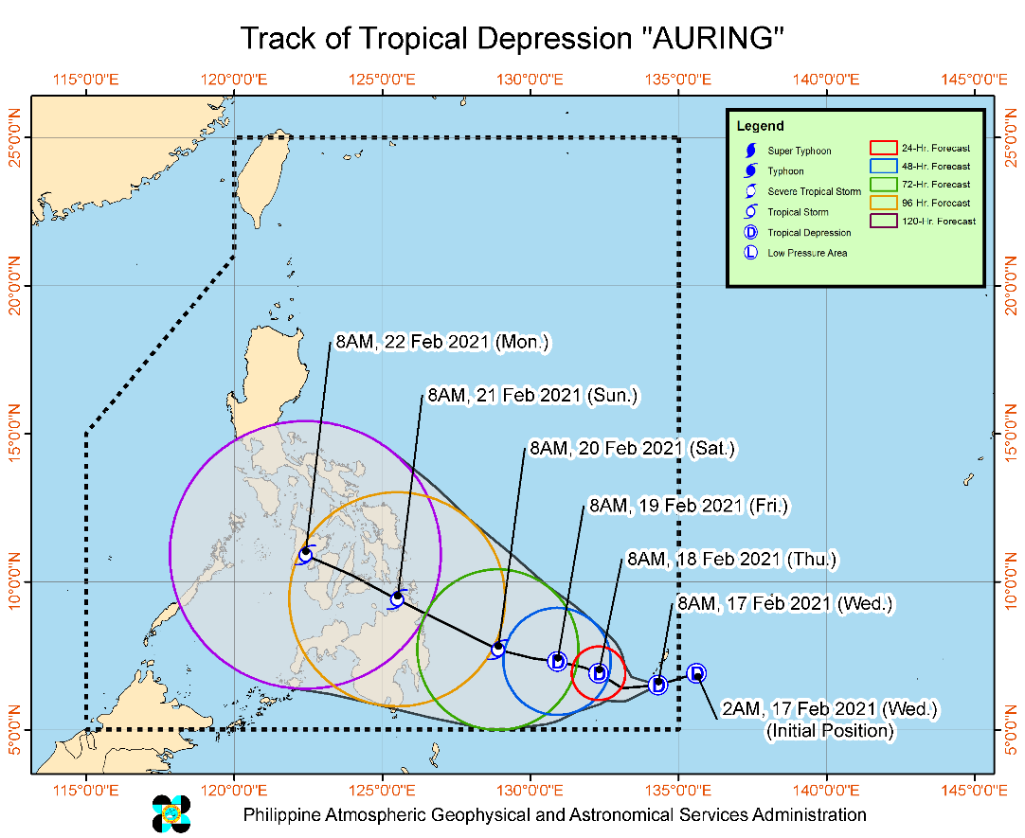
Situation Overview

Issued at 11:00 AM, 17 February 2021, THE TROPICAL DEPRESSION SOUTHEAST OF HINATUAN, SURIGAO DEL SUR HAS ENTERED PAR AND WAS NAMED "AURING".

- “AURING” entered the PAR at 8:00 AM today.
- Tropical Depression “AURING” is forecast to move generally westward or west-southwestward in the next 12 hours. Afterwards, “AURING” will move generally west-northwestward and is forecast to make landfall over Caraga on Saturday evening or Sunday morning as Tropical Storm.
- “AURING” is currently not affecting any part of the country. However, localities in Visayas, Bicol Region, MIMAROPA, Caraga, Northern Mindanao, Davao Region, Cotabato, and Lanao del Sur, especially those situated in areas identified in hazard maps to be highly or very highly susceptible to these hazards, are advised to take appropriate preparatory measures due to increasing likelihood of heavy rains and gusty conditions associated with the potential passage of a tropical cyclone during the weekend through Monday.
- Meanwhile, today, the Tail-End of a Frontal System will bring moderate to heavy rains over Eastern Visayas, Sorsogon, Masbate, Albay, Catanduanes and light to moderate with at times heavy rains over Central Visayas, Dinagat Islands, Surigao del Norte, and the rest of Bicol Region. Isolated flooding and rain-induced landslides may occur due to heavy rainfall or prolonged periods of rainfall, especially in areas identified in hazard maps to be highly or very highly susceptible to these hazards. Adjacent or nearby areas may also experience flooding in the absence of such rainfall occurrence due to surface runoff or swelling of river channels.
- Strong Winds: No locality is currently under Tropical Cyclone Wind Signal (TCWS) #1. However, in anticipation of the arrival of strong breeze to near-gale conditions due to “AURING”, TCWS #1 may be raised over several provinces of Caraga and Davao Region as early as Friday, which may result in the disruption of maritime activities.
- In the next 24 hours, rough to very rough seas (2.8 to 4.5 m) will be experienced over the seaboards of Northern Luzon. Sea travel is risky over these areas, especially for mariners of small seacrafts.
- Moderate to rough seas (1.2 to 3.1 m) will be experienced over the eastern seaboards of Central and Southern Luzon, Visayas, and Mindanao. Mariners of small seacrafts are advised to take precautionary measures when venturing out to sea. Inexperienced mariners should avoid navigating in these conditions.

At 10:00 AM today, the center of Tropical Depression "AURING" was estimated based on all available data at 900 km East Southeast of Hinatuan, Surigao del Sur (06.3 °N, 134.2 °E)
Source: DOST-PAGASA Severe Weather Bulletin

Status of Prepositioned Resources: Stockpile and Standby Funds
The DSWD Central Office (CO), Field Offices (FOs), and National Resource Operations Center (NROC) have stockpiles and standby funds amounting to ₱1,204,692,327.12 with breakdown as follows (see Table 2):

- Standby Funds
A total of ₱496,446,273.45 standby funds in the CO and FOs. Of the said amount, ₱459,860,852.15 is the available Quick Response Fund (QRF) in the CO.

- Stockpiles
A total of 274,922 family food packs (FFPs) amounting to ₱123,694,940.97, other food items amounting to ₱194,658,346.09 and non-food items (FNIs) amounting to ₱389,892,766.61 are available.

Table 2. Available Stockpiles and Standby Funds
REGIONAL / FIELD OFFICE | STANDBY FUNDS | FAMILY FOOD PACKS |  | OTHER FOOD ITEMS | NON-FOOD RELIEF ITEMS | TOTAL STANDBY FUNDS & STOCKPILE
 |  | QUANTITY | TOTAL COST | TOTAL COST | TOTAL COST
TOTAL | 496,446,273.45 | 274,922 | 123,694,940.97 | 194,658,346.09 | 389,892,766.61 | 1,204,692,327.12
Central Office | 459,860,852.15 | - | - | - | - | 459,860,852.15
NRLMB - NROC | - | 40,709 | 19,799,485.00 | 68,500,443.80 | 174,607,352.37 | 262,907,281.17
NRLMB - VDRC | - | 17,445 | 7,769,025.00 | 10,188,535.05 | 6,350,620.00 | 24,308,180.05
I | 3,000,000.00 | 9,954 | 5,050,499.44 | 3,185,750.00 | 26,566,093.29 | 37,802,342.73
II | 3,000,000.00 | 15,775 | 7,903,396.90 | 2,174,477.11 | 9,623,584.45 | 22,701,458.46
III | 3,000,908.30 | 7,558 | 951,540.02 | 1,457,158.46 | 15,962,362.00 | 21,371,968.78
CALABARZON | 3,000,000.00 | 4,055 | 1,897,635.00 | 6,823,648.80 | 3,980,373.37 | 15,701,657.17
MIMAROPA | 3,967,396.58 | 33,107 | 14,898,150.00 | 898,346.00 | 5,879,212.90 | 25,643,105.48
V | - | 29,419 | 11,871,098.43 | 3,721,132.21 | 14,360,854.90 | 29,953,085.54
VI | 3,000,000.07 | 36,146 | 14,755,609.54 | 33,303,600.94 | 13,104,605.69 | 64,163,816.24
VII | 3,077,030.00 | 15,186 | 6,605,910.00 | 3,778,009.95 | 7,397,048.23 | 20,857,998.18
VIII | 3,194,543.00 | 9,697 | 4,755,505.43 | 11,562,948.98 | 28,018,576.95 | 47,531,574.36
IX | 570,000.00 | 10,655 | 5,822,850.95 | 9,491,450.96 | 10,277,040.11 | 26,161,342.02
X | 1,116,679.92 | 16,539 | 7,734,481.91 | 16,588,875.38 | 31,177,178.24 | 56,617,215.45
XI | 3,000,000.00 | 2,364 | 1,139,992.48 | 3,078,025.00 | 3,182,152.25 | 10,400,169.73
XII | 3,000,513.85 | 3,503 | 1,928,850.00 | 9,482,830.04 | 4,433,691.49 | 18,845,885.38
CARAGA | - | 7,607 | 3,280,117.82 | 2,180,618.16 | 13,469,504.87 | 18,930,240.85
NCR | 3,000,559.00 | 1,676 | 760,317.40 | 7,478,108.45 | 3,703,274.28 | 14,942,259.13
CAR | 657,790.58 | 13,527 | 6,770,475.65 | 764,386.80 | 17,799,241.22 | 25,991,894.25
Note: The Inventory Summary is as of 17 February 2021, 4PM.
Source: DRMB and NRLMB

Situational Reports

DSWD-DRMB
DATE | SITUATIONS / ACTIONS UNDERTAKEN
17 February 2021 | - The Disaster Response Management Bureau (DRMB) is closely coordinating with the concerned field offices for significant disaster response updates  - All QRT members and emergency equipment are on standby and ready for deployment.  - DRMB participated in the Online Pre-Disaster Risk Assessment Meeting on Tropical Depression (TD) “Auring” on 17 February 2021 with other response cluster member agencies. Further meetings shall be conducted on the implementation of COVID-19 protocols during the response efforts on TD “Auring”.
DSWD-FO V
DATE | SITUATIONS / ACTIONS UNDERTAKEN
17 February 2021 | - DSWD-FO V continuous to monitor weather updates and information.  - The Resource Operation Section ensures the availability of Family Food Packs (FFPs) and non-food items as need arises.  - DSWD-FO V Quick Response Teams (QRTs) are alerted  - PAT and MAT members in the six (6) provinces are activated and instructed to coordinate with the P/MDRRMOs, C/MSWDOs for weather reports and updates.

DSWD-FO X
DATE | SITUATIONS / ACTIONS UNDERTAKEN
17 February 2021 | - 4 Samsung Grand Cellphones are currently in use for the Regional Quick Response Team for Covid-19 Response.  - For disaster response, DROMIC focal person may be contacted directly.

*****
The Disaster Response Operations Monitoring and Information Center (DROMIC) of the DSWD-DRMB is closely monitoring the effects of Tropical Depression “Auring” and is coordinating with the concerned DSWD Field Offices for any significant updates.

Prepared by:

DIANE C. PELEGRINO

RODEL V. CABADDU
Releasing Officer

