DSWD DROMIC Preparedness for Response Report #2
on Tropical Depression “Auring”
as of 18 February 2021, 6PM

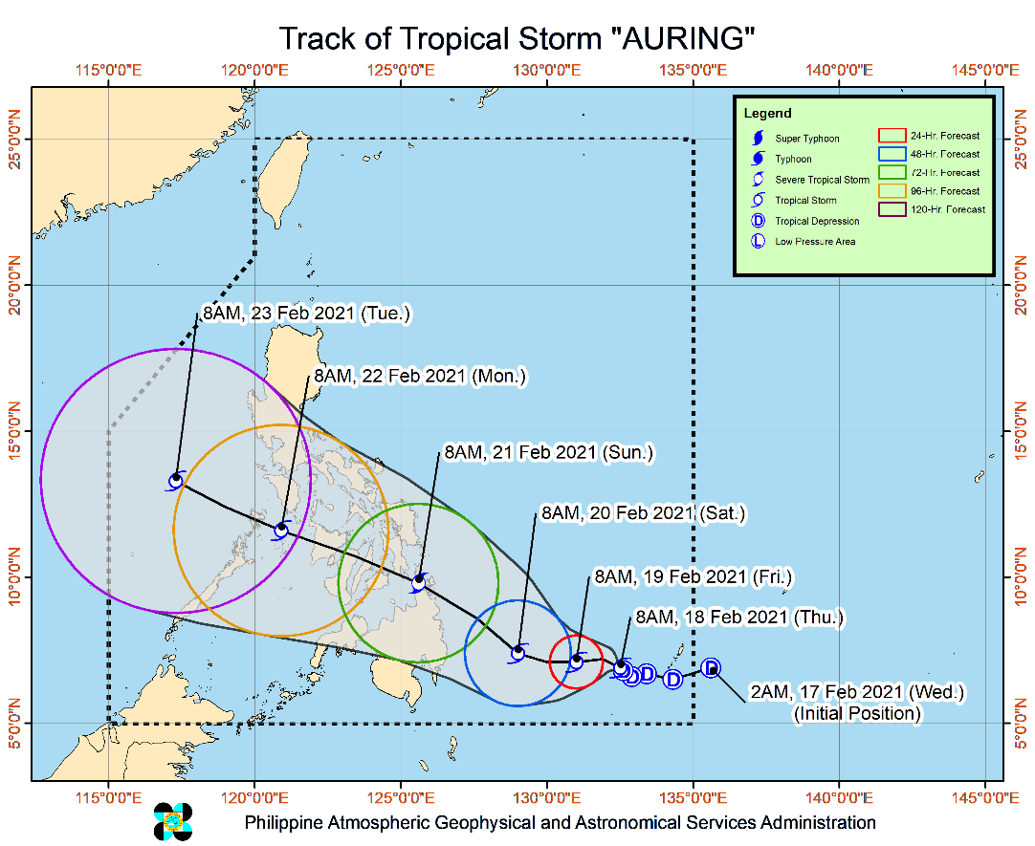
Situation Overview

Issued at 11:00 AM, 18 February 2021, "AURING" INTENSIFIES INTO A TROPICAL STORM WHILE MOVING SLOWLY NORTHWESTWARD OVER THE PHILIPPINE SEA.

- Heavy Rainfall: Tropical Storm "AURING" is not yet expected to bring heavy rains today. However, there is an increasing likelihood of heavy rainfall affecting Visayas, Caraga, Northern Mindanao, Bicol Region, CALABARZON, Davao Oriental, Davao de Oro, Davao del Norte, Lanao del Sur, Mindoro Provinces, Marinduque, Romblon, Northern Palawan including Calamian and Cuyo Islands over the weekend through Monday. Residents in these areas and all disaster risk reduction and management offices concerned, especially those situated in areas identified in hazard maps to be highly or very highly susceptible to flooding and rain-induced landslides, are advised to take appropriate preparatory measures.
- Strong Winds: No locality is currently under Tropical Cyclone Wind Signal (TCWS) #1. However, in anticipation of the arrival of strong breeze to near-gale conditions due to “AURING”, TCWS #1 may be raised over several provinces of Caraga and Davao Region as early as tomorrow, which may result in disruption of maritime activities.
- In the next 24 hours, rough to very rough seas (2.8 to 5.0 m) will be experienced over the seaboards of Northern Luzon and the eastern seaboards of Central and Southern Luzon, Visayas, and Mindanao due to the surge of the Northeast Monsoon and "AURING". Sea travel is risky over these areas, especially for mariners of small seacrafts.
- Moderate to rough seas (1.2 to 3.1 m) will be experienced over the rest of the seaboards of the country. Mariners of small seacrafts are advised to take precautionary measures when venturing out to sea. Inexperienced mariners should avoid navigating in these conditions.
- Track: Tropical Storm “AURING” will move generally westward to west-northwestward through the forecast period, with an increase in speed tomorrow as it turn more west-northwestward.
- Intensity: "AURING" intensified into a Tropical Storm at 8:00 AM today. On the forecast track, “AURING” may intensify into severe tropical storm prior to landfall over Caraga on Saturday evening or Sunday morning.

At 10:00 AM today, the center of Tropical Storm "AURING" was estimated based on all available data at 685 km East Southeast of Hinatuan, Surigao del Sur (07.1 °N, 132.4 °E)
Source: DOST-PAGASA Severe Weather Bulletin

Status of Prepositioned Resources: Stockpile and Standby Funds
The DSWD Central Office (CO), Field Offices (FOs), and National Resource Operations Center (NROC) have stockpiles and standby funds amounting to ₱1,227,926,488.18 with breakdown as follows (see Table 2):

- Standby Funds
A total of ₱496,446,273.45 standby funds in the CO and FOs. Of the said amount, ₱459,860,852.15 is the available Quick Response Fund (QRF) in the CO.

- Stockpiles
A total of 284,973 family food packs (FFPs) amounting to ₱126,915,033.18, other food items amounting to ₱194,963,492.26 and non-food items (FNIs) amounting to ₱409,601,689.29 are available.

Table 2. Available Stockpiles and Standby Funds
REGIONAL / FIELD OFFICE | STANDBY FUNDS | FAMILY FOOD PACKS |  | OTHER FOOD ITEMS | NON-FOOD RELIEF ITEMS | TOTAL STANDBY FUNDS & STOCKPILE
 |  | QUANTITY | TOTAL COST | TOTAL COST | TOTAL COST
TOTAL | 496,446,273.45 | 284,973 | 126,915,033.18 | 194,963,492.26 | 409,601,689.29 | 1,227,926,488.18
Central Office | 459,860,852.15 | - | - | - | - | 459,860,852.15
NRLMB - NROC | - | 42,494 | 20,656,285.00 | 72,049,551.80 | 185,133,452.37 | 277,839,289.17
NRLMB - VDRC | - | 17,445 | 7,769,025.00 | 10,188,535.05 | 6,350,620.00 | 24,308,180.05
I | 3,000,000.00 | 7,954 | 4,030,499.44 | 3,185,750.00 | 26,566,093.29 | 36,782,342.73
II | 3,000,000.00 | 15,775 | 7,903,396.90 | 2,174,477.11 | 9,623,584.45 | 22,701,458.46
III | 3,000,908.30 | 7,558 | 951,540.02 | 1,001,458.46 | 15,962,362.00 | 20,916,268.78
CALABARZON | 3,000,000.00 | 5,605 | 2,623,140.00 | 6,485,292.60 | 7,713,196.05 | 19,821,628.65
MIMAROPA | 3,967,396.58 | 33,107 | 14,898,150.00 | 898,346.00 | 5,879,212.90 | 25,643,105.48
V | - | 30,689 | 12,368,049.43 | 3,737,864.00 | 14,360,854.90 | 30,466,768.33
VI | 3,000,000.07 | 37,855 | 15,370,849.54 | 32,006,689.10 | 13,104,605.69 | 63,482,144.40
VII | 3,077,030.00 | 15,186 | 6,605,910.00 | 3,778,009.95 | 7,397,048.23 | 20,857,998.18
VIII | 3,194,543.00 | 9,124 | 4,641,816.09 | 10,972,884.12 | 28,018,576.95 | 46,827,820.16
IX | 570,000.00 | 10,347 | 5,654,532.03 | 8,911,790.24 | 10,277,040.11 | 25,413,362.38
X | 1,116,679.92 | 24,951 | 11,577,539.00 | 16,588,875.38 | 31,177,178.24 | 60,460,272.54
XI | 3,000,000.00 | 2,364 | 1,139,992.48 | 3,078,025.00 | 3,182,152.25 | 10,400,169.73
XII | 3,000,513.85 | 2,653 | 1,461,350.00 | 9,482,830.04 | 9,883,691.49 | 23,828,385.38
CARAGA | - | 6,663 | 1,732,165.20 | 2,180,618.16 | 13,469,504.87 | 17,382,288.23
NCR | 3,000,559.00 | 1,676 | 760,317.40 | 7,478,108.45 | 3,703,274.28 | 14,942,259.13
CAR | 657,790.58 | 13,527 | 6,770,475.65 | 764,386.80 | 17,799,241.22 | 25,991,894.25
Note: The Inventory Summary is as of 18 February 2021, 4PM.
Source: DRMB and NRLMB

Situational Reports

DSWD-DRMB
DATE | SITUATIONS / ACTIONS UNDERTAKEN
18 February 2021 | - The Disaster Response Management Bureau (DRMB) is closely coordinating with the concerned field offices for significant disaster response updates.  - All QRT members and emergency equipment are on standby and ready for deployment.  - DRMB participated in the Online Pre-Disaster Risk Assessment Meeting on Tropical Depression (TD) “Auring” on 17 February 2021 with other response cluster member agencies. Further meetings shall be conducted on the implementation of COVID-19 protocols during the response efforts on TD “Auring”.
DSWD-FO V
DATE | SITUATIONS / ACTIONS UNDERTAKEN
17 February 2021 | - DSWD-FO V continuous to monitor weather updates and information.  - The Resource Operation Section ensures the availability of Family Food Packs (FFPs) and non-food items as need arises.  - DSWD-FO V Quick Response Teams (QRTs) are alerted.  - PAT and MAT members in the six (6) provinces are activated and instructed to coordinate with the P/MDRRMOs, C/MSWDOs for weather reports and updates.

DSWD-FO VI
DATE | SITUATIONS / ACTIONS UNDERTAKEN
18 February 2021 | - QRT members are on stand by and ready for augmentation/deployment if needed. There were 30 QRT members that can assist in reports generation which also undergone training on DROMIC reporting last September 17-19 and 24-26, 2020. The new normal protocols in response operation of the agency will strictly be observed.  - DROMIC Provincial Focal Persons are in-placed in Provinces of Negros Occidental, Iloilo, Antique, Capiz and Aklan ready to consolidated DROMIC Reports of affected municipalities. DSWD-DRMD technical staff recently conducted technical assistance session to the said Provincial DROMIC Focals and selected Municipal DROMIC Focal Persons.

DSWD-FO VII
DATE | SITUATIONS / ACTIONS UNDERTAKEN
18 February 2021 | - Regional/Provincial/City/Municipal Quick Response Team is on standby alert and ready for mobilization for any assistance and augmentation support needed from the LGUs.  - City and Municipal Action Team and SWAD Offices were alerted and already requested to closely coordinate with their local counterparts and their respective LDRRMCs. Field staff requested to monitor AOR and provide reports and updates to the Regional DROMIC Focal for any impacts/effects.  - Continuous monitoring by the DSWD Regional DROMIC Focal for the latest weather updates from PAGASA and cascading the same for widest dissemination to Provincial /City/Municipal Action Teams.  - Regional Disaster Division is in closed coordination with OCD-7 and other members of the RDRRMC for any response mobilization activities/strategies. Regional QRT members and warehouses located in the three island provinces are on standby alert for any response activities and relief augmentation.

DSWD-FO VIII
DATE | SITUATIONS / ACTIONS UNDERTAKEN
18 February 2021 | - Prepositioned Family Food Packs (FFPs) in Samar Island and Biliran which can be distributed immediately by the P/C/MATs to Local Government Units that need augmentation support.  - Ongoing packing of FFPs in the DRMD Operations Office with staff augmentation from different division.  - DSWD-FO VIII continuous to monitor the weather situation through watching the live updates of PAGASA regarding the weather disturbance.  - DSWD-FO VIII is in close coordination with SWAD Teams and City/Municipal Actions Teams to be alerted on the impending Tropical Depression “Auring” as it may intensify in the coming days.

DSWD-FO X
DATE | SITUATIONS / ACTIONS UNDERTAKEN
17 February 2021 | - 4 Samsung Grand Cellphones are currently in use for the Regional Quick Response Team for Covid-19 Response.  - For disaster response, DROMIC focal person may be contacted directly.

DSWD-FO XII
DATE | SITUATIONS / ACTIONS UNDERTAKEN
18 February 2021 | - DSWD-FO XII is continuously monitoring the weather updates of Tropical Depression “Auring”.  - DSWD-FO XII is in close coordination with the PSWDO/MSWDO, OCD XII and DOST-PAGASA.

DSWD-FO CARAGA
DATE | SITUATIONS / ACTIONS UNDERTAKEN
18 February 2021 | - DSWD-FO CARAGA is continuously monitoring the weather updates.  - DSWD-FO CARAGA QRT members are on standby for possible deployment.  - DSWD-FO CARAGA has two (2) smartphones available to be utilized for communication support in the Emergency Operations Center.  - DSWD-FO CARAGA is in close coordination with SWADTLs and LSWDOs for monitoring of the situation in their respective area of responsibility.

*****
The Disaster Response Operations Monitoring and Information Center (DROMIC) of the DSWD-DRMB is closely monitoring the effects of Tropical Depression “Auring” and is coordinating with the concerned DSWD Field Offices for any significant updates.

Prepared by:

MARIEL B. FERRARIZ
DIANE C. PELEGRINO

LESLIE R. JAWILI
Releasing Officer

