DSWD DROMIC Report #6 on Severe Tropical Storm “AURING”
as of 22 February 2021, 6PM

Situation Overview
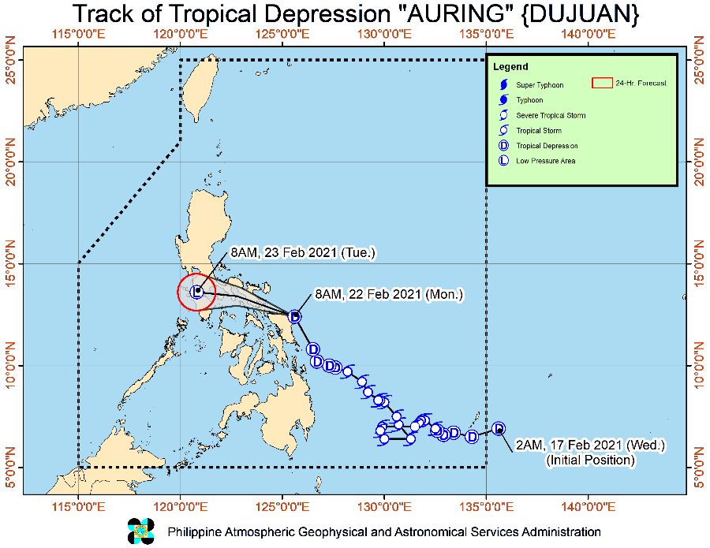

Issued at 2:00 PM, 22 February 2021, "AURING" WEAKENS INTO A LOW PRESSURE AREA AND IS NOW MOVING TOWARDS THE EASTERN COAST OF ALBAY.

“AURING” weakened into a Low Pressure Area at 11:00 AM today prior to crossing the Rapu-Rapu Islands, Albay.

It is forecast to move northwestward to westward and may traverse Bicol Region, southern Quezon, Marinduque, and northern Mindoro in the next 24 hours. There is an increasing likelihood of the disturbance dissipating while traversing Southern Luzon.

Heavy Rainfall
- Tomorrow: Moderate to heavy with at times intense rains over Bicol Region, Quezon, Marinduque, and Romblon. Light to moderate with at times heavy rains over Aurora, Rizal, Laguna, Northern Samar, and the rest of MIMAROPA.
- Tomorrow: Moderate to heavy rains over Camarines Norte, Quezon, and Aurora. Light to moderate with at times heavy rains over Metro Manila, the rest of CALABARZON, MIMAROPA, Camarines Sur, Bulacan, Nueva Ecija, Isabela, Cagayan including Babuyan Islands, and Batanes.
- Under these conditions, isolated to scattered flooding (including flash floods) and rain-induced landslides are still likely during heavy or prolonged rainfall especially in areas that are highly or very highly susceptible to these hazards as identified in hazard maps and in localities that received significant rainfall over the past couple of days. Adjacent or nearby areas may also experience flooding in the absence of such rainfall occurrence due to surface runoff or swelling of river channels. PAGASA Regional Services Divisions may issue local thunderstorm/rainfall advisories and heavy rainfall warnings while the Hydrometeorology Division and River Basin Flood Forecasting and Warning Centers may issue General Flood Advisories and Basin Flood Bulletins as appropriate.

Strong Winds
- Tropical Cyclone Wind Signal #1 is now lifted. However, the Northeast Monsoon will continue to bring strong breeze conditions over Batanes, Babuyan Islands, Aurora, and Quezon.

At 1:00 PM today, the center of the Low Pressure Area (LPA)(formerly "AURING") was estimated based on all available data Over the coastal waters of Rapu-Rapu, Albay. (13.3 °N, 124.0 °E )

Source: DOST-PAGASA Severe Weather Bulletin

- Status of Affected Families / Persons
A total of 31,876 families or 121,937 persons were affected in 373 barangays in Regions X, XI and CARAGA (see Table 1).

Table 1. Number of Affected Families / Persons
REGION / PROVINCE / MUNICIPALITY |  | NUMBER OF AFFECTED
 |  | Barangays | Families | Persons
GRAND TOTAL |  | 373 | 31,876 | 121,937
REGION X |  | 1 | 18 | 66
Misamis Oriental |  | 1 | 18 | 66
 | Talisayan | 1 | 18 | 66
REGION XI |  | 14 | 566 | 2,341
Davao de Oro |  | 10 | 431 | 1,667
 | Mawab | 2 | 29 | 119
 | New Bataan | 8 | 402 | 1,548
Davao Oriental |  | 4 | 135 | 674
 | Baganga | 1 | 50 | 250
 | Banaybanay | 1 | 49 | 247
 | Caraga | 1 | 6 | 27
 | City of Mati (capital) | 1 | 30 | 150
CARAGA |  | 358 | 31,292 | 119,530
Agusan del Norte |  | 46 | 1,900 | 6,954
 | Butuan City (capital) | 9 | 529 | 1,194
 | City of Cabadbaran | 21 | 1,032 | 4,493
 | Carmen | 2 | 11 | 31
 | Jabonga | 4 | 118 | 344
 | Kitcharao | 6 | 133 | 596
 | Nasipit | 4 | 77 | 296
Agusan del Sur |  | 16 | 291 | 1,205
 | Bunawan | 1 | 9 | 39
 | Loreto | 4 | 121 | 560
 | Prosperidad (capital) | 1 | 19 | 63
 | Rosario | 3 | 42 | 170
 | Santa Josefa | 3 | 55 | 202
 | Sibagat | 2 | 22 | 85
 | Trento | 2 | 23 | 86
Dinagat Island |  | 1 | 15 | 39
 | San Jose (capital) | 1 | 15 | 39
Surigao del Norte |  | 101 | 8,101 | 30,990
 | Bacuag | 8 | 692 | 2,499
 | Claver | 10 | 1,046 | 3,708
 | General Luna | 4 | 359 | 1,482
 | Gigaquit | 6 | 480 | 1,734
 | Mainit | 14 | 842 | 4,186
 | Malimono | 2 | 206 | 742
 | Pilar | 2 | 137 | 606
 | Placer | 10 | 301 | 1,204
 | San Benito | 2 | 59 | 216
 | San Francisco (Anao-aon) | 1 | 6 | 74
 | San Isidro | 10 | 306 | 1,194
 | Sison | 8 | 1,065 | 3,737
 | Socorro | 2 | 46 | 192
 | Surigao City (capital) | 5 | 501 | 2,233
 | Tagana-an | 9 | 1,834 | 6,303
 | Tubod | 8 | 221 | 880
Surigao del Sur |  | 194 | 20,985 | 80,342
 | Barobo | 8 | 1,554 | 5,710
 | Bayabas | 7 | 440 | 1,714
 | City of Bislig | 13 | 1,705 | 6,335
 | Cagwait | 11 | 1,294 | 3,204
 | Carmen | 6 | 298 | 1,023
 | Carrascal | 7 | 777 | 3,083
 | Cortes | 8 | 376 | 1,421
 | Hinatuan | 7 | 745 | 2,662
 | Lanuza | 11 | 572 | 2,129
 | Lianga | 7 | 1,022 | 4,840
 | Lingig | 5 | 359 | 1,795
 | Madrid | 9 | 438 | 1,497
 | Marihatag | 10 | 736 | 3,053
 | San Agustin | 13 | 2,069 | 8,594
 | San Miguel | 18 | 3,306 | 13,309
 | Tagbina | 19 | 1,604 | 6,332
 | Tago | 16 | 1,739 | 7,164
 | City of Tandag (capital) | 19 | 1,951 | 6,477
Note: Ongoing assessment and validation being conducted.
Source: DSWD-FOs X, XI and CARAGA

- Status of Displaced Families / Persons
- Inside Evacuation Centers
There are 19,890 families or 77,778 persons currently taking temporary shelter in 343 evacuation centers in Regions X, XI and CARAGA (see Table 2).

Table 2. Number of Displaced Families / Persons Inside Evacuation Centers
REGION / PROVINCE / MUNICIPALITY |  | NUMBER OF EVACUATION CENTERS (ECs) |  | NUMBER OF DISPLACED
 |  |  |  | INSIDE ECs
 |  |  |  | Families |  | Persons
 |  | CUM | NOW | CUM | NOW | CUM | NOW
GRAND TOTAL |  | 589 | 343 | 27,400 | 19,890 | 105,886 | 77,778
REGION X |  | 1 | 1 | 18 | 18 | 66 | 66
Misamis Oriental |  | 1 | 1 | 18 | 18 | 66 | 66
 | Talisayan | 1 | 1 | 18 | 18 | 66 | 66
REGION XI |  | 15 | 2 | 368 | 111 | 1,469 | 423
Davao de Oro |  | 12 | 1 | 288 | 86 | 1,070 | 298
 | Mawab | 1 | - | 24 | - | 99 | -
 | New Bataan | 11 | 1 | 264 | 86 | 971 | 298
Davao Oriental |  | 3 | 1 | 80 | 25 | 399 | 125
 | Baganga | 1 | 1 | 25 | 25 | 125 | 125
 | Banaybanay | 1 | - | 49 | - | 247 | -
 | Caraga | 1 | - | 6 | - | 27 | -
CARAGA |  | 573 | 340 | 27,014 | 19,761 | 104,351 | 77,289
Agusan del Norte |  | 57 | 34 | 1,872 | 858 | 6,841 | 2,434
 | Butuan City (capital) | 12 | 12 | 529 | 529 | 1,194 | 1,194
 | City of Cabadbaran | 23 | - | 1,012 | - | 4,402 | -
 | Carmen | 1 | 1 | 3 | 3 | 5 | 5
 | Jabonga | 6 | 6 | 118 | 116 | 348 | 343
 | Kitcharao | 11 | 11 | 133 | 133 | 596 | 596
 | Nasipit | 4 | 4 | 77 | 77 | 296 | 296
Agusan del Sur |  | 24 | 9 | 288 | 144 | 1,193 | 646
 | Bunawan | 1 | - | 9 | - | 39 | -
 | Loreto | 5 | 5 | 121 | 121 | 560 | 560
 | Prosperidad (capital) | 1 | - | 19 | - | 63 | -
 | Rosario | 5 | - | 39 | - | 158 | -
 | Santa Josefa | 5 | - | 55 | - | 202 | -
 | Sibagat | 3 | - | 22 | - | 85 | -
 | Trento | 4 | 4 | 23 | 23 | 86 | 86
Dinagat Island |  | 1 | 1 | 15 | 15 | 39 | 39
 | San Jose (capital) | 1 | 1 | 15 | 15 | 39 | 39
Surigao del Norte |  | 182 | 81 | 7,337 | 4,633 | 27,567 | 17,956
 | Bacuag | 24 | - | 463 | - | 1,405 | -
 | Claver | 19 | 19 | 1,040 | 1,030 | 3,686 | 3,643
 | General Luna | 4 | 4 | 353 | 353 | 1,448 | 1,448
 | Gigaquit | 15 | - | 469 | - | 1,679 | -
 | Mainit | 16 | 15 | 743 | 650 | 3,731 | 3,266
 | Malimono | 10 | 8 | 194 | 73 | 700 | 246
 | Pilar | 3 | - | 137 | - | 606 | -
 | Placer | 8 | 8 | 301 | 158 | 1,204 | 633
 | San Benito | 5 | - | 59 | - | 216 | -
 | San Francisco (Anao-aon) | 1 | 1 | 6 | 6 | 74 | 74
 | San Isidro | 20 | - | 281 | - | 1,093 | -
 | Sison | 12 | - | 707 | - | 2,199 | -
 | Socorro | 4 | 4 | 28 | 28 | 110 | 110
 | Surigao City (capital) | 5 | 5 | 501 | 501 | 2,233 | 2,233
 | Tagana-an | 17 | 17 | 1,834 | 1,834 | 6,303 | 6,303
 | Tubod | 19 | - | 221 | - | 880 | -
Surigao del Sur |  | 309 | 215 | 17,502 | 14,111 | 68,711 | 56,214
 | Barobo | 18 | 18 | 1,554 | 1,544 | 5,710 | 6,005
 | Bayabas | 7 | 7 | 433 | 433 | 1,692 | 1,692
 | City of Bislig | 22 | 22 | 1,705 | 1,705 | 6,335 | 6,335
 | Cagwait | 15 | 15 | 732 | 732 | 2,560 | 2,560
 | Carmen | 8 | 7 | 157 | 141 | 507 | 439
 | Carrascal | 7 | 7 | 749 | 749 | 2,998 | 2,998
 | Cortes | 11 | 9 | 376 | 227 | 1,421 | 893
 | Hinatuan | 8 | 8 | 745 | 745 | 2,662 | 2,662
 | Lanuza | 7 | 6 | 522 | 428 | 2,065 | 1,680
 | Lianga | 9 | 9 | 992 | 992 | 3,950 | 3,950
 | Lingig | 6 | 6 | 359 | 359 | 1,795 | 1,795
 | Madrid | 11 | 11 | 432 | 432 | 1,470 | 1,470
 | Marihatag | 30 | 29 | 736 | 645 | 3,053 | 2,621
 | San Agustin | 24 | 24 | 1,371 | 1,361 | 5,588 | 5,560
 | San Miguel | 17 | 16 | 2,424 | 2,424 | 10,293 | 10,293
 | Tagbina | 74 | 3 | 1,416 | 29 | 5,675 | 157
 | Tago | 18 | 18 | 1,399 | 1,165 | 6,028 | 5,104
 | City of Tandag (capital) | 17 | - | 1,400 | - | 4,909 | -
Note: Ongoing assessment and validation being conducted.
Source: DSWD-FOs X, XI and CARAGA

- Outside Evacuation Centers
A total of 2,285 families or 9,100 persons are temporarily staying with their relatives and/or friends in Regions XI and CARAGA (see Table 3).

Table 3. Number of Displaced Families / Persons Outside Evacuation Centers
REGION / PROVINCE / MUNICIPALITY |  | NUMBER OF DISPLACED
 |  | OUTSIDE ECs
 |  | Families |  | Persons
 |  | CUM | NOW | CUM | NOW
GRAND TOTAL |  | 2,351 | 2,285 | 9,468 | 9,100
REGION XI |  | 80 | 80 | 323 | 323
Davao de Oro |  | 55 | 55 | 198 | 198
 | Mawab | 5 | 5 | 20 | 20
 | New Bataan | 50 | 50 | 178 | 178
Davao Oriental |  | 25 | 25 | 125 | 125
 | Baganga | 25 | 25 | 125 | 125
CARAGA |  | 2,271 | 2,205 | 9,145 | 8,777
Agusan del Norte |  | 28 | 28 | 117 | 117
 | City of Cabadbaran | 20 | 20 | 91 | 91
 | Carmen | 8 | 8 | 26 | 26
Agusan del Sur |  | 3 | 3 | 12 | 12
 | Rosario | 3 | 3 | 12 | 12
Surigao del Norte |  | 764 | 698 | 3,423 | 3,055
 | Bacuag | 229 | 229 | 1,094 | 1,094
 | Claver | 6 | 6 | 22 | 22
 | General Luna | 6 | 6 | 34 | 34
 | Gigaquit | 11 | 11 | 55 | 55
 | Mainit | 99 | 99 | 455 | 455
 | Malimono | 12 | 12 | 42 | 42
 | San Isidro | 25 | 25 | 101 | 101
 | Sison | 358 | 292 | 1,538 | 1,170
 | Socorro | 18 | 18 | 82 | 82
Surigao del Sur |  | 1,476 | 1,476 | 5,593 | 5,593
 | Bayabas | 7 | 7 | 22 | 22
 | Cagwait | 18 | 18 | 80 | 80
 | Carmen | 141 | 141 | 516 | 516
 | Carrascal | 28 | 28 | 85 | 85
 | Lanuza | 50 | 50 | 64 | 64
 | Madrid | 6 | 6 | 27 | 27
 | San Agustin | 698 | 698 | 3,006 | 3,006
 | Tagbina | 188 | 188 | 657 | 657
 | Tago | 340 | 340 | 1,136 | 1,136
Note: Ongoing assessment and validation being conducted.
Source: DSWD-FOs XI and CARAGA

- Damaged Houses
There are 239 damaged houses; of which, 60 are totally damaged and 179 are partially damaged (see Table 4).

Table 4. Number of Damaged Houses
REGION / PROVINCE / MUNICIPALITY |  | NO. OF DAMAGED HOUSES
 |  | Total | Totally | Partially
GRAND TOTAL |  | 239 | 60 | 179
CARAGA |  | 239 | 60 | 179
Surigao del Norte |  | 32 | - | 32
 | General Luna | 1 | - | 1
 | Socorro | 1 | - | 1
 | Tagana-an | 30 | - | 30
Surigao del Sur |  | 207 | 60 | 147
 | Bayabas | 2 | - | 2
 | City of Bislig | 2 | 1 | 1
 | Lanuza | 2 | 1 | 1
 | Madrid | 4 | - | 4
 | San Agustin | 58 | 55 | 3
 | Tago | 139 | 3 | 136
Note: Ongoing assessment and validation being conducted.
Source: DSWD-FO CARAGA

- Assistance Provided
A total of ₱909,235.20 worth of assistance was provided to the affected families; of which, ₱78,246.00 from DSWD and ₱830,989.20 from LGUs (see Table 5).

Table 5. Cost of Assistance Provided to Affected Families / Persons
REGION / PROVINCE / MUNICIPALITY |  | COST OF ASSISTANCE
 |  | DSWD | LGUs | NGOs | OTHERS | GRAND TOTAL
GRAND TOTAL |  | 78,246.00 | 830,989.20 | - | - | 909,235.20
REGION X |  | 78,246.00 | 10,000.00 | - | - | 88,246.00
Misamis Oriental |  | 78,246.00 | 10,000.00 | - | - | 88,246.00
 | Talisayan | 78,246.00 | 10,000.00 | - | - | 88,246.00
CARAGA |  | - | 820,989.20 | - | - | 820,989.20
Agusan del Norte |  | - | 304,200.00 | - | - | 304,200.00
 | Butuan City (capital) | - | 304,200.00 | - | - | 304,200.00
Agusan del Sur |  | - | 1,185.00 | - | - | 1,185.00
 | Bunawan | - | 1,185.00 | - | - | 1,185.00
Surigao del Norte |  | - | 294,604.20 | - | - | 294,604.20
 | San Isidro | - | 33,396.00 | - | - | 33,396.00
 | Surigao City (capital) | - | 261,208.20 | - | - | 261,208.20
Surigao del Sur |  | - | 221,000.00 | - | - | 221,000.00
 | Cortes | - | 179,000.00 | - | - | 179,000.00
 | Tago | - | 42,000.00 | - | - | 42,000.00
Source: DSWD-FOs X and CARAGA

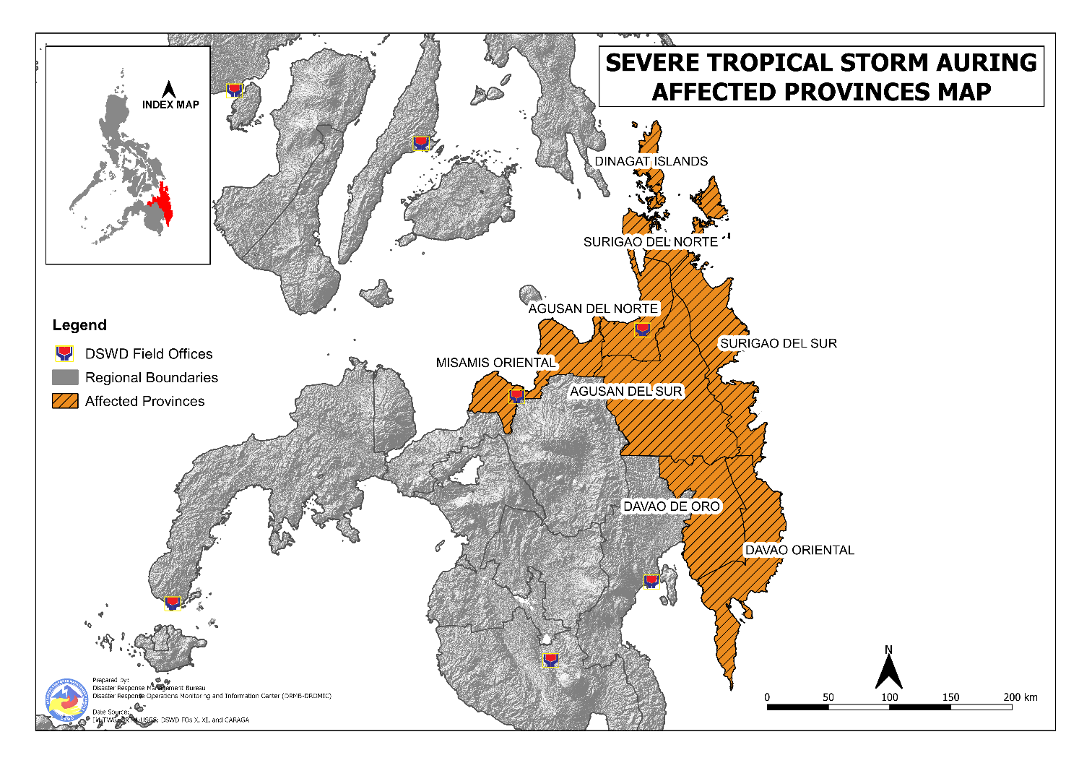
DSWD DISASTER RESPONSE INFORMATION

Situational Reports

DSWD-DRMB
DATE | SITUATIONS / ACTIONS UNDERTAKEN
22 February 2021 | - The Disaster Response Management Bureau (DRMB) is closely coordinating with the concerned field offices for significant disaster response updates.  - All QRT members and emergency equipment are on standby and ready for deployment.

DSWD-FO CAR
DATE | SITUATIONS / ACTIONS UNDERTAKEN
19 February 2021 | - DSWD-FO CAR was cascading the alert advisory and 72-hr rainfall forecasts to the SWADTs of the six (6) provinces.  - DSWD-FO CAR ensured the availability and readiness of transport vehicles, telecommunications and generators.  - DSWD-FO CAR was updating the master list of all available and active evacuation centers all over the region and ensure compliance to the CCCM and IDP Protection COVID-19 guidelines and other issuances to COVID-19 response in the event of evacuation.

DSWD-FO CALABARZON
DATE | SITUATIONS / ACTIONS UNDERTAKEN
19 February 2021 | - DSWD-FO CALABARZON participated in the Pre-Disaster Risk Assessment (PDRA) for STS “Auring” conducted by the Regional Response Cluster of the Regional Disaster Risk Reduction and Management Council (RDRRMC) IV-A on 18 February 2021.  - DSWD-FO CALABARZON was closely coordinating with RDRRMC IV-A’s response agencies, and Local Government Units (LGUs) for the possible effects of STS “Auring” that may require response from the regional level.  - The Disaster Response Management Division (DRMD) of DSWD-FO CALABARZON coordinated with the Local Social Welfare and Development Offices (LSWDOs) in the flood, landslide and storm surge prone areas. They were advised to conduct pre-emptive evacuation and activate additional evacuation centers to ensure that minimum health standards will be observed in the evacuation centers.  - Continuous coordination with the SWAD Team Leaders and Provincial Action Team of the Region and advised them to monitor and check with the LGUs to gather any reports on the effects of the weather disturbance.  - Coordinated with LSWDOs and Local Disaster Risk Reduction and Management Offices (LDRRMOs) and instructed them to be on standby alert, and to prepare their respective evacuation centers and family food packs should need arises.  - DSWD-FO CALABARZON coordinated with RDRRMC IV-A Operation Center for updates on the status of the members of the Regional Response Cluster.  - DSWD-FO CALARARZON continuously monitored the track of STS “Auring” through news reports and social media.

DSWD-FO V
DATE | SITUATIONS / ACTIONS UNDERTAKEN
17 February 2021 | - DSWD-FO V continuously monitored weather updates and information.  - The Regional Resource Operation Section (RROS) of DSWD-FO V ensured the availability of family food packs (FFPs) and non-food items as need arises.  - DSWD-FO V Quick Response Teams (QRTs) were alerted.  - Provincial/Municipal Action Team (P/MAT) members in the six (6) provinces were activated and instructed to coordinate with the Provincial/Municipal Disaster Risk Reduction and Management Offices (P/MDRRMOs) and LSWDOs for weather reports and updates.

DSWD-FO VI
DATE | SITUATIONS / ACTIONS UNDERTAKEN
22 February 2021 | - A total of 36 families or 161 persons took pre-emptive evacuation in four (4) evacuation centers in Region VI.  - DSWD-FO VI issued agency memo activation of Blue Alert status to all Quick Response Team (QRT) members  - DSWD-FO VI DRMD technical staff continuous to monitor the DOST-PAGASA Severe Weather Bulletin updates to coordinate to all QRT members.  - DSWD-FO VI is in continuous monitoring of actual weather update from concerned LGUs through MSWDOs, DROMIC Focal and QRT members.

DSWD-FO VII
DATE | SITUATIONS / ACTIONS UNDERTAKEN
22 February 2021 | - A total of 2,030 families or 5,873 persons took pre-emptive evacuation in 61 evacuation centers in Region VII. Local Governments Units (LGUs) are providing for the needs of the families inside evacuation camps.  - There are a total of 574 individuals stranded at various sea ports in Cebu. LGUs have provided meals to stranded passengers while private groups and companies have also distributed relief items.  - DSWD-FO VII through its Crisis Intervention Section (CIS) in coordination with the Cebu City DSWS provided lunch and dinner to the stranded passengers accommodated in San Roque Gym. A total of ₱11,520.00 worth of assistance was distributed by the QRT members on duty.  - DSWD-FO VII is continuously coordinating with the affected LGUs through the City and Municipal Social Welfare Offices for any augmentation support needed.

DSWD-FO VIII
DATE | SITUATIONS / ACTIONS UNDERTAKEN
22 February 2021 | - A total of 952 families or 3,749 persons took pre-emptive evacuation while 139 families or 554 persons have temporarily stayed with their relatives and/or friends in Region VIII.  - Prepositioned FFPs in Samar Island and Biliran can be distributed immediately by the P/C/MATs to LGUs that need augmentation support.  - Packing of FFPs at the DRMD Operations Office is ongoing with staff augmentation from different DSWD-FO VIII divisions.  - DSWD-FO VIII continuously monitors the weather situation through live updates from PAGASA.  - The Regional Resource Operations Center (RROC) is conducting repacking of FFPs from the available raw materials and the Disaster Response Information Management Section is in coordination with SWAD Teams and DRMD PDOs on the ground to collect data and information as to the situation and effect of TS AURING in Eastern Visayas.

DSWD-FO X
DATE | SITUATIONS / ACTIONS UNDERTAKEN
22 February 2021 | - DSWD-FO X DRMD is in constant coordination with the affected LGU and in response to the immediate need of food and non-food assistance. DSWD-FO X provided a total of 54 Family Food Packs and 18 Family Kits to the affected families.  - DSWD-FO X Quick Response Team including the P/MAT are on standby along with the operational vehicles and telecommunications equipment should the situation escalate and a need for deployment arise.

DSWD-FO XI
DATE | SITUATIONS / ACTIONS UNDERTAKEN
22 February 2021 | - DSWD-FO XI-QRT and DRMD staff rendered skeletal duty to monitor the weather disturbance.  - DSWD-FO XI-DRMD is closely coordinating with P/C/MAT for relevant updates and status of affected families inside and outside evacuation centers.

DSWD-FO XII
DATE | SITUATIONS / ACTIONS UNDERTAKEN
18 February 2021 | - DSWD-FO XII was continuously monitoring the weather updates of Tropical Depression “Auring”.  - DSWD-FO XII was in close coordination with the LMSWDOs, OCD XII and DOST-PAGASA.

DSWD-FO CARAGA
DATE | SITUATIONS / ACTIONS UNDERTAKEN
22 February 2021 | - DSWD-FO CARAGA is continuously monitoring the weather through updates from PAGASA.  - DSWD-FO CARAGA Quick Response Team (QRT) is now activated to support the Disaster Response Management Division staff who already rendered duty in the Emergency Operation Center on a 24/7 basis to monitor the disaster response operation of the LGUs.  - DSWD-FO CARAGA is continuously coordinating with SWADTLs and LSWDOs to monitor the situation in their respective area of responsibility.  - DSWD-FO CARAGA QRT also closely coordinates with the Office of Civil Defense (OCD) and other concerned agencies for updates.  - The CARAGA Disaster Response Reporting Information Management System (CDRRIMS) is utilized for the automated consolidation of reports submitted by LGUs.  - DSWD-FO CARAGA requested for standby fund replenishment from Central Office.
*****
The Disaster Response Operations Monitoring and Information Center (DROMIC) of the DSWD-DRMB is closely monitoring the effects of Severe Tropical Storm “Auring” and is coordinating with the concerned DSWD Field Offices for any significant updates.

Prepared by: Releasing Officer:

MARIEL B. FERRARIZ LESLIE R. JAWILI
MARIE JOYCE G. RAFANAN
PHOTO DOCUMENTATION

