DSWD DROMIC Report #1 on the Displacement due to Armed Conflict in Brgy. Trinidad, Guihulngan City Negros Oriental
as of 30 March 2021, 6PM

SUMMARY

On 23 March 2021, an ecounter ensued between government troops and the New People’s Army (NPA) in Brgy. Trinidad, Guihulngan City, Negros Oriental resulting to the displacement of the families and individuals in the area.
Source: DSWD-FO VII

- Status of Affected Families / Persons
A total of 95 families or 300 persons were affected in Brgy. Trinidad, Guihulngan City, Negros Oriental (see Table 1).

Table 1. Number of Affected Families / Persons
REGION / PROVINCE / MUNICIPALITY |  | NUMBER OF AFFECTED
 |  | Barangays | Families | Persons
GRAND TOTAL |  | 1 | 95 | 300
REGION VII |  | 1 | 95 | 300
Negros Oriental |  | 1 | 95 | 300
 | City of Guihulngan | 1 | 95 | 300
Note: Ongoing assessment and validation being conducted.
Source: DSWD-FO VII

- Status of Displaced Families / Persons Inside Evacuation Center
There are 95 families or 300 persons currently taking temporary shelter at the three (3) evacuation centers (see Table 2).

Table 2. Number of Displaced Families / Persons Inside Evacuation Center
REGION / PROVINCE / MUNICIPALITY |  | NUMBER OF EVACUATION CENTERS (ECs) |  | NUMBER OF DISPLACED
 |  |  |  | INSIDE ECs
 |  |  |  | Families |  | Persons
 |  | CUM | NOW | CUM | NOW | CUM | NOW
GRAND TOTAL |  | 3 | 3 | 95 | 95 | 300 | 300
REGION VII |  | 3 | 3 | 95 | 95 | 300 | 300
Negros Oriental |  | 3 | 3 | 95 | 95 | 300 | 300
 | City of Guihulngan | 3 | 3 | 95 | 95 | 300 | 300
Note: Ongoing assessment and validation being conducted.
Source: DSWD-FO VII

- Assistance Provided
A total of ₱ 82,200.00 worth of assistance was provided by DSWD to the affected families (see Table 3).

Table 3. Cost of Assistance Provided to Affected Families / Persons
REGION / PROVINCE / MUNICIPALITY |  | COST OF ASSISTANCE
 |  | DSWD | LGU | NGOs | OTHERS | GRAND TOTAL
GRAND TOTAL |  | 82,200.00 | - | - | - | 82,200.00
REGION VII |  | 82,200.00 | - | - | - | 82,200.00
Negros Oriental |  | 82,200.00 | - | - | - | 82,200.00
 | City of Guihulngan | 82,200.00 | - | - | - | 82,200.00
Source: DSWD-FO VII

SITUATIONAL REPORT

DSWD-DRMB
DATE | SITUATIONS / ACTIONS UNDERTAKEN
30 March 2021 | - The Disaster Response Operations Monitoring and Information Center (DROMIC) of the DSWD-DRMB is closely coordinating with DSWD-FO VII for significant reports on the status of affected families, assistance, and relief efforts.

DSWD-FO VII
DATE | SITUATIONS / ACTIONS UNDERTAKEN
29 March 2021 | - DSWD-FO VII provided 120 family food packs and malongs to the affected families amounting to ₱82,200.00to the affected families.  - DSWD-FO VII is in close coordination with the local government for further augmentation support needed by the affected families.

*****
The Disaster Response Operations Monitoring and Information Center (DROMIC) of DSWD-DRMB continues to closely coordinate with DSWD-FO VII for significant disaster response updates and assistance provided.

Prepared by:

MARIEL B. FERRARIZ

LESLIE R. JAWILI
Releasing Officer

PHOTO DOCUMENTATION

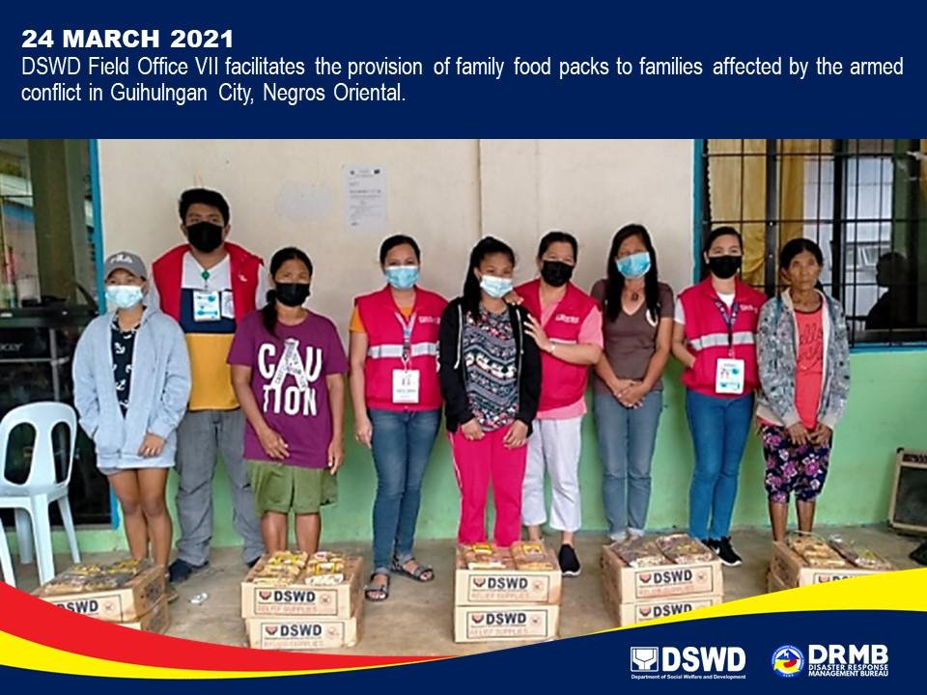

PHOTO DOCUMENTATION
