DSWD DROMIC Report #1 on the
Mw 6.1 Earthquake Incident in Magsaysay, Davao del Sur
as of 11 February 2021, 6PM

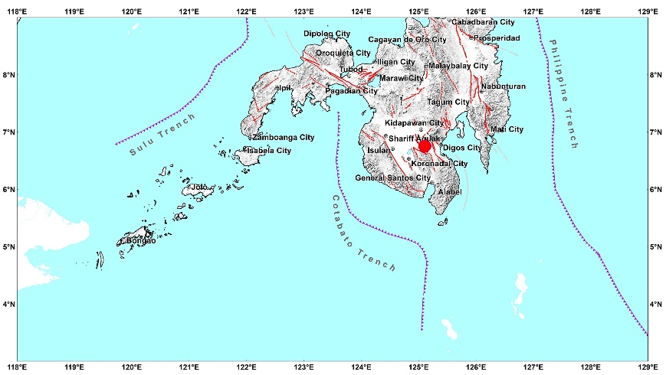

Situation Overview

On 07 February 2021 at 12:22 PM, a 6.1 magnitude earthquake jolted the municipality of Magsaysay, Davao del Sur (06.75°N, 125.11°E - 005 km S 85°W) with a tectonic origin and a depth of focus of 10 km. The earthquake was also felt in the neighboring municipalities of Davao del Sur.

Date/Time: | 07 Feb 2021 - 12:22:55 PM
Reported Intensities: | Intensity VII- M'Lang, Makilala and Kabacan, Cotabato  Intensity VI- Isulan, Sultan Kudarat  Intensity V - Magsaysay, Digos City, Hagonoy, Santa Cruz, Sulop, Bansalan and Matanao, Davao Del Sur; Pres. Roxas, Arakan, Carmen, Kidapawan City,  Matalam and Tulunan, Cotabato; Koronadal City, Banga, Tupi and Tampakan, South Cotabato; Malungon, Sarangani; Columbio, Sultan Kudarat  Intensity IV - Davao City and Padada, Davao Del Sur; Antipas, Banisilan, Midsayap, Cotabato; Alabel, Kiamba, Malapatan, Sarangani; General Santos City;  Norala, Polomolok, South Cotabato; Bagumbayan, Esperanza, Lutayan, Palimbang, Pres. Quirino, Sen. Ninoy Aquino, Tacurong City, Sultan Kudarat; Don Carlos,  Bukidnon  Intensity III - Maco and Nabunturan, Davao De Oro; Tagum City, Davao Del Norte; Malalag, Davao Del Sur; Cotabato City; Aleosan, Cotabato; T'Boli, South  Cotabato; Kadingilan and Kitaotao, Bukidnon; Datu Odin Sinduat, Maguindanao; Balingasag, Medina, Cagayan De Oro City, Gingoog, Salay and Tagaloan,  Misamis Oriental; Kalamansig, Lambayong and Lebak, Sultan Kudarat  Intensity II - Alamada, Cotabato; Tantangan, South Cotabato; Baungon, Damulog, Kalilangan, Libona, Maramag, Talakag, Malaybalay City and Valencia  City, Bukidnon; Iligan City, El Salvador and Manticao, Misamis Oriental  Intensity I - Bislig City, Surigao Del Sur  Instrumental Intensities:  Intensity V - Kidapawan City, Cotabato; Koronadal City, South Cotabato  Intensity IV - Alabel and Kiamba, Sarangani; General Santos City, South Cotabato  Intensity II - Cagayan de Oro and Gingoog, Misamis Oriental  Intensity I - Zamboanga City
Expecting Damage: | YES
Expecting Aftershocks: | YES
Source: DOST-PHIVOLCS Earthquake Bulletin

- Status of Affected Families / Persons
There were 187 families or 935 persons affected by the earthquake incident in 12 barangays in Region XII (see Table 1).

Table 1. Number of Affected Families / Persons
REGION / PROVINCE / MUNICIPALITY |  | NUMBER OF AFFECTED
 |  | Barangays | Families | Persons
GRAND TOTAL |  | 12 | 187 | 935
REGION XII |  | 12 | 187 | 935
North Cotabato |  | 12 | 187 | 935
 | Kabacan | 7 | 95 | 475
 | City of Kidapawan (capital) | 1 | 86 | 430
 | M'lang | 4 | 6 | 30
Note: Ongoing assessment and validation are continuously being conducted.
Source: DSWD-FO XII

- Status of Displaced Families / Persons Inside Evacuation Center
There are 10 families or 50 persons currently taking temporary shelter at the Balabag Relocation Site (open field) (see Table 2).

Table 2. Number of Displaced Families / Persons Inside Evacuation Center
REGION / PROVINCE / MUNICIPALITY |  | NUMBER OF EVACUATION CENTERS (ECs) |  | NUMBER OF DISPLACED
 |  |  |  | INSIDE ECs
 |  |  |  | Families |  | Persons
 |  | CUM | NOW | CUM | NOW | CUM | NOW
GRAND TOTAL |  | 1 | 1 | 22 | 10 | 110 | 50
REGION XII |  | 1 | 1 | 22 | 10 | 110 | 50
North Cotabato |  | 1 | 1 | 22 | 10 | 110 | 50
 | City of Kidapawan (capital) | 1 | 1 | 22 | 10 | 110 | 50
Note: Ongoing assessment and validation are continuously being conducted.
Source: DSWD-FO XII

- Damaged Houses
There were 95 damaged houses; of which, 1 was totally damaged and 94 were partially damaged (see Table 3).

Table 3. Number of Damaged Houses
REGION / PROVINCE / MUNICIPALITY |  | NO. OF DAMAGED HOUSES
 |  | Total | Totally | Partially
GRAND TOTAL |  | 95 | 1 | 94
REGION XII |  | 95 | 1 | 94
North Cotabato |  | 95 | 1 | 94
 | Kabacan | 95 | 1 | 94
Note: Ongoing assessment and validation are continuously being conducted.
Source: DSWD-FO XII

Situational Reports

DSWD-DRMB
DATE | SITUATIONS / ACTIONS UNDERTAKEN
11 February 2021 | - The Disaster Response Operations Monitoring and Information Center (DROMIC) of the DSWD-DRMB is closely coordinating with DSWD-FO XII for significant reports on the status of affected families, assistance, and relief efforts.

DSWD-FO XII
DATE | SITUATIONS / ACTIONS UNDERTAKEN
11 February 2021 | - DSWD-FO XII conducted validation through phone call to the affected LGUs and PSWDO of Cotabato province.  - DSWD-FO XII DRMD staff together with the DRMD Chief went to affected areas to conduct monitoring and validation of the IDPs and damaged houses in close coordination with the concerned LGUs.  - DSWD-FO XII facilitated the food and non-food items request of LGU Kidapawan City.  - DSWD-FO XII is in close coordination with the LGU for possible augmentation assistance needed by the affected families.

*****
The Disaster Response Operations Monitoring and Information Center (DROMIC) of the DSWD-DRMB is closely coordinating with DSWD-FO XII for any significant updates and actions taken relative to the 6.1 Earthquake incident in Magsaysay, Davao del Sur.

Prepared by: Releasing Officer

MARIE JOYCE G. RAFANAN MARC LEO L. BUTAC

