DSWD DROMIC Report #2 on the
Mw 6.1 Earthquake Incident in Magsaysay, Davao del Sur
as of 05 March 2021, 6PM

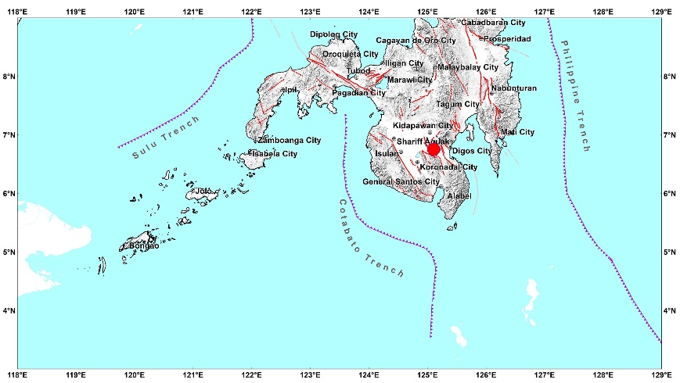

Situation Overview

On 07 February 2021 at 12:22 PM, a 6.1 magnitude earthquake jolted the municipality of Magsaysay, Davao del Sur (06.75°N, 125.11°E - 005 km S 85°W) with a tectonic origin and a depth of focus of 10 km. The earthquake was also felt in the neighboring municipalities of Davao del Sur.

Date/Time: | 07 Feb 2021 - 12:22:55 PM
Reported Intensities: | Intensity VII- M'Lang, Makilala and Kabacan, Cotabato  Intensity VI- Isulan, Sultan Kudarat  Intensity V - Magsaysay, Digos City, Hagonoy, Santa Cruz, Sulop, Bansalan and Matanao, Davao Del Sur; Pres. Roxas, Arakan, Carmen, Kidapawan City,  Matalam and Tulunan, Cotabato; Koronadal City, Banga, Tupi and Tampakan, South Cotabato; Malungon, Sarangani; Columbio, Sultan Kudarat  Intensity IV - Davao City and Padada, Davao Del Sur; Antipas, Banisilan, Midsayap, Cotabato; Alabel, Kiamba, Malapatan, Sarangani; General Santos City;  Norala, Polomolok, South Cotabato; Bagumbayan, Esperanza, Lutayan, Palimbang, Pres. Quirino, Sen. Ninoy Aquino, Tacurong City, Sultan Kudarat; Don Carlos,  Bukidnon  Intensity III - Maco and Nabunturan, Davao De Oro; Tagum City, Davao Del Norte; Malalag, Davao Del Sur; Cotabato City; Aleosan, Cotabato; T'Boli, South  Cotabato; Kadingilan and Kitaotao, Bukidnon; Datu Odin Sinduat, Maguindanao; Balingasag, Medina, Cagayan De Oro City, Gingoog, Salay and Tagaloan,  Misamis Oriental; Kalamansig, Lambayong and Lebak, Sultan Kudarat  Intensity II - Alamada, Cotabato; Tantangan, South Cotabato; Baungon, Damulog, Kalilangan, Libona, Maramag, Talakag, Malaybalay City and Valencia  City, Bukidnon; Iligan City, El Salvador and Manticao, Misamis Oriental  Intensity I - Bislig City, Surigao Del Sur  Instrumental Intensities:  Intensity V - Kidapawan City, Cotabato; Koronadal City, South Cotabato  Intensity IV - Alabel and Kiamba, Sarangani; General Santos City, South Cotabato  Intensity II - Cagayan de Oro and Gingoog, Misamis Oriental  Intensity I - Zamboanga City
Expecting Damage: | YES
Expecting Aftershocks: | YES
Source: DOST-PHIVOLCS Earthquake Bulletin

- Status of Affected Families / Persons
There were 219 families or 1,095 persons affected by the earthquake incident in 12 barangays in Region XII (see Table 1).

Table 1. Number of Affected Families / Persons
REGION / PROVINCE / MUNICIPALITY |  | NUMBER OF AFFECTED
 |  | Barangays | Families | Persons
GRAND TOTAL |  | 12 | 219 | 1,095
REGION XII |  | 12 | 219 | 1,095
North Cotabato |  | 12 | 219 | 1,095
 | Kabacan | 7 | 95 | 475
 | City of Kidapawan (capital) | 1 | 109 | 545
 | M'lang | 4 | 15 | 75
Note: Ongoing assessment and validation are continuously being conducted.
Source: DSWD-FO XII

- Status of Displaced Families / Persons
  - Inside Evacuation Center
There are 33 families or 165 persons currently taking temporary shelter at the Balabag Relocation Site (see Table 2).

Table 2. Number of Displaced Families / Persons Inside Evacuation Center
REGION / PROVINCE / MUNICIPALITY |  | NUMBER OF EVACUATION CENTERS (ECs) |  | NUMBER OF DISPLACED
 |  |  |  | INSIDE ECs
 |  |  |  | Families |  | Persons
 |  | CUM | NOW | CUM | NOW | CUM | NOW
GRAND TOTAL |  | 1 | 1 | 33 | 33 | 165 | 165
REGION XII |  | 1 | 1 | 33 | 33 | 165 | 165
North Cotabato |  | 1 | 1 | 33 | 33 | 165 | 165
 | City of Kidapawan (capital) | 1 | 1 | 33 | 33 | 165 | 165
Note: Ongoing assessment and validation are continuously being conducted.
Source: DSWD-FO XII

  - Outside Evacuation Center
A total of 64 families or 320 persons sought temporary shelter with their relatives and/or friends (see Table 3). All of these families have returned home.

Table 3. Number of Displaced Families / Persons Outside Evacuation Center
REGION / PROVINCE / MUNICIPALITY |  | NUMBER OF DISPLACED
 |  | OUTSIDE ECs
 |  | Families |  | Persons
 |  | CUM | NOW | CUM | NOW
GRAND TOTAL |  | 64 | - | 320 | -
REGION XII |  | 64 | - | 320 | -
North Cotabato |  | 64 | - | 320 | -
 | City of Kidapawan (capital) | 64 | - | 320 | -
Note: Ongoing assessment and validation are continuously being conducted.
Source: DSWD-FO XII

- Damaged Houses
There were 110 damaged houses; of which, 3 were totally damaged and 107 were partially damaged (see Table 4).

Table 4. Number of Damaged Houses
REGION / PROVINCE / MUNICIPALITY |  | NO. OF DAMAGED HOUSES
 |  | Total | Totally | Partially
GRAND TOTAL |  | 110 | 3 | 107
REGION XII |  | 110 | 3 | 107
North Cotabato |  | 110 | 3 | 107
 | Kabacan | 95 | 1 | 94
 | M'lang | 15 | 2 | 13
Note: Ongoing assessment and validation are continuously being conducted.
Source: DSWD-FO XII

- Assistance Provided
A total of ₱493,056.00 worth of assistance was provided by DSWD to the affected families (see Table 5).

Table 5. Cost of Assistance Provided to Affected Families / Persons
REGION / PROVINCE / MUNICIPALITY |  | COST OF ASSISTANCE
 |  | DSWD | LGU | NGOs | OTHERS | GRAND TOTAL
GRAND TOTAL |  | 493,056.00 | - | - | - | 493,056.00
REGION XII |  | 493,056.00 | - | - | - | 493,056.00
North Cotabato |  | 493,056.00 | - | - | - | 493,056.00
 | City of Kidapawan (capital) | 493,056.00 | - | - | - | 493,056.00
Source: DSWD-FO XII

Situational Reports

DSWD-DRMB
DATE | SITUATIONS / ACTIONS UNDERTAKEN
05 March 2021 | - The Disaster Response Operations Monitoring and Information Center (DROMIC) of the DSWD-DRMB is closely coordinating with DSWD-FO XII for significant reports on the status of affected families, assistance, and relief efforts.

DSWD-FO XII
DATE | SITUATIONS / ACTIONS UNDERTAKEN
05 March 2021 | - DSWD-FO XII provided 428 family food packs, 214 laminated sacks, 214 pieces of malong, 214 blankets and 214 sleeping mats to the affected families in Kidapawan City.

*****
The Disaster Response Operations Monitoring and Information Center (DROMIC) of the DSWD-DRMB is closely coordinating with DSWD-FO XII for any significant updates and actions taken relative to the 6.1 Earthquake incident in Magsaysay, Davao del Sur.

Prepared by:

MARIE JOYCE G. RAFANAN

MARC LEO L. BUTAC
Releasing Officer

