DSWD DROMIC Terminal Report on the Fire Incident
in Brgy. Baliwasan Seaside, Zamboanga City
23 July 2021, 6PM

- Situation Overview

This is the final report on the fire incident that occurred in Brgy. Baliwasan Seaside, Zamboanga City on 20 March 2021 at 5:35 AM.
Source: DSWD-FO IX

- Status of Affected Areas and Population
A total of 416 families or 1,112 persons were affected in Brgy. Baliwasan Seaside, Zamboanga City (see Table 1).

Table 1. Number of Affected Families / Persons
REGION / PROVINCE / MUNICIPALITY |  | NUMBER OF AFFECTED
 |  | Barangays | Families | Persons
GRAND TOTAL |  | 1 | 416 | 1,112
REGION IX |  | 1 | 416 | 1,112
Zamboanga del Sur |  | 1 | 416 | 1,112
 | Zamboanga City | 1 | 416 | 1,112
Source: DSWD-FO IX

- Status of Displaced Population
- There were a total of 416 families or 1,112 persons took temporary shelter inside Baliwasan Central SPED Center (see Table 2).

Table 2. Number of Displaced Families / Persons Inside Evacuation Center
REGION / PROVINCE / MUNICIPALITY |  | NUMBER OF EVACUATION CENTERS (ECs) |  | NUMBER OF DISPLACED
 |  |  |  | INSIDE ECs
 |  |  |  | Families |  | Persons
 |  | CUM | NOW | CUM | NOW | CUM | NOW
GRAND TOTAL |  | 1 | - | 416 | - | 1,112 | -
REGION IX |  | 1 | - | 416 | - | 1,112 | -
Zamboanga del Sur |  | 1 | - | 416 | - | 1,112 | -
 | Zamboanga City | 1 | - | 416 | - | 1,112 | -
Source: DSWD-FO IX

- Total Displaced Population
There were a total of 416 families or 1,112 persons displaced in Zamboanga City (see Table 3).

Table 3. Total Number of Displaced Families / Persons
REGION / PROVINCE / MUNICIPALITY |  | TOTAL DISPLACED SERVED
 |  | Families |  | Persons
 |  | Total Families |  | Total Persons
 |  | CUM | NOW | CUM | NOW
GRAND TOTAL |  | 416 | - | 1,112 | -
REGION IX |  | 416 | - | 1,112 | -
Zamboanga del Sur |  | 416 | - | 1,112 | -
 | Zamboanga City | 416 | - | 1,112 | -
N ote: Ongoing assessment and validation are continuously being conducted.
Source: DSWD-FO VI

- Damaged Houses
There were a total of 416 damaged houses; of which, 386 were totally damaged and 30 were partially damaged (see Table 4).

Table 4. Number of Damaged Houses
REGION / PROVINCE / MUNICIPALITY |  | NO. OF DAMAGED HOUSES
 |  | Total | Totally | Partially
GRAND TOTAL |  | 416 | 386 | 30
REGION IX |  | 416 | 386 | 30
Zamboanga del Sur |  | 416 | 386 | 30
 | Zamboanga City | 416 | 386 | 30
Source: DSWD-FO IX

- Cost of Humanitarian Assistance Provided
A total of ₱1,927,799.43 worth of assistance was provided to the affected families; of which, ₱1,551,799.43 from DSWD and ₱376,000.00 from LGU (see Table 5).

Table 5. Cost of Assistance Provided to Affected Families / Persons
REGION / PROVINCE / MUNICIPALITY |  | COST OF ASSISTANCE
 |  | DSWD | LGU | NGOs | OTHERS | GRAND TOTAL
GRAND TOTAL |  | 1,551,799.43 | 376,000.00 | - | - | 1,927,799.43
REGION IX |  | 1,551,799.43 | 376,000.00 | - | - | 1,927,799.43
Zamboanga del Sur |  | 1,551,799.43 | 376,000.00 | - | - | 1,927,799.43
 | Zamboanga City | 1,551,799.43 | 376,000.00 | - | - | 1,927,799.43
Source: DSWD-FO IX

- Response Actions and Interventions

- Food and Non-Food Items (NFIs)

- DSWD-FO IX provided family food packs, sleeping kits, hygiene kits and kitchen kits to the affected families.
- Other Activities

DATE | ACTIVITIES
19 July 2021 | - DSWD-FO IX submitted their terminal report.

- Photo Documentation

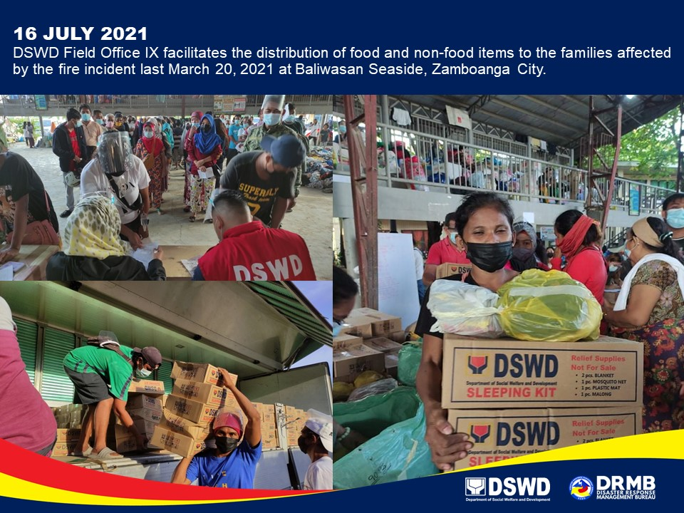

*****
The Disaster Response Operations Monitoring and Information Center (DROMIC) of DSWD-DRMB continues to closely coordinate with DSWD-FO IX for any request of Technical Assistance and Resource Augmentation (TARA

Prepared by:  MARIEL B. FERRARIZ  JOANNA CAMILLE R. JACINTO | Released by:  RODEL V. CABADDU

