DSWD DROMIC Preparedness for Response Report #1 on Typhoon “Bising”
as of 16 April 2021, 6PM

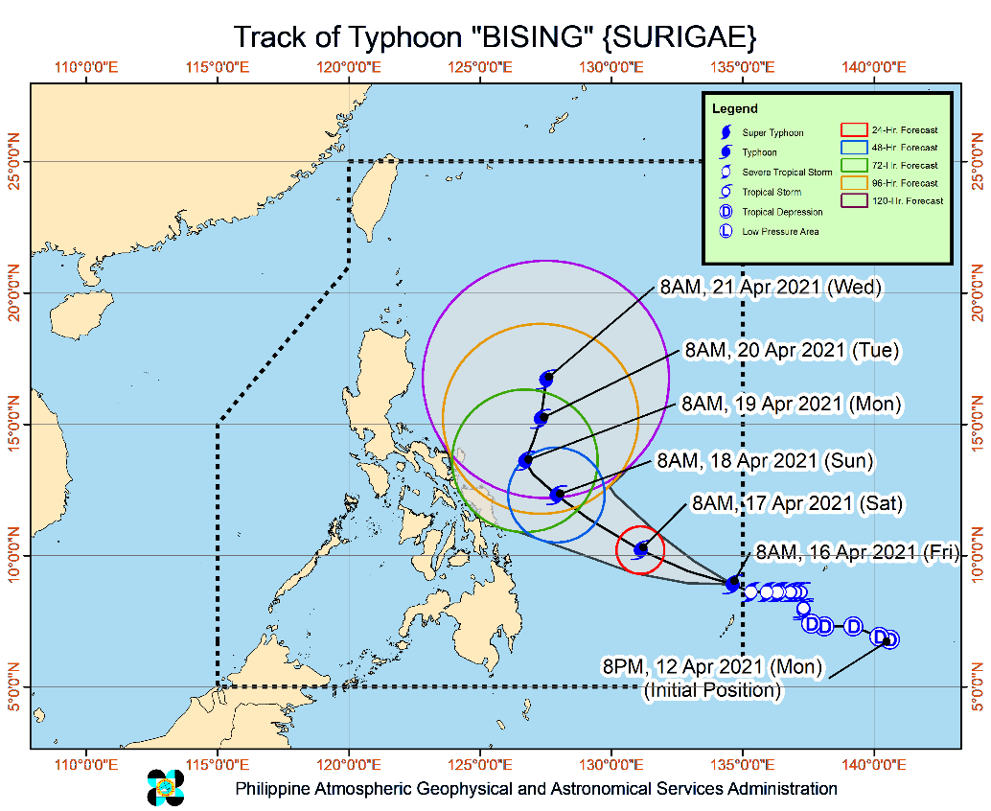
Situation Overview

Issued at 11:00 AM, 16 April 2021, “BISING” ENTERS THE PHILIPPINE AREA RESPONSIBILITY (PAR) AND INTENSIFIES INTO A TYPHOON.

- “BISING” is currently not directly causing severe weather over any portion of the country. It is likely that the winds and heavy rains associated with this tropical cyclone will begin affecting portions of Eastern Visayas and Bicol Region beginning on Sunday.
- Based on available data, Tropical Cyclone Wind Signal #1 may be raised over some localities in Northern Samar and Eastern Samar as early as tonight in anticipation of the onset of strong breeze to near gale conditions associated with “BISING”.
- In the next 24 hours, “BISING” will bring rough to very rough seas (2.8 to 4.5 m) over the eastern seaboards of Visayas and Mindanao. Mariners of small seacrafts are advised to take precautionary measures when venturing out to sea.
- "BISING” entered the PAR at 6:20 AM today. On the forecast track, Typhoon “BISING” will move generally west-northwestward until Monday. Afterwards, it is forecast to turn northeastward. “BISING” is less likely to make landfall in any part of the country.
- At 8:00 AM today, “BISING” intensified into Typhoon category. Over the next three days, “BISING” is forecast to steadily intensify.

At 10:00 AM today, the center of the eye of Typhoon "BISING" was located based on all available data at 960 km East of Surigao City, Surigao del Norte (09.1 °N, 134.2 °E )
Source: DOST-PAGASA Severe Weather Bulletin
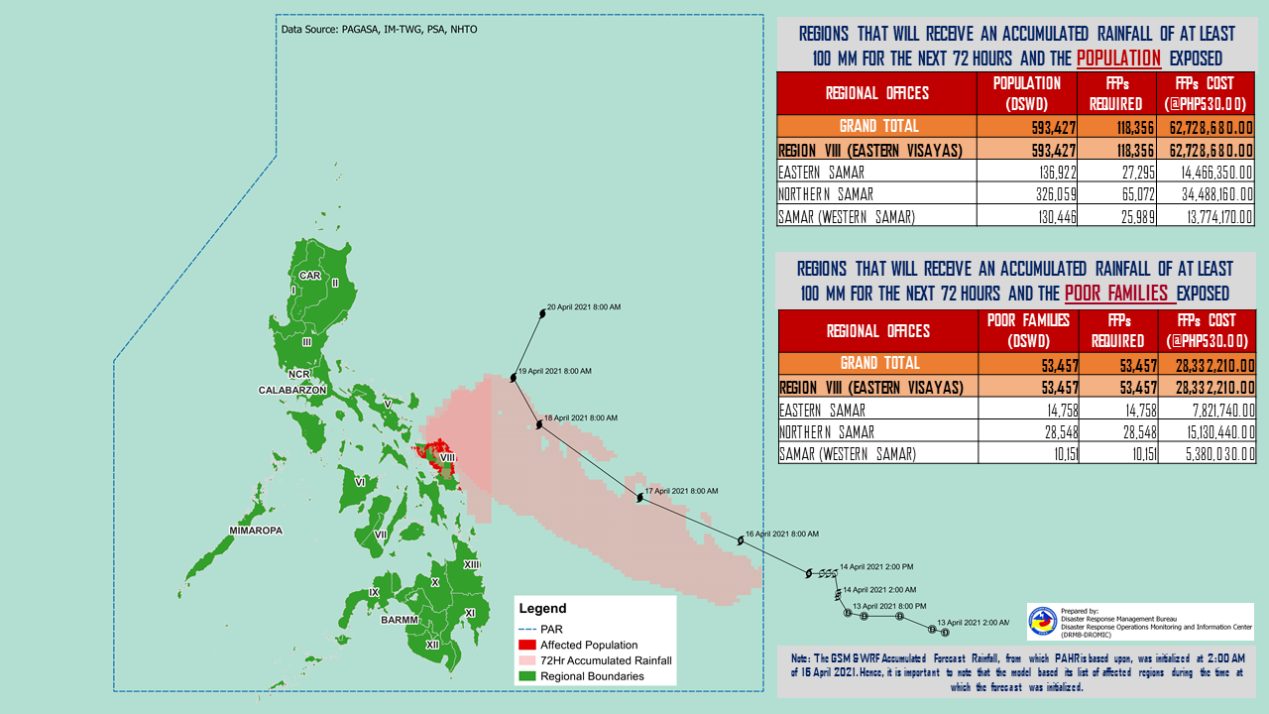
PREDICTIVE ANALYTICS FOR HUMANITARIAN RESPONSE

Status of Prepositioned Resources: Stockpile and Standby Funds
The DSWD Central Office (CO), Field Offices (FOs), and National Resource Operations Center (NROC) have stockpiles and standby funds amounting to ₱1,594,411,367.23 with breakdown as follows (see Table 2):

- Standby Funds
A total of ₱556,438,277.65 standby funds in the CO and FOs. Of the said amount, ₱517,992,176.43 is the available Quick Response Fund (QRF) in the CO.

- Stockpiles
A total of 355,672 family food packs (FFPs) amounting to ₱182,166,142.96, other food items amounting to ₱338,486,457.37 and non-food items (FNIs) amounting to ₱517,320,489.25 are available.

Table 2. Available Stockpiles and Standby Funds
REGIONAL / FIELD OFFICE | STANDBY FUNDS | FAMILY FOOD PACKS |  | OTHER FOOD ITEMS | NON-FOOD RELIEF ITEMS | TOTAL STANDBY FUNDS & STOCKPILE
 |  | QUANTITY | TOTAL COST | TOTAL COST | TOTAL COST
TOTAL | 556,438,277.65 | 355,672 | 182,166,142.96 | 338,486,457.37 | 517,320,489.25 | 1,594,411,367.23
Central Office | 517,992,176.43 | - | - | - | - | 517,992,176.43
NRLMB - NROC | - | 93,893 | 51,912,181.00 | 176,321,147.72 | 275,889,699.25 | 504,123,027.97
NRLMB - VDRC | - | 39,547 | 17,612,415.00 | 30,338,894.34 | 5,077,232.50 | 53,028,541.84
I | 1,497,055.20 | 22,004 | 11,222,040.00 | 7,624,408.24 | 27,597,549.08 | 47,941,052.52
II | 97,869.36 | 13,366 | 6,279,674.00 | 4,465,470.96 | 14,601,214.84 | 25,444,229.16
III | 3,000,908.30 | 5,135 | 2,585,051.35 | 1,622,400.00 | 13,650.00 | 7,222,009.65
CALABARZON | 3,000,000.00 | 5,948 | 2,790,852.00 | 7,243,016.20 | 8,893,219.27 | 21,927,087.47
MIMAROPA | 2,471,062.78 | 32,626 | 20,844,160.95 | 1,307,574.00 | 8,919,596.60 | 33,542,394.33
V | - | 22,978 | 9,275,485.93 | 6,499,399.20 | 15,975,310.90 | 31,750,196.03
VI | 3,000,006.07 | 23,268 | 9,681,962.09 | 27,194,656.70 | 15,013,617.28 | 54,890,242.14
VII | 2,983,087.16 | 18,240 | 8,027,040.00 | 12,673,619.32 | 7,496,480.98 | 31,180,227.46
VIII | 2,215,796.00 | 14,994 | 8,155,686.42 | 6,208,683.36 | 28,014,480.95 | 44,594,646.73
IX | 3,920,000.00 | 16,272 | 8,892,485.28 | 8,873,791.28 | 12,557,978.69 | 34,244,255.25
X | 4,116,679.92 | 16,969 | 9,435,909.68 | 12,778,169.96 | 28,765,533.66 | 55,096,293.22
XI | - | 4,006 | 1,825,133.60 | 9,398,425.00 | 14,025,445.30 | 25,249,003.90
XII | 2,748,513.85 | 2,936 | 1,614,800.00 | 6,535,679.82 | 17,967,738.53 | 28,866,732.20
CARAGA | 3,451,832.02 | 1,972 | 848,857.22 | 4,478,244.90 | 17,610,878.42 | 26,389,812.56
NCR | 2,931,000.00 | 1,259 | 571,145.35 | 6,881,986.45 | 3,661,874.28 | 14,046,006.08
CAR | 3,012,290.56 | 20,259 | 10,591,263.09 | 8,040,889.92 | 15,238,988.72 | 36,883,432.29
Note: The Inventory Summary is as of 16 April 2021, 4PM.
Source: DRMB and NRLMB

Situational Reports

DSWD-DRMB
DATE | SITUATIONS / ACTIONS UNDERTAKEN
16 April 2021 | - The Disaster Response Management Bureau (DRMB) is closely coordinating with the concerned field offices for significant disaster response updates  - All QRT members and emergency equipment are on standby and ready for deployment.  - DRMB participated in the Online Pre-Disaster Risk Assessment Meeting on Typhoon “Bising” on 16 April 2021 with other response cluster member agencies.

DSWD-FO CAR
DATE | SITUATIONS / ACTIONS UNDERTAKEN
14 April 2021 | - DSWD-FO CAR is closely monitoring weather updates and information.  - DSWD-FO CAR ensures availability of food and non-food items for resource augmentation as the need arises.  - DSWD-FO CAR DRR Focal persons in close coordination with LDRRMOs and MSWDOs for weather reports and updates.

DSWD-FO MIMAROPA
DATE | SITUATIONS / ACTIONS UNDERTAKEN
15 April 2021 | - SWADT Offices are alerted to monitor daily local weather condition and related eventualities, and ensure provision of information to all concerned offices, divisions, sections, and units.  - On-call status of the expanded R/P/C/M QRTs together with special projects staff on a 24/7 basis for possible activation of Operation Center to respond in case any untoward incident and eventualities are reported.  - DSWD-FO MIMAROPA is in close coordination with the Office of Civil Defense (OCD) and RDRRMC MIMAROPA for any updates for monitoring purposes and response mechanism for areas that will be affected.  - Standby logistical equipment and workforce through coordination with SWADT Offices and concerned LGUs on the management of stranded passengers, if any, in ports and terminals.  - Information and Communication Technology Management Unit (ICTMU) is on standby status to ensure robust communication system.

DSWD-FO VI
DATE | SITUATIONS / ACTIONS UNDERTAKEN
14 April 2021 | - All QRT members are on stand by and ready for augmentation if needed, following the new normal protocols of the agency.  - RDANA team is composed of 40 trained QRTs and is ready to be deployed if needed. 30 QRT members in-charge for reports also undergone training on DROMIC Protocols last September 17-19 and 24-26, 2020.  - DSWD-FO VI continuously conducts TA provision to LGUs and SWAD Offices on DROMIC Reporting.  - DSWD-FO VI issued a total of 150 vests, 50 GO bags, 50 survival bags, and 50 sleeping kits to QRT members in the region and field staff.

DSWD-FO VIII
DATE | SITUATIONS / ACTIONS UNDERTAKEN
16 April 2021 | - DSWD-FO VIII prepositioned Family Food Packs (FFPs) in Samar Island, Biliran and Southern Leyte which can be distributed immediately by the P/C/MATs to Local Government Units that need augmentation support.  - DSWD-FO VIII alerted QRT members of the DSWD particularly SWADT leaders in Northern Samar and Eastern Samar;  - DSWD-FO VIII monitored the weather situation through watching the live updates of PAGASA regarding the weather disturbances.  - DSWD-FO VIII attended the RDRRMC PDRA Meeting on April 16, 2021 in preparation for possible effects of Typhoon “Bising”.  - DSWD-FO VIII communicated SWAD Teams and City/Municipal Actions Teams to be alerted on the weather disturbance.

*****
The Disaster Response Operations Monitoring and Information Center (DROMIC) of the DSWD-DRMB is closely monitoring the effects of Typhoon “Bising” and is coordinating with the concerned DSWD Field Offices for any significant updates.

Prepared by:

MARIE JOYCE G. RAFANAN

RODEL V. CABADDU
Releasing Officer

