DSWD DROMIC Preparedness for Response Report #3 on Typhoon “Bising”
as of 18 April 2021, 6PM
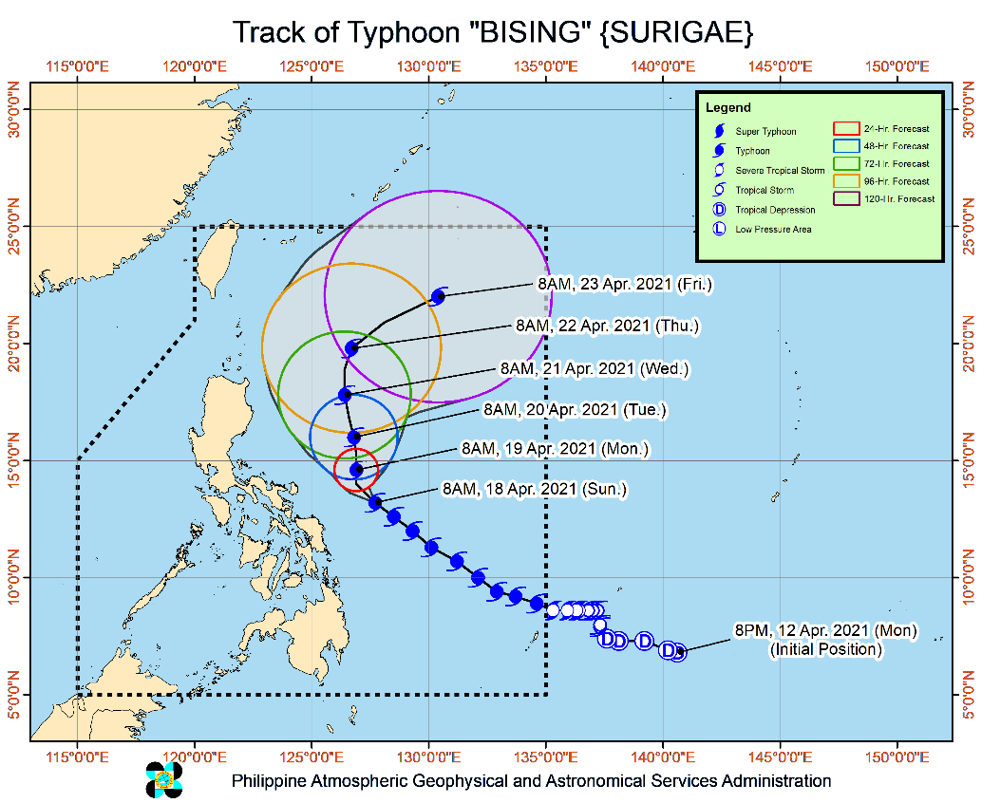
Situation Overview

Issued at 5:00 PM, 18 April 2021, TYPHOON "BISING" SLIGHTLY WEAKENS AND DECELERATES WHILE MOVING WEST-NORTHWESTWARD OVER THE PHILIPPINE SEA EAST OF CATANDUANES.

- Hazards affecting land areas
- Heavy Rainfall:
  - Today, the rain bands of Typhoon “BISING” will bring moderate to heavy with at times intense rains over Eastern Visayas and Bicol Region.
  - Tomorrow (19 April), moderate to heavy with at times intense rains will be experienced over Bicol Region and Northern Samar.
- Under these conditions, flooding (including flashfloods) and rain-induced landslides are likely to occur especially in areas identified in hazard maps as highly or very highly susceptible to these hazards.
- Severe WindsSevere Winds:
  - Tropical cyclone winds of at least strong breeze to near gale in strength extend outward up to 440 km from the center of the typhoon. Destructive typhoon-force winds extend outward up to 110 km from the center of the typhoon.
- Hazards affecting coastal waters
- In the next 24 hours, under the influence of Typhoon “BISING” and an enhanced northeasterly wind flow, the following sea conditions will be experienced over the coastal waters of the country.
- Very rough to very high seas will be experienced over the northern and eastern seaboard of Eastern Visayas (4.0 to 12.0 m), rough to very high seas over the eastern seaboard of Luzon (2.5 to 12.0 m), and rough to very rough seas over the eastern seaboard of Caraga (3.0 to 5.0 m). Sea travel is risky for all types of seacrafts over these waters.
- Rough to very rough seas over the northern and western seaboards of Northern Luzon (2.5 to 5.0 m) and rough seas over the eastern seaboard of Davao Region (2.5 to 3.5 m). Sea travel is risky for small seacrafts over these waters. Mariners without the proper experience should immediately seek safe harbor.
- Moderate to rough seas over the western seaboard of Central Luzon and the remaining seaboards of localities where wind signals are in affect (1.5 m to 3.0 m). Mariners of small seacrafts are advised not to venture out over these waters. Inexperienced mariners of these vessels should avoid navigating in these conditions.
- Track and Intensity Outlook:
  - Today, Typhoon “BISING” will begin to move slowly northwestward over the Philippine Sea east of Bicol Region until tomorrow early morning. The typhoon will then move generally northward until Tuesday (20 April) afternoon before turning north northwestward while over the Philippine Sea east of Cagayan Valley. By Wednesday early morning, the typhoon is forecast to turn northeastward or east northeastward away from the landmass of Luzon.
- Considering the uncertainty in the track forecast of the typhoon, a westward shift in the current forecast track may result in potentially significant impacts over the eastern portions of Southern Luzon and Visayas. The possibility of a close approach scenario is not ruled out.
- The typhoon is forecast to gradually weaken throughout the forecast period.
At 4:00 PM today, the eye of Typhoon "BISING" was located based on all available data including from Guiuan Doppler Weather Radar at 290 km East of Virac, Catanduanes (13.5 °N, 126.9 °E )
Source: DOST-PAGASA Severe Weather Bulletin
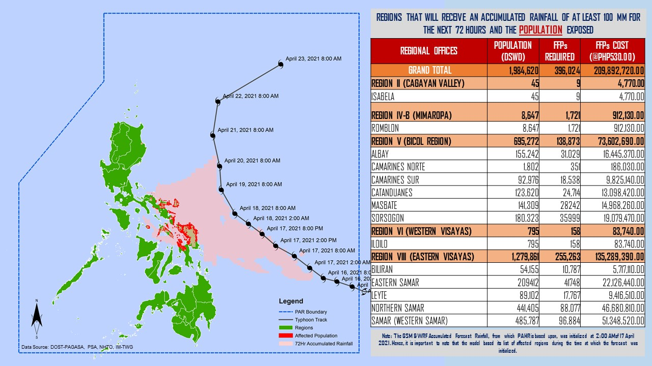
PREDICTIVE ANALYTICS FOR HUMANITARIAN RESPONSE
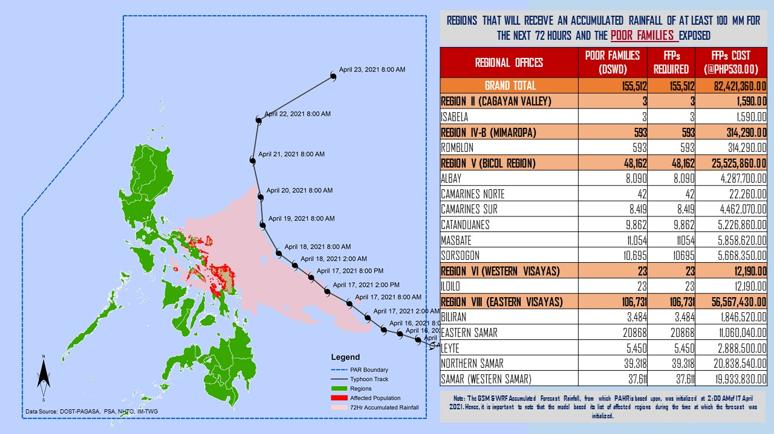

Status of Prepositioned Resources: Stockpile and Standby Funds
The DSWD Central Office (CO), Field Offices (FOs), and National Resource Operations Center (NROC) have stockpiles and standby funds amounting to ₱1,597,270,310.98 with breakdown as follows (see Table 2):

- Standby Funds
A total of ₱556,438,277.65 standby funds in the CO and FOs. Of the said amount, ₱517,992,176.43 is the available Quick Response Fund (QRF) in the CO.

- Stockpiles
A total of 372,991 family food packs (FFPs) amounting to ₱189,965,376.93, other food items amounting to ₱332,608,687.14 and non-food items (FNIs) amounting to ₱518,257,969.26 are available.

Table 2. Available Stockpiles and Standby Funds
REGIONAL / FIELD OFFICE | STANDBY FUNDS | FAMILY FOOD PACKS |  | OTHER FOOD ITEMS | NON-FOOD RELIEF ITEMS | TOTAL STANDBY FUNDS & STOCKPILE
 |  | QUANTITY | TOTAL COST | TOTAL COST | TOTAL COST
TOTAL | 556,438,277.65 | 372,991 | 189,965,376.93 | 332,608,687.14 | 518,257,969.26 | 1,597,270,310.98
Central Office | 517,992,176.43 | - | - | - | - | 517,992,176.43
NRLMB - NROC | - | 97,888 | 53,703,996.00 | 173,605,128.56 | 275,657,675.25 | 502,966,799.81
NRLMB - VDRC | - | 39,547 | 17,612,415.00 | 30,338,894.34 | 5,077,232.50 | 53,028,541.84
I | 1,497,055.20 | 22,004 | 11,222,040.00 | 7,624,408.24 | 27,597,549.08 | 47,941,052.52
II | 97,869.36 | 13,366 | 6,279,674.00 | 4,465,470.96 | 14,601,214.84 | 25,444,229.16
III | 3,000,908.30 | 9,639 | 4,370,660.85 | 1,458,080.00 | 13,650.00 | 8,843,299.15
CALABARZON | 3,000,000.00 | 5,948 | 2,790,852.00 | 7,243,016.20 | 8,893,219.27 | 21,927,087.47
MIMAROPA | 2,471,062.78 | 32,626 | 20,844,160.95 | 1,307,574.00 | 8,919,596.60 | 33,542,394.33
V | - | 25,904 | 10,459,199.23 | 6,520,625.40 | 15,975,310.90 | 32,955,135.53
VI | 3,000,006.07 | 23,268 | 9,681,962.09 | 27,194,656.70 | 15,013,617.28 | 54,890,242.14
VII | 2,983,087.16 | 18,240 | 8,027,040.00 | 12,673,619.32 | 7,496,480.98 | 31,180,227.46
VIII | 2,215,796.00 | 14,994 | 8,155,686.42 | 6,208,683.36 | 28,014,480.95 | 44,594,646.73
IX | 3,920,000.00 | 16,272 | 8,892,485.28 | 8,873,791.28 | 12,557,978.69 | 34,244,255.25
X | 4,116,679.92 | 16,969 | 9,435,909.68 | 12,778,169.96 | 28,765,533.66 | 55,096,293.22
XI | - | 4,006 | 1,825,133.60 | 9,398,425.00 | 14,025,445.30 | 25,249,003.90
XII | 2,748,513.85 | 3,859 | 2,122,450.00 | 6,067,654.21 | 17,967,738.53 | 28,906,356.59
CARAGA | 3,451,832.02 | 3,972 | 1,693,137.22 | 3,633,964.90 | 17,610,878.42 | 26,389,812.56
NCR | 2,931,000.00 | 1,259 | 571,145.35 | 6,881,986.45 | 3,661,874.28 | 14,046,006.08
CAR | 3,012,290.56 | 23,230 | 12,277,429.26 | 6,334,538.26 | 16,408,492.73 | 38,032,750.81
Note: The Inventory Summary is as of 18 April 2021, 4PM.
Source: DRMB and NRLMB

Situational Reports

DSWD-DRMB
DATE | SITUATIONS / ACTIONS UNDERTAKEN
18 April 2021 | - The Disaster Response Management Bureau (DRMB) is closely coordinating with the concerned field offices for significant disaster response updates  - All QRT members and emergency equipment are on standby and ready for deployment.  - DRMB participated in the Online Pre-Disaster Risk Assessment Meeting on Typhoon “Bising” on 16 April 2021 with other response cluster member agencies.

DSWD-FO CAR
DATE | SITUATIONS / ACTIONS UNDERTAKEN
18 April 2021 | - DSWD-FO CAR DRMD is on standby for the possible effects of the weather disturbance  - DSWD-FO CAR is closely monitoring weather updates and information.  - DSWD-FO CAR ensures availability of food and non-food items for resource augmentation as the need arises.  - DSWD-FO CAR DRR Focal persons in close coordination with LDRRMOs and MSWDOs for weather reports and updates.  - DSWD-FO CAR DRMD staff and Planning Division staff attended the Public Service Continuity Plan orientation

DSWD-FO I
DATE | SITUATIONS / ACTIONS UNDERTAKEN
17 April 2021 | - DSWD-FO I is closely monitoring the movement of Typhoon ”BISING” through the DOST – PAGASA and in close coordination with the Regional Disaster Risk Reduction and Management Council 1 (RDRRMC1). Likewise, Provincial Operations Offices (POOs) are in close coordination with the different Provincial/City/Municipal Disaster Risk Reduction and Management Councils (P/C/MDRRMCs) and Provincial/City/ Municipality Social Welfare and Development Offices (P/C/MSWDOs) to monitor the adverse effects that might be brought by the weather disturbance.  - DSWD-FO I Incident Management Team (IMT) is still activated and on duty while other DSWD staff are on standby for possible augmentation. Likewise, the Field Office ensures availability and readiness of resources.

DSWD-FO III
DATE | SITUATIONS / ACTIONS UNDERTAKEN
17 April 2021 | - Activated the Rapid Development Team (RDT) of DRMD that will render skeletal duties during onset of disaster to continuously monitor weather disturbance and coordinates with the Provincial Extension Offices for the situation of their respective LGUs.  - The 15 QRTs are ready for deployment upon the activation of the Blue and Red alert status of the RDRRMC 3.  - The Regional Warehouse and Fort Magsaysay Hub has ongoing repacking of Family Food Packs.

DSWD-FO MIMAROPA
DATE | SITUATIONS / ACTIONS UNDERTAKEN
15 April 2021 | - SWADT Offices are alerted to monitor daily local weather condition and related eventualities, and ensure provision of information to all concerned offices, divisions, sections, and units.  - On-call status of the expanded R/P/C/M QRTs together with special projects staff on a 24/7 basis for possible activation of Operation Center to respond in case any untoward incident and eventualities are reported.  - DSWD-FO MIMAROPA is in close coordination with the Office of Civil Defense (OCD) and RDRRMC MIMAROPA for any updates for monitoring purposes and response mechanism for areas that will be affected.  - Standby logistical equipment and workforce through coordination with SWADT Offices and concerned LGUs on the management of stranded passengers, if any, in ports and terminals.  - Information and Communication Technology Management Unit (ICTMU) is on standby status to ensure robust communication system.

DSWD-FO V
DATE | SITUATIONS / ACTIONS UNDERTAKEN
18 April 2021 | - DSWD FO-V is continuously monitoring weather updates and information.  - The Resource Operation Section ensures the availability of family food packs and non-food items as need arises.  - DSWD FO-V QTRs are alerted.  - PAT and MAT members in the six (6) provinces are activated and instructed to coordinate with the P/MDRRMOs, C/MSWDOs for weather reports and updates.  - A total of 97 families or 732 persons are currently taking preemptive evacuation in 10 evacuation centers in Region V.

DSWD-FO VI
DATE | SITUATIONS / ACTIONS UNDERTAKEN
14 April 2021 | - All QRT members are on stand by and ready for augmentation if needed, following the new normal protocols of the agency.  - RDANA team is composed of 40 trained QRTs and is ready to be deployed if needed. 30 QRT members in-charge for reports also undergone training on DROMIC Protocols last September 17-19 and 24-26, 2020.  - DSWD-FO VI continuously conducts TA provision to LGUs and SWAD Offices on DROMIC Reporting.  - DSWD-FO VI issued a total of 150 vests, 50 GO bags, 50 survival bags, and 50 sleeping kits to QRT members in the region and field staff.

DSWD-FO VIII
DATE | SITUATIONS / ACTIONS UNDERTAKEN
18 April 2021 | - DSWD-FO VIII prepositioned Family Food Packs (FFPs) in Samar Island, Biliran and Southern Leyte which can be distributed immediately by the P/C/MATs to Local Government Units that need augmentation support.  - DSWD-FO VIII alerted QRT members of the DSWD particularly SWADT leaders in Northern Samar and Eastern Samar;  - DSWD-FO VIII monitored the weather situation through watching the live updates of PAGASA regarding the weather disturbances.  - DSWD-FO VIII attended the RDRRMC PDRA Meeting on April 16, 2021 in preparation for possible effects of Typhoon “Bising”.  - DSWD-FO VIII communicated SWAD Teams and City/Municipal Actions Teams to be alerted on the weather disturbance.  - DSWD-FO VIII delivered 700 FFPs for prepositioning at the ESSU Campus in Can-avid, Eastern Samar on April 15, 2021. While, 700 FFPs were also delivered for prepositioning at the Eastern Samar States University (ESSU) Main Campus in Borongan City, Eastern Samar on April 16, 2021.  - A total of 997 families or 3,944 persons have preemptively evacuated in 26 evacuation centers in Region VIII.

DSWD-FO CARAGA
DATE | SITUATIONS / ACTIONS UNDERTAKEN
17 April 2021 | - DSWD-FO CARAGA is continuously monitoring the weather updates.  - DSWD-FO CARAGA QRTs are on standby for possible deployment.  - DSWD-FO CARAGA is continuously coordinating with SWADTLs and LSWDOs to monitor the situation in their respective area do responsibility.

*****
The Disaster Response Operations Monitoring and Information Center (DROMIC) of the DSWD-DRMB is closely monitoring the effects of Typhoon “Bising” and is coordinating with the concerned DSWD Field Offices for any significant updates.

Prepared by:

MARIEL B. FERRARIZ

LESLIE R. JAWILI
Releasing Officer

PHOTO DOCUMENTATION
